How to apply to become a PPV partner for NHS England

1. Introduction
Please read this information pack before filling in the application form.

This will tell you how to apply.
It will also help you decide whether you have the skills and time to become a PPV partner.
 | The closing date to apply is Monday 10th September 2018.
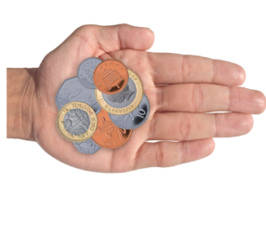 | NHS England will pay expenses and involvement payments to successful candidates.  You must tell the tax office and the Job Centre about any payments.  This may affect whether you receive benefits/insurance policy payments.  Please get advice before applying for the role.  You can choose not to be paid, or only paid in part if you choose.  This would depend on your payment limits.  We will usually get in touch with you by email.  If you would like us to contact you by phone or letter, please write this on your form.

2. How to apply
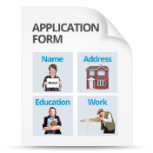 | You need to complete and return these two documents:  - Application Form  - Equality Opportunity Monitoring Form
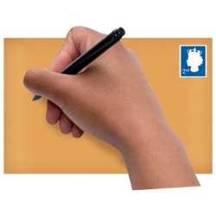 | You can return these by email to: england.digitalhealth@nhs.net  Or post them to:  NHS England,  Coral Pearce,  6th Floor, Zone D,  Skipton House,  80 London Road,  SE1 6LH
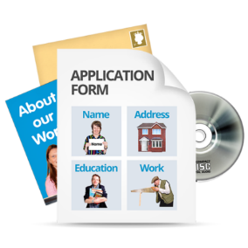 | If you would like this application pack in other formats, email:  england.digitalhealth@nhs.net
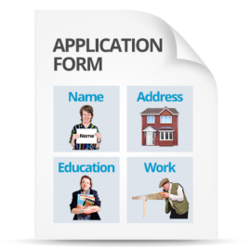 | We will use the information on your form to decide whether you have the skills and experience needed to be a PPV partner.

3. Diversity and equality of opportunity
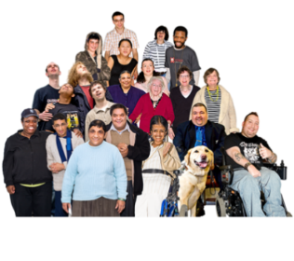 | NHS England aims to promote diversity.  We want equality of opportunity for all.  To check if we are achieving this, please fill in our Equality Opportunity Monitoring Form.
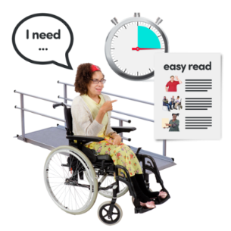 | Tell us if you have special needs that we need to support.  This is to enable you to fully take part.

4. Once we receive your application
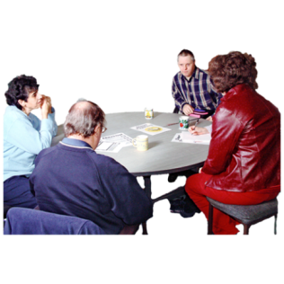  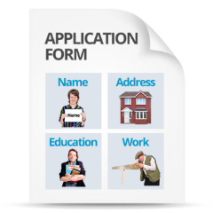 | We will acknowledge receipt of your Application Form.  If you do not receive this within 3 days, please get in touch.  A panel will shortlist applications.  They will be assessed against the role, skills and experience needed.  Selection will be made on the application form.  Interviews will take place in the week beginning 17th September 2018.  Two references will be taken up for successful applicants.  A referee is somebody who can tell us about your skills and experience.  We will tell everyone whether they have been successful or not.  People who are successful will be sent information about what will happen next.
If you have questions, or would like to discuss the role, email:
england.digitalhealth@nhs.net

5. Background to PPV

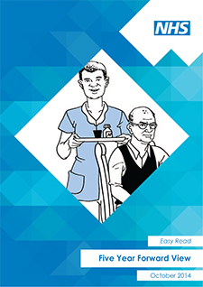 | The Five Year Forward View sets out how information and technology help us provide care and services that are good for patients and efficient for the NHS.  This will help get people to the right care as quickly as possible.  We are empowering people to co-produce their health and care.
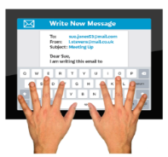 | There are lots of digital health services available to patients.  We are working to develop more.
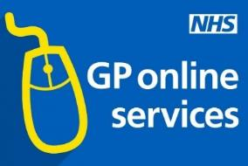  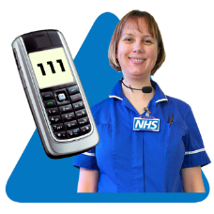  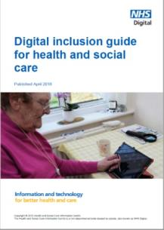  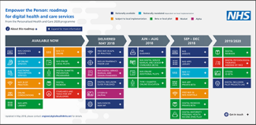 | GP Online Services and NHS Choices are working well.  We are bringing in NHS 111 Online and the digital redbook.  We are bringing in free NHS WiFi.  We have written a digital inclusion best practice guide.  We published our first Empower the Person roadmap this year.
The NHS App will be out by the end of 2018.
This will give people access to online services through one easy entry-point.
Our priorities are:
- supporting the system with digital change
- telling the workforce about digital tools
- launching new services
- helping the public to know about and use these new services.

6. Role of the groups

6.1 Empower the Person (EtP) Uptake and Adoption Steering Group
Patients and the public do not generally know about digital services.

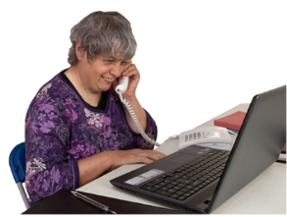 | We want more people to use digital services.  We want to change patient behaviour, from face to face into digital services.  We want to change attitudes so that digital is the channel of choice.

The Uptake and Adoption Steering Group
This group reports to the Empower the Person Board.
It wants more people to use digital services, so they can manage their health and care.
The Steering Group is made up of representatives from bodies such as: NHS England, NHS Digital and Public Health England, and regional NHS technology directors.
There are two vacancies for PPV partners.
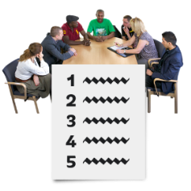 | The Steering Group meets every 6 weeks for up to 2 hours.  Papers and agenda are issued one week before meeting.
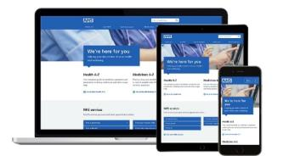 | 6.2 Online Services in Primary Care Stakeholder Forum  The Forum provides stakeholder consultation to support the Empower the Person and Primary Care Digital Transformation programmes.  It provides stakeholder views for the Boards to respond to.  It responds to Board requests. It can recommend subjects to groups for discussion.  There are 6 vacancies for PPV partners.
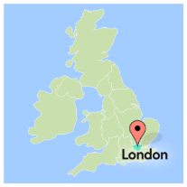  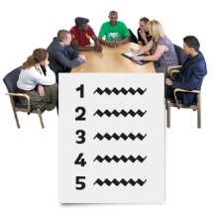  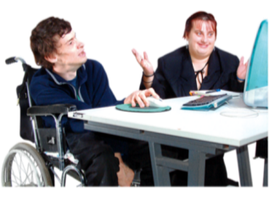 | The Forum meets for a full day three times a year in London.  The meetings use breakout sessions and group working.  Members should get to know the agenda subjects before meetings.  There will also be three webinars.

6.3 Primary Care Digital Transformation Clinical Advisory Group
This group supports implementing new practice, clinical and business processes in primary care.

It is supported by digital tools for the benefit of patients, clinicians and the public.
 | The group has representatives from senior staff including NHS England, NHS Digital and various other health organisations across England.
The Advisory group will meet every four months.
This may be in person and/or by webinars.

7. Why PPV partners are important
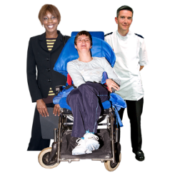  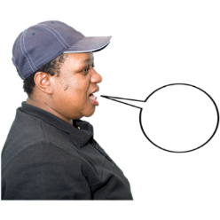 | NHS England wants to make sure patient and public voices play a bit part in shaping our services.  Their views should shape how services develop.

8. What is the role of PPV partners?
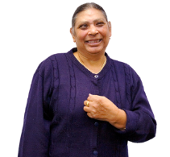 | PPV brings important views, perspective and challenge.  This role champions a service user, patient and/or carer/family viewpoint.  It makes sure their needs are met through outcomes of the group.
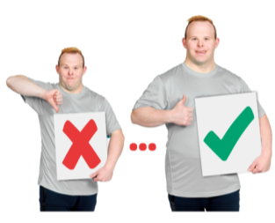 | The role of the PPV partner is to:  - champion the range of PPV views - not just to represent their own experience  - advocate for more patient and public awareness of programme outcomes  - make sure patients and citizens can influence the programmes, systems, processes and products  - they should enable the views of wider patient and public voices through different channels  - keep the programme true to its purpose:  better health outcomes, patient experience, safety and efficiency  - they should represent views of patients, building on evidence and research  - keep two-way communication with patient / citizen networks  - promote the programme through own networks nationally and locally  - keeping discussions confidential when this is needed.

9. Skills and experience needed
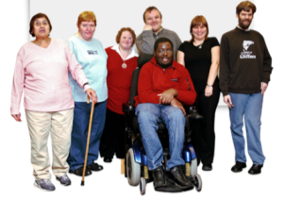 | - experience of speaking in large groups  - understanding and interest in digital health services and how they support people in managing their health and care  - making sure different patients, public and carers voices are at the centre of discussions and decisions  - understanding the health and care system  - experience of using digital services in care settings  - be confident interacting with multiple stakeholders at senior management level  - being able to understand and evaluate information and evidence  - experience of representing PPV in healthcare forums and networks  - experience of working with healthcare organisations or NHS England programmes  - be able to display sound judgement and objectivity  - being committed to equality and diversity  - understand the need for confidentiality.

10. Time Commitment
Membership is for 12 months.
After this, membership will be reviewed.

11. Support for PPV partners

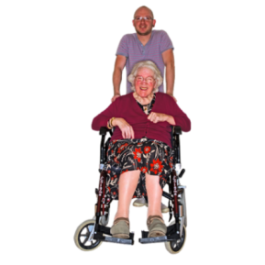 | There will be an induction session.  A named link will be provided to support PPV partners with information.  Other support:  - meeting documents, and if needed, pre-meeting briefings will be provided  - expenses and involvement payment will be paid  - expenses usually cover travel, accommodation and/or subsistence.  You should tell us anything making it difficult to take part in PPV.  This might be the costs of a carer needed to go to meetings with a PPV rep.  Email: england.digitalhealth@nhs.net to tell us your support needs.
Pictures by Photosymbols
Easy read by otherness

