Equality Opportunity Monitoring Form

Why we need this information
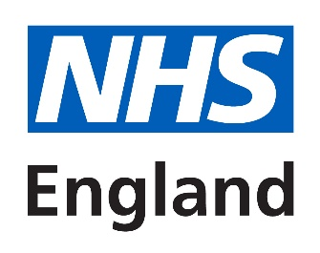 | NHS England is committed to promoting equality of opportunity.  This makes sure everyone has the chance to take part in the activities and decisions of the organisation.
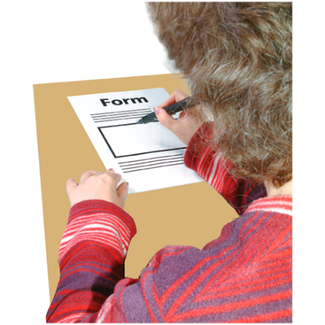  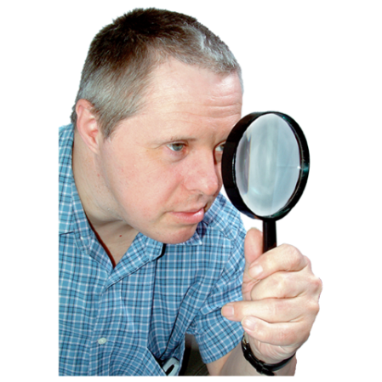 | By filling in this form, you will help us understand who we are reaching and how we can better serve everyone in our community.  It will tell us about our PPV members, and to check we are fulfilling our commitments.  You have a right not to tell us the information.
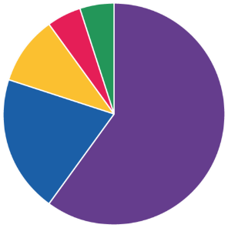  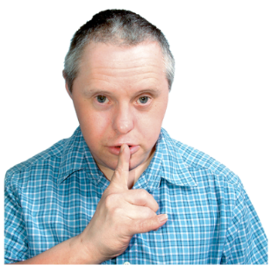  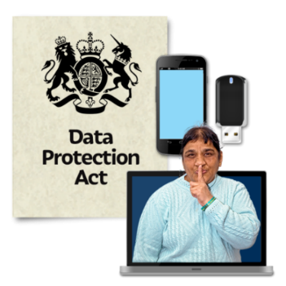 | Data protection  The information you give us will not be stored with any identifying information about you.  Your information will not allow you to be identified.  All information is held in line with the Data Protection Act 1998.
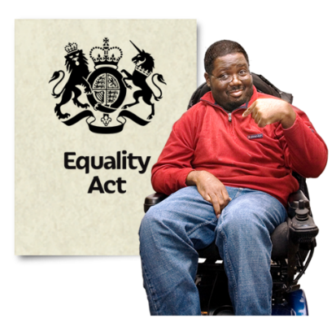 | The information that we need is in the 2010 Equality Act. It includes information about:  - age  - disability  - gender reassignment  - marital status  - maternity  - race  - religious belief  - sex and sexual orientation

The form starts here
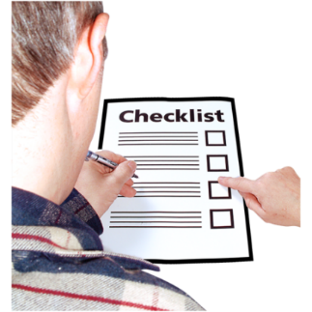 |  | Please tick the boxes which are relevant to you.

Ethnicity
Please tick the box for what you consider your ethnic origin to be.
Asian/Asian British
☐ Indian
☐ Pakistani
☐ Bangladeshi
☐ Chinese
☐ Any other Asian background

(More choices on the next page)

Mixed/multiple ethnic groups
☐ White and Black Caribbean
☐ White and Black African
☐ White and Asian
☐ Any other mixed/multiple ethnic background

Black/African/Caribbean/ Black British
☐ Caribbean
☐ African
☐ Any other Black/African/Caribbean background

(More choices on the next page)

White
☐ English
☐ Northern Irish
☐ Scottish
☐ Welsh
☐ British
☐ Irish
☐ Gypsy/Irish traveller
☐ Any other White background

Other ethnic group
☐ Arab
☐ Any other ethnic group

Rather not say
☐ Rather not say

Age
☐ 10 – 14
☐ 15 – 19
☐ 20 – 24
☐ 25 – 34
☐ 35 – 44
☐ 45 – 54
☐ 55 – 64
☐ 65+
☐ Rather not say

Sex/Sexual orientation
☐ Male (M)
☐ Heterosexual
☐ Female (F)
☐ Gay man
☐ Lesbian
☐ Rather not say
☐ Other
☐ Rather not say

Gender re-assignment
Have you gone through any part of a process (including thoughts or actions) to change from the sex you were described as at birth, to the gender you identify with?
Or do you intend to?
This could include:
- changing your name
- wearing different clothes
- taking hormones
- or having any gender reassignment surgery
☐ Yes
☐ No
☐ Rather not say

Religion / belief
☐ No religion
☐ Buddhist
☐ Christian
☐ Hindu
☐ Jewish
☐ Muslim
☐ Sikh
☐ Atheist
☐ Any other religion
☐ Rather not say

Disability
The Disability Discrimination Act 1995 says a person is disabled if they have a physical or mental impairment which has a substantial and long-term adverse effect on their ability to carry out normal day-to-day activities.
This includes conditions such as cancer, HIV, mental illness and learning disabilities.
By this definition, do you consider yourself to have a disability?
☐ Yes, limited a lot
☐ Yes, limited a little
☐ No
☐ Rather not say

If you selected yes, please tick your disability:
☐ Vision
(e.g. blindness or partial sight)
☐ Hearing
(e.g. deafness or partial hearing)
☐ Mobility
(e.g. difficulty walking short distances, climbing stairs, lifting and carrying)
☐ Learning, concentrating or remembering
☐ Mental health
☐ Stamina or breathing difficulty
☐ Social or behavioural issues
(e.g. conditions such as Autism, Attention Deficit Disorder or Asperger’s Syndrome)
☐ Other impairment
☐ Prefer not to say

Carer responsibility
Do you look after, or support family members, friends, neighbours or others because of:
- Long-term physical or mental ill-health / disability OR
- Problems related to old age
☐ Yes
☐ No
☐ Rather not say
If yes, please show your responsibility (tick all that apply):
☐ Primary carer of a child/children (under 18)
☐ Primary carer of disabled child/children
☐ Primary carer of disabled adult (18 and over)
☐ Primary carer of older person (65+)
☐ Secondary carer
☐ Rather not say

Where did you hear about this advert to apply?
_________________________________________________
Pictures by Photosymbols
Easy read by otherness

