**BUSINESS CASE SUBMISSION TEMPLATE**

|  |  |
| --- | --- |
| **Title** | Electronic Maternity Information System Replacement |
| **Version No.** | 3.0 |

**Type of business case**

|  |  |  |
| --- | --- | --- |
| **Revenue business case** | **No significant capital component** |  |
| **Capital business case** | **No significant revenue component other than capital charges** |  |
| **Combined business case** | **Significant revenue and capital components** | **√** |

**Version control**

|  |  |  |
| --- | --- | --- |
| **Version** | **Date** | **Changes from previous version** |
| 1.0 | 28/4/15 | Draft |
| 1.1 | 25/06/2015 | Amendments after first review |
| 1.2 | 13/07/2015 | Further amendments following internal review |
| 1.3 | 29/07/2015 | Further amendments following review by Finance |
| 1.4 | 10/08/2015 | Further amendments following review – Supplier costs updated |
| 1.5 | 14/08/2015 | Further amendments – supplier costs updated |
| 1.5a | 27/08/2015 | Formatting draft in prep for |
| 1.6 | 12/10/2015 | Redo of the financial case |
| 1.7 | 18/10/2015 | Updated financial costs and exit strategy |
| 1.8 | 21/10/2015 | Updated financial tables and appendices |
| 1.9 | 21/10/2015 | Updated financial analysis and commentary |
| 2.0 | 22/10/2015 | Updated for VAT and other commentary amendments |
| 2.1 | 27/10/2015 | Updated to include Options 3 savings table |
| 3.0 | 04/11/2015 | Updated to Final draft following trust board and approval |

**Business case sponsor**

|  |  |
| --- | --- |
| Name of persons responsible/lead | X |
| Designation | Service Line Manager  Modern Matron |
| Department | Women’s Health Department |
| Contact details |  |

Notes:

1. Ensure all relevant support is involved as early as possible when developing business cases to ensure adequate lead-in essential technical advice. This includes financial and information advice but also appropriate procurement advice, i.e. for significant equipment purchase or tendering for sub –contractors.
2. Ensure that a revenue stream is identified for proposals that will incur capital charges

**Authorisation and support for proposal**

|  |  |  |
| --- | --- | --- |
| Executive Director | X |  |
| Associate Director /  Corporate head of service | X |  |
| Business Unit/Directorate Financial Manager | Case reviewed and supported: Yes /NA |  |
| Case reviewed and not supported: No /NA  If ‘no’ please give reason: |  |
| Cross Business Unit sign-off | Dialogue taken place and priority agreed  Implications identified /can be met: Yes/No |  |

**Business case development team**

Please identify other individuals not already listed who have been involved in preparing this case. Include external stakeholders where appropriate.

|  |  |  |
| --- | --- | --- |
| **Name** | **Department** | **Contact details: Tel/email** |
| X | Women’s Health Department |  |
| X | Maternity |  |
| X | Projects |  |
| X | Finance |  |

|  |  |  |  |  |  |  |  |
| --- | --- | --- | --- | --- | --- | --- | --- |
| **1.Executive Summary** | | | | | | | |
|  | To ensure that the Maternity Department provides high quality, safe care to women, babies and families, the department, since 1999, has used an electronic patient recording system. This enables the department to record Maternity care and comply with national requirements by producing the Maternity data set.  In July 2016 the contract expires and the current system becomes unsupported and a replacement needs to be procured. This gives the Trust an opportunity to identify current and future needs of the department and potential alternative IT solutions to meet those needs.  A key factor in terms of a replacement for the department would be to consider a system which not only replaces current functionality but also provides improved integration between clinical systems. This will support improved accessibility and visibility of data which in turn enables a more efficient work flow. One of the key aims is to improve the quality of care and reduce risk across the department. Improved quality of service will lead to an improvement in the patient experience throughout their pregnancy and may help increase the number of deliveries carried out in X. | | | | | | |
| **2.The Strategic Case** | | | | | | | |
|  | X is the IT electronic documentation system used within Women’s Health, which currently manages and archives patient information during pregnancy.  X has been utilised by the Trust in the Maternity department since 1999, including an upgrade 3-4 years ago. This system captures data at the beginning and end of pregnancy and provides limited departmental reports. It also provides discharge documentation to the primary care teams.  In July 2016 the current system becomes unsupported and the contract ceases. The Trust has placed this procurement as a Category 2 clinical systems replacement.  **Overview of the current system**  The current IT system is a basic data collection tool which is populated at only two points of the forty week pathway, the remainder of the data is captured by patient hand held records/hospital based medical records.  The lack of electronic clinical data capture throughout the pregnancy presents a risk in clinical review and decision making across acute and community services. In summary, we, as an organisation, are reliant on the public providing us with their clinical information in the form of the hand held notes.  The current process captures Information through the following:   * X: Electronic information capture at point of booking and delivery. * Hand held notes: Generated by the community midwife and held by the patient. * X: Patient activity only captured * Hospital Maternity record: Paper based inpatient documentation. * Maternity Screening Pathology Database. There is a uni-directional interface from X to X to X   The collection of clinical data in a hand written patient held document restricts the amount of information available to the full team at any one time throughout pregnancy and postnatal period. This lack of clinical information presents a risk in clinical review and decision making in the absence of the hand held hand written notes.   * X does not interface with any of the diagnostic systems therefore the user has to access these independently. * The system is managed remotely and therefore administration and changes to the user base can be protracted. * Operational reports have to be provided by X therefore limiting the amount of intelligence to support quality and safety initiatives. * X is unable to support the sharing of information with the patient and the wider health community including GP’s, health visitors and social workers. * There is no capability within the system to record risk or harm and there is no interface with the Trust incident reporting system ( X).   The current system presents failings in its inability to provide continuous, accessible electronic clinical information throughout the patient pathway resulting in an increased probability of risk realisation.  In addition, the current process is heavily reliant on additional external resources to support business processes which are inefficient and costly.  Examples of this are:   * The input of community data capture is reliant on community midwives transporting populated hand held records to the hospital site, which are then transcribed onto the electronic system.   Electronic data capture within the community at point of care would negate this.   * Data entry: All clinical community activity is captured retrospectively by paper based sheets which are submitted per midwife (WTE 20), per day to a data clerk who then enters them onto X. This information populates not only clinical pathways but also collates financial PbR intelligence.   Electronic data capture within the community at point of care would negate this.   * The current system offers limited potential for development. * Limited operational reports are available by request to external providers due to X being a hosted system. The system does not create ad hoc reporting and reports are restricted to specific staff which can only be created after a manual update from the external server. * The archive of information has limited use and is secondary to the hand written records which is where the wealth of clinical information remains, questioning the fitness for purpose of the existing system. * There is a Risk (current risk score 15) with the cohort information not matching from evolution compared to the pathology systems and X system.     In addition to the risks mentioned above, the current system and the processes around it pose an increased risk to patient safety. The following two examples illustrate occasions that may have resulted in legal action, with potentially expensive claims/settlements. In addition this may have caused reputational damage resulting in loss of income through reduction in the number of ladies selecting X as their hospital of choice.  **Case 1: No Harm – Near Miss**  **Patient A** booked for care in the community and had a significant amount of safeguarding and engagement owing to a drug and alcohol addiction.  When she presented in labour on the unit she purposefully omitted to bring her hand held documentation which had significant live information regarding this patient. The patient declared that by omitting to bring this information she would have the opportunity immediately after birth to discharge without social service input. This presented huge risks to both mother and baby with regard to drug/alcohol withdrawal and safeguarding. This was avoided as the community teams regularly duplicate all safeguarding information by hand into the medical records. This is extremely timely and is often the sole purpose of the drive to the hospital to deliver the documentation. The ease at which the patient could hide important information from the hospital team demonstrates that the current system can lead to significant safeguarding issues for both the baby and/or the mother.  **Case 2:  Moderate Harm**  **Patient B** booked for maternity care at X and the documentation was completed in her hand held notes, the notes were then taken to X for her demographics to be hand typed into X by a data clerk and another clerk hand typing the clinical data into Evolution.  Her antenatal care was as per NICE guidance and all within normal limits. All antenatal care was within the community other than scans. All clinical details were documented in the patient hand held record other than the scans.  The community visits are populated on X by a data input clerk from individual written midwifery activity sheets.  At 38 weeks pregnant the community midwife felt the baby was considerably small for its gestational age, which could indicate a reduction in the efficiency of the placenta which basically keeps the baby healthy and supports growth.  The woman was referred to the antenatal clinic for medical opinion. At the clinic the very junior medic felt the growth was normal and discussed the case with a senior medic, however human error led to the conversation being about 2 different patients and the case discussed did not result in a scan to review the growth of the baby.  The community midwife has no way presently of reviewing what happened at the referral within the hospital and accepted the patient’s feedback and reassurance that everything was normal.  When a woman rings the maternity unit for advice then staff can only rely on the information from the woman as she holds all her live records, when the woman contacted the unit she did not explain that the midwife had felt the baby was small or the detail of review from the junior medic. If this information was available the staff would have suggested an immediate review of her care and pregnancy when she telephoned for advice in late pregnancy.  The total summary of clinical care was not available to the assessment unit staff and only that described by the woman, when the woman arrived on the unit there was not a fetal heart and a stillbirth was confirmed.  At the postmortem it was confirmed that the baby was significantly small and the placenta had not been working effectively.  Whilst there were other factors that contributed to this outcome, significant issues were noted in the inability to review live clinical information regarding a review and, essentially as an example, as soon as the medic had seen the patient in clinic the community midwife should have that information available and vice versa with the hospital staff having the community clinic care available to review whilst triaging a woman.  The inability to review live clinical information in a care pathway that is live for at least 42 weeks and across acute and community services demonstrates a risk to decision making and clinical outcomes.  **Maternity Services IT requirements to support patient care.**   * An IT solution that can be utilized within primary care to be populated at every patient contact from booking to discharge. With an efficient synchronisation to systems within secondary care real time. * Mobile devices in primary care which are compliant with information governance, to support real-time data capture. The secondary care data would be populated on a suitable mobile device directly in the clinical areas and not paper records. * Patient Portal: To enable patients to own a patient level record. This would be available continuously throughout pregnancy and provide the ability to communicate virtually with the clinical teams confirming, reminding and offering appointments, advice and classes etc.   + The ability to provide patient the electronic record in their preferred language whilst ensuring the professional would see the record in English. * The ability to print from the system to support situations where a patient does not have email or internet access. Printing options need to accommodate   + Patients with disabilities i.e. Visually impaired   + Translation into the patients preferred language * A system that will provide locally configurable alerts including safeguarding, risk management, clinical decision support with supplementary functionality e.g. ‘Confidential mode’ etc. * The system will have the ability to “tell the patient’s story” by providing the functionality to capture adhoc information e.g. telephone advice. * A system that will interface (ideally both uni and bi-directional) with the relevant Trust systems including the TIE (Trust Integration Engine). * A system that will have the ability to interface with national IT systems such as national baby numbers and the Perinatal Institute. * Trust requires the ability to create standard and adhoc reports, provide compliance, assurance and performance information at differing levels for clinical to performance staff groups. The system must also be able to produce reports to be able to produce the minimal maternity data set. * The system must be fully auditable and be able to provide a full audit trail of a patients record. * The system must be able to support clinical archiving * It must provide automatic population of PBR tariff. * Should enable Trust System Administration to locally configure the system e.g. the access rights to add staff, update passwords, make fields mandatory etc. * The system will have the ability to populate a live performance dashboard, which will be displayed at a simple public level on the unit, up to a detailed level by the departmental managers. * Will be required to interface with X to produce dashboards * Have a 24 hour helpline access with features such as a user portal.   A solution is required to be in place by April 2016 to ensure services to patients and flow of information is continued using electronic systems. Any procured solution will be required to support future service development and have the ability to create information needed to give assurance, provide compliance and monitor performance by interfacing with systems and develop reports at a multitude of levels.  Ultimately, increasing the quality of patient care and safety is X main priority. | | | | | | |
| **3. Financial Case** | | | | | | | |
| **Summary of available Capital and Revenue**  The table below outlines what has been identified as the total Capital and Revenue budget for the procurement of a Maternity Information System. Any option with costs exclusive of this will result in a financial pressure.   |  |  |  |  |  |  |  | | --- | --- | --- | --- | --- | --- | --- | |  | **2015/16**  **£000’s** | **2016/17**  **£000’s** | **2017/18**  **£000’s** | **2018/19**  **£000’s** | **2019/20**  **£000’s** | **Total**  **£000’s** | | **Capital Budget** | X | X | X | X | X | X | | **Revenue Budget** | X | X | X | X | X | X |   **Options Appraisal**  **Do nothing is not an option, as we will have no maternity documentation.**  **Option One: Stay with the current system**  Stay with the current system, pay for extended support and maintenance, tying the trust into a financial contract with X, and accept all the inherent risks and issues the trust is currently experiencing.   1. **Benefits**  * No staff training would be required  1. **Risks**  * Community and Hospital staff will not be able to review what has happened to the lady/family prior to patient review. * The implications for patient safety around Health care Professionals working without full information, as a result of the patient’s notes being in different locations will remain. * Continued risk of error during data input due to dual entry of information. * The Risk (current risk score 15) with the cohort information not matching from X compared to the pathology systems and X system as the data does not match would remain. * The department would not be able to produce accurate and timely reports reducing the effectiveness of the information. * Reputational risk from bad publicity resulting from incidents involving patient harm/near misses due to the occurrence of one of the above risks. * Potential loss of income due to reputational damage as a result of any of the known risks coming to fruition, resulting in fewer ladies selecting X as their place of delivery, (costs dependent on whether delivery is with complications or not) ranging from £X - £X. per delivery * Any costs incurred due to legal settlements/fees resulting from the realisation of the risk highlighted in the strategic case involving health care professionals working in isolation at different stages of the patient’s pregnancy with no access to prior information.  1. **Mitigation**  * Processes stay the same, marginally reducing the likelihood risks occurring due to staff familiarity with the process * No other mitigation available.  1. **Financial Implications**   The full financial analysis of Option 1 is detailed in appendix A. There is no capital requirement for Option 1 therefore the £k budget allocation is not needed. The revenue budget available for 15/16 will not be utilised if this option is implemented therefore there would be an underspend of £X in year (15/16). However, the financial pressure identified when implementing this option is detailed below:-   |  |  |  |  |  |  |  | | --- | --- | --- | --- | --- | --- | --- | |  | **2015/16**  **£000’s** | **2016/17**  **£000’s** | **2017/18**  **£000’s** | **2018/19**  **£000’s** | **2019/20**  **£000’s** | **Total over 5 Years**  **£000’s** | | **Total Revenue Expenditure incl VAT** | X | X | X | X | X | X | | **Total Revenue Expenditure Budget** | X | X | X | X | X | X | | **Total Revenue Expenditure (Saving) / Pressure** | X | X | X | X | X | X |   **Option Two: Purchase an Electronic Documentation system**  Purchase an Electronic Patient Documentation system rather than an electronic Document /Data collection tool (As current version of X); with the capabilities of electronically documenting the ladies care whilst in hospital.   1. **Benefits**  * Potential to provide a platform to realise the full patient record. * Potential release of CRP relating to to paper inpatient records. Part year effect in 16/17 of £X and full year effect 17/18 of £X.  1. **Risks**  * Financial Status quo would remain. * Would rely on administration staff to input community midwifery documentation, meaning the current risks of data transfer and the risk to patient safety around health care professionals not being able to see all of the information at all times would remain (Case study of risk highlighted in strategic case). This also includes the risk of transcription errors and forgotten data. * Would rely on ladies to still carry and bring their paper copies of their maternity notes. * Would not eliminate risk of cohort data not matching. * Ladies could still attend Pregnancy Assessment Unit without the department being aware that they have booked in with a midwife and what they have been told/what their risks are.   Data input required twice if there is no interface available – once into X and once into electronic documentation system   * Potential loss of income due to reputational damage as a result of any of the known risks coming to fruition, resulting in fewer ladies selecting Xas their place of delivery, (costs dependent on whether delivery is with complications or not) ranging from £X - £X. per delivery * Any costs incurred due to legal settlements/fees resulting from the realisation of the risk highlighted in the strategic case involving health care professionals working in isolation at different stages of the patient’s pregnancy with no access to prior information.  1. **Mitigation**  * Ensure the procured system has interfaces to connect to the and other systems to reduce the risk of Cohort data not matching. * Robust procedures put in place to ensure data transfer is as seamless as possible to reduce  1. **Financial Implications**   The costs below have been derived from marketplace enquiries and site visits. The figures show the costs for implementing the system. A comparison of the market has been made for your information. The full financial analysis of Option 2 is detailed in appendix B. The capital savings and revenue pressure as identified when implementing this option are detailed below:-   |  |  |  |  |  |  |  | | --- | --- | --- | --- | --- | --- | --- | |  | **2015/16**  **£000’s** | **2016/17**  **£000’s** | **2017/18**  **£000’s** | **2018/19**  **£000’s** | **2019/20**  **£000’s** | **Total over 5 Years**  **£000’s** | | **Total Capital incl VAT** | X | X | X | X | X | X | | **Total Capital Budget** | X | X | X | X | X | X | | **Total Capital (Saving) / Pressure** | X | X | X | X | X | X |  |  |  |  |  |  |  |  | | --- | --- | --- | --- | --- | --- | --- | |  | **2015/16**  **£000’s** | **2016/17**  **£000’s** | **2017/18**  **£000’s** | **2018/19**  **£000’s** | **2019/20**  **£000’s** | **Total over 5 Years**  **£000’s** | | **Total Revenue Expenditure incl VAT** | X | X | X | X | X | X | | **Total Revenue Expenditure Budget** | X | X | X | X | X | X | | **Total Revenue Expenditure (Saving) / Pressure** | X | X | X | X | X | X |   **Market comparison –**   |  |  |  |  |  |  |  | | --- | --- | --- | --- | --- | --- | --- | | **System C -** | **2015/16**  **£000’s** | **2016/17**  **£000’s** | **2017/18**  **£000’s** | **2018/19**  **£000’s** | **2019/20**  **£000’s** | **Total over 5 Years**  **£000’s** | | **Total Capital incl VAT** | X | X | X | X | X | X | | **Total Capital Budget** | X | X | X | X | X | X | | **Total Capital (Saving) / Pressure** | X | X | X | X | X | X |  |  |  |  |  |  |  |  | | --- | --- | --- | --- | --- | --- | --- | | **System C -** | **2015/16**  **£000’s** | **2016/17**  **£000’s** | **2017/18**  **£000’s** | **2018/19**  **£000’s** | **2019/20**  **£000’s** | **Total over 5 Years**  **£000’s** | | **Total Revenue Expenditure incl VAT** | X | X | X | X | X | X | | **Total Revenue Expenditure Budget** | X | X | X | X | X | X | | **Total Revenue Expenditure (Saving) / Pressure** | X | X | X | X | X | X |   **Option Three: Purchase an Electronic Documentation System with capabilities for Community use**  Purchase a full Electronic (paper light) Patient Electronic Documentation Record which can be commenced electronically at community booking appointment and will integrate with the acute sector and the Trusts other electronic systems and also flow between community, secondary and our regional neighbouring hospitals to provide a high quality safe service and provide the service itself with the functionality to produce reports. This will provide continuity of care from the first booking visit, all aspects of antenatal care, including early pregnancy assessment and ultrasound scan viewing, annotation and reporting, right through to comprehensive labour management, postnatal and discharge information.   1. **Benefits:**  * Cost effective – no paper records, no postage, no printing of leaflets, results, data input, scans, less DNA due to automated reminders, accurate timely tariff input, live performance data. * No risk of loss of data. * Quality – high quality communication flow, patient engagement, accurate live patient clinical information to support decision making and care planning. * Information – timely information for the patient, the professionals, the trust and the commissioners. * Reduction in overall risk as maternity staff will be required to undertake training in new system and at same time could be training in uploading to the system which will save on training/disruption in the future to fit in with Trust IM and T strategy. Future proofing and modernising in one go. * Any midwife, whether community or Trust, will be able to access patient record instantly to ensure they are aware of what has been said/done for lady prior to a visit. * Instant access to reporting. * Integration with X to reduce double input. * Ability to integrate with Trust electronic systems increase compliance for screening and reduce risk to lady/baby being missed. * Better quality of service (i.e. Community data being available in hospital) will aid in attracting more ladies to select X as their place of delivery. * More services offered (electronic information in the community for expectant mothers) could result in more ladies selecting X as their place of delivery including more ladies from out of the area. * Potential release of CRP relating to to paper inpatient and community records. Part year effect in 16/17 of £X and full year effect 17/18 of £X. * Potential release of CRP relating to 1.5 WTE Band 2 staff. Part year effect in 16/17 of £X and full year effect in 17/18 of £X.  1. **Risk**  * System not being fully operational by June 2016 due to extra training requirements. * This option would require training of the community midwives in the system to ensure that the data entered is accurate and up to date to ensure there is no risk of other health care professionals treating the patient without all of the available information.  1. **Mitigation**  * Training schedules planned in advance to ensure all staff are trained to make sure accurate data is entered in a timely manner. * Phase the rollout to ensure that the system is operational by the key date of June 2016. I.e. First phase being to ensure the Hospital system is replaced in time for the National contract with X ending so the processes can be picked up, the second phase being to roll out to the community midwives to enable a full information flow.  1. **Financial Implications**   The costs below have been derived from marketplace enquiries and site visits.The full financial analysis of Option 3 is detailed in appendix C. This option would release capital savings however, it would also produce a revenue pressure as detailed :-   |  |  |  |  |  |  |  | | --- | --- | --- | --- | --- | --- | --- | | **CleverMed - Badger** | **2015/16**  **£000’s** | **2016/17**  **£000’s** | **2017/18**  **£000’s** | **2018/19**  **£000’s** | **2019/20**  **£000’s** | **Total over 5 Years**  **£000’s** | | **Total Capital incl VAT** | X | X | X | X | X | X | | **Total Capital Budget** | X | X | X | X | X | X | | **Total Capital (Saving) / Pressure** | X | X | X | X | X | X |  |  |  |  |  |  |  |  | | --- | --- | --- | --- | --- | --- | --- | | **CleverMed - Badger** | **2015/16**  **£000’s** | **2016/17**  **£000’s** | **2017/18**  **£000’s** | **2018/19**  **£000’s** | **2019/20**  **£000’s** | **Total over 5 Years**  **£000’s** | | **Total Revenue Expenditure incl VAT** | X | X | X | X | X | X | | **Total Revenue Expenditure Budget** | X | X | X | X | X | X | | **Total Revenue Expenditure (Saving) / Pressure** | X | X | X | X | X | X |   **Options Summary**  This table shows the summary capital and revenue (savings) / pressures for each of the options identified and appraised above.  Although option 1 would create a capital requirement saving of £k the revenue implications are the highest of the 3 options at £X over the 5 years of the project.  Both options 2 and 3 would reduce the capital requirement for the Trust. Implementing either option would create a financial pressure over the 5 years of the project. However, the financial pressure of option 3 is only £X higher than that of option 2. Option 3 also releases greater CRP to Maternity services through staff and non staff resources.  **Option 2** would release recurrent CRP to Maternity of £X PYE for 16/17 and £X FYE 17/18. This relates to the paper inpatient booklets.  **Option 3** would release recurrent CRP £X PYE for 16/17 and £X FYE from 17/18. This relates to paper inpatient booklets, community booklets and 1.5 WTE band 2 staff.   |  |  |  |  |  |  |  |  | | --- | --- | --- | --- | --- | --- | --- | --- | |  |  | **15/16**  **£000’s** | **16/17**  **£000’s** | **17/18**  **£000’s** | **18/19**  **£000’s** | **19/20**  **£000’s** | **Totals**  **£000’s** | | **Option 1** | Capital | X | X | X | X | X | X | | Revenue | X | X | X | X | X | X | |  |  |  |  |  |  |  |  | | **Option 2** | Capital | X | X | X | X | X | X | | Revenue | X | X | X | X | X | X | |  |  |  |  |  |  |  |  | | **Option 3** | Capital | X | X | X | X | X | X | | Revenue | X | X | X | X | X | X |  |  |  |  |  |  |  |  | | --- | --- | --- | --- | --- | --- | --- | | **Total savings for CRP for Option 3** | | | | | | | |  | **15/16**  **£000’s** | **16/17**  **£000’s** | **17/18**  **£000’s** | **18/19**  **£000’s** | **19/20**  **£000’s** | **Total**  **£000’s** | | **Maternity booklet (Savings) /Pressure** | X | X | X | X | X | X | | **Staff (Savings) /Pressure** | X | X | X | X | X | X | | **Total Revenue (Savings) /Pressure** | X | X | X | X | X | X |   **Recommendation**  Both options one and two have an inherent risk that can actually cause harm to the patients. This is a risk that is currently being taken by X and cannot be taken any longer. As highlighted in the Strategic case there have been some near misses. As well as the risk to the patients, there is also the potential legal action and the financial penalties that can follow these incidents. Option 3 is the only option that mitigates this risk as well as providing additional benefits to improve the quality of patient care. Option 3 also provides X with the opportunity to modernise and future-proof their Maternity service. The recommendation is to select Option 3 as X presents the most cost effective solution whilst also being the solution that offers the most functionality that will benefit the organisation and provide a higher level of patient care and safety. | | | | | | | |
| **4. Procurement and Contract Strategy** | | | | | | |
| The procurement strategy for this project is to issue an RFI to view the marketplace, view demonstrations and site visits from the suppliers that reply in order to build an informed specification and make a selection of an appropriate Framework which supports direct award. Use of a framework will expedite the procurement and will provide a solution that will also provide value for money. | | | | | | |
| **5. The Project Management Case** | | | | | | | |
| A project board will be formed with appropriate stakeholders to own the benefits.   |  |  |  |  | | --- | --- | --- | --- | |  | **Project Milestone** | **Achievement Criteria** | **Date** | |  | Project Board | Initial meeting of Project Board | Early June 2015 | |  | Business Case Approved | Revised Maternity System replacement business case approved by Trust | October 2015 | |  | Procurement/  Tendering Process | Procurement Specification/tender and demos of systems and devices. | August - November 2015 | |  | Supplier Choice | Trust stakeholder decision reached on appropriate system and device suppliers | November 2015 | |  | Contract sign with MIS and device suppliers | Contracts signed with suppliers | November 2015 | |  | Device Purchase and configuration | Procure appropriate tablets, compatible with newly procured software following service audit to determine numbers of community staff requiring access to tablets | Jan 2016 | |  | Pre-Implementation Activity | * Supplier on site * Project Plans confirmed * Process Mapping carried out * Training Preparation * Software Installation | Dec 2015 | |  | Implementation Start | * Data Clean/up and migration begins * Configuration and Testing of the system begins * Training delivery | Jan 2016 | |  | Implementation Go-Live | Staff to commence using the system | May 2016 | |  | Implementation End | Maternity System fully implemented and switched over.  Community now has access to X via tablets in the community (If Option 3 is selected) | June 2016  August 2016 | |  | Post Implementation Review | Completion of a project review and lessons learnt.  Including 6 month post Go-live and 12 month post Go-live | July 2016  Dec 2016  July 2017 | | | | | | | | |
| 1. **6. Benefits Realisation** | | | | | | | |
| The following baseline metrics will be captured before the Go Live date of the new Maternity Information System and then will be re-measured and analysed accordingly in the 6 month and 12 month Post Implementation Review to measure the actual benefits found against the business case expectations.   |  |  |  |  | | --- | --- | --- | --- | | **Objective** | **Metrics Measured** | **Baseline** | **Review Date** | | To have new software in place by July 2016 | Is the new software installed on time | May 2016 | August 2016 | | Maternity management team are able to produce in house reports | The ability of Maternity Staff to create their own reports in-house | June 2016 | Dec 2016 | | Information department are able to provide a timely/live dashboard | The provision of a timely/live dashboard | June 2016 | August 2016 | | Reduction in stationary spend (Paper, Ink etc.) | The cost of the stationary spend for the 6 months pre Go-Live compared with the stationary spend for 6 months post Go-Live | June 2016 | Dec 2016 | | Cohort data aligned to electronic documentation system which shows that all screening and ICE reports are correct | Is the cohort data aligned and correct | May 2016 | Dec 2016 | | All booking information is available by all maternity staff as soon as uploaded to system by June 2016 | Comparison of booking data availability pre Go-Live against the availability post Go-live (i.e. how many people can access it after patient is booked onto system) | May 2016 | Dec 2016 | | No duplication of input to electronic documentation or X system by administration staff by September 2016 | Comparison of the amount of data dual entered post Go-live compared with pre Go-Live | May 2016 | Dec 2016 | | | | | | | | |
| 1. **Business Continuity** | | | | | | | |
| As a mission critical system, Business Continuity details will be a key part of the procurement specifications and more detailed information will become available once a supplier has been selected.  The following contingencies have been assumed and included in the business case costings   * Resilient server/storage provision * Sufficient business continuity processes in the event of system failure * 24/7 on call support to support the service | | | | | | | |
| 1. **Risk Management** | | | | | | | |
| **Risk**  i.e. risks identified when proceeding with the project | | | **L’hood** | **Impact** | **Score**  likelihood x impact | **Mitigation**  (Mandatory to document mitigation for any scores over 9) | **Lead** |
| Data migration unsuccessful | | | 2 | 4 | 8 |  |  |
| Staff not trained in time | | | 3 | 3 | 9 | Robust training package required, support from both Trust and Software company required. |  |
| Software does not comply with what was required | | | 2 | 4 | 8 | Follow an open, flexible procurement approach with many site visits, demonstrations and discussions with suppliers allowing the trust to create a specification that reflects the trusts requirements whilst still matching what is available on the market. |  |
| Maternity System suppliers unable to provide solution within the timescales due to high demand from Maternity departments due to National contract ending in July 2016 | | | 3 | 4 | 12 | Clear defined implementation timescales written into contract for suppliers to sign up to during procurement process. |  |
| 1. **The Exit Strategy** | | | | | | | |
| The exit strategy involved in selecting the recommended option (Option 3, X) involves procuring another Maternity Information solution at a time appropriate to the Trust. This is due to the contract being based on a ‘per birth’ basis meaning it can be cancelled at any time, allowing the trust time to evaluate other options and procure another system. | | | | | | | |

**FORMAL APPROVALS**

|  |  |  |  |
| --- | --- | --- | --- |
| On behalf of: | Name & position | Signature | Date |
|  |  |  |  |
|  |  |  |  |

**Appendix A**

**Option 1 – Financial Analysis**

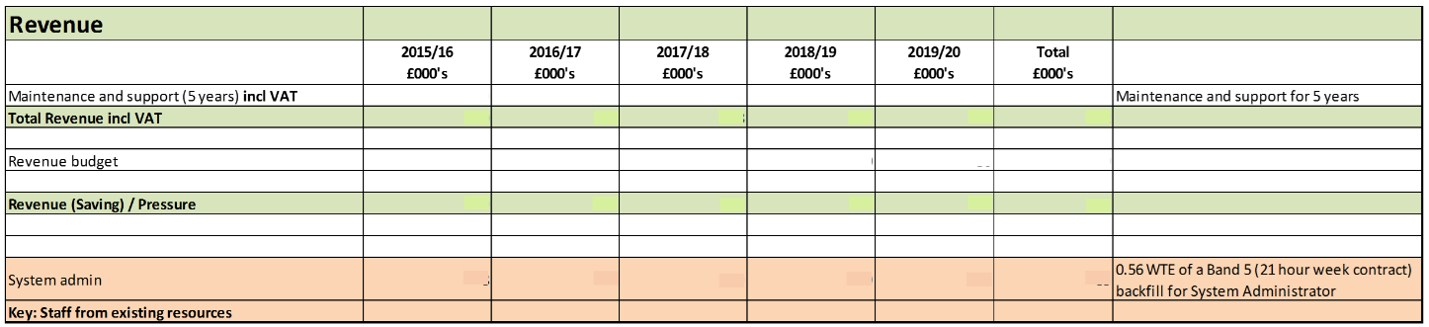

**Appendix B**

**Option 2 – Financial Analysis X**

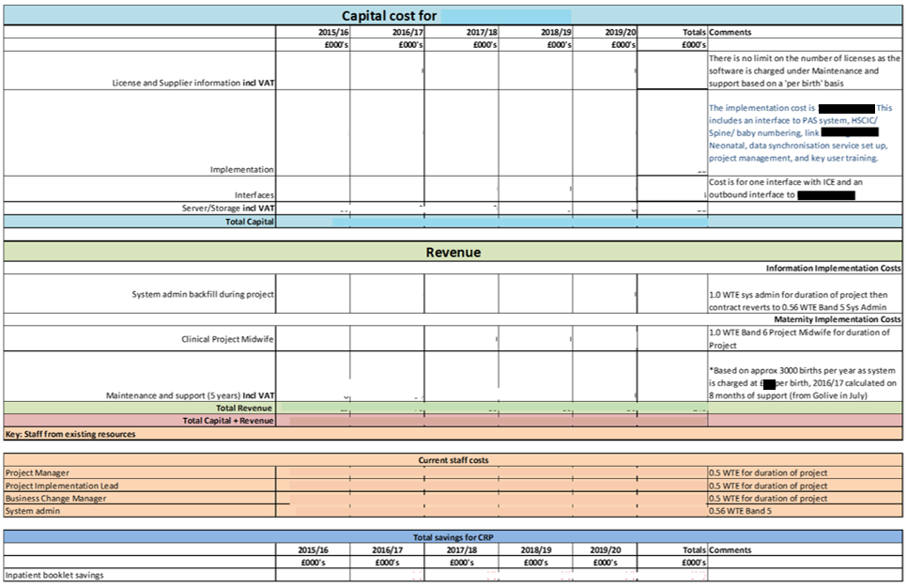

**Appendix C**

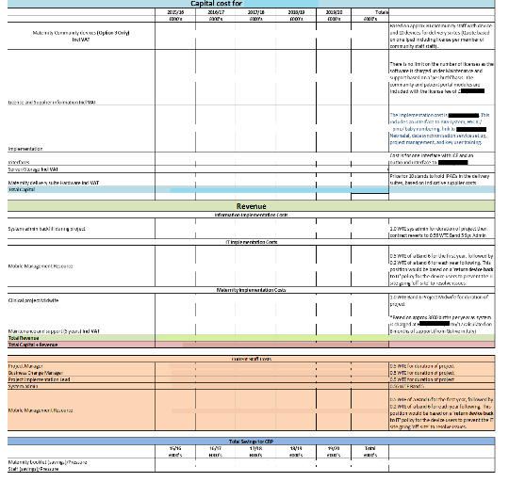**Option 3 – Financial Analysis X**