Shared Decision Making (SDM) implementation checklist

This checklist should be read in conjunction with the Summary Guide to Shared Decision Making.
To embed optimal SDM almost always means changing and redesigning the clinical pathway. Changing established pathways requires a programme of work that is co-designed by all local stakeholders including the people who use services and teams providing care.
The checklist is designed to help anyone who is responsible for implementing and embedding SDM in their local area. It is based on the SDM implementation framework (see Figure 1) and will help you start conversations with key stakeholders so that you can understand where you are locally in terms of SDM and support you to make improvements together. It will also help you put in place the key elements of a successful change programme.
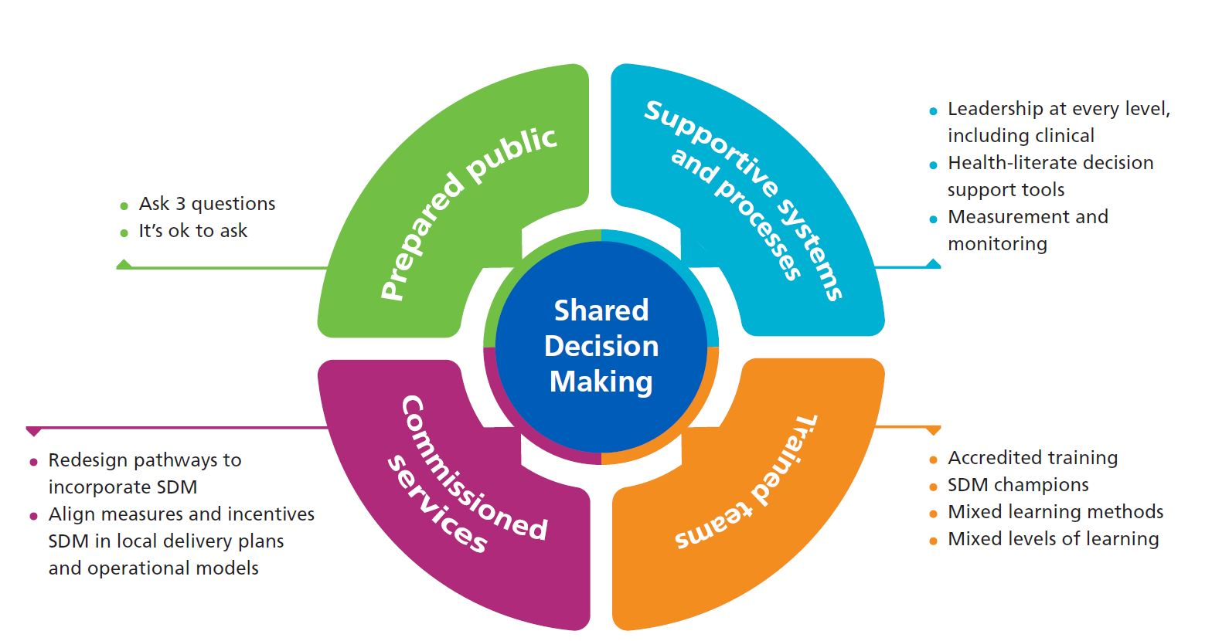
Figure 1: NHS England shared decision making Implementation Framework

We are interested to hear your learning from using this checklist. To ask questions, or to feedback any comments, please email us at england.sharedecisionmaking@nhs.net.

SDM implementation checklist
Enabler | Measure | Your Score
1. Supportive systems and processes (strategy and  leadership) | 1.1 Our SDM programme is led by a clinical lead, a person with lived experience, a representative from the voluntary and community sector, a programme manager, and both an executive and non-executive sponsor. | Please select
Are you going to take an improvement action? Choose an item.
Rationale Click here to enter text.
Which resource(s) will you implement? Click here to enter text.
Do you foresee any possible obstacle/challenge? Choose an item.
If yes, the best solution is to: Click here to enter text.
 | 1.2 We have a SDM strategy to embed, sustain and spread the work that we do. | Please select
Are you going to take an improvement action? Choose an item.
Rationale Click here to enter text.
Which resource (s) will you implement? Click here to enter text.
Do you foresee any possible obstacle/challenge? Choose an item.
If yes, the best solution is to: Click here to enter text.
 | 1.3 We have a defined work programme/plan, with an underlying theory of change drawing on a driver diagram or a logic model. | Please select
Are you going to take an improvement action? Choose an item.
Rationale Click here to enter text.
Which resource (s) will you implement? Click here to enter text.
Do you foresee any possible obstacle/challenge? Choose an item.
If yes, the best solution is to: Click here to enter text.
 | 1.4 We have a good network of local champions, including engaged GPs, AHPs and nurses, occupational therapists and health coaches who are supported to maintain and develop these networks. | Please select
Are you going to take an improvement action? Choose an item.
Rationale Click here to enter text.
Which resource(s) will you implement? Click here to enter text.
Do you foresee any possible obstacle/challenge? Choose an item.
If yes, the best solution is to: Click here to enter text.
 | 1.5 We have a business plan that sets out the case for investing in SDM. | Please select
Are you going to take an improvement action? Choose an item.
Rationale Click here to enter text.
Which resource(s) will you implement? Click here to enter text.
Do you foresee any possible obstacle/challenge? Choose an item.
If yes, the best solution is to: Click here to enter text.
 | 1.6 Our Governing Body/Board receives a minimum of 2 SDM progress reports every year. | Please select
Are you going to take an improvement action? Choose an item.
Rationale Click here to enter text.
Which resource(s) will you implement? Click here to enter text.
Do you foresee any possible obstacle/challenge? Choose an item.
If yes, the best solution is to: Click here to enter text.
 | 1.7 Our SDM clinical lead has protected time specifically allocated to this role. | Please select
Are you going to take an improvement action? Choose an item.
Rationale Click here to enter text.
Which resource(s) will you implement? Click here to enter text.
Do you foresee any possible obstacle/challenge? Choose an item.
If yes, the best solution is to: Click here to enter text.
2. Trained teams | 2.1 All clinical team members have an awareness of the importance of SDM | Please select
Are you going to take an improvement action? Choose an item.
Rationale Click here to enter text.
Which resource(s) will you implement? Click here to enter text.
Do you foresee any possible obstacle/challenge? Choose an item.
If yes, the best solution is to: Click here to enter text.

 | 2.2 All commissioners have an awareness of the importance of SDM | Please select
Are you going to take an improvement action? Choose an item.
Rationale Click here to enter text.
Which resource(s) will you implement? Click here to enter text.
Do you foresee any possible obstacle/challenge? Choose an item.
If yes, the best solution is to: Click here to enter text.
 | 2.3 All members of clinical teams have been trained in SDM and simplified communication techniques, which helps check whether complex information has been explained effectively i.e. in a way that makes sense to people (e.g. Teachback across the pathway) | Please select
Are you going to take an improvement action? Choose an item.
Rationale Click here to enter text.
Which resource(s) will you implement? Click here to enter text.
Do you foresee any possible obstacle/challenge? Choose an item.
If yes, the best solution is to: Click here to enter text.
 | 2.4 All clinical team members demonstrably practice shared decision making | Please select
Are you going to take an improvement action? Choose an item.
Rationale Click here to enter text.
Which resource(s) will you implement? Click here to enter text.
Do you foresee any possible obstacle/challenge? Choose an item.
If yes, the best solution is to: Click here to enter text.
 | 2.5 There is a long-term program in place to build SDM capability within the workforce | Please select
Are you going to take an improvement action? Choose an item.
Rationale Click here to enter text.
Which resource(s) will you implement Click here to enter text..
Do you foresee any possible obstacle/challenge Choose an item.
If yes, the best solution is to: Click here to enter text.
 | 2.6 SDM forms part of every new member of staff’s induction. | Please select
Are you going to take an improvement action? Choose an item.
Rationale Click here to enter text.
Which resource(s) will you implement? Click here to enter text.
Do you foresee any possible obstacle/challenge? Choose an item.
If yes, the best solution is to: Click here to enter text.
 | 2.7 SDM is recognised as an ongoing CPD need for clinicians. | Please select
Are you going to take an improvement action? Choose an item.
Rationale Click here to enter text.
Which resource(s) will you implement? Click here to enter text.
Do you foresee any possible obstacle/challenge? Choose an item.
If yes, the best solution is to: Click here to enter text.
 | 2.8 SDM is a routine element of all clinical audit activity, including through a peer-review process for assessing and providing peer feedback to team members on their shared decision-making practice. | Please select
Are you going to take an improvement action? Choose an item.
Rationale Click here to enter text.
Which resource(s) will you implement? Click here to enter text.
Do you foresee any possible obstacle/challenge? Choose an item.
If yes, the best solution is to: Click here to enter text.
3. Commissioned Services | 3.1 We use a range of shared decision-making evaluation and monitoring tools | Please select
Are you going to take an improvement action? Choose an item.
Rationale Click here to enter text.
Which resource(s) will you implement? Click here to enter text.
Do you foresee any possible obstacle/challenge? Choose an item.
If yes, the best solution is to: Click here to enter text.
 | 3.2 We incentivise continuous improvement of shared decision making amongst our providers | Please select
Are you going to take an improvement action? Choose an item.
Rationale Click here to enter text.
Which resource(s) will you implement? Click here to enter text.
Do you foresee any possible obstacle/challenge? Choose an item.
If yes, the best solution is to: Click here to enter text.
 | 3.3 Our providers use a relevant clinical code to capture that an SDM conversation has taken place between clinician and patient | Please select
Are you going to take an improvement action? Choose an item.
Rationale Click here to enter text.
Which resource(s) will you implement? Click here to enter text.
Do you foresee any possible obstacle/challenge? Choose an item.
If yes, the best solution is to: Click here to enter text.
 | 3.4 We have a defined set of process and outcome metrics? | Please select
Are you going to take an improvement action? Choose an item.
Rationale Click here to enter text.
Which resource(s) will you implement? Click here to enter text.
Do you foresee any possible obstacle/challenge? Choose an item.
If yes, the best solution is to: Click here to enter text.
 | 3.5 We measure the financial impact, including return on investment, of implementing SDM | Please select
Are you going to take an improvement action? Choose an item.
Rationale Click here to enter text.
Which resource(s) will you implement? Click here to enter text.
Do you foresee any possible obstacle/challenge? Choose an item.
If yes, the best solution is to: Click here to enter text.
 | 3.6 We use one of the following validated tools to measure patient and clinical involvement in shared decision making | Please select
- CollaboRATE
- Sure
- SDM-Q9 / SDM-Q-DOC

Are you going to take an improvement action? Choose an item.
Rationale Click here to enter text.
Which resource(s) will you implement? Click here to enter text.
Do you foresee any possible obstacle/challenge? Choose an item.
If yes, the best solution is to: Click here to enter text.
 | 3.7 SDM is included as a requirement in all relevant procurement specifications. | Please select
Are you going to take an improvement action? Choose an item.
Rationale Click here to enter text.
Which resource(s) will you implement? Click here to enter text.
Do you foresee any possible obstacle/challenge? Choose an item.
If yes, the best solution is to: Click here to enter text.
4.Prepared public | 4.1 We have a range of health literate decision support resources (e.g., leaflets, videos, decision aids etc.) | Please select
Are you going to take an improvement action? Choose an item.
Rationale Click here to enter text.
Which resource(s) will you implement? Click here to enter text.
Do you foresee any possible obstacle/challenge? Choose an item.
If yes, the best solution is to: Click here to enter text.
 | 4.2 We have an on-going campaign (e.g. Ask me 3, BRAN, It’s ok to ask, WMTY) which encourages people to ask key questions so they are better supported to make a decision about care, support or treatment options; and mechanisms for providers to actively engage patients in the approach. | Please select
Are you going to take an improvement action? Choose an item.
Rationale Click here to enter text.
Which resource(s) will you implement? Click here to enter text.
Do you foresee any possible obstacle/challenge? Choose an item.
If yes, the best solution is to: Click here to enter text.
 | 4.3 We have patient and public input into developing health literate decision support resources | Please select
Are you going to take an improvement action? Choose an item.
Rationale Click here to enter text.
Which resource(s) will you implement? Click here to enter text.
Do you foresee any possible obstacle/challenge? Choose an item.
If yes, the best solution is to: Click here to enter text.
 | 4.4 We regularly audit how useful people find these resources | Please select
Are you going to take an improvement action? Choose an item.
Rationale Click here to enter text.
Which resource(s) will you implement? Click here to enter text.
Do you foresee any possible obstacle/challenge? Choose an item.
If yes, the best solution is to: Click here to enter text.
 | 4.5 There is a system in place to ensure that all patients and clinicians have access to a range of up to date, evidence-based health literate decision support resources. Their use is audited annually. | Please select
Are you going to take an improvement action? Choose an item.
Rationale Click here to enter text.
Which resource(s) will you implement? Click here to enter text.
Do you foresee any possible obstacle/challenge? Choose an item.
If yes, the best solution is to: Click here to enter text.
 | 4.6 There is a programme to develop patients’ skills, knowledge and confidence to participate in SDM conversations | Please select
Are you going to take an improvement action? Choose an item.
Rationale Click here to enter text.
Which resource(s) will you implement? Click here to enter text.
Do you foresee any possible obstacle/challenge? Choose an item.
If yes, the best solution is to: Click here to enter text.

Having gone through this scorecard, I can confidently convince my peers of the importance and need to implement, assess and continuously improve each of the above-mentioned measures Choose an item.
If no, what could we do to help you? Click here to enter text.

Is there any other feedback you would like to share?
Click here to enter text.

Contact details for further information: This checklist has been produced by the Shared Decision Making team within the Personalised Care Group at NHS England. You can contact us at england.sharedecisionmaking@nhs.net.

This information can be made available in alternative formats, such as easy read or large print, and may be available in alternative languages, upon request. Please contact england.personalisedcare@nhs.net

https://www.england.nhs.uk/publication/shared-decision-making-summary-guide/

