Annex 1

Stage 1 of a List Maintenance Programme

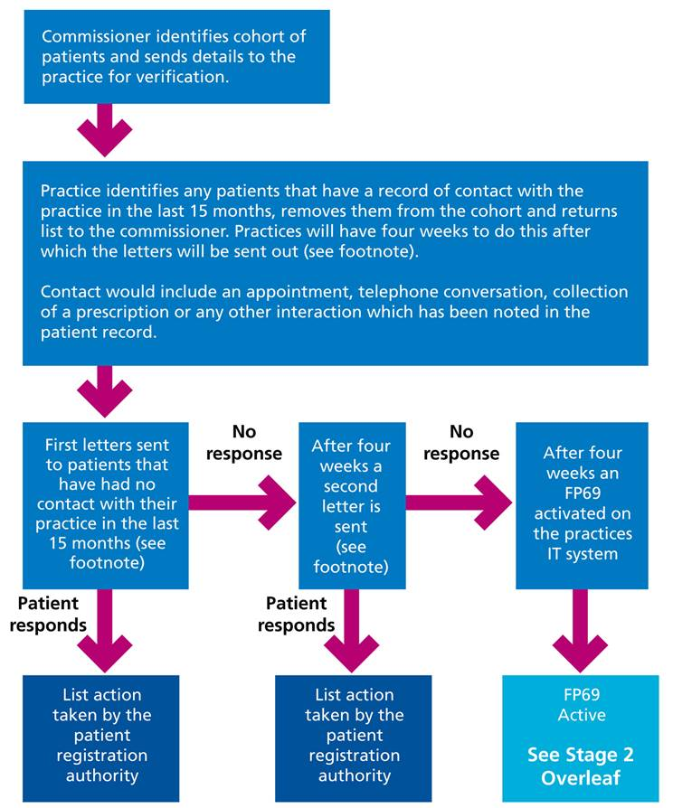[1][1]

1. [1] Letters should take into account the requirement to ensure that disabled patients receive information in a format that they can understand and they receive support to help them communicate (as mandated in the Accessible Information Standard)