Safeguarding LES
Child Protection Case Conference Report
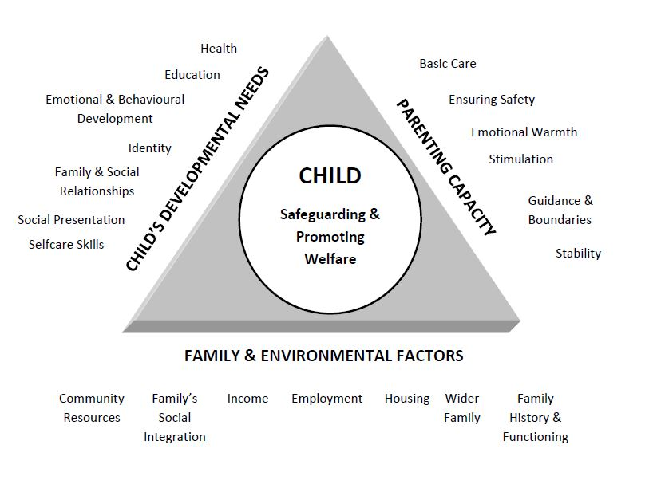

Agency’s Name |  | Professional’s Role / Job Title
Professional’s Name |  | Professional’s e-mail address
Professional’s Address |  | Professional’s Contact Number
Date of Conference

- Child(ren)’s Details
Forename | Surname | DOB | Address | Ethnicity | Disability or  Special Need | School or Nursery
- Details of Parents, Carers or Significant Family or Household Members
Forename | Surname | DOB | Address | Ethnicity | Disability or  Special Need | Relationship To Child | Parental Responsibility?

- When did the family register at your surgery?

- What are the current medical problems of the
members of the household that are
relevant for safeguarding purposes?
Please comment on the severity of these problems, in language that can be understood by non-medical professionals.
- What are the inactive medical problems of the
members of the household that are
relevant for safeguarding purposes?
Please comment on these in language that can be understood by non-medical professionals.
- Are there any other positive factors?
Are you aware of any other positive features of family life and parenting that have a positive effect on the children’s lives. Please refer to the triangle diagram above for relevant areas to consider.
- Do you have any other concerns?
Please refer to the triangle diagram above for areas to consider. If you have no other concerns then please state “no other concerns.”
- What might reduce your medical and other concerns?
- If you have discussed concerns above, please advise what the outcome would be if these concerns continue.

- How might your GP surgery help to reduce these concerns?

- If you have been able to discuss this report with the family, what are the views of the parents/carers and/or the child(ren)/young person on this report?

- For review meetings, if you have discussed the child protection plan with the family, what difference do the child and parents think the plan has made to their lives and the difficulties they were facing?

Author’s Name |  |  |  | Designation
Signature |  |  |  | Date
Manager’s Name |  |  |  | Designation
Signature if appropriate |  |  |  | Date
Has this report been shared with parents/carers? |  | Y | N | Has this report been shared with the child(ren)/young person? |  | Y | N
If yes, date: |  |  |  | If yes, date:
If not, state reason why |  |  |  | If not, state reason why

It is the responsibility of all agencies who have participated in as child protection enquiry or who have relevant information to make this available to the conference in the form of a legible and signed report. The report should be provided to parents at least 2 working days in advance of initial conferences and 5 working days before review conferences.

