Better Births: Personal and Safe - Social Media Posts

Image copy | Image | Supporting copy
Working together to provide personal and safe care for all | 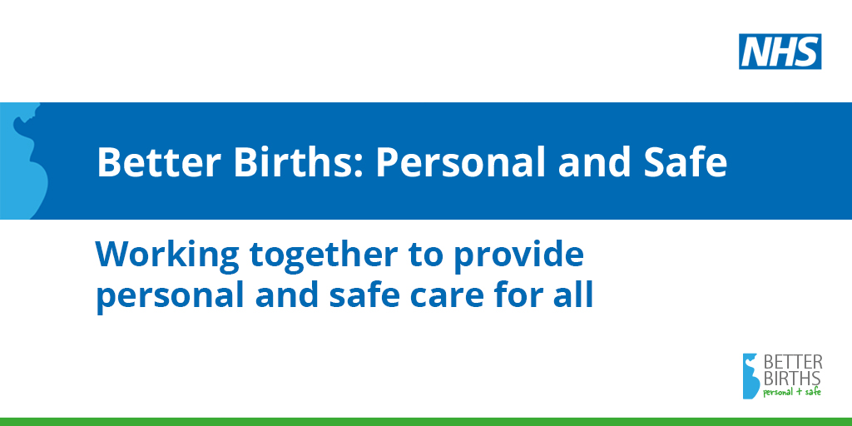 | Option 1:  #BetterBirths set out a vision for Personal and Safe maternity care for every woman. We’re working together to deliver that vision. Teams can find out more about Personal and Safe care by downloading the Better Births toolkit: www.england.nhs.uk/personalandsafe  Option 2:  We’re working together to deliver Personal and Safe maternity care for all women. Teams are helping save babies’ lives by reducing stillbirths, neonatal deaths and brain injuries. Find out more about providing Personal and Safe care: www.england.nhs.uk/personalandsafe

Working together to achieve equity, to deliver personal and safe outcomes for all | 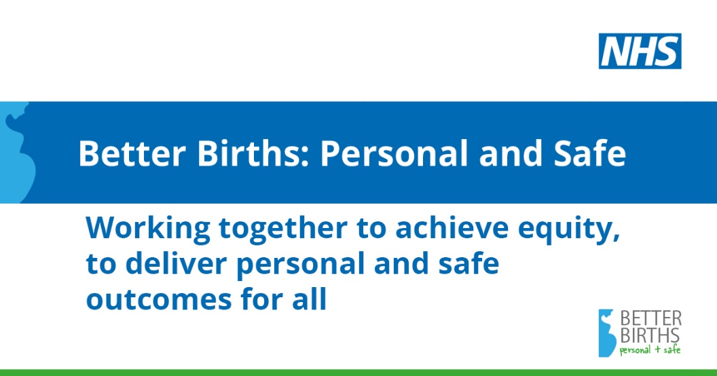 | Option 1:  In line with the NHS Long Term Plan, we’re working towards 75% of Black and Asian women receiving #ContinuityofCarer by 2024, along with women living in the most deprived areas. Find out more about providing safer, personalised care at: www.england.nhs.uk/personalandsafe  Option 2:  We’re working together to achieve equity in maternity care, to deliver Personal and Safe outcomes for all women, no matter their background. Teams can find out more about providing safer, personalised care at: www.england.nhs.uk/personalandsafe

Working together to provide Continuity of Carer to achieve safe and personalised outcomes | 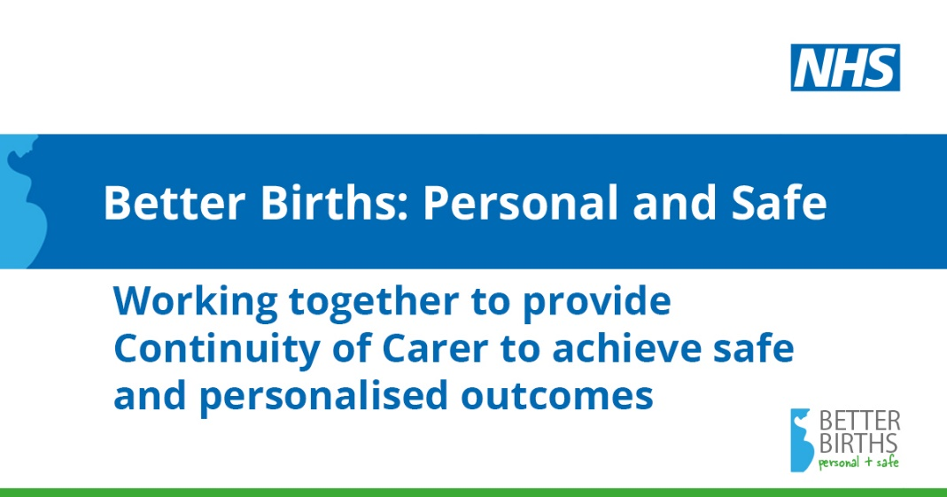 | Option 1:  Women who receive #ContinuityofCarer are less likely to lose their baby or to experience pre-term birth. Find out more about how #ContinuityofCarer is key for delivering safer, personalised care by downloading the new Better Births toolkit: www.england.nhs.uk/personalandsafe  Option 2:  Did you know that working in a #ContinuityofCarer model gives you more control over your own diary and how you balance your work and home life? Find out more about what delivering safer, personalised care means for you: www.england.nhs.uk/personalandsafe

Working together to provide personal care | 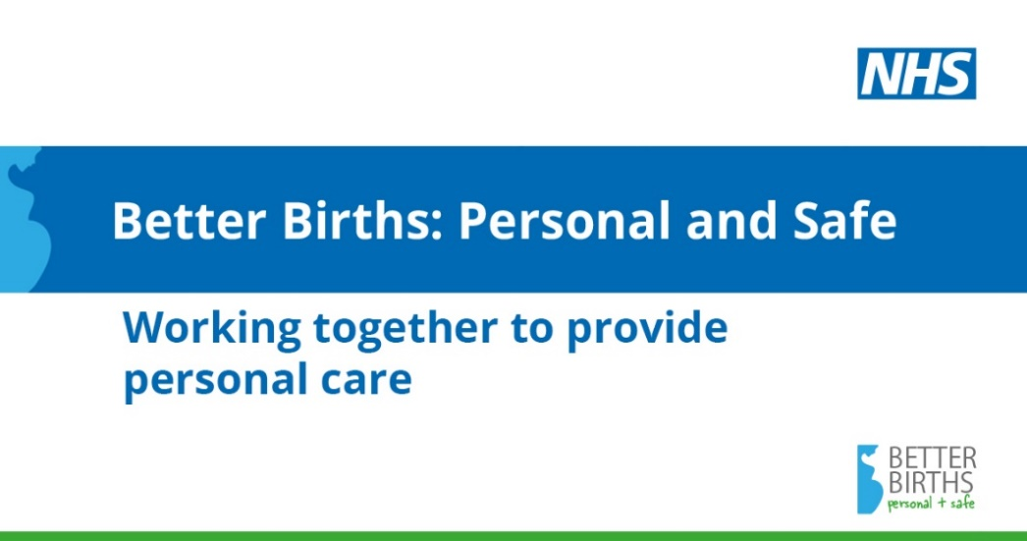 | Option 1:  #BetterBirths set out a vision for personalised, safer maternity care for every woman. We’re working together to deliver that vision. Teams can find out more about Personal and Safe care by downloading the Better Births toolkit: www.england.nhs.uk/personalandsafe  Option 2:  We’re working together to deliver Personal and Safe maternity care for all women. As of March 2019, over 10,000 women were on a #ContinuityofCarer pathway. Find out more about Personal and Safe care: www.england.nhs.uk/personalandsafe

Working together to provide safer care | 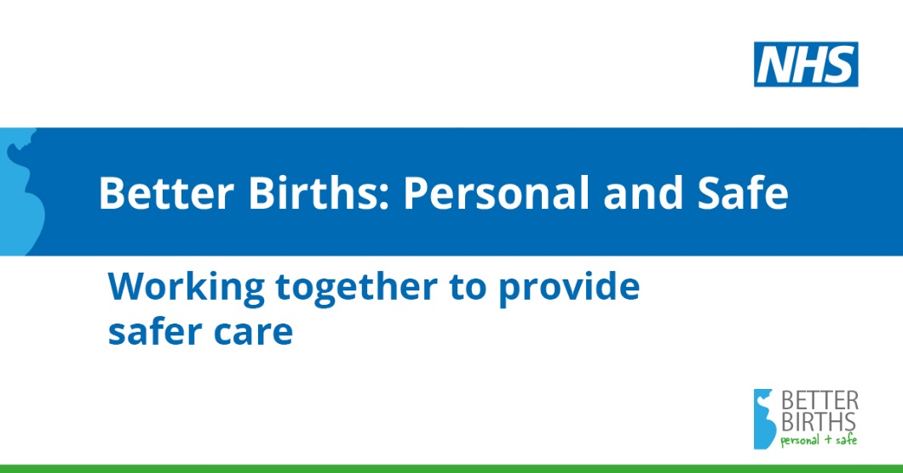 | Option 1:  Between 2013 and 2017 there were 500 fewer baby deaths and 350 fewer stillbirths in England. Midwives and obstetricians are all part of the #BetterBirths journey, creating the safest maternity service in the world. Find out more: www.england.nhs.uk/personalandsafe  Option 2:  Did you know that women who receive #ContinuityofCarer are less likely to lose their baby or to experience pre-term birth? Find out more about delivering safer, personalised maternity care: www.england.nhs.uk/personalandsafe

