Please enter GP practice name Address here
Phone number Email
Date

This letter is about a change to your 2021 annual health check Dear xxxxxxx

We hope you are well during this time.
We want to tell you about how your appointment may be affected by coronavirus.
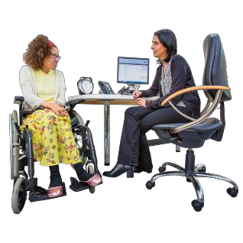 | It is still really important that you have your annual health check.
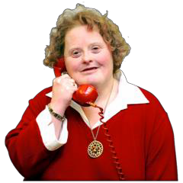 | Before your annual health check, we will call you to have a chat and decide the safest way to do your appointment. You can also tell your GP how you would prefer to do it.

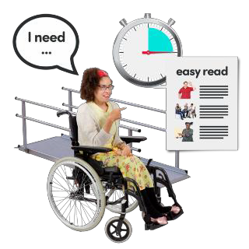 | If there is anything you need for this appointment, for example a translator, information in braille or sign language, or anything else, please let us know.
The details of your 2021 annual health check are:

Date: Time: Where:
Who will do your annual health check:

Face to face Telephone Video call
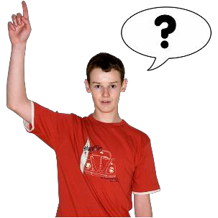 | If you have any questions or concerns, please feel free to get in touch.
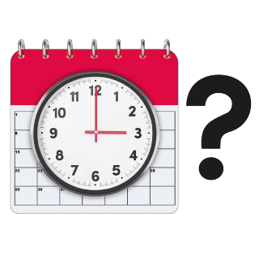

Yours sincerely

Add doctor’s signature and name here

