Using proxy access to information for authorised care home staff through GP online services | Example of good practice
This example of good practice comes from a care home that worked in partnership with their local GP practice to implement proxy access by care staff to:
- order medication online
- see residents’ online records

Care home description
Care home | Bed occupancy | GP practice | GP system | CCG/region
The Lodge Romford | 94 | North Street Medical Care | EMIS | Havering/London

What was the problem?
Sharing information between general practice and social care providers has always been, and remains, a challenge. Here in Romford, GPs and the care home agreed that working differently by sharing information would reduce risks and issues; and bring benefits to them and their patients/residents. There had been many occasions when information had not got to the right care giver at the right time. The absence of information sharing between health and social care staff caused confusion; and staff were not able to always to give the best care to residents/patients.

What was the solution?
The agreed solution was for care home staff to be given access to information on behalf of their residents (by proxy) to improve the quality of direct care.
The effect of this has been to ensure that relevant information is shared between the practice and The Lodge. Information is shared securely and when needed, helping to improve the safety, quality, and timeliness of care to residents.
This in turn saves both care home and GP staff time and efficiency savings.

What information do care home staff need and why?
Item | Why
Allergies and adverse reactions | Resident safety
Immunisations | Current status and next due time
Problems and diagnoses | Meet direct care needs
Medications | Ordering medications  Meet direct care needs and medicines optimisation, structured medication review support
Test results | Meet direct care needs and provide appropriate response with treatment
Clinical correspondence | Meet direct care needs and provide appropriate response with treatment  Long-term personalised care planning and support virtually
Appointments | Management of direct long-term care needs

Benefits of proxy access to residents’ online records by care home staff
Care home staff and GP practices have reported the following benefits:
- a closer working relationship between the GP practice and the care home
- staff have their own username and password, i.e. they do not have to log on and off for each patient, so saving a lot of time
- care home staff can access information or order medications at any time of the day or night
- access to information online is easier for the GP practice and the care home; it saves time and reduces errors due to a lack of information when needed
- a clear, easily accessible, audit trail of access to the GP record is maintained
- having secure email, commonly NHS mail, allows care homes to message GPs directly for queries or requests, if necessary
- fewer queries and requests for information saves time in both practice and care home

Other reported benefits of sharing information across organisations
More widely, the following benefits of sharing information between health and social care providers have been reported. It:
- saves time and money by reducing phone calls across all settings
- improves people’s experience by avoiding the need for them to provide the same information to different health and care professionals time and time again
- improves health and care professionals’ understanding of an individual’s condition, which enables an individual to be provided with a personalised treatment plan
- improves safety and saves money by reducing the need for unnecessary repeated tests or assessments
- improves safety and experience by making comprehensive and reliable allergy, medication, diagnosis, and social circumstance information readily available across all health and care settings
- prevents unnecessary admissions to hospital by giving health and care professionals more information about the individual when making their professional decisions
- improves people’s engagement in their own care and adherence with medications and care plans by providing individuals and their carers access to their shared records
- supports safeguarding by sharing alerts across multiple care settings
Calculated benefits| proxy medication ordering
The table below shows the approximate time spent on processing medication orders for 60 care home residents each month, based on findings from several projects. These figures will, of course, change according to the number of residents in a home.
Medication ordering for 60 residents: time taken each month
 | Before proxy access for care staff: time in hours per month | After proxy access for care staff: time in hours per month
Care home | 24 | 2
GP practice | 24 | 4
Pharmacy | 24 | 8

The financial savings were calculated as shown below, using this benefits tool.
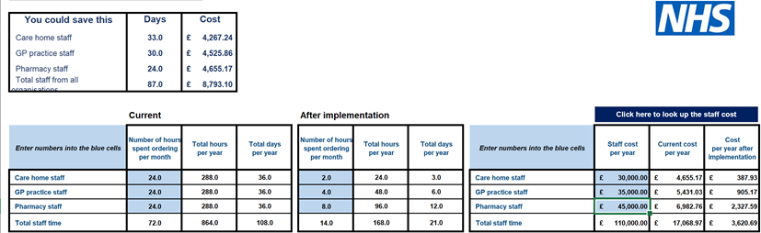
Calculated benefits| access to online patient records
Based on the roll out of access to online patient records by care staff in several projects, the following savings in time have been calculated. The figures will, of course, change according to the number of residents in a home.
Online record access for 60 care home residents: time taken each month to find/share patient information needed to support direct care
 | Before proxy access for care staff: time in hours per month | After proxy access for care staff: time in hours per month
Care home | 28 | 14
GP practice | 20 | 10
Pharmacy | 8 | 4

Using the benefits tool again, the financial savings have been calculated.

