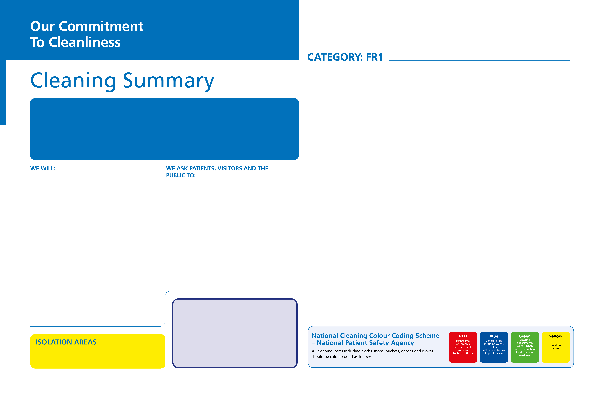
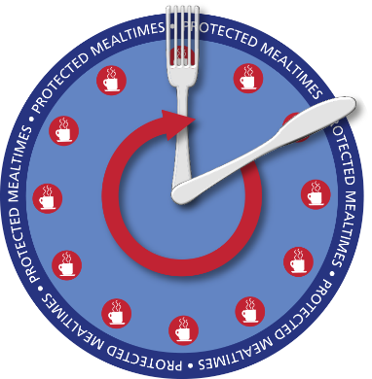
- Treat patients in a clean and safe environment and minimise exposure to healthcare associated infections
- Provide a well maintained, clean and safe environment, using the most appropriate and up to date cleaning methods and frequencies
- Maintain fixtures and fittings to an acceptable condition to enable effective and safe cleaning to take place regularly
- Allocate specific roles and responsibilities for cleaning, linked to infection prevention and control, that are underpinned by strong, clear leadership that encourages a culture where cleanliness matters
- Have clinical leads who will establish and promote a cleanliness culture across their organisation
- Constantly review cleanliness and improve performance
- Take account of your views about the quality and standards of cleanliness by involving patients and visitors in reporting and monitoring how well we are doing
- Provide the public with clear information on any measures which they can take, to assist in the prevention and control of healthcare associated infections
- Provide the public with clear and precise information relating to the potential risk of contracting a healthcare associated infection. This will include highlighting other helpful information sources so that patients and public can access up to date local data
- Provide structured and pro-active education and training to ensure all our staff are competent in delivering infection prevention and control practices within the remit of their role
- Design any new facilities with ease of cleaning in mind
- Follow good hygiene practices which are displayed in and around the organisation
- Tell us if you require any further information about cleanliness or prevention of infection
- Work with us to monitor and improve standards of cleanliness and prevention of infection

CLEANING TASK | CLEANING FREQUENCY | RESPONSIBILITY
Sanitary Areas
Toilets, urinals, sinks and taps | 1 x full daily, 2 x check daily | Healthcare Cleaning Professional (HCP)
Showers | 1 x full daily, 1 x check daily | HCP
Mirrors | 1 x full daily, 1 x check daily | HCP
Operating Theatres and Recovery Areas
Operating tables and trollies | 1 x full daily and between each use | Theatre staff
Switches, sockets, data points, wall fixtures | 1 x full daily, 1 x check daily | HCP
Walls (accessible up to 2m) | 1 x full annually, 1 x check daily | HCP
Ceilings and walls (not accessible above 2m) | 1 x full annually, 1 x check as req. | HCP
Doors, including ventilation grilles | 1 x full daily | HCP
Windows | 1 x full every 6 months | External contractor
Internal glazing | 1 x full daily | HCP
Ventilation grilles, extracts and inlets | 1 x full weekly, 1 x check daily | HCP
Low surfaces | 1 x full daily | HCP
Middle surfaces | 1 x full daily | HCP
High surfaces | 1 x full daily | HCP
Waste receptacles | 1 x full daily, 1 x check daily | HCP
Replenishment of consumables | Check and replenish 3 x daily | HCP
Floors
Floors hard | 1 x full daily, 2 x check daily | HCP
Floors soft | 1 x full daily, 2 x check daily | HCP
Kitchen Areas
Fridges and freezers | 1 x full weekly, 1 x check daily | HCP
Cupboards | 1 x full monthly, 1 x check daily | HCP
Medical Equipment
Medical equipment | Refer to local protocol | Clinical staff
Cleaning Equipment
All cleaning equipment including trolley | Full clean after each use | HCP

Operating Theatres

Keeping the NHS clean and preventing infection is everybody’s responsibility from the Chief Executive to the healthcare cleaner. It is important for patients, visitors, the public and staff.

Cleanliness matters, and to ensure consistency throughout the NHS, and to support hospitals and healthcare services, this commitment has been adopted in every organisation.

This Charter sets out our commitment to ensure a consistently high standard of cleanliness is delivered in all of our healthcare facilities. It also sets out how we would like you to help us maintain high standards.

Name / Signature
Name / Signature
Trust Logo To
Go Here
If you require further information regarding cleaning or wish to comment about the cleanliness of this area, please contact:

Chairman
Chief Executive

Website to Go Here
PROTECTED
MEAL TIMES

The Trust places great
importance upon the need
to ensure patients receive
appropriate nutritional intake
and assistance at meal times.
Therefore during ‘Protected Meal
Time periods’ cleaning will be undertaken in areas which do
not interrupt the patient’s enjoyment or distract Nurses from assisting patients with eating.

All areas identified as Isolation Areas are cleaned using yellow colour coded equipment in accordance with the Trust’s Infection, Prevention and Control Policy requirements.

