Role Description for Patient and Public Voice (PPV) partners:
Outpatient Transformation Programme

Positions available:
- 2 x Patient and Public Voice (PPV) partners
- 1 x Chair
- 1 x deputy Chair
Complete the attached application form and email to Kevwe.raleigh-ekeke@nhs.net

Background
Outpatient care is a planned appointment at a hospital or clinic that does not need an overnight stay.
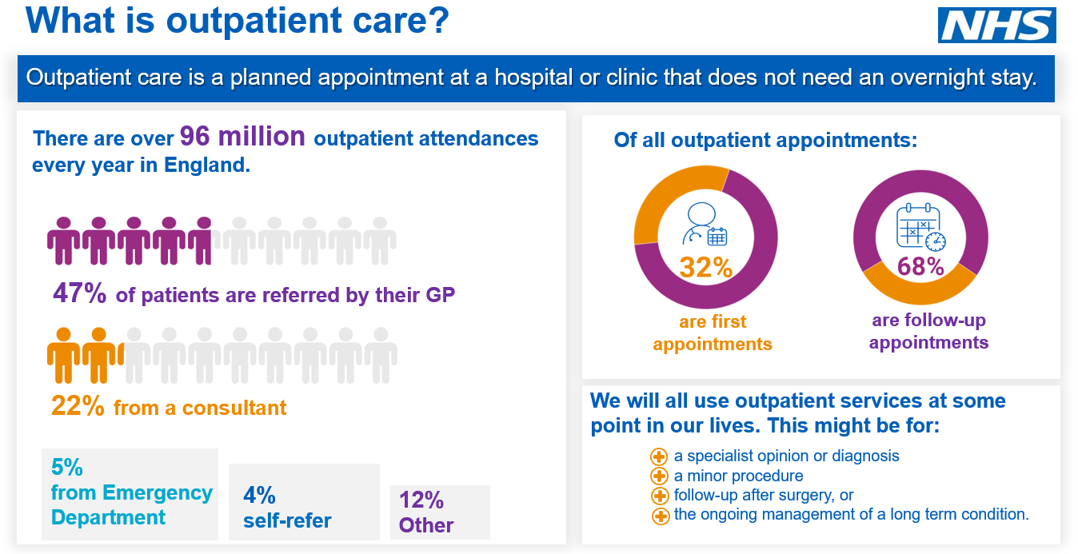

Aims of the programme
The Outpatient Transformation Programme is committed to the fundamental re-design of outpatient services, aiming to reduce unnecessary face to face outpatient appointments by a third by 2023/24, avoiding up to £1.1 billion in additional NHS expenditure and improving care for patients, while releasing clinical time.

Objectives of the advisory group:
- Provide user insight, advice and recommendations to the workstreams within the Outpatient Transformation Programme.
- Support the Outpatient Transformation Programme to identify issues that matter most to patients and carers and work in partnership with the programme to co-design solutions.
- Ensure the design of outpatient transformation initiatives is centred around patients and their families? by taking into consideration the whole patient journey throughout relevant pathways (end to end pathway review).
- Ensure the commitment to move to digitally enabled care does not exacerbate worsen? inequity and inequalities in access to health care for the diverse population that utilise outpatient services across the country.
- Be an accessible vehicle for outpatient transformation ideas and projects to be tested with representatives of diverse patient groups.
- Hold the Outpatient Transformation Programme to account and ensure that the programme complies with the requirement to consult with members of the public.

What is the role of Patient and Public Voice (PPV) Partners?
PPV representation will bring important insight into the Outpatient Transformation Programme:
The role of the PPV partner is to:
- Attend working group meetings (monthly for 1.5 hrs)
- Contribute to the goals of the working group (and possibly associated sub-group meetings).
- Collaborate with the other working group members to ensure a joined-up approach to transforming outpatient services
- Participate in relevant training
- Ensure the working group considers and prioritises the service user, patient, carer and family perspectives.
- Play an active part in linking patient and professional networks together
- Champion the diversity of PPV views, and not just to represent their own experience
- Be a ‘critical friend’ and provide appropriate challenge
- Help raise awareness of the programme’s outcomes and achievements
- Review and comment on documentation/proposed approaches
Through these activities you may be asked to share views on:
- Your personal or your organisation’s experience/reflections in relation to accessing outpatient services
- Your decision-making processes/ discussions with clinicians
- Your understanding and / or experience of health inequalities in relation to your experience of accessing health care
- The development of patient information leaflets/or other communication materials
- Existing support available to patients and how this information can be improved
- How patients and the public can be effectively involved in the transformation of outpatient services
- Proposed and ongoing outpatient initiatives and their benefits or disbenefits to patients

Person Specification essential attributes
- Experience of using NHS outpatient services (either personal experience or through friends, family or as a carer)
- Keen interest in contributing to the improvement of NHS services
- Access to networks of service users and/or `seldom heard communities` i.e BAME, LGBTQ, disabled communities etc
- Experience of representing the views of service users and `seldom heard groups`
- Exposure and awareness of the views of NHS service users either through lived experience or through engaging with such groups
- Willing and able to communicate with a diverse range of individuals with different communication needs
- Able to commit to attending the meetings, which are 1.5hrs monthly
- Open to engaging with other teams within the outpatient transformation programme to provide advice and insight
- Experience of taking part in meetings or panels
- Understanding of shared decision-making approaches

Time commitment:
- Attend monthly advisory group meetings for 1.5 hours, reviewing documents and attending regular sub-groups.
- Other possible engagement activity as and when needed - up to 3 hours per month.
- The Chair will be required to attend the National Outpatient Programme Board which is 2.5 hrs monthly and may be required to attend the Clinical Advisory Group which is 2 hrs monthly.

Expenses
NHS England and NHS Improvement (NHSEI) will fund reimbursement costs at a rate of £75 per half day (up to 4 hours) per the NHSEI Patient and Public Voices reimbursement policy.
You will also be able to claim expenses in line with the NHSI Patient and Public Voices reimbursement policy.

Access and support:
If you require any learning, access support needs or reasonable adjustments please let us know so we can discuss how best to support you.
Training:
NHS England and NHS Improvement asks that all new PPV Partners complete an interactive online induction webinar and eLearning modules.
You will also receive an induction from the programme team that is leading this work. A welcome pack, meeting documents, and support will be provided to support you in your role.
You will receive an involvement payment for training that is required for the role. Additionally, you will be offered access to wider learning and development opportunities available to PPV Partners, to support personal development, details can be found on the Involvement Hub (please note there are no involvement payments for undertaking wider training at your own discretion)
More information:
Kevwe Raleigh-Ekeke (Senior Project Manager) at Kevwe.raleigh-ekeke@nhs.net
How to apply:
Complete the attached application form and email to Kevwe.raleigh-ekeke@nhs.net

