Focus Group Prompt Questions
These are designed to help facilitators initiate discussions with participants and ensure that they get enough data. Amend this wording to suit your participants and organisation.

Six cultural elements
Introductory questions (optional)
- What words would you use to describe our organisation?
- What are you most proud of at our organisation?
Vision and values
- Does our organisation as a whole have a clear idea of what its overall strategy is?
- How closely linked is our strategy to our vision (our overall purpose and aim), values and culture (how we do things in our organisation)?
- Does everyone in our organisation model our vision and values?
- If we were to start again, what principles should guide how we work? Can you explain why?
- Do you think the leaders and managers of our organisation put quality of patient care at the centre of everything the organisation does?
Goals and performance
- Do staff, teams, directorates and the board have clear, challenging and measurable objectives which are easy to link to the organisation’s vision?
- How often do all staff, teams, directorates and the board get timely, helpful, relevant and developmental feedback on their performance?
- How often do you see staff, teams, directorates and the board make sure we are all:
- involved in decision-making?
- given autonomy and discretion in our work?
- Do you believe managers and leaders in our organisation help to remove the obstacles to staff being able to do their jobs efficiently and effectively?
- Do you have any examples you could share?
- If you or someone else you know in our organisation has needed more support from a manager, what was the experience like? Was it helpful, or did it make things more difficult?
Learning and innovation
- If someone in our organisation came up with a way to do something better, how supportive would this organisation be of them?
- What would you say if a friend who doesn’t work here asked whether quality and quality improvement were a core part of our organisation’s culture?
- To what extent is everyone encouraged to lead changes in order to improve the quality of work?
- To what extent does the organisation encourage and reward members for improving their skills take over and performance?
Support and compassion
- To what extent is our organisation committed to compassionate and supportive leadership, at every level of the organisation? For example, a compassionate leader engages with people, puts people first, is meaningful and sincere while remaining frank, courageous and affirming.
- To what extent are staff genuinely compassionate towards patients and each other?
- How does the organisation ensure that staff and patients are included in conversations, discussions and decision-making, and not discriminated against in any way, shape or form?
- Would you describe this organisation as a warm, supportive and caring place to work?
- How can we act more compassionately?
Equity and Inclusion
- How does our organisation as a whole demonstrate that it is committed to equity, diversity and inclusion?
- What would you say if a friend who doesn’t work here asked if valuing equity, diversity and inclusion were a core part of our organisations culture?
- To what extent does every individual take responsibility for modelling positively, diverse and inclusive behaviours?
- What can you and your team members do to ensure that you take responsibility for encouraging inclusion, valuing diverse perspectives and listening to all voices?
Teamwork
- How well do you think teams in this organisation work together (both within a team and between teams)? - What are the strengths and weaknesses?
- To what extent does the leadership style in the organisation have characteristics which indicate a collective rather than command and control approach to leadership?
Compassionate and inclusive leadership means everyone taking responsibility for the success of the organisation as a whole – not just for their own jobs. It requires organisations to distribute leadership power to wherever the expertise, capability and motivation sit within that organisation at that time.
- To what extent do our leaders ensure accessibility, supportiveness, empowerment, fairness, transparency, and openness to learning and feedback?
- When we talk to one another, how do we sound? (e.g. friendly, happy, angry, irritated, loud, quiet, etc)
- What do you think our partners in the local area would say about how we work with them? Do you have any examples?

Five levels of compassionate and inclusive leadership
The King’s Fund in partnership with other organisations and members has identified five levels of focus for compassionate, diverse and inclusive leadership (see graphic below).
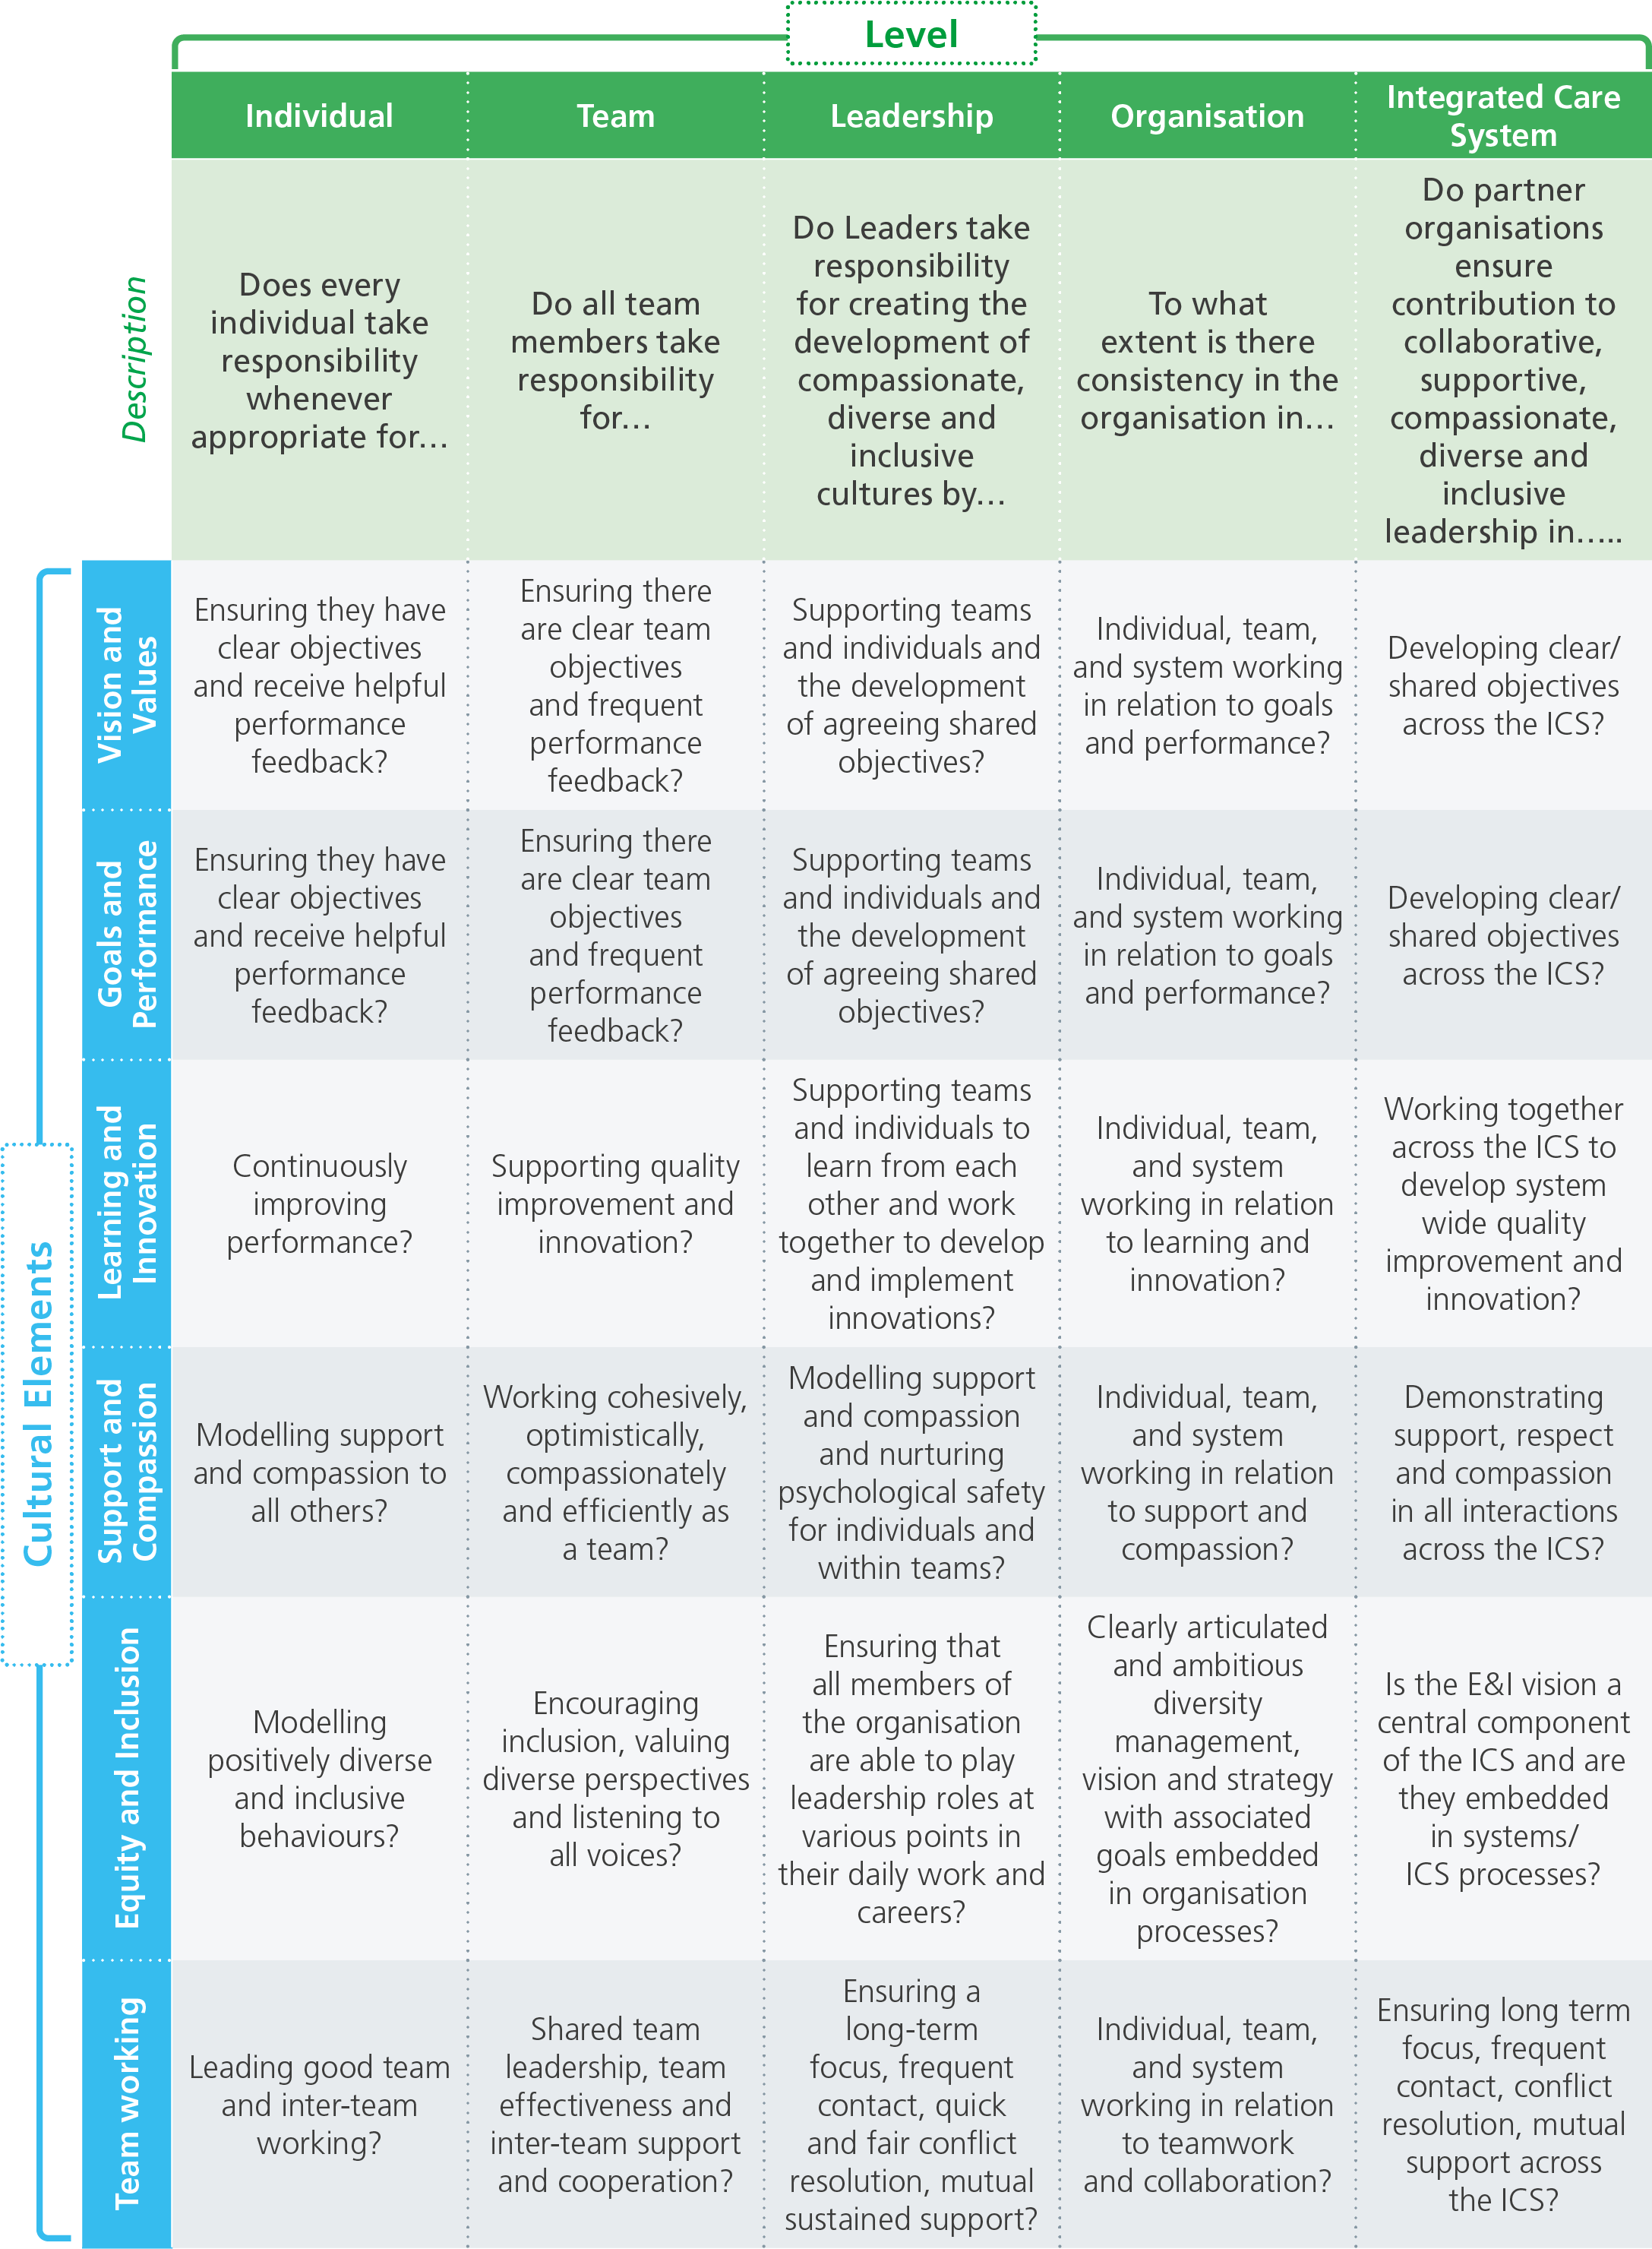
This purposeful, visible distribution of leadership responsibility onto the shoulders of every person in the organisation is vital for nurturing high quality care cultures.
This implies reducing reliance on traditional command and control styles of leadership which research shows are not effective in delivering high quality healthcare cultures. However, it is not only individual leaders that determine organisational performance, but the extent to which everyone acts collectively to implement the six key elements of culture within the organisation and across local communities.
The following questions are intended to help you to understand from participants how they experience collective leadership at each of these five levels.

At the ‘individual’ level
Do you think individual members of staff in our organisation:
- model the organisation’s vision and values on a daily basis?
- have clear objectives and receive helpful feedback on whether they’ve achieved them?
- always look to do their job better?
- are compassionate and supportive towards others (patients and staff)?
- always ensure that they treat others with equity, valuing diversity and inclusion?
- are team players?
At the ‘team level’
Do the different teams (clinical and non-clinical) in our organisation:
- Part 1: ensure its work is in line with the organisation’s vision?
- Part 2: ensure the way it works is in line with the organisation’s values?
- have clear objectives and receive helpful feedback on whether they’ve achieved them?
- support quality improvement and innovation?
- work together in a positive and compassionate way?
- share leadership among them and support one another?
- seek to ensure a positive team climate that supports equity, values diversity and promotes inclusion?
At the ‘inter-team’ level
When different teams are working together:
- do they work around a shared vision and set of values that align with the organisation’s?
- do they agree on objectives?
- do they frequently learn from one another to be innovative?
- do they foster a supportive, respectful and compassionate environment for them to work in?
- do they demonstrate equity and inclusive behaviour between their teams>
- do they work well with one another?
At the ‘organisation’ level
When thinking about our organisation as a whole, how consistent are we when it comes to:
- knowing, understanding and living our vision and values?
- setting ourselves goals, and holding ourselves to account?
- focusing on continuous improvement and thinking of new ways to improve what we do?
- being supportive and compassionate towards one another (i.e. towards other staff as well as patients)?
- demonstrating equity, positive diversity and comprehensive inclusion for all.
- working together as a team?
At the ‘integrated care system’ level
By ‘integrated care system’ we refer to the interactions between our organisation and any other organisations across the system: locally, regionally and nationally (such as other providers, commissioners and voluntary organisations).
When thinking about how our organisation works with other organisations:
- do we try to ensure our vision and values are in line with those of our partners?
- do we have a clear and shared set of objectives?
- do we work together to ensure we learn from one another and push ourselves to develop ideas that benefit everyone (not just ourselves)?
- do we respect our partners in the same way that we respect ourselves?
- do we ensure that equity and inclusion are a central component of the processes we use to work together?
- would our partners think of us as good team players?

