Tool 2.3: Report template
This template shows how the data from the board interviews could be presented. It is not prescriptive, and you should adjust it depending on your needs.
Executive summary
[Brief summary of some of the key points emerging from the board interviews, themes running across all questions or interesting ideas for making changes in the future.]
Purpose
The board interviews diagnostic aims to involve and include the views of the board in the Discovery Phase of our culture and leadership programme.
Method
[A group of [insert organisation name] employees working as part of the [insert name of change team/group]/external interviewers] used a set of 16 questions exploring board views on and behaviour in relation to culture and leadership. They used one-hour semi-structured interviews with individual board members. Board members were asked to give their perception of the overall performance of the board.

The questions
There are qualitative (‘to what extent…’) and quantitative (‘on a scale of 1-5’) questions. They fall into seven broad areas, including five areas covering the key elements of cultures of high quality care.
General
1. What does the term ‘culture’ mean to you?
2. What are the key elements of the current culture of your organisation?
Vision and values
3. What objectives does the board have for developing the organisation’s culture?
4a. To what extent do staff at all levels understand the vision of the organisation?
4b. Why have you given that score? How do leaders at all levels reinforce the vision?
5a. To what extent do organisation values influence the board’s strategic decisions?
5b. How frequently and openly does the board use organisation values to influence their strategic decisions?
Goals and performance
6a. To what extent are staff managed effectively, eg clear objectives, helpful feedback on performance, manageable workloads, appropriate training, effective appraisals and opportunities to contribute to decisions that affect their work?
6b. Why have you given this score? How does the board assure this?
Support and compassion
7. How is the board assuring itself that staff feel valued, have high levels of wellbeing, good work-life balance, stress management and resilience?
8. How does the board genuinely seek to understand the work challenges of staff without imposing a hierarchical understanding?
9. How does the board include patients in its day-to-day business?

Learning and innovation
10a. To what extent are innovation, learning and improvement frequently and effectively fostered in the organisation?
10b. Why have you given this score?
Equity and Inclusion
11. How does the board assure itself that the organisation is making progress in promoting equity, diversity and inclusion at all levels?
12a. To what extent does the board value equity and inclusion and the lived experience of staff?
12b. Why have you given this score?
Teamwork
13. Is there effective team, inter-team and cross-boundary working in the organisation and across the system?
14a. To what extent does the whole board operate as an effective team with clear objectives, regular performance reviews and supportive team working?
14b. How does the board do this?
Other
15a. To what extent is there a culture of openness and transparency across the organisation and are all staff empowered to speak up when they see things going wrong?
15b. Why have you given this score? How does the board assure itself of this?
16a. To what extent does the organisation have appropriately skilled leaders at every level, committed to enabling compassionate and supportive leadership?
16b. Why have you given this score?

Response rate
[Of a total of XXX board members, XXX completed the interviews (XX % response rate).]
Answers and themes
The key themes emerging from the interviews are summarised below, along with summary data for the quantitative questions.
Make sure that the data is anonymised and individuals cannot be identified.
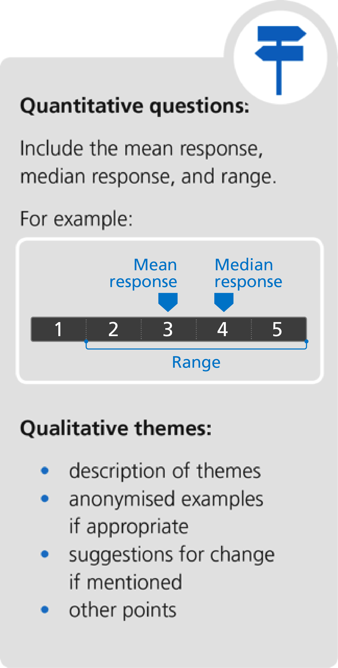
Culture in general
- Qualitative themes
Vision and values
- Quantitative question 4
- Quantitative question 5
- Qualitative themes
Goals and performance
- Quantitative question 6
- Qualitative themes
Support and compassion
- Qualitative themes
Learning and innovation
- Quantitative question 10
- Qualitative themes

Equity and Inclusion
- Quantitative question 12
- Qualitative themes
Teamwork
- Quantitative question 14
- Qualitative themes
Openness and transparency
- Quantitative question 15
- Qualitative themes
Workforce capacity
- Quantitative question 16
- Qualitative themes
Summary and conclusions
This could include key points, themes running across all questions and interesting ideas for future changes.

