Patient and Public Voice (PPV) Partners Influence and Impact - interactive virtual training from NHS England and NHS Improvement

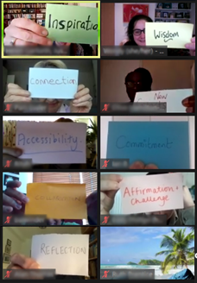
What is it?
Two days (or equivalent) of interactive learning over Zoom, with a focus on influencing change and developing skills and confidence to make the most of the Patient and Public Voice (PPV) Partner role.
Who is it for?
For PPV Partners involved in NHS England and NHS Improvement or in similar voluntary roles supporting health and care system transformation programmes (for example, within an Integrated Care System (ICS)) on a regular basis. It is aimed at people who are supporting major changes in health and care services and who would like to further develop their influencing skills.
What does it cover?
Key topic | Session aim
Exploring patient and public voice in the integrated health and care system | In this module participants will gain a clear understanding of how Patient and Public Voice Partner roles fit into health and care, and will explore the routes that are available to have an impact in different parts of the health and care landscape.
Patient and Public Voice Partner roles and responsibilities. | By the end of this module participants will gain a clear and shared understanding of the role and key responsibilities of a Patient and Public Voice Partner.
Partnership and influence. | By the end of this module participants will have explored effective skills for influence and collaboration through partnership working.
Putting it all into practice. | Participants will explore ways to increase their confidence and identify some clear actions to take away.

Feedback from past participants:
- ‘I felt fully supported to participate by the whole team, and equally as importantly I didn't feel forced to participate’.
- ‘I think all the trainers and peer trainers were highly skilled so thank you. Just keep up the good work! An excellent two days! Loved it’.
- ‘It was hard work but very rewarding. The breaks were timed well so the day was manageable’.
- ‘It was an intense 2 days, but I think it worked well as it meant we were all completely focused for that time’.

We are now taking applications for two cohorts of this training. To better meet the needs of people’s varying circumstances and learning styles, these offer the training in different ways. You can indicate which cohort or cohorts you would like to apply for. As the content has been adapted for each delivery style, it is not possible to mix sessions from different cohorts. It is vital that you are able to attend all sessions from a cohort.

Cohort 3
Seven 90-minute bitesize sessions
Tuesday 15 March 9.30 to 11.00 and 1.00 to 2.30
Wednesday 16 March 9.30 to 11.00 and 1.00 to 2.30
Thursday 17 March 9.30 to 11.00 and 1.00 to 2.30
Tuesday 22 March 9.30 to 11.00

Cohort 4
Tuesday 29 March 9.30 – 12.30 and 1.30 – 4.00
Wednesday 30 March 9.30 – 12.30 and 1.30 – 4.00

The training will take place online, using Zoom.
When applying, please make sure you can commit to all the sessions within your chosen cohort and that other meetings do not clash with the training.
Please return applications by 6pm on Wednesday 16 February, to england.ppve-learning@nhs.net.
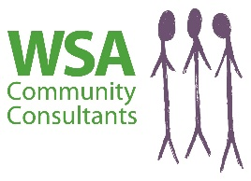
Applications will need a short supporting statement from an NHS employee who knows you and your work in your PPV Partner role (usually your lead contact or chair of your committee) – please allow enough time for your referee to provide this.
NHS England and NHS Improvement

