NHS England and NHS Improvement: Advisory Group for the Insights and Experiences of people living with diabetes programme
Advisory Group description and application pack
May 2022

If you require this information in another format such as large print or easy read

call 07702 420246

or

email england.digitaldiabetes@nhs.net

Applying to be a Lived Experience Partner to join Advisory Group for people living with diabetes

We’re delighted to hear you’re interested in becoming a Lived Experience Partner on the Advisory Group for the Insights and Experiences of people living with diabetes programme.

The only experience needed to get involved is experience of living with type 1 diabetes or type 2 diabetes, or as a carer/family member of an adult living with diabetes.

We want to make sure we are hearing from people with lots of different health care experiences, so welcome applications from everyone who this applies to.

We particularly encourage applications from trans and non-binary people, disabled people, neurodivergent people, and people from ethnic minority backgrounds.

We want to make sure that the Advisory Group is accessible. We will try to meet any adjustments you need to make sure you can apply for the role, and that you are supported to take part if you are successful. If you have any accessibility needs please include them in your application or contact us for help with your application, and tell us what support we can provide to make sure you can take part fully.

Please read the role description below carefully to think about how you are right for the role. In your application, please answer THREE questions. All applications will be considered carefully, and we will use the information to shortlist for an informal interview.

Closing date for applications is: 9am Monday 27th June 2022

How to apply

Please complete and return the application form by email to: england.digitaldiabetes@nhs.net
You can choose to answer the questions in the application form either:
- in writing or
- as a short video or
- contact the team if you need to speak with them to take note of your answers over the telephone.

For more information or if you need support to apply, contact Arron Sandhu at:
- Email: england.digitaldiabetes@nhs.net
- Telephone: 07702 420246

Please note that communication will be mostly via email.
Lived Experience Partners (sometimes referred to as Patient and Public Voice Partners)

NHS England and NHS Improvement will pay an involvement payment for your time attending meetings and supporting the programme. Rates for partners will be £75 per half day (four hours or less), including travel and preparation time. All out of pocket expenses will also be covered. More information can be found in the Patient and Public Voices Partner Expenses and Involvement Payments Policy.

- Involvement payments may be classed as earnings or income by Her Majesty’s Revenue and Customs service (HMRC) or the Department for Work and Pensions (DWP).

- A role 4 PPV partner will be paid their involvement payments through the NHS England and NHS Improvement payroll system. We will help you set this up if you are chosen to take part in the programme.

- The payment will go directly to your bank account. Payments will be subject to statutory deductions including tax and national insurance (NI), although this will be dependent on individuals’ earnings and tax code.

- If you are in receipt of state benefits, you should seek advice from the relevant agency, for example JobCentre Plus, ideally in advance of applying, and certainly before accepting an offer.

For further information see the PPV Partners Expenses and Involvement Payments Policy and the PPV Partners Policy.

The Citizens Advice Bedford flyer at the end of this application pack provides a helpline number if you have questions about receiving involvement payments and claiming expenses related to being involved in NHS England or NHS Improvement’s work.

Advisory Group for the Insights and Experiences of people living with diabetes programme

Special Terms: involvement payment paid position
Hours: ½ day (approx. 4 hours) per month.

Who are we?

The Advisory Group provide direction to the Insights and Experiences of people living with diabetes programme.

This programme builds on a need identified by people living with diabetes that the NHS needs to understand the experiences of, and satisfaction with diabetes services and care.

To do this we want to:
- involve people living with diabetes in the design and delivery of services
- develop a national survey to understand what matters to people living with diabetes
- use the survey results to improve services and people’s experiences.

The Advisory Group will provide recommendations to the Diabetes Programme Board, who make decisions about how programmes should be delivered.

The Group will also provide input into the development and delivery of the programme to the national programme team.

The membership of the Group will be made up of equal numbers of lived experience partners, healthcare professionals and public health staff, to:

- Advise on how to make sure the programme puts the perspective of the people who use our services first.
- Develop and contribute to the programme’s plans for carrying out the work.
- Provide suggestions and recommendations on how the results of the work can be turned into actions, which will improve people’s experiences of services.

What is your role in the group?

You will bring representation into the Group by bringing important views, lived experience and perspective.

- This role is important in championing the views of:
  - people who use our services
  - people with diabetes and/or carers/family views

- By providing your feedback you will influence:
  - how the project is delivered
  - actions that need to be taken based on the findings of the project.

There are also optional opportunities to support the programme. Involvement in these options will be based on your experience and how much you would like to take part in the programme. Time spent will also be reimbursed in addition to the Advisory Group meeting attendance. Options include:

- commenting on or writing content for project documentation
- supporting procurement processes for externally contracted work
- presenting project findings or asking for input at meetings
- gathering feedback from wider patient and public networks.

Skills and experience required for this role

- Living with diabetes or caring for someone with diabetes.
- Experience of using healthcare services.
- Confidence to speak in meetings or to comment in meetings by the chat function or share by other communication means.
- Ability to consider a range of information and evidence.
- Ability to show sound judgement and objectivity in order to represent wider views and experiences not only your own.
- An awareness of, and commitment to, equality and diversity.
- Understand the need for confidentiality.
- Working creatively and collaboratively.
- Feeling comfortable offering objective challenges.

We do not expect you to share personal details about your own health and/or healthcare. This applies both for the application process and your involvement in the programme. However, you can share this information if you are comfortable to do so, to support a better understanding of the experiences people living with diabetes may have and their engagement with healthcare services.

Time commitment

- Membership of the group is for 2 years but will be reviewed after 6 months.
- We ask for you to be available for 1/2 day per month. This is flexible and may vary slightly depending on the progress of the project and what input is needed.
Advisory Group Meetings will usually take place:
- during normal working hours (between 9am and 5pm)
- approximately every 6-8 weeks
- remotely via Microsoft Teams
- for up to 2 hours
In the first 4-6 weeks, the time commitment will be used for completion of your induction and training. Lived Experience Partners in role 4 are required to complete training which includes:
- Information Governance
- Equality and Diversity and/or Safeguarding Level One
The training is accessed online via the Skills for Health website and Lived Experience Partners are able to complete the training from home. Each training module should take about 30 minutes to complete.
If circumstances change (for the project and/or the individual) it is possible to withdraw from the role.

Support for you

The team leading the programme, led by the Programme Manager, Helen Slee, will be available to support you with:

- Completing your application if needed.
- Feeling prepared and comfortable to attend an informal interview if shortlisted.
- An induction about the programme, to help you understand the aims of the programme and be clear on your involvement.
- Ongoing support and assistance to enable your involvement in the Advisory Group, including:
  - Documents shared and, if necessary, pre-meeting briefings will be provided 2 weeks ahead of meetings.
  - Meetings arranged around your availability as far as is possible.
  - Support to contribute to the programme if you miss a meeting.
  - Availability to address any questions you have and provide any help as needed.
  - Check-in meetings or emails to hear your feedback and support your involvement.
- Access to learning and development opportunities available to Lived Experience Partners, details can be found on the Involvement Hub.

NHS England and NHS Improvement also ask that all new Lived Experience Partners complete an interactive online induction session. This webinar lasts an hour and will provide some background information to NHS England and NHS Improvement and the work that we do, as well as wider support available to Lived Experience Partners.

Diversity and equality of opportunity

NHS England values and promotes diversity and is committed to equality of opportunity for all. To help us understand if we are achieving this, we ask you to fill out the equal opportunity monitoring part of the application form as part of the application process.

This information will be kept confidential.

Once we receive your application

The steps will be:

- We will let you know we have received your application form via email. If you do not receive a response from us to confirm receipt within three days, please get in touch.

- Interviews will take place via teleconference (Microsoft Teams) week commencing 4th July 2022

- We will need two references for successful applicants before the role can begin. These can be personal (friend or family) or work references.

- We will reply to everyone who sends us an application, to let you know if you have been successful or unsuccessful in being invited to interview.

- Emails to successful applicants will include information about next steps.

To hear about future involvement opportunities, please sign up to NHS England and NHS Improvement’s In Touch newsletter. It includes details of current opportunities.

If you have any questions about the application process, or would like a chat about the opportunity – please contact Helen Slee at: england.digitaldiabetes@nhs.net

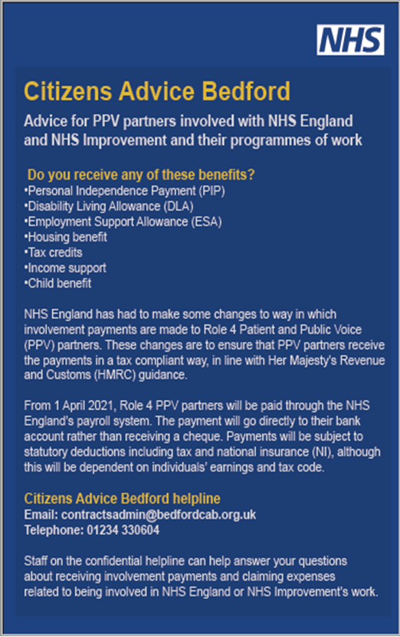
For advice if you receive state benefits:

