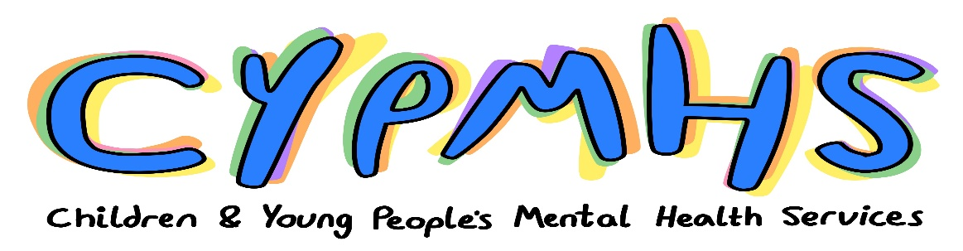

Introduction
The national Children and Young People’s Mental Health (CYPMH) Team at NHS England and Improvement are looking for a number of National Lived Experience Partners to work with the team to improve NHS funded CYPMH mental health services in England.
This is a new role and an exciting opportunity for young people with experience of mental health difficulties as a child or young person, or as a parent or carer of a child or young person with mental health difficulties to play a key role in supporting the CYPMH programme to incorporate coproduction into all aspects of our work. The team are trialling this role for the first time which means that those working with us will have a unique opportunity to shape how it works. Working with Lived Experience Partners will help us to find practical solutions to common issues and improve policy and programmes.
Lived experience partners would be working with a friendly and supportive team who are committed to improvement in community CYPMH. The CYPMH team are responsible for setting the strategic direction and monitoring systems. Pathways and services included in the Community CYPMH programme include those commonly referred to as Child and Adolescent Mental Health Services (CAMHS), Mental Health Support Teams (MHST) in schools and colleges, community eating disorder services, and urgent and emergency care (crisis services). We also work with adult mental health colleagues to improve services for young adults aged 18-25, and the teams responsible for improving inpatient services, learning disability and autism services, children and young people’s health and health and justice.

Overview
The team are looking to work with:
- 2 young people aged 18-25 who experienced mental health problems as a child and/or young person
- and 2 parents or carers who’s children experienced poor mental health before they turned 18
Time: generally 4 hours/ a half day per week for a minimum of 6-12 months which may be flexed over the month in agreement with team needs and the needs of the individual. Occasionally more hours may be agreed between the team and the individual to a maximum of three days across the month. Most meetings will take place in core office hours (9am – 5pm), but activity, such as reviewing documents, can be done out of hours if preferred. We will try to support flexibility in the hours working with team and project needs as well as the availability of the lived experience partner.
Base: Primarily online with occasional office/event-based activity across the country
Salary: £75 for 4 hours, minus deductions, in line with NHS England and Improvement’s Patient and Public Voice policy
Travel: Where travel is required we will book trains and accommodation if needed for you, this is the preferred option as it helps us reduce our carbon footprint. If you prefer to travel by car rates of reimbursement are set by HMRC and submit receipts through expenses.
Expenses: Expenses can be claimed back with a receipt for:
- travel (including for food while away from home, and taxis if necessary), reasonable costs for carers or support workers, reasonable costs if an unofficial carer (eg a family member) is required
- office supplies of up to £5 per meeting to cover costs of calls, paper, printing ink, internet connection etc
Impact on benefits: If any applicants are unsure of how this might affect their access to benefits Citizens Advice Bedford provides a confidential telephone helpline service to help answer queries and resolve any benefit concerns that arise from being offered (and accepting) involvement payments and having expenses reimbursed when participating in involvement activities. The service should be contacted by email at contractsadmin@bedfordcab.org.uk with a brief summary of the query, or by calling 01234 330 604.

About the role:
Applicants would be applying to work with a friendly team which works at a fast pace. It is an exciting opportunity to get a glimpse of the vast amount of work that is undertaken nationally to improve NHS funded services. Furthermore, this is a chance to help shape and strengthen our work with experts by experience across the team.
Successful applicants will provide lived experience voice to the work of CYPMH team, through, but not limited to, the below activities:
- Working in the team to champion the voice of lived experience:
  - championing the voice of experts by experience and bringing this lens and perspective to the work
  - helping to identify team priorities
  - bring ideas and vision in collaboration with the team
- Co-producing and reviewing materials:
  - helping to develop guidance and materials for online events to help systems to improve and understand priorities
  - supporting with the development of governance board papers with lived experience in mind
- Representing lived experience voice in meetings and events:
  - attending meetings such as regular team, project and governance meetings, providing views and suggestions as work progresses in a constructive manner
  - chairing or co-chairing some meetings such as advisory groups
  - attending events alongside team members to co-present on areas of work and represent the team, for example presenting on the Lived Experience perspective in national webinars (online events) and regional events

- Support the team to ensure work reflects wider perspectives of CYP and parents and carers by helping the team to:
  - engage with more diverse voices; this might include through co-chairing meetings with other experts by experience, helping to design surveys, linking into other spaces,
  - think about which voices are not represented and how we might address this.
  - use this information to reduce health inequalities, eg. reflecting learning in guidance.

- Supporting team recruitment
  - supporting interview processes, for example reading applications, developing interview questions for candidates, helping to develop tests for candidates, sitting on interview panels

Experience, skills and attributes:
We are looking for people who:
- have direct experience of mental health difficulties as a child or young person or in a caring role for a child or young person with mental health difficulties, this may include experience of accessing children and young people’s mental health services
- are able to draw upon personal experiences to influence work
We will work with Lived Experience Expert Partners find the right approach to helping them communicate their vision and thoughts and will make reasonable adjustments to the post.
People applying should demonstrate what experience they have of the following:
- involvement and co-production and of representing lived experience, including in the NHS
- participating in meetings and committees
- reading and commenting on documents such as guidance and papers for meetings
- developing slides for and presenting at events
- communicating in written form – e.g. email and writing reports
- using IT packages, such as email, Microsoft packages including Teams, Word, PowerPoint
People most likely to enjoy the role would:
- be flexible in approach as work can change quickly
- understand that national transformation takes place over a long period of time
- be collaborative and constructive in work, but prepared to provide challenge
- interested in learning about and working on national policy and data
- have knowledge of key NHS policy documents, legislation and commitments
- reflect our team values such as compassion, empathy, respect

Practicalities
Applicants will need:
- an active email account,
- access to IT equipment such as a laptop or a computer that will run windows applications such as Word, Power Point, and means to access Microsoft Teams either from their phone or their computer
- adequate anti-viral software installed.

Support package:
The support package will be finalised with the selected lived experience expert advisors in order to reflect their personal needs and preferences and reasonable adjustments made. As a minimum the national team will offer:
- an induction to the team, our stakeholders and the NHS system
- monthly one to one supervision with a programme manager or senior project manager
- a space for peer supervision
- a safe space to talk about any issues arising from discussing difficult subject matters
- bi-monthly team meetings - these occur fortnightly on a Thursday morning at 9.15am. Attendance from the lived experience advisors not a requirement, but encouraged.

NHS England and NHS Improvement ask that all new PPV Partners complete an interactive online induction session. This webinar lasts an hour and will provide some background information to NHS England and NHS Improvement and the work that we do, as well as wider support available to PPV Partners.

Meeting documents, and if necessary, pre-meeting briefings will be provided. There are a range of learning and development opportunities available to PPV Partners, details can be found on the Involvement Hub.

Benefits for Lived Experience Partners
Candidates would be working with a friendly and supportive team who are passionate about change and improvement in CYPMH.
Opportunity to:
- make a difference to children and young people’s mental health
- work on and shape national programmes
- demonstrate ability to participate in national and local events and meetings
- demonstrate experience of working with data

NHS Values and Organisational Policies
The Lived Experience Partners will need to work to organisational policies on:
- confidentiality – eg. Discussions and documents should be treated as confidential
- anti-fraud and anti-bribery policies
- anti-bullying and harassment policies
Lived experience partners will be asked to complete e-learning modules for:
- information Governance
- safeguarding level 1
- equality and Diversity
Lived experience partners will need to work in line with our values:
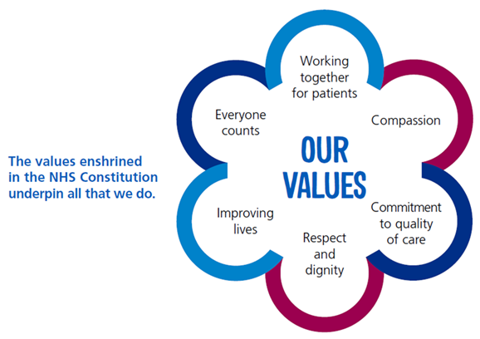

About the team
We are the CYPMH team in NHS England and Improvement (NHSEI). NHSEI is responsible for setting strategic direction for the NHS – e.g. contributing to the development of the NHS Long Term Plan, monitoring ‘Systems’ (the local collective organisations and services) against public commitments, and supporting them to deliver these well.

The CYPMH team works with systems to improve NHS funded community mental health services and pathways – for example those which are often called CAMHS, the new Mental Health Support Teams in schools and colleges, Community Eating Disorder Services and Urgent and Emergency Care (crisis) services. We work with the teams who are responsible for inpatient services, and health and justice, Learning disability and autism among others.

We have several national commitments that we are working towards, including:
- Maintaining the progress achieved through the Five Year Forward View for Mental Health
- Continuing to improve access so that 345,000 more children and young people (aged 0-25) can access support from NHS funded services
- Continuing to work towards the community eating disorders waiting time standards
- Ensuring that children and young people experiencing a mental health crisis will be able to access the support that they need
- Continuing to roll out the mental health support teams in schools and colleges to provide early intervention and ongoing help
- Improving the offer for young adults aged 18-25

Our main activities include:
- Developing policy and sharing best practice – e.g. developing guidance documents
- analysing data and developing ‘national metrics’ to help us track progress – e.g. how will we know how long people wait to get help and whether or not they are getting better
- Speaking to colleagues in regional teams and systems to share ideas and find out how we can help
- Presenting at meetings and conferences about our work to communicate vision and requirements
- Briefing senior people and responding to questions from DHSC, Parliament, and the media
- Working with stakeholders to ensure CYPMH remains a priority.

How to Apply
Please complete and return to Jessica & Ellie by email (england.cyp-mentalhealth@nhs.net):
- The application form
- The equal opportunities monitoring form

If you have any questions please get in touch with Jessica or Ellie by email on england.cyp-mentalhealth@nhs.net. Subject to the level of interest it may not be possible to respond to every query.

Diversity and equality of opportunity
NHS England and NHS Improvement values and promotes diversity and is
committed to equality of opportunity for all. To help us understand if we are achieving this, we ask you to fill out an equal opportunities monitoring form as part of the application process.

Please let us know if you have support needs so that we can understand how we can support you to participate fully.

We particularly welcome applications from:
- People with a Black, Asian or Mixed ethnic background
- People living in the most deprived areas of England
- People with protected characteristics as listed in the Equality Act (2010).

Once we receive your application
- We will acknowledge receipt of your application form via automatic email so that you can be sure it has been received.
- Applications will be shortlisted by a panel and assessed against the skills and experience required.
- Selection will be made on the basis of the content of the application form.
- We will let unsuccessful applicants know the outcome via email, and will be in touch with those who we would like to interview.
- Interviews will take place via MS Teams on 9th, 10th and 11th August.
- Please note that two references will be taken up for successful applicants before involvement can commence.
- All applications will receive a successful or unsuccessful notification. The successful notifications will include information about next steps.

If you wish to be informed about future involvement opportunities, please sign up to
NHS England and NHS Improvement’s InTouch newsletter, which includes details of current opportunities.

