Overview of change
A local county health system, that serves within it a rural district area with a population of around 90,000 people, used a Citizens’ Jury to decide the location of a new community hospital. This case study draws upon interviews with members of the decision-making and wider transformation team. It highlights the ways in which public evidence, gathered through a deliberative decision-making method such as a Citizens’ Jury, was used alongside more traditional methods such as focus groups and survey consultations. It concludes that the Citizens’ Jury increased trust between decision-makers and the public through creating a process that established a shared framing and shared evidence for the decision.

Local context: challenges and framing of information
The move from two hospitals to one in the area had a long and emotive history. The change had been proposed and firmly rejected more than 10 years previously by a very vocal and well-organised opposition. Local opposition remained this time, but crucially there was support from more local political representatives for the change.
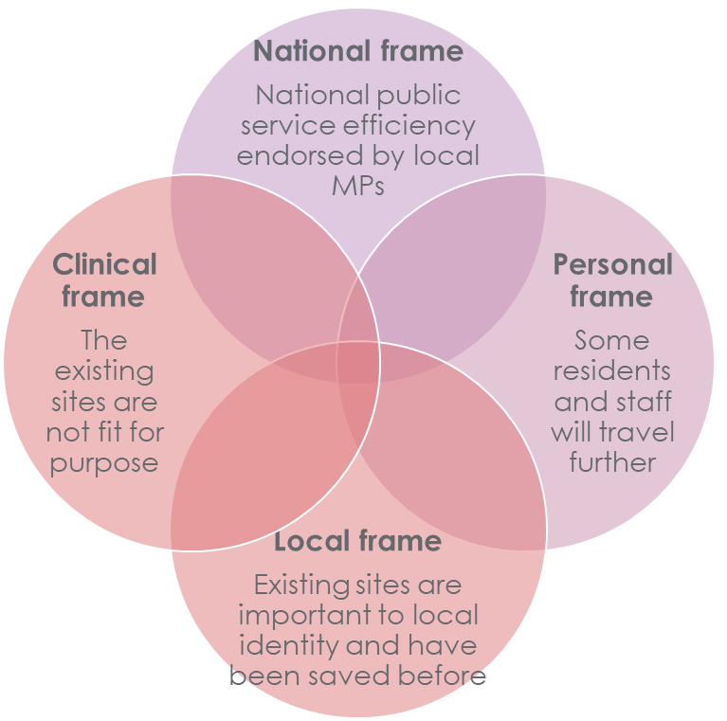
Public involvement in this decision-making process involved the public navigating two ways that the information was framed. Here we are using a ‘frame’ as the dominant way in which an issue is understood. Frames are underpinned by narratives (based on evidence or lived experience) that emphasise different national, local and clinical factors.
In this case study the system framing was clinical and emphasized a rational evidence-based narrative that it was not possible to deliver high quality care across two sites comprised of older building stock. Communicating this to the public was seen as challenging as the local population have experienced high-quality care in both hospitals over time and may not understand the benefit that a new site would bring to the quality of their care.
Local campaigners framed the decision around local identity, which emphasised emotional narratives rooted in the local area. These included the origin story of the sites that were built to serve the former mining community, and the idea that being born in one of the hospitals was necessary to truly call yourself ‘from’ the local area.
Figure 1.0 Competing framings of change.
To involve the public in the change process and gather strong public evidence, the team needed to recognise the strength of local identity framing before trying to gather public views within a clinical, evidence-based framing.
The presence of local staff at involvement events who understood the history of the two hospitals helped recognise the significance of the change for local identity. Their presence helped support residents to provide views about quality of care. They also reported that showing the experience of new community hospitals elsewhere in the county helped highlight the increased quality of care that could be delivered at a new site. This approach helped the public navigate the tension between local access to services and quality of care.
Ongoing local workforce engagement also needed to navigate this tension as significant members of the workforce would be required to travel further to work. The clinical case was known to the local workforce as they saw the issues with the buildings on a daily basis and a local workforce champion held regular informal engagement sessions to answer questions.

Impact: How public evidence was used at each stage
A combination of traditional and deliberative involvement informed decision-making and design at each stage. The CCG and the Trust made separate decisions following their governance arranges as commissioner and service provider respectively. However, they worked as one team through joint agreements, ensuring that there was co-ordination. Decisions were made publicly in well attended Town Hall meetings where each body explained their decision to the public.
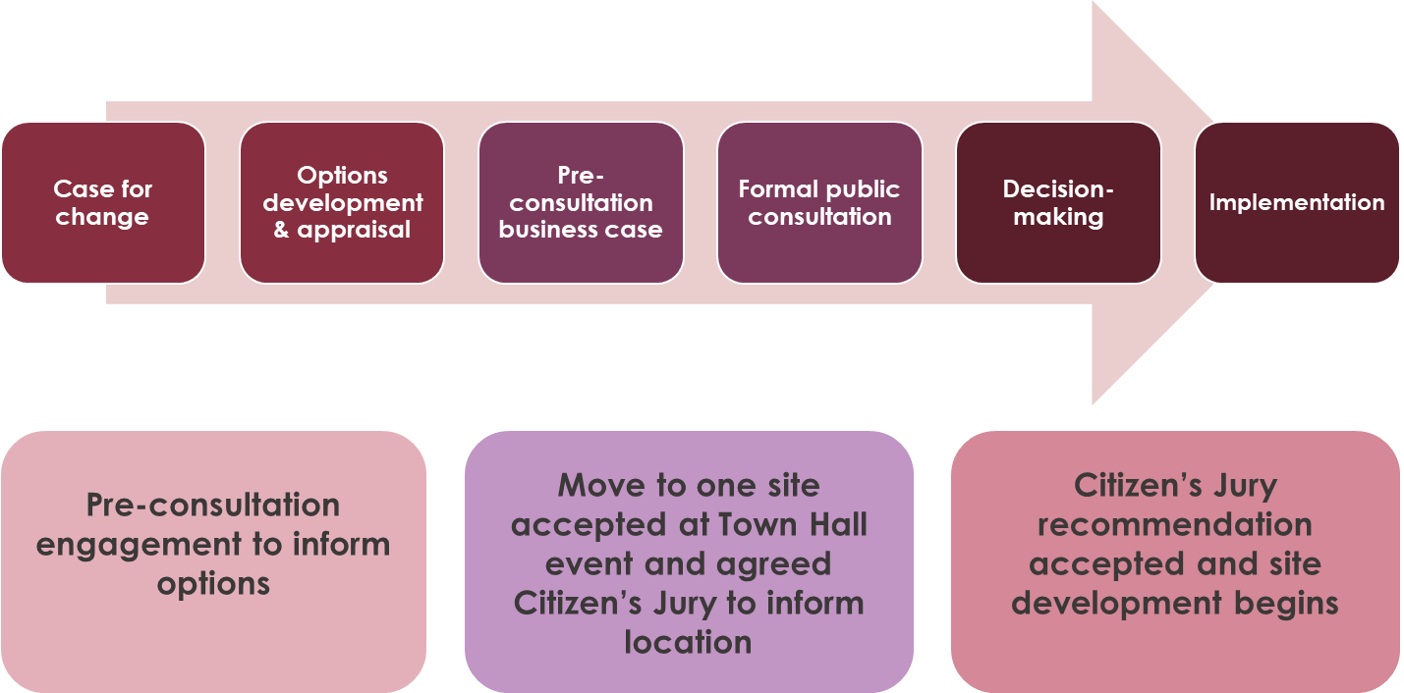
Figure 2.0 The use of public evidence at each stage of the change process
Qualitative evidence gathered through public events and discussions helped answer the question, ‘what good looks like’ at the pre-consultation business case stage. It highlighted issues around access, ensuring continuity of history and the potential impact of inequalities that the team would need to consider in more depth in the design of options.
The case for change to move from two sites to one site was a straightforward decision for the team as the clinical evidence was well-established. Pre-consultation engagement with local stakeholders and residents indicated a shift in opinion regarding the one site option. As required by legislation, the team then conducted a formal consultation that included public involvement events, a survey, website and social media engagement. The formal consultation indicated 52% support for the case for change, which decision-makers interpreted as sufficient to imply consent.
The site selection stage of options development used an independent Citizens’ Jury to make a recommendation from three possible locations. A Citizen’s Jury is an involvement method where a small group of the public are selected to deliberate over a policy issue and asked to make a recommendation based on evidence presented. The Jury has no decision-making power as it is not a legal entity, and instead makes a recommendation to the Trust and CCG as accountable decision-makers. Neither the Trust nor the CCG had a preferred option out of three possible locations – all were understood to have the potential to deliver high quality care. The local population did have preferred options – it was a highly contentious local decision.
The jury was run by an independent company that recruited a mix of residents through public advertisement where residents applied to take part. This ensured a geographical spread across the area and as well as selecting people who were genuinely interested to take the recommendation-making responsibility.
The system accepted the Citizens’ Jury recommendation because they trusted the process that had created more neutral, clinically framed public evidence.

Key reflections on Citizens’ Jury
Decision-makers highlighted several strengths of the Jury process that led them to trust the recommendation and use a Jury in future options appraisals:
- Selection of residents: they felt that Jurors were selected from across the geographical location and so mitigated the bias of people selecting the site closest to where they live. They were confident that the Jury was not dominated by campaigners who already had a firm view of their preferred location and would be unlikely to change after deliberating evidence in the public interest.
- Framing and role: the Jurors were asked to assess evidence and provide a recommendation for the whole community rather than their own personal interests. Traditional engagement tends to ask people to speak from their own experience, and so decision-makers quite reasonably interpret this as emotionally driven personal interest. The Jury system asks a different question of the public and so the decision-makers felt more comfortable placing more weight on it as public evidence.
- Scope of the question: the Jury had a clearly defined remit to select a site, which the change team felt was a decision that local residents were well placed to make. The Jury were not asked to review the clinical case for moving to one site, and so were not asked to understand more complicated clinical evidence. Instead, they were asked to weigh up local analysis of travel times and equalities impact. These were seen as areas where the public can add real value – based on where they live with the consequences of the decision and understanding of access better than the system. The team have gone on to use two Juries to inform decisions around specialist acute care, reflecting a high level of trust in the Citizens’ Jury process to make an evidence-based decision.
- Close and evidence based: The Jury narrowly chose one of the three options, which felt right to decision-makers. It was a very difficult decision with no clear preferred option, so the fact that the Jury returned a very close result reflected the right balance of evidence. The Jury had also been exposed to the same evidence as the change team, and this further established trust that the jurors had made a fair, evidence-based decision.
- Public acceptability: Finally, the Jury was held in public and campaign groups accepted the decision. The change team felt that it helped gain public acceptance from the local population because the recommendation for the location had been made by local people rather than the system.

Contacts
Becky Parish, Associate Director, Engagement and Experience, NHS Gloucestershire
becky.parish@nhs.net
Caroline Smith, Senior Manager Engagement and Inclusion, NHS Gloucestershire
Caroline.smith37@nhs.net

Further resources /information
Get involved Gloucestershire –A new hospital for the Forest of Dean- this has all the history from the engagement, through to consultation and Jury recommendation.
https://getinvolved.glos.nhs.uk/fit-for-the-future11

Not a consultation – podcasts about all things patient and public involvement and NHS service change.
Episode 5 – Case Study – choosing a new hospital site: https://notaconsultation.com/podcast/episode-5-case-study-choosing-a-new-hospital-site/

https://participedia.net/method/155

