Tool 4.4: Report template
This template provides an example of how the data from the culture focus groups might be presented. It is not prescriptive, and you can amend or adjust it depending on your particular needs.

Executive summary
[Brief summary of the findings from the culture focus groups, underlying themes and potential causes.].

Purpose
The culture focus groups offer an in-depth insight into what staff in our organisation think about the six key elements of high quality compassionate and inclusive culture and the strength of collective leadership at each of the five levels (see below).

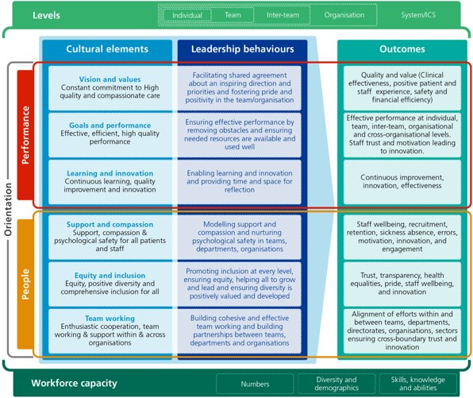
Methodology
[A group of [insert trust name] employees working as part of the [insert name of change team/group] were asked to arrange a series of focus groups with employees from across the organisation. In each session facilitators sought the opinions of participants in relation to one of six cultural elements and/or one of the five levels of collective leadership, using a list of ‘prompt’ questions as a starting point. The outputs of every discussion were recorded and then analysed to give a snapshot of our trust’s assessment of its own culture.
Communications and Engagement
In this section you could describe the approach you took to engage diverse range of staff members from all parts of your organisation to participate in the focus groups. You could also describe any challenges you faced with engagement.

Sessions and participants
This could include the total number of focus groups, whether they were full or mini focus groups, the total number of participants and a breakdown of the different staff groups and trust sites that were engaged.

The questions
You may wish to include a sample of the prompt questions to improve the board’s understanding of what was asked during the focus groups.

Results and themes
This section summarises the key themes that emerged from the focus groups. You can present them however you think is most appropriate. The example below presents the findings according to level of collective leadership, with the associated findings for each of the six cultural elements.

Including graphs/charts and quotes may help your board understand the findings. Make sure that the data is anonymised, and individuals cannot be identified.

Discussion
Include your interpretation of the results, underlying reasons and factors that may need to be considered when interpreting the results.

Conclusions and recommendations
Include a brief summary of the key points, underlying themes and potential causes, and suggestions about the most appropriate next steps.

