|  |
| --- |
|  |
| Part 2 – Do Resource B Business Continuity Workshop Delegate Book |
|  |
| Version 3.0, 17 April 2023 |

|  |
| --- |
| Classification: Official |
| Publication approval reference: PR1254 |

## Contents

1) Introduction 2

2) Workshop 3

3) Workshop Activity 1 5

4) Workshop Activity 2 9

5) Workshop Activity 3 10

6) Workshop Activity 4 11

7) Workshop Activity 5 14

8) Workshop Activity 6 15

1) Introduction

The document has been designed to assist you to meet the outcomes of the workshop you are to undertake today. This workbook then will be used to assist in the development of your Business Impact Analysis and Business Continuity Plan.

The first part of the process is to ensure that you understand the risks and the business impact of your organisation, service, or department. Today’s workshop will assist you in identifying these. Please do not hesitate to discuss any part of this workshop with your facilitator if you are unsure or have any queries.

If you have one you will need a copy of your service/department/organisation’s risk register today to assist you in the completion of the workshop objectives. In some organisations risk is viewed in a very clinical context. If you do not have access to one of these then the workshop will allow you to explore the benefits of aligning the Business Continuity risks to your organisational risk management systems.

**Overview of the Workshop**

The workshop is split into a number of sections which include:

* Overview of Business Continuity Management & its Cycle
* Legal aspects and NHS England Core Standards
* Business Impact Analysis
* Business Continuity Strategy Outcomes
* Business Continuity Incident Response Plans
* Exercising, Maintaining & Reviewing

**Objectives**

The objectives of today’s workshop are:

* To develop an understanding of a business continuity management system.
* To understand how to use the entire toolkit
* To understand how to develop a business continuity plan

**Supporting Documents**

There are a number of key documents that support the entire business continuity management process.

These include:

* NHS England Business Continuity Management Framework (Service Resilience)
* NHS England Core Standards for EPRR
* PAS 2015
* ISO 22301 (2019)
* ISO 22313 (2020)
* NHS Standard Contract
* Data Security and Protection Toolkit – NHS Digital

# 2) Workshop

**Elements of Business Continuity Management**

(Source: ISO 22313)

**Plan-Do-Check-Act Cycle**

The ISO 22301 & 22313 uses a ‘Plan-Do-Check-Act’ Cycle to planning, establishing, implementing, operating, monitoring, reviewing, maintaining, and continually improving the effectiveness of your organisation’s Business Continuity Management System.

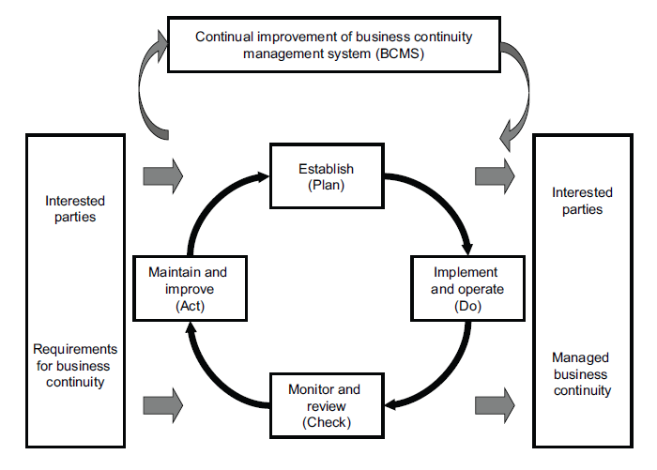(Source: ISO 22301)

# 3) Workshop Activity 1

In your groups discuss what the legal and/or regulatory responsibilities for Business Continuity are for your organisation and the wider NHS

**Interested Parties**

This is a diagram to show an example of interested parties to be considered in the health sector. List is not definitive and an example. Only each organisation will have additional stakeholders who they will need to engage with.

# 

**Understanding the Organisation**

Through understanding, the organisation is able to ensure that its business continuity aligns with its purpose, statutory duties, and obligations to its interested parties.

Understanding is achieved through the processes of BIA and risk assessment. These processes provide the information that the organisation needs to determine and select business continuity strategies. The BIA and risk assessment should enable the organisation to identify measures that:

* limit the impact of a disruption on the organisation.
* shorten the period of disruption; and
* reduce the likelihood of a disruption.

The context, evaluation criteria and format of the outcome of the BIA and risk assessment should be defined and agreed in advance. Information collected should be regularly reviewed, particularly during periods of change.

(Source: ISO 22313)

**Business Impact Analysis**

* Risk assessment and treatment
* Prioritisation of activities including Recovery Time Objectives (RTO) and Maximum Tolerable Period of Disruption (MTPD)
* Identify resources required for maintenance of priority services

# 4) Workshop Activity 2

In your groups:

* Identify your organisation’s department’s essential activity/service
* What are the resources required to deliver these?
* Are there any apparent risks to these critical activities?
* How will you reorganise to maintain these critical activities in the event of a disruptive incident?

# 

# 5) Workshop Activity 3

In your groups discuss:

* Does your organisation have a business continuity strategy?
* What do you think a business continuity strategy should contain and why?
* Who is the organisation’s senior business continuity champion?
* Does your organisation have an agreed essential service list?

# 6) Workshop Activity 4

Using the table overleaf consider:

* What are your organisation key activities?
* What are the critical activity and resources required to deliver these?
* What are the key risks to these critical activities?
* How will you maintain these critical activities in the event of an incident?

# 

**Business Continuity Requirements**

|  |  |
| --- | --- |
| **People** |  |
| **Premises** |  |
| **Technology** |  |
| **Information** |  |
| **Suppliers & Partners** |  |

**Mitigating Impacts through effective BC – Sudden Disruption**

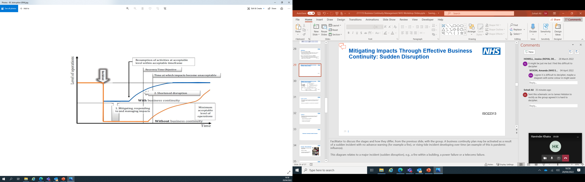

(Source: ISO 22313)

**Mitigating Impacts through effective BC – Gradual Disruption**

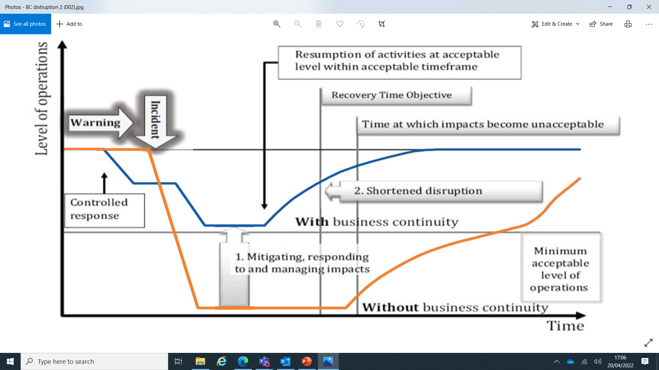

(Source: ISO 22313)

# 7) Workshop Activity 5

List as many examples as you can of measures which could be considered in the context of flooding due to failure of internal plumbing systems to:

* Reduce the likelihood of a disruption
* Shorten any period of disruption
* Limit the impact of a disruption

# 8) Workshop Activity 6

In your groups:

* What strategies might be needed for maintaining core skills and knowledge?
* What elements should your premises strategy consider to reduce the impact of the unavailability of one or more worksites?
* What technology strategies for BC could your organisation adopt in the event of a disruption to the main area of your building following a fire, with a recovery time objective of 3 months?

(Source: ISO 22301)

**Record Keeping**

Why is record keeping so important?