Name: _________________________________ Date of Birth:__________________
My mouth care routine:
Support required | Toothbrush  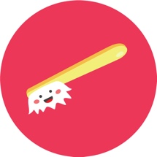 | Toothpaste | Where? | I brush my teeth at  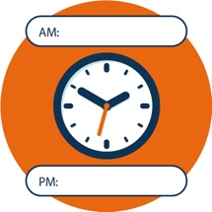
I like to:
Example: John likes to listen to the Brush DJ app whilst he is brushing and sing along
_____________________________________________________________________
_____________________________________________________________________
Mouth Care Log:
BA  Brushes alone | BWH  Brushes with help | U  Unwell | R  Refused

Date / Time | Mouth  Care |  | Area of mouth cleaned |  | Appearance of mouth, concerns, comments? | Staff Signature
Eg: 01.01.01  8.30am | BWH | Upper only |  | Mouth looks clean only managed upper today  No concerns |  | Alison Smith
Eg: 01.01.01  9pm | BWH | Started with lower managed full mouth |  | Food stored in cheek  John co-operated – cleaned full mouth  No concerns |  | Alison Smith

Mouth care should be recorded as part of general health care plans.
If a care plan exists that already includes mouth care, this document may not be required.
When daily mouth care is NOT carried out/not possible, this record should be completed, and any difficulties encountered communicated between staff during handovers.

