Book your measles, mumps and rubella vaccines

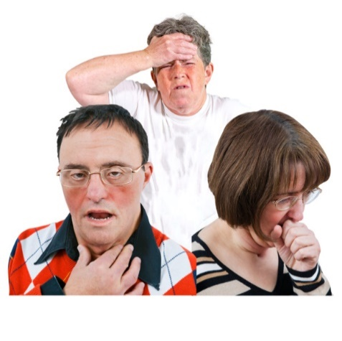 | Measles, mumps and rubella are infections that can spread easily between people. They can spread through coughs and sneezes.
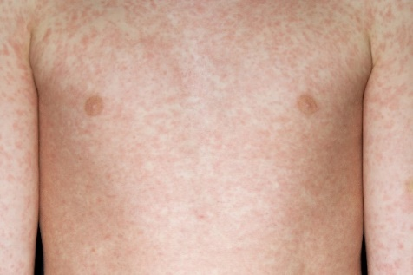 | More people in England are getting measles.  It can make you feel ill and give you a rash.
 | For some people measles, mumps and rubella can lead to serious health problems. It’s important you get protected.
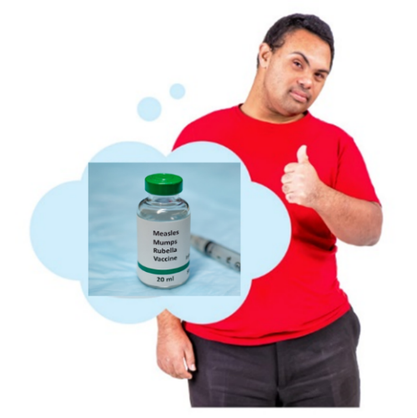 | You can have an injection called a vaccination to protect you from measles, mumps and rubella. It is called the MMR vaccine.
How to book your MMR vaccines
 | The information on your health record shows that you might not have had your MMR vaccines.
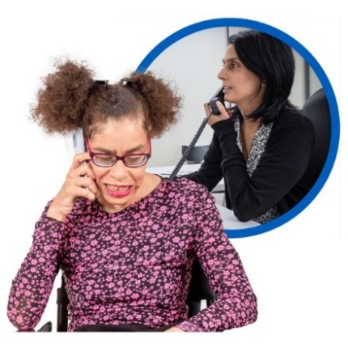 | Please contact your GP surgery or doctor to book an appointment for the MMR vaccine.
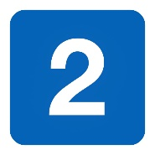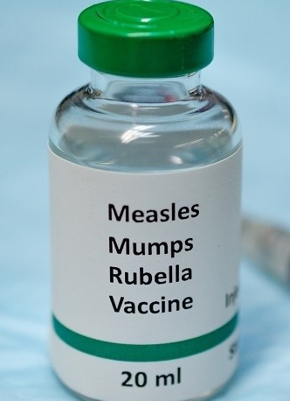 | You need 2 doses of the MMR vaccine for the best protection.  You will get them at 2 different appointments.
You can ask if you need any other vaccines.
If you do, you may be able to have these at the same appointment.
What happens at your appointment
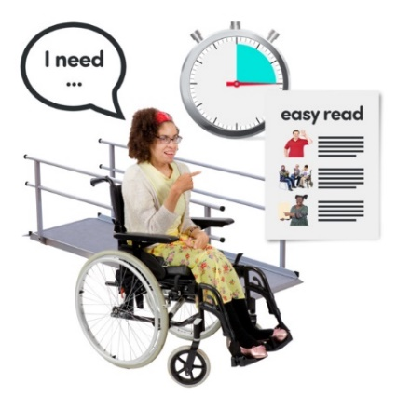 | You can ask your GP surgery to do things to make your appointment easier for you.  This is called a reasonable adjustment.
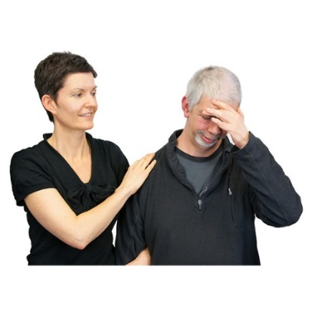 | If you don’t like needles or are worried about having an injection, you can take someone with you for support.
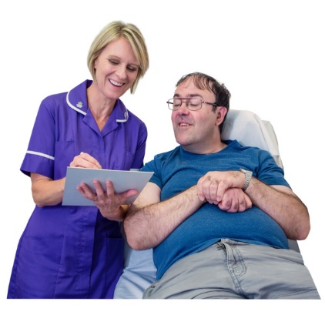 | At your appointment the doctor or a nurse will talk to you about the vaccine. They will make sure you are happy to have it.
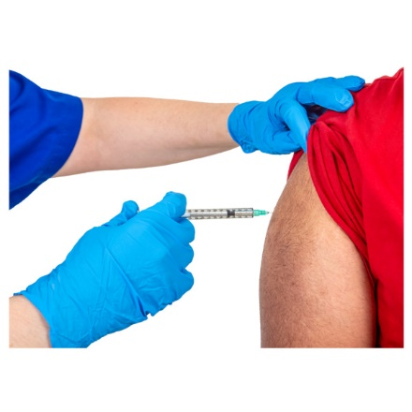 | The vaccine is an injection in your arm that will be given by the doctor or nurse.

What happens after your appointment
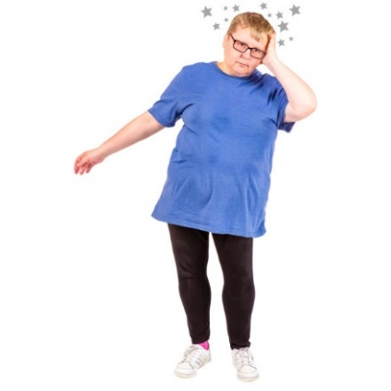 | Some people might feel a bit different after the vaccine. This is called a side effect.  The person who gives you the vaccine will talk to you about side effects and what to do.
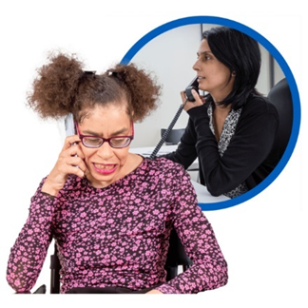 | If you feel very unwell after your vaccination or if you are worried you can contact your doctor.
 | If you need a second dose, the doctor or nurse will tell you to book another appointment.

More information
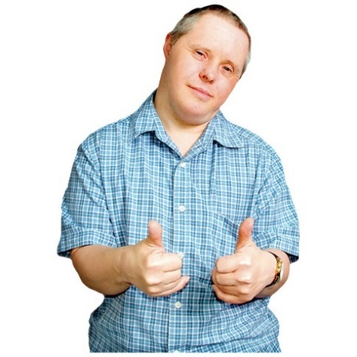 | The vaccine is the best way to protect you from measles, mumps and rubella.
 | Lots and lots of people have the vaccine every year.
You can find more information about the vaccine online.
Go to www.nhs.uk/mmr

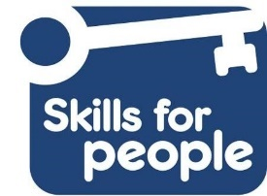
Easy read made by the Easy Info Team at Skills for People employing people with a learning disability.

