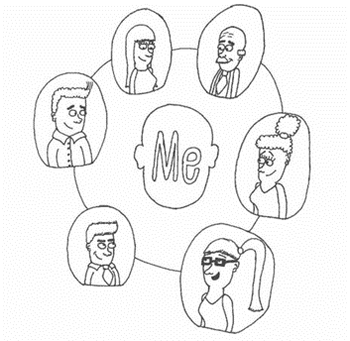
This is one of two leaflets for children, young people and adults. It is to help you make decisions about your support:
- Dynamic Support Register
- Care Education and Treatment Review

If you need help to think about this information, ask the person who gave you this leaflet or someone else you trust.

2
Care Education and Treatment Review

What is this information about?
You have been given this information to help you decide if you want to have a Care Education and Treatment Review.
Care Education and Treatment Review is usually shortened to CETR.
This information will tell you:
- What a Care Education and Treatment Review is.
- What should happen before, during and after.
- Questions to help you decide what to do.

What is a Care Education and Treatment Review?
A Care Education and Treatment Review is an important meeting about you and your health and care needs.
A Care Education and Treatment Review is for people who are autistic, who have a learning disability or both.
You will only be offered a Care Education and Treatment Review if you are at risk of going into a mental health hospital or are already in a mental health hospital.
The aim of the meeting is for your needs to be met, for you to have good quality support and to overcome any barriers stopping this happening. Actions from the meeting are monitored to make sure they happen.

It is a special meeting because it is likely to be the only time professionals will review all your health, social care, education, and treatment in one meeting with you and your family.

People at the meeting will include:
- You.
- Your family or carers (you can choose about this).
- Health, social care, and education workers who support you.
- A panel of 3 people (for more information about the panel see ‘who runs the Care Education and Treatment Review’).
- Other people you trust to help you speak up and understand.
You will have time and support before the meeting to plan what to say about how you feel and what you want. See the link to My CETR Planner at the end of this leaflet.

“The CETR was the first time someone spoke to my daughter and asked her what she needed to help her. Afterwards she realised there was a desire to improve outcomes and a willingness from people to support her as an individual.” Parent.

How can the Care Education and Treatment Review help you?
- You are heard.
People will listen to you and your family about your needs, the support you are getting and your hopes and wishes.

- Professionals will work with you and your family to develop a plan.
The plan will include what needs to be done, who will do it and when they will do it by.

- Your needs are met.
People will work to make sure your care, education, treatment, and support meets your needs. If your needs are not being met, the people in the meeting will identify and recommend changes with you. Recommendations from the meeting will be followed and you will be kept up to date with their progress.

- Barriers are challenged and un-blocked.
Things that are stopping you getting the right support you need are challenged and overcome.

- People will do the actions agreed in the plan.
People will meet regularly to check actions in the plan are being done (see Dynamic Support Register leaflet).

- People will work together better.
Working together will provide you with joined up care, education, and treatment.

Who runs the Care Education and Treatment Review?
The meeting is run by a panel. The panel is 3 people who are chosen because they have skills and knowledge to help everyone get the best from the meeting:
Person who chairs the meeting – this is usually the ‘responsible commissioner’. This person will know about you and your history and has the ability and authority to make decisions about funding your support.
Clinical Expert – a person who has medical training like a nurse or doctor, who has not worked with you before.
Expert by Experience – a person who has had similar experiences to you or your parent / carer who has not met you before. They can share their experiences and suggest ways to support you.
The panel will use a set of questions called ‘Key Lines of Enquiry’ to make sure the meeting covers all areas of your life including your physical health needs, medication, support, education and where you live.

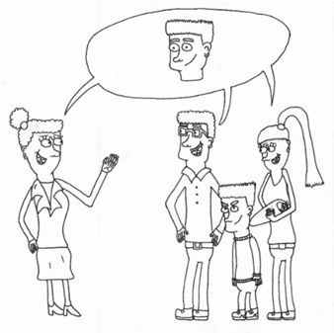

“The CETR is the only meeting I get to chair that is solely about an individual person’s needs. I get the privilege to hear directly from the young person and their families to understand what is and what isn’t working in their care, education, and treatment. Together, we make a plan, which I am then responsible to ensure turns into actions. Without the CETR, this is much harder to achieve.” Commissioner

Questions other people asked about a Care Education and Treatment Review
Do I have to go to the meeting?
You can choose if you go to the meeting or not.
If you choose not to go, it is a good idea to ask someone else you trust to go to the meeting for you. They can tell people what you want to say, ask questions for you, listen, and tell you what happened at the meeting.
You can choose to go to some of the meeting, all of it or none of it.
You can choose to just meet with one of the three people from the panel.

Where will the meeting take place?
The person organising the meeting should ask you where you want it to be.
Some people prefer to join the meeting face to face. Other people prefer to join the meeting online such as Zoom or Microsoft Teams.

Will I have to speak to anyone?
You can choose to speak at the meeting or not.
You can choose to answer questions from the people in the meeting or not.
It is a good idea to ask someone else you trust to go to the meeting with you. You can plan together what you want to say. If you do not want to speak, they can tell people what you want to say and ask questions for you.
Some people choose to speak to someone from the meeting on their own instead of going to the meeting. That is okay.

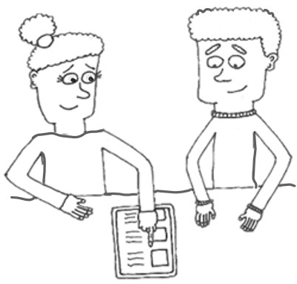
What can I do to prepare for the meeting?
There are some forms and questions to help you prepare what you want to say or ask at the meeting and to tell people what they need to do so you are best included in the meeting.
To get to these forms and questions ask the person who gave you this leaflet or follow the links at the end of this leaflet.

How many people will be at the meeting?
This is different for each person. You can ask the person organising your meeting to tell you who will be there.
All the professionals involved in your care and support will be invited. This could include your social worker, someone from your school or education department, someone from your community mental health team. If you're in hospital, some of your hospital team will also be there.
They are not all in the meeting at the same time.

How long will the meeting be?
The meeting is usually about six hours in total, you don’t need to be at all of it. The panel spend the whole day reviewing your care, education, and treatment.

What happens at the Care Education and Treatment Review?
- The panel meet on their own to read reports about your care, education and treatment. They prepare what they want to ask you and the other people at the meeting. This happens before they meet with you.

- It is then your time to tell the panel what you want to say, what is important to you, answer their questions, and ask your questions. You can stay for as long as you want to.

- The panel then meet with each of the other people invited to the meeting.

- The last part of the meeting is when everyone comes back together to discuss what should be included in your plan about what needs to happen and who needs to do what. You can stay for as long as you want to.

Who makes sure that the actions will happen so it’s not a waste of time?
The person who chaired the meeting will write a plan of all the actions that are agreed at your Care Education and Treatment Review.
Each action will include the person who is responsible for that action and when they need to do it by.
The actions will be shared with the people who work on the Dynamic Support Register. They will keep checking on the actions to make sure they are completed. This is to make sure you have access to the right care, education, and treatment to keep you well.
(see Dynamic Support Register leaflet)

How do I access more information if I want it?
Ask the person who gave you this leaflet.
Ask someone you trust.

Follow links to access NHS England information related to:
Key lines of Enquiry:
www.england.nhs.uk/publication/care-and-treatment-review-key-lines-of-enquiry

Dynamic Support and Care Education and Treatment Review Policy:
www.england.nhs.uk/publication/dynamic-support-register-and-care-education-and-treatment-review-policy-and-guide

My Care Education and Treatment Planner:
www.england.nhs.uk/learning-disabilities/care/ctr/my-ctr

“These meetings are your chance to say what you want and how you feel. It is good to prepare well for your meetings so you can say what you are struggling with and what you need. Talk to staff. Tell them what helps.” Young person.

