

**NHS Talking Therapies for Anxiety and Depression**

**National workforce census**

1 April 2023-31 March 2024

Developed in partnership with the NHS Benchmarking Network



## Contents

Introduction to NHS Talking Therapies for anxiety and depression p 3

Executive Summary p 6

Introduction p 12

Timeseries… p 15

Service Provision and Activity p 21

Workforce Profile p 27

Salary Profile… p 37

High Intensity Workforce… p 41

Low Intensity Workforce… p 44

Workforce Demographics… p 45

Workforce Summary Metrics… p 49

Workforce Discrimination p 58

Appendices… p 59

Acknowledgements… p 71

## Introduction to NHS Talking Therapies for anxiety and depression

The NHS Talking Therapies for anxiety and depression programme (previously known as Improving Access to Psychological Therapies - IAPT) began in 2008 and has transformed the treatment of adult anxiety disorders and depression in England. NHS Talking Therapies is widely recognised as the most ambitious programme of psychological therapies in the world and in 2022-23 more than 670,000 courses of treatment for depression or anxiety disorders were completed within the service. Two thirds of patients receiving a course of treatment improved significantly, and half recovered during treatment.

NHS Talking Therapies services provide evidence-based treatments for people with depression and anxiety disorders, and comorbid long-term physical health conditions (LTCs) or Persistent Physical Symptoms (PPSx), also known as Medically Unexplained Symptoms, (MUS). NHS Talking Therapies services are characterised by three key principles:

1. Evidence-based psychological therapies at the appropriate dose: where NICE recommended therapies are matched to the mental health problem, and the intensity and duration of delivery is designed to optimise outcomes.
2. Appropriately trained and supervised workforce: where high-quality care is provided by clinicians who are trained to an agreed level of competence and accredited in the specific therapies they deliver, and who receive weekly

outcomes focused supervision by senior clinical practitioners with the relevant competences who can support them to continually improve.

1. Routine outcome monitoring on a session-by-session basis, so that the person having therapy and the clinician offering it have up-to-date information on the person’s progress. This helps guide the course of each person’s treatment and provides a resource for service improvement, transparency, and public accountability.

Services are delivered using a stepped-care model, which works according to the principle that people should be offered the least intrusive intervention appropriate for their needs first. People with some presentations of mild to moderate depression or anxiety disorders are likely to benefit from a course of low intensity treatment delivered by a psychological wellbeing practitioner (PWP). Individuals who do not fully recover at this level should be stepped up to a course of high intensity treatment. Further details about NHS Talking Therapies services can be found in the [NHS Talking Therapies Manual](https://www.england.nhs.uk/publication/the-improving-access-to-psychological-therapies-manual/).1

[*1. NHS Talking Therapies Manual*](https://www.england.nhs.uk/publication/the-improving-access-to-psychological-therapies-manual/)*, updated 2024.*

### Introduction to NHS Talking Therapies - workforce role

The NHS Talking Therapies workforce consists of low intensity practitioners and high intensity therapists who together deliver the full range of NICE- recommended interventions for people with mild, moderate and severe depression and anxiety disorders, operating within a stepped-care model.

Guidance suggests working towards a model where 40% of the workforce in a core NHS Talking Therapies service should be psychological wellbeing practitioners (PWPs) and 60% high intensity therapists (HITs).

For NHS Talking Therapies- long term conditions services (LTCs) it is recommended that there is a slightly stronger focus on high intensity interventions with the workforce being 30% PWPs, 60% high intensity therapists and 10% senior therapists (such as clinical health psychologists) who have expertise in Long Term Conditions / Persistent Physical Symptoms and can manage more complex problems as well as providing supervision to others.

All current NHS Talking Therapies curricula [and training materials can be found on the NHS Talking Therapies section of the NHS England website.](https://www.england.nhs.uk/mental-health/adults/nhs-talking-therapies/)  
  
*Low intensity workforce*PWPs deliver low intensity interventions for people with some presentations of mild to moderate depression. All PWPs should have completed an NHS Talking Therapies training course or be in the process of doing so, with linked professional registration with the relevant professional body following training.

The core NHS Talking Therapies low intensity courses for PWPs are accredited by the British Psychological Society. PWPs are required to be registered with either the British Psychological Society or the British Association for Behavioral and Cognitive Psychotherapies (BABCP). PWPs who work with LTC service users are also expected to have completed the relevant NHS Talking Therapies continuing professional development (CPD) course for working with LTCs.

*High intensity workforce*High intensity therapists deliver a range of NICE-recommended evidence-based therapies. Therapists need to have been trained in the particular therapy or therapies that they deliver in NHS Talking Therapies, with linked professional accreditation with the relevant professional body. NICE recommends cognitive behavioural therapy (CBT) for anxiety disorders and six different high intensity therapies for depression (cognitive behavioural therapy (CBT), interpersonal therapy (IPT), brief dynamic interpersonal therapy (DIT), person-centred experiential counselling for depression (PCE-CfD), couple therapy for depression (CTfD), and mindfulness-based cognitive therapy (MBCT). CBT is recommended for chronic depression.

NICE recommends both trauma-focused cognitive behavioural therapy (TfCBT) and eye movement desensitization and reprocessing (EDMR).

## Executive Summary Background and Purpose

Workforce growth and retention are cornerstones of effective health and care delivery. Ensuring a workforce of the right size, in the right place, with the right skills is essential to meeting current population needs and underpinning the ambitious transformation plans set out in key healthcare policy documents. However, the provision of high-quality health and care services is currently impacted by significant workforce challenges including staff shortages, staff retention, training and skills gaps, coupled with systemic issues related to equality of opportunity and diversity. These issues are evident throughout health and care service delivery and are a particular issue within mental health care.

There has been a sustained focus on improving the provision of mental health care for all ages. A key lever to delivering transformation objectives relates to how services are delivered, with a greater emphasis on collaborative delivery across statutory and non-statutory services, and across health and care services. While this is an opportunity to create provision and delivery of services in innovative ways to meet increasing and changing needs, it creates a challenge for understanding the wider workforce outside of NHS statutory services. In 2022, roughly 1 in 6 adults aged 16 years and over reported moderate to severe depressive symptoms. 1 Common mental health disorders such as anxiety and depression, if left untreated can have a detrimental effect on one's health and wellbeing as well as society.

The NHS Talking Therapies for anxiety and depression programme, formerly “Improving Access to Psychological Therapies” (IAPT), was launched in 2008 to improve the quality and accessibility of mental health services in England. The programme specialises in therapies such as cognitive behavioural therapy, counselling for depression, and guided self-help support (collectively referred to as 'talking therapies’) to assist working-age individuals dealing with common mental health disorders.

The programme has steadily grown so that more than 670,000 people completed a course of treatment in 2023/24 6. The continued success will only be possible if systems and services continue to track progress and plan for expanding the workforce to support the targets laid out in the NHS Long Term Plan 7 and the subsequent 2023 Autumn Statement.

To continue the progress of workforce developments and following on from the successful 2023 report, the NHS England commissioned the NHS Benchmarking Network (NHSBN) to undertake a sixth annual census and analysis of the talking therapies workforce across England for 2024. This sixth iteration of the census will provide detailed tracking of the workforce across occupations, building on the success of the 2023 census it details workforce size and composition, service model, demographics and metrics for NHS Talking Therapies for anxiety and depression services. This census scope includes NHS Talking Therapies staff working in NHS and NHS-commissioned independent, local authority, and VCSE sectors.

### Participation

In the 2024 NHS Talking Therapies for Anxiety and Depression Workforce Census:

* 106 NHS Trusts and 72 Non-NHS organisations were contacted about the census.
* 94% of organisations participated in the census.
* For the organisations that did not participate, their 2023 workforce positions have been included within the latest findings to allow for year-on-year comparisons, with the presumption of zero growth.

## Workforce Summary

##### Workforce Growth

* There were 16,297 WTE staff reported as working within NHS Talking Therapies for anxiety and depression services in the scope of the census. This was a 10% increase from 14,881 WTE reported in the 2023 census and an increase of 58% since the first talking therapies workforce census in 2019.
* The total high intensity (HI) workforce including trainees comprised 6,913 WTE staff (a growth of 6% from 2023).
* The total PWP workforce including trainees comprised 4,695 staff (a growth of 4% from 2023)
* Patient facing roles including clinical roles and employment support, taken together, showed a growth of 8% and non-patient facing roles including supervision, management/leadership, administration/clerical and other job roles increased by 15%
* The high intensity non-trainee workforce grew by 7% from 2023 to 2024 (and 44% since 2019) and the qualified psychological wellbeing practitioner (PWP) workforce grew by 11% from 2023 - 2024 (and 60% since 2019).

### Workforce profile

* The proportion of PWPs (38%) and HITs (62%) maps closely to the overall expected staffing model of 60% HITs for core services and 65% HITs for long term condition (LTC) pathways.
* There had been a small increase WTE of staff without the required NHS Talking Therapies qualification in PWP roles (32, up from 30 in 2023). In HITs roles, in those without recognised NHS Talking Therapies qualification, the year-on-year reduction continues (163, down from 179 in 2023).
* High intensity (HI) other modality therapists / counsellors with an NHS Talking Therapies recognised qualification in PCE-CfD/IPT/DIT/CTfD/BCT/MBCT/EMDR comprised 27% of the overall HIT workforce in 2024 compared to 26% in 2023. The position remains consistent with the overall staffing model that advises that 10-30% of the HIT WTE workforce in any area will be delivering these modalities, with 70-90% delivering CBT. However, further growth in the other modality therapist and counsellor WTE should be matched by corresponding rates of growth in the CBT therapist WTE to retain balance.
* There was a decrease in trainee numbers reported from 2023 to 2024 in low intensity (-10%) and a small increase in trainee numbers in high intensity roles (1%). Low intensity trainee roles (trainee PWPs) made up 51% of the trainee workforce, with 49% comprising high intensity trainees (including 1,136 trainee HI CBT therapists and 256 trainee HI other modality therapist/counsellors).
* A total of 384 WTE PWPs progressed to HI CBT training during the year of the 2024 census period, an 8% increase from the 356 who progressed in 2023.
* This year there was a reduction in senior and lead PWP roles, with senior roles reducing by 3% (from 453 to 439) and lead roles reducing by 9% (from 94 to 85).

18% of PWPs were paid above band 5.

* Senior clinical roles for HITs were hard to identify, with 6% of CBT therapists and 5% of other modality therapists / counsellors paid above Band 7, although some additional sessions at higher band were evident in the salaries listed for supervisors.
* In 2024 92% of supervisory WTE had undertaken the NHS Talking Therapies supervision module, a 2% reduction on the position reported in 2023.

### Service provision and activity

* + The majority (97%) of services offered video consultation. The proportion of services that offered service users access via some other digital technologies

continued to decrease, such as apps (62%,2021 / 41%,2023 / 29%,2024) and web chat (32%,2022 / 20%,2023 / 17%,2024).

* + NHS Talking Therapies LTC service offer reduced marginally in 2024, with 82% of services confirming this as part of their service model compared to 85% in 2023, 80% in 2022 and 72% in 2021. The most widely offered pathways were for service users with long COVID, diabetes, Chronic Obstructive Pulmonary Disease, Cardiovascular conditions and Chronic Pain.
  + All recommended NHS Talking Therapies modalities were available. 70% of HIT time was attributed to CBT, 14% PCE-CfD, 6% EMDR, 3% IPT, 2% CTfD, 2% DIT, 1% MBCT and less than 1% BCT. 2% of delivery was by therapists not recognised by the NHS Talking Therapies manual. CBT is at the lower margin of the recommend range of HIT capacity per service, and PCE-CfD and EMDR are above the expected level. The proportion of EMDR provision remained static when compared to 2023.

### Salary profile

* + The high intensity workforce salary profile showed that for fully qualified and trained HITs there is a disparity between CBT therapists and other modality therapists / counsellors. The most common pay band for both groups was band 7, but whereas 46% of other modality therapists / counsellors were paid below band 7, only 2% of CBT therapists were paid below band 7. The NHS England position is that all HITs with full NHS Talking Therapies qualifications and training, regardless of modality, should be paid at least band 7.

### Demographics

* + The ethnicity profile of the NHS Talking Therapies workforce continued to map closely onto the England working age population, as in previous years.
  + The NHS Talking Therapies workforce was 80% female. 54% of the workforce were aged 39 and under, with 24% aged 29 and under.
  + It was reported that 11% of staff had a disability, an increase from 9% in the previous year.

### Vacancies and Retention

* + The vacancy rate reported was 6.2%, a notable decrease from the 12% reported in 2023. The highest vacancy rate was reported in low intensity roles (7.6%) compared to 5.5% in high intensity roles.
  + The staff sickness absence rate across all roles was 4.2%. This compared to 4.7% for all NHS staff in March 2024 5.
  + There was a total of 2,798 WTE joiners during the census period. Low intensity roles showed a joiner rate of 29.3% compared to 13.4% for high intensity roles.
  + High intensity roles showed a leaver rate of 10%, compared to 21% for low intensity roles.
  + Of those leaving their roles in the past 12 months, 50% of the overall leavers went to unknown destinations. Of those leaving clinical roles to a known other

work destination, 24% remained in NHS Talking Therapies.

* + From high intensity roles, 49% had an unknown destination on leaving, 21% of leavers remained in NHS Talking Therapies services, 21% left NHS Talking Therapies, and 9% retired from the service.
  + From low intensity roles, 49% had an unknown destination on leaving, 31% of leavers remained in NHS Talking Therapies, 19% left the service, and 1% retired from Talking Therapy services.

### Introduction

### Objectives

Provide a comprehensive census of the workforce, service model, demographics and metrics for NHS Talking Therapies for anxiety and depression services. The objectives of the NHS Talking Therapies for anxiety and depression workforce census included:

* Provide a current overview of the national NHS Talking Therapies workforce, enabling comparisons with previous annual submissions to give an accurate picture of overall workforce expansion and its alignment with the NHS Long-Term Workforce Plan.
* Provide a series of outputs to support work nationally, regionally and locally to retain, diversify and grow the workforce.

The NHS Talking Therapies for anxiety and depression workforce census forms part of a larger programme of work within the NHS Benchmarking Network which

focuses on workforce profiling and analysis. <https://www.wfbenchmarking.nhs.uk/nhs-talking-therapies-for-anxiety-and-depression>.

### Scope

The project scope will include NHS Talking Therapies for anxiety and depression services including NHS and NHS-commissioned independent, local authority, and VCSE (voluntary, community, and social enterprise) sectors in England.

### Data collection template

The workforce census was designed jointly by NHSBN and NHSE. Data collection included:

* Details of organisation and the NHS Talking Therapies services they provide.
* Workforce data by salary/banding.
* Workforce demographic data on gender, age, disability, and ethnic group.
* HR metric data including vacancies, sickness absence, staff retention, joiners, and leavers.

### Process

The 2024 NHS Talking Therapies Workforce census launched in March 2024 and was open for 8 weeks. Extensions were agreed to maximize participation. A walkthrough event of the data collection templates took place a week after launch to promote participation and provide guidance on how to fill out the template, the project scope, understanding the built in validation tools, and the project deadlines. The data collection template and walkthrough video were uploaded to the project webpage. Weekly drop-in sessions took place across the data collection period to provide further opportunity for participants to raise queries. Data was reviewed for completeness, consistency, and validity. The validation process took place across the data collection and analysis period.

### Definitions and Terminology

Details of the definitions included in the collection template are included for reference along with the details of the calculations used for the workforce metrics in Appendix D.

### Participation

Data submissions were received from 167 services across England. NHS providers comprised 63% of submissions (106 returns) with the remaining 37% (61 returns) received from non-NHS services. 11 services did not participate in this year's census. Participation by sectors which are within the scope of the project are detailed in table 1.

Of the 11 services that did not participate, 7 participated previously in 2023. Their 2023 workforce positions have been included within the latest findings to allow for year-on-year comparisons, with the presumption of zero growth.

|  |  |  |  |  |
| --- | --- | --- | --- | --- |
| **Organisation type** | **Invited to participate** | **Participated** | **Not participated** | **Participation rate** |
| **NHS Trusts** | 106 | 106 | 0 | 100% |
| **Independent Sector** | 22 | 18 | 4 | 82% |
| **Voluntary Sector** | 33 | 28 | 5 | 85% |
| **Social Enterprise / CIC** | 17 | 15 | 2 | 88% |
| **Total** | **178** | **167** | **11** | **94%** |

###### Table 1

## Timeseries

### National NHS Talking Therapies workforce overview – timeseries

Overall growth from 2023 to 2024 was 10%, and the total workforce reported in post on the census date of 31 March 2024 was 16,297 whole time equivalents (WTE).

High intensity roles comprised 6,913 (WTE) representing a 6% increase from 2023, low intensity roles comprised 4,695 (WTE) representing a 4% increase.

The top line of the timeseries chart includes the total workforce including clinical and non-clinical roles. High intensity and low intensity shown in the lower lines are

specific subsets of the total, the composition of which is detailed in table 3.

Patient facing roles grew by 8% and non-patient facing roles increased by 15%. The timeseries chart should be read in conjunction with tables 2 and 3.

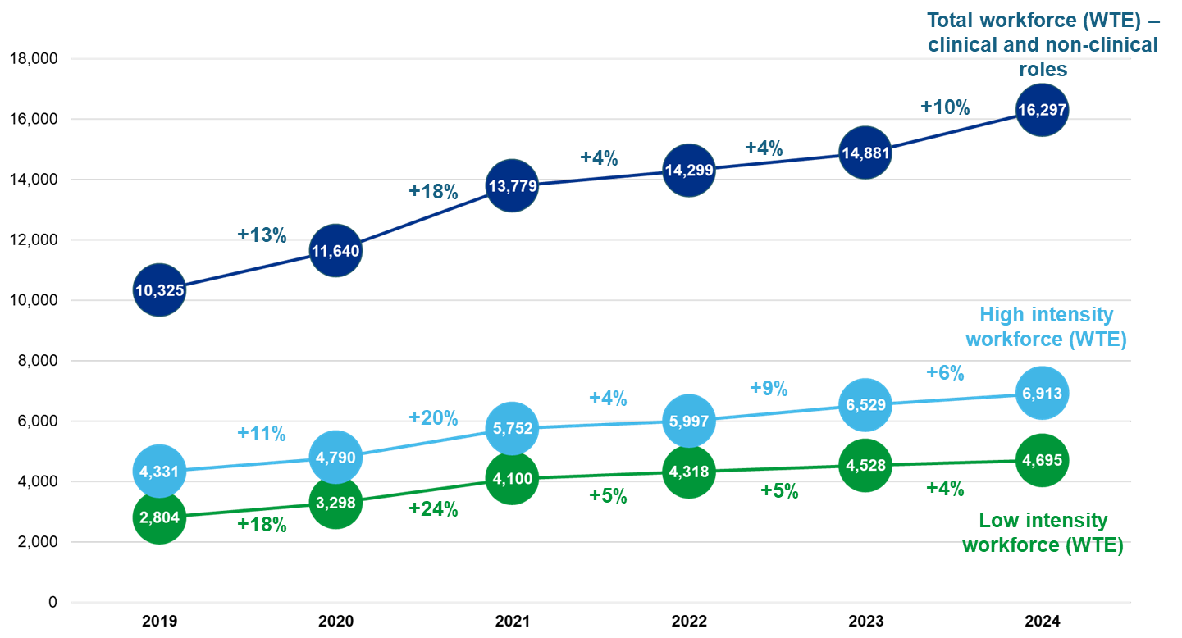

### National NHS Talking Therapies workforce overview 2019-2023

The workforce growth from 2019 to 2024 was 58%, including a 10% increase from 2023 to 2024. Employment support showed a notable change with an increase of 169% reported from 2023 to 2024. This was based on 635 WTE in 2024 compared to 236 WTE in 2023 and contrasted with the 33% decrease reported in 2023.

There was an increase of 61% in patient facing staff between 2019 and 2024, including an 8% increase between 2023 and 2024. Non-patient facing roles within services increased by 58% between 2019 and 2023 and 15% in the past year. This followed a 6% decrease reported in 2023.

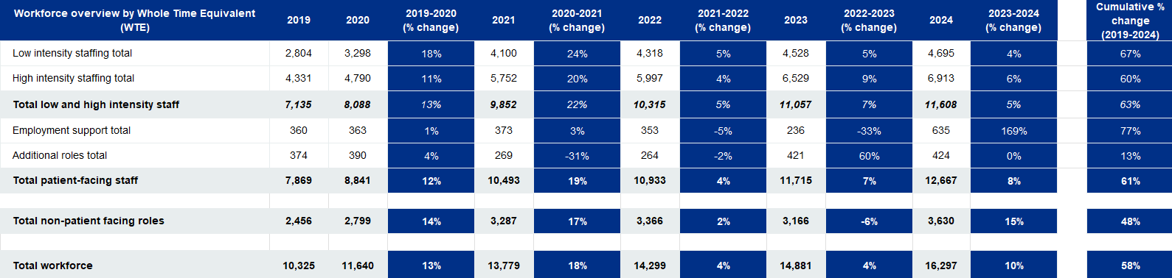Further breakdown of these role groupings are provided in tables 2, 3 and 4.

###### Table 2

### National NHS Talking Therapies workforce overview 2019-2023 – breakdown by role

Qualified psychological wellbeing practitioners (PWPs) increased by 11% year on year from 2023 to 2024 and qualified (non-trainee) high intensity roles increased by 7%. For high intensity trainee roles, trainee HI CBT therapists reported a 1% decrease from the 2023 position while trainee HI other modality therapists / counsellors reported a 12% increase. Low intensity trainee roles reported a 10% decrease from 2023-2024.

The greatest proportional increase was seen in psychological wellbeing practitioners (15%). There was a decrease of 9% in other high intensity therapists e.g. without NHS Talking Therapies recognised modality training, which indicated that as of 31 March 2024, 3.0% of non-trainee HITs had not completed an NHS Talking Therapies recognised training course, compared to 7.5% in 2020.

Roles included in red text in tables 3 and 4 are no longer collected in the workforce census.

## 

|  |  |  |  |  |  |  |  |  |  |  |  |  |  |  |
| --- | --- | --- | --- | --- | --- | --- | --- | --- | --- | --- | --- | --- | --- | --- |
| **Workforce Overview - Breakdown by Role (WTE)** | **2019** | **2020** |  | **2019-2020 (%**  **Change)** | **2021** | **2020-2021 (%**  **Change)** | **2022** | **2021-2022 (%**  **Change)** | **2023** | **2022-2023 (%**  **Change)** | **2024** | **2023-2024 (%**  **Change)** |  | **Cumulative %**  **Change (2019-2024)** |
| **Qualified and trainee low intensity** |  |  | |  |  |  |  |  |  |  |  |  |  |  |
| Psychological wellbeing practitioner | 1,713 | 1,747 | | 2% | 2,149 | 23% | 2,225 | 4% | 2,367 | 6% | 2,716 | 15% |  | **59%** |
| Senior psychological wellbeing practitioner | 314 | 350 | | 11% | 431 | 23% | 428 | 17% | 453 | 6% | 439 | -3% |  | **67%** |
| Lead psychological wellbeing practitioner |  |  | |  |  |  | 74 | 94 | 27% | 85 | -9% |  |  |
| **Qualified PWPs subtotal** | ***2,028*** | ***2,097*** | | ***3%*** | ***2,580*** | ***23%*** | ***2,728*** | ***6%*** | ***2,915*** | ***7%*** | ***3,240*** | ***11%*** |  | **60%** |
| Trainee Psychological Wellbeing Practitioner | 777 | 1,201 | | 55% | 1,520 | 27% | 1,590 | 5% | 1,613 | 1% | 1,455 | -10% |  | **87%** |
| **Qualified and Trainee low intensity total** | **2,804** | **3,298** | | **18%** | **4,100** | **24%** | **4,318** | **5%** | **4,528** | **5%** | **4,695** | **4%** |  | **67%** |
| **High intensity** |  |  | |  |  |  |  |  |  |  |  |  |  |  |
| HI CBT Therapist | 2,804 | 2,762 | | 9% | 3,331 | 21% | 3,387 | 2% | 3,645 | 8% | 3,853 | 6% |  | **37%** |
| Other High Intensity Therapist e.g. without NHS Talking Therapies  recognised modality training* |  | 304 | | 243 | -20% | 292 | 20% | 179 | -39% | 163 | -9% |  | **-47%** |
| HI other modality Therapist / Counsellor e.g.  (CfD/IPT/DIT/CTfD/BCT/MBCT/EMDR)* | 801 | 855 | | 7% | 1,006 | 18% | 929 | -8% | 1,331 | 43% | 1,505 | 13% |  | **88%** |
| *Applied psychologist - Clinical* | 216 | 155 | | -28% | 112 | -28% |  | | | | | |  | **-** |
| **Non-trainee High Intensity Therapists subtotal** | ***3,822*** | ***4,077*** | | ***7%*** | ***4,692*** | ***15%*** | ***4,609*** | ***-2%*** | ***5,155*** | ***12%*** | ***5,521*** | ***7%*** |  | **44%** |
| Trainee HI CBT Therapist | 509 | 714 | | 40% | 1,060 | 48% | 1,389 | 31% | 1,146 | -1% | 1,136 | -1% |  | **173%** |
| Trainee HI Other modality Therapist / Counsellor (undertaking NHS  Talking Therapies recognised modality training) | 12% |  |
| **High intensity total** | **4,331** | **4,790** | | **11%** | **5,752** | **20%** | **5,997** | **4%** | **6,529** | **9%** | **6,913** | **6%** |  | **60%** |
|  |  |  | |  |  |  |  |  |  |  |  |  |  |  |
| **Total low and high intensity staff** | **7,135** | **8,088** | | **13%** | **9,852** | **22%** | **10,315** | **5%** | **11,057** | **7%** | **11,608** | **5%** |  | **63%** |

###### Table 3

There was an increase of 169% in employment support roles from 2023 to 2024. Employment support advisors increased by 165% and senior employment support advisors increased by 187% during this period.

From 2023-2024, there was little change in the total additional roles WTE, and the 37% decrease between 2023 and 2024 for other low intensity / assistant worker not in a PWP role can largely be accounted for by the separation of assistant psychologists from this role group for the 2024 census.

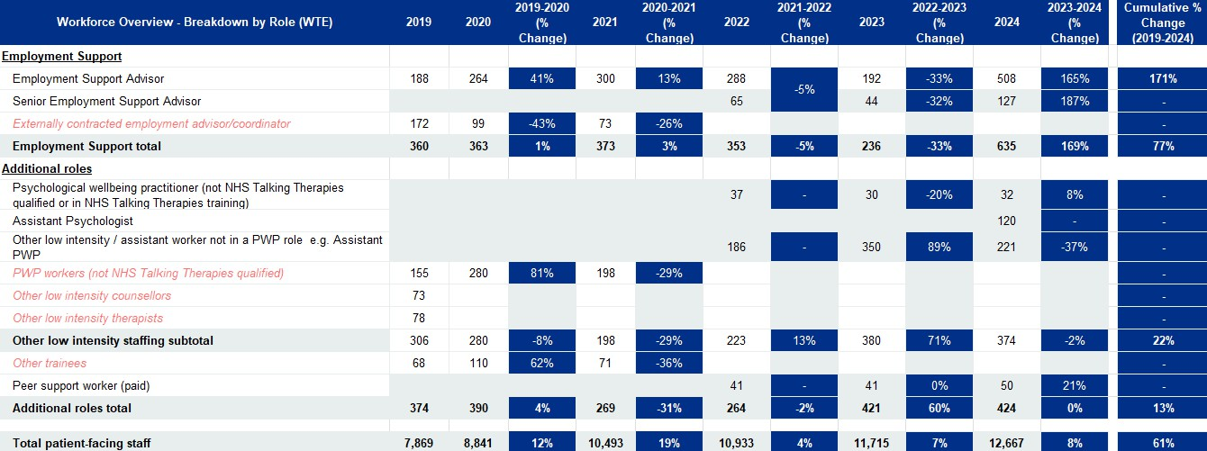There was an 8% growth in the workforce for patient facing staff, including those listed in the previous paragraph and high and low intensity clinical roles in table 3.

**Table 4**

Staff who had undertaken the NHS Talking Therapies supervision module comprised 92% of the supervisory WTE reported, a reduction from the 2023 position (94%). The WTE of trained supervisors decreased by 15%, whilst the WTE for supervisors who had not undertaken the NHS Talking Therapies supervision module increased by 14% between 2023 and 2024.

Other non-patient facing roles including management/leadership, admin and clerical staff including data analysts and other job roles all saw notable increases in 2024 compared to the 2023 position with the largest being reported for other job roles (44%).

As previously stated, the total workforce reported was 16,297 WTE representing a 10% increase from 2023 and a 58% cumulative increase from the first NHS Talking Therapies workforce census in 2019.

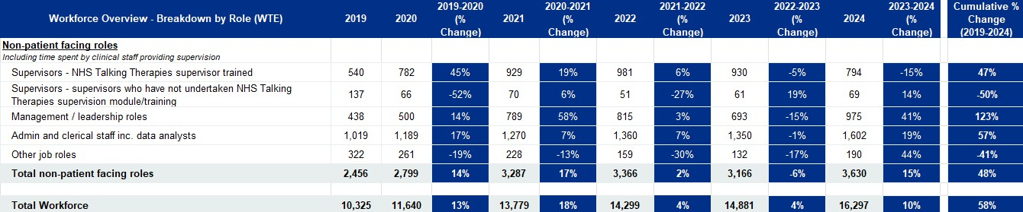

###### Table 5

## Service Provision and Activity Service Provision - Access

The workforce census of NHS Talking Therapies for anxiety and depression services also captured metrics regarding service provision and activity. As at 31 March 2024, services were asked to confirm if they had pathways in place for specific cohorts of service users. 26% reported pathways for both young people aged 18 to 25 years and older adults, this was based on 164 services that provided data on access.

Access for 18–25-year-olds and older adults had risen from the findings from the 2023 census (from 19% and 22% respectively).

These metrics relate to the provision of specific pathways; however it is worth noting that they do not indicate the absence of provision to these age groups within

services which do not have specific pathways in place.

**Service Provision - Access**

Yes, 26%

18-25 year olds

n= 164

No, 74%

Yes, 26%

Older Adults n= 164

No, 74%

### Lower Age Limit

Services were asked to report their lower age limit for services. 170/178 respondents reported a lower age limit of 16, 17, and 18 years, which was a slight reduction on previous iterations of the census, where all services reported lower age limits.

The most common lower age limit amongst services was 16 years old (55%) which had increased by 8% compared to last year’s census.

**Lower Age Limit**

16 years, 54%

n= 171

17 years, 14%

18 years, 32%

**Lower Age Limit**

16 years, 55%

n= 164 17 years, 14%

18 years, 31%

### Therapy Languages

The majority of services (69%) confirmed that some of their workforce provide therapy in languages other than English (including sign language), which was in line with previous censuses.

Services who did not have staff who provide therapy in languages other than English (including sign language) comprised 31% (48 respondents).

Many services reported having multilingual staff who provided therapy, whilst others reported that they also used interpreters to facilitate access. This metric will vary based on the staff in post on the census date, however as with the data from last year, the most commonly reported languages were Polish, Urdu and Punjabi.

Table 6 shows the top 10 offered languages by services that answered ‘Yes’ to providing therapy in another language.

|  |  |
| --- | --- |
| **Language** | **Services** |
| Polish | 45 |
| Urdu | 42 |
| Punjabi | 28 |
| Hindi | 25 |
| Spanish | 25 |
| French | 22 |
| Italian | 22 |
| Greek | 14 |
| Arabic | 13 |
| Portuguese | 13 |

###### Table 6

**Do any of your staff provide therapy in languages other than English (including sign language)?**

No, 31%

Yes, 69%

### Digital Offer

Services were asked to report their digital offer against a provided list of categories. The categorisations had remained the same as the 2023 census. Amongst the digital offers that were reported by the services, video consultations remained the most offered (97%).

Online referral systems, websites, and digitally enabled therapies were provided by similar proportions of services to those in 2023.

Apps was one of the least prevalent digital offer at 28%, and continued a reduction previously reported from 62% in 2021 to 41% in 2023.

Web chat was offered by 17% of respondents, down from 20% in 2023 and 32% in 2022.

|  |  |  |  |
| --- | --- | --- | --- |
| **Digital Offer** | **Yes** | **No** | **Number of Responses** |
| Video consultations | 97% | 3% | 164 |
| Online referral system | 89% | 11% | 164 |
| Websites | 87% | 13% | 161 |
| Digitally enabled therapies | 80% | 20% | 163 |
| Online appointment booking systems | 73% | 27% | 164 |
| Digital front-door | 49% | 51% | 162 |
| Apps | 29% | 71% | 160 |
| Digital support post-discharge | 41% | 59% | 162 |
| Web chat | 17% | 83% | 161 |

###### Table 7

### NHS Talking Therapies - LTC

NHS Talking Therapies services offer specific provision of services to people who are also living with long-term physical health conditions (LTCs) in the context of anxiety and depression disorders.

133/163 of this year’s respondents confirmed that their service had a LTC service (82%), a reduction on the 85% of services who reported offering LTC services in

2023.

**Provision of NHS Talking Therapies LTC Services**

18%

Yes No

82%

**Provision of NHS Talking Therapies LTC Services**

No, 18%

Yes, 82%

### NHS Talking Therapies – LTC Pathways

Included for the second time in the 2024 workforce census, organisations were also asked to report any specific LTC pathways in place within their service.

Long COVID (84%) and diabetes (83%) remained the most offered LTC pathways, both rising between 11% and 7% from last year’s census. Additionally, 40% of services advised they had specific pathways other than those identified, including support for those living with renal issues, irritable bowel syndrome, asthma, menopause and obesity.

|  |  |  |  |
| --- | --- | --- | --- |
| **NHS Talking Therapies - LTC Pathways** | **Yes** | **No** | **Number of Responses** |
| Long COVID | 84% | 16% | 135 |
| Diabetes | 83% | 17% | 132 |
| Chronic obstructive pulmonary disease (COPD) | 78% | 22% | 131 |
| Musculoskeletal (MSK) conditions | 60% | 40% | 131 |
| Cancer | 62% | 38% | 132 |
| Persistent Physical Symptoms, (PPSx)/ Medically unexplained symptoms (MUS) – including Myalgic Encephalomyelitis (ME)/ Chronic Fatigue Syndrome (CFS) | 58% | 42% | 132 |
| Cardiovascular conditions | 68% | 32% | 131 |
| Stroke | 46% | 54% | 131 |
| Gastrointestinal conditions | 41% | 59% | 129 |
| Neurological conditions | 43% | 57% | 130 |
| Chronic pain | 67% | 33% | 132 |
| Other | 40% | 60% | 110 |

***Table 8***

### Workforce Profile - Workforce Composition (WTE)

Throughout the census dates from 2019 to 2024 the workforce composition remained relatively stable.

The overall NHS Talking Therapies for Anxiety and Depression workforce (excluding trainees) had increased by 13% to 13,450 from 11,893 in 2023.

HI CBT therapists remained the largest group within the workforce composition, the total WTE in this job role increased from 3,645 in 2023 to 3,853 in this year’s census (29% of roles). Psychological wellbeing practitioners (PWPs), senior PWPs and lead PWPs accounted for 24% of the workforce, a marginal decrease from 25% in 2023. The proportion of staff in management and leadership roles, including admin and clerical staff and data analysts increased in 2024 to 19% from 17% in 2023. The other category increased from 6% of staff in 2023 to 7% of staff in 2024.

**Workforce Composition (WTE)**

4500

4000

3,853, 29%

3500

3,240, 24%

3000

2,577, 19%

2500

2000

1,505, 11%

1500

1000

863, 6%

875, 7%

500

374, 2.8%

163, 1%

0

HI CBT Therapist

HI Other modality Therapist/Counsellor (CfD/IPT/DIT/CTfD/ BCT/MBCT/EMDR)

Other High Intensity Therapist

e.g. without NHS Talking Therapies

recognised modality training

* Supervisors

Management/Leadership roles,

Admin and Clerical staff inc. Data Analysts

** Others

PWPs/ Senior PWPs/

Lead PWPs

Psychological Wellbeing Practitioner (not NHS Talking Therapies qualified or in NHS Talking Therapies training) / Assistant Psychologist / Other low intensity roles

* Supervisors includes all supervisors regardless of whether they have undertaken NHS Talking Therapies training

** Others include Employment Support Advisor, Senior Employment Support Advisor, Peer Support Worker (paid), other low intensity / assistant worker not in a PWP role e.g. assistant PWP, assistant psychologist, other

### Workforce Size by Service

The column chart shows the workforce size (WTE) reported excluding trainees, with one bar representing each service. Responses ranged from 0.72 to 452 with a median average of 64 WTE.

This chart is not benchmarked and is included to demonstrate the range of staffing numbers per service reported on the census date. NHS services are shown in the

blue bands and non-NHS services are shown in green.

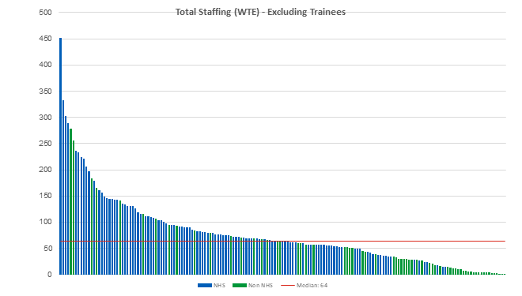

## Workforce Composition – Qualified HITs vs PWPs

The chart shows the split of the high and low intensity roles and includes only those who have completed NHS Talking Therapies training. Those in PWP or other high intensity therapist roles without NHS Talking Therapies training comprised less than 1.5% of the overall workforce and have been excluded from this chart.

|  |  |  |
| --- | --- | --- |
|  | 18% |  |
|  |  |
| 45% |
|  |  |
|  |  |
|  |  |
|  |  |
|  |  |
| 38% |
|  |  |
|  |  |
|  |  |

**Workforce composition HITs vs PWPs**

HI other modality Therapist / Counsellor

(CfD/IPT/DIT/CTfD/BCT/MBCT/EMDR)

HI CBT Therapist

PWPs / Senior PWPs / Lead PWPs

WTE

The numbers of high intensity therapists (HITs) and counsellors including HI CBT therapists and HI other modality therapists / counsellors comprised 63% of the qualified workforce, this was consistent with the position in 2023.

The low intensity workforce of psychological wellbeing practitioners (PWPs), including senior and lead PWPs comprised 38% a marginal increase from 37% in 2023. HI CBT therapists decreased from 46% to 45% whilst HI other modality therapists, offering high intensity therapies other than CBT had a small increase from 17% to 18%.

These proportions are broadly aligned to the expected staffing model of 60:40 HIT to PWP for Core provision, and 65:35 HIT to PWP for LTC provision. A total of 72% of HIT provision was for CBT which aligns with the expected need for between 70% and 90% of HIT provision to be for CBT to deliver a NICE compliant service and meaningful choice of therapies.

*\* Totals may not aggregate to 100% due to rounding.*

### Workforce Composition by Service – Qualified HITs

The chart shows the high intensity roles only, including high intensity therapists and counsellors including HI CBT therapists and HI other modality therapists /

counsellors as a proportion of the total workforce (WTE) excluding trainees.

The total WTE reported for these roles was 5,225 WTE, an increase of 6% from the 2023 census when 4,976 WTE were reported.

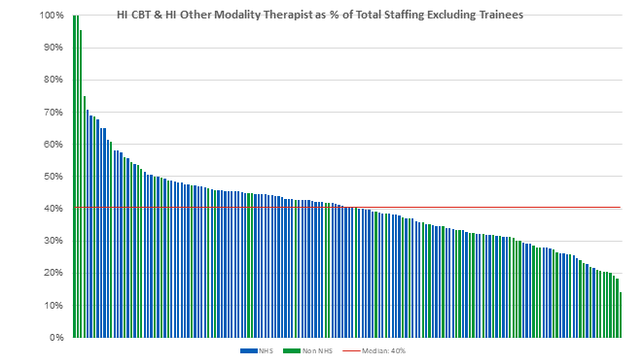

## Workforce Composition by Service – Qualified PWPs

On the 2024 census date, the total WTE reported for qualified PWPs was 3,185 WTE, an increase of 9% from the 2023 census (2,915 WTE).

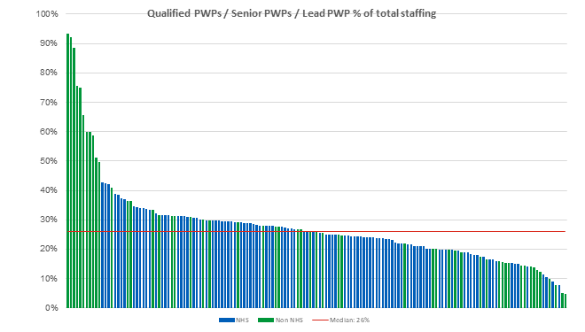

## Supervisory Roles

Supervisory roles reported 863 WTE, including 794 WTE (92%) who had undertaken the NHS Talking Therapies supervision module and 69 WTE who had not

undertaken the supervision module.

Of the cohort who were NHS Talking Therapies supervisor trained, 66% were reported as high intensity supervisors including CBT supervisors (52%) and HI other modality supervisors (14%). Low intensity supervision of PWPs was reported as 31% by WTE and 3% comprised other supervisors on the census date.

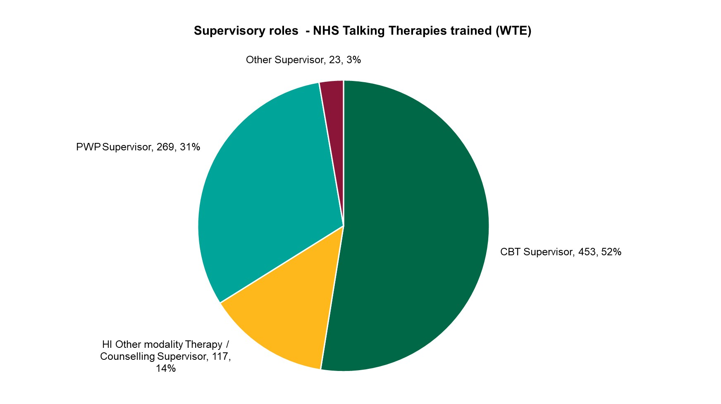

**Supervisory roles - NHS Talking Therapies trained (WTE)**

Other Supervisor, 23, 3%

PWP Supervisor, 269, 31%

CBT Supervisor, 453, 52%

HI Other modality Therapy /

Counselling Supervisor, 117,

14%

## Trainees

Total trainee staffing was 2,847 (WTE), with each bar in the chart representing the trainees in one service.

Responses ranged from 1.54 to 87 with a median average of 14 trainees (WTE) per service. 89% of services reported some trainee WTE within their total workforce

numbers.

High intensity trainee roles comprised:

* 1,136 (WTE) - trainee HI CBT therapist
* 256 (WTE) - trainee HI other modality therapist / counsellor (undertaking NHS Talking Therapies recognised modality training)

Low intensity trainee roles:

* 1,455 (WTE) - trainee psychological wellbeing practitioner

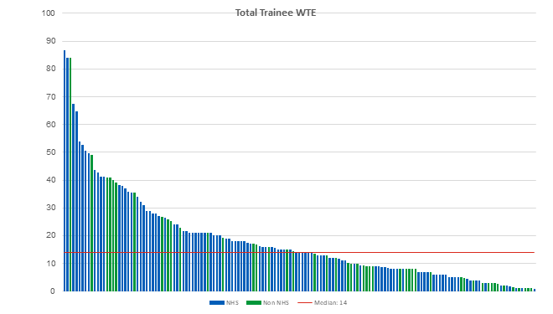

## Low to High Intensity Trainees by Service

Services who reported trainees are shown in the chart below with one bar per service split by low and high intensity trainee roles. The overall split of high intensity trainees (49%) and low intensity trainees (51%) was similar to the previous year’s census.

Low intensity trainees comprise trainee psychological wellbeing practitioners. High intensity trainees include trainee HI CBT therapist and trainee HI other modality therapist / counsellor (undertaking NHS Talking Therapies recognised modality training).

Trainee HI CBT therapists represented 82% of the high intensity trainee roles with the remaining 18% being trainee HI other modality therapist / counsellors.

**Total Trainee Staffing (WTE) - High vs Low Intensity**

100

90

80

70

60

50

40

30

20

10

0

 High intensity  Low intensity Median - 14

## Trainee Qualification by Service

Services who reported trainees that have qualified within the last year are shown in the chart with one bar per service split by low and high intensity trainee roles. This was the first time the services were asked to report this data.

The overall split of high intensity trainees and low intensity trainees qualifying in the previous year was 39% and 61% respectively.

**Number of trainees (WTE) that have qualified in the last year by service**

40

35

30

25

20

15

10

5

0

 High intensity  Low intensity Median - 9

## HITs Progressing from PWPs

Once PWPs have qualified for more than two years, they are eligible to apply for HI CBT training. Some choose to take this path, with others remaining in PWP role, and some progressing to Senior PWP roles (where available). Services were asked to identify any PWPs who progressed into HIT training during 1 April 2023 – 31 March 2024.

Responses ranged from 1-16 WTE, including 107 services who reported progression via this route with a total of 384 WTE PWPs progressed to HI CBT training

during the year of the 2024, an 8% increase from the 356 WTE who progressed in 2023.

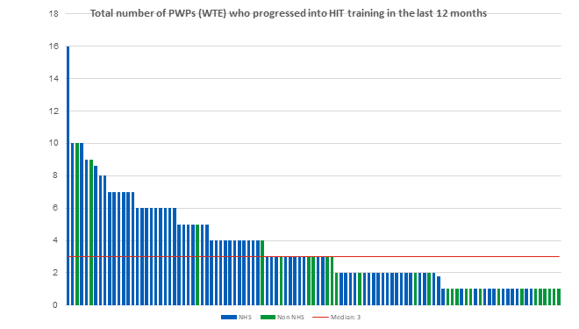

## Salary Profile

### Workforce - Salary

Salary bandings were included in the census for the second time, reported by WTE as at the census date of 31 March 2024. Where services do not use the NHS Agenda for Change salary bandings, equivalent salary ranges were provided as shown in the headings of table 9. Salary band was provided for 98% of the workforce WTE submitted (15,968 WTE). A marginal increase on the 97% submitted in 2023.

The majority of the overall workforce reported (72% of total staff (including trainees)) were within bands 5 to 7. When trainees were excluded 77% of staff were within bands 5 to 7. 6% of the total workforce including trainees reported were in band 8a and above.

For trainees, 95% of staff were in bands 4 to 6, most high intensity trainees were paid in band 6 and most low intensity trainees were paid in band 4.

|  |  |  |  |  |  |  |  |  |  |  |  |  |  |
| --- | --- | --- | --- | --- | --- | --- | --- | --- | --- | --- | --- | --- | --- |
| **NHS Talking Therapies Salary Profile** | **Unpaid / Volunteers** | **Bands 1-3** | **Band 4** | **Band 5** | **Band 6** | **Band 7** | **Band 8a** | **Band 8b** | **Band 8c** | **Band 8d** | **Band 9** | **Consultants** | **Total WTE** |
| Trainees | 1% | 3% | 45% | 7% | 43% | 2% | 0% | 0% | 0% | 0% | 0% | 0% | 2,798 |
| Total staffing - excluding trainees | 1% | 8% | 7% | 26% | 13% | 38% | 6% | 1% | 1% | 0% | 0% | 0% | 13,170 |
| **Total staffing - including trainees** | **1%** | **7%** | **14%** | **22%** | **18%** | **32%** | **5%** | **1%** | **0%** | **0%** | **0%** | **0%** | **15,968** |

###### Table 9

* Excludes WTE from the 7 submissions that have been included from the 2023 census

### High Intensity Workforce - Salary

Overall, for HI staffing 88% of staff were in bands 6 and 7. HI CBT therapists were predominantly band 7 (92%). Across all high intensity staffing - excluding trainees

- 8% were paid at band 8a or above.

HI other modality therapists / counsellors had a broader distribution, with 85% in bands 6 to 7 including 35% in band 6 and 50% in band 7, in comparison 41% of the therapists were in band 7 in 2023. NHSE expectation was that all qualified HITs should be paid at least band 7, regardless of modality.

Other high intensity therapists e.g. without NHS Talking Therapies recognised modality training were reported in lower salary bandings with 90% in band 6 and below including 66% in band 6 and 17% in band 5.

Trainee HI roles comprising Trainee HI CBT therapist and Trainee HI other modality therapist / counsellors reported 87% in band 6 and 5% band 7. NHSE expectation was that trainee HI roles were band 6, however 111 WTE (9%) were reported in band 5 and below.

|  |  |  |  |  |  |  |  |  |  |  |  |  |  |
| --- | --- | --- | --- | --- | --- | --- | --- | --- | --- | --- | --- | --- | --- |
| **NHS Talking Therapies Salary Profile**  **- High Intensity** | **Unpaid / Volunteers** | **Bands 1-3** | **Band 4** | **Band 5** | **Band 6** | **Band 7** | **Band 8a** | **Band 8b** | **Band 8c** | **Band 8d** | **Band 9** | **Consultants** | **Total WTE** |
| HI CBT Therapist | 0% | 0% | 0% | 0% | 2% | 92% | 5% | 1% | 0% | 0% | 0% | 0% | 3,762 |
| HI Other modality Therapist / Counsellor (CfD/IPT/DIT/CTfD/BCT/MBCT/EMDR) | 0% | 0% | 1% | 10% | 35% | 50% | 4% | 1% | 0% | 0% | 0% | 0% | 1,463 |
| Other High Intensity Therapist e.g. without NHS Talking Therapies recognised modality training | 0% | 3% | 4% | 17% | 66% | 6% | 1% | 0% | 0% | 0% | 0% | 2% | 163 |
| High intensity supervisors | 0% | 0% | 0% | 1% | 18% | 46% | 30% | 4% | 1% | 0% | 0% | 0% | 758 |
| **High intensity staffing**  **- excluding trainees** | **0%** | **0%** | **0%** | **3%** | **14%** | **74%** | **7%** | **1%** | **0%** | **0%** | **0%** | **0%** | **6,145** |
| Trainee HI roles | 1% | 0% | 0% | 8% | 87% | 5% | 0% | 0% | 0% | 0% | 0% | 0% | 1,372 |
| **High intensity staffing**  **- including trainees** | **0%** | **0%** | **0%** | **4%** | **27%** | **61%** | **6%** | **1%** | **0%** | **0%** | **0%** | **0%** | **7,517** |

###### Table 10

* Excludes WTE from the 7 submissions that have been included from the 2023 census

### Low Intensity Workforce – Salary

The majority of PWPs who had undertaken the NHS Talking Therapies training were reported in band 5 (80%). Smaller proportions of this cohort were reported in band 6 (16%) with 2% lower on band 4 and 2% higher on band 7.

Of the 32 (WTE) PWPs with salary data recorded who were not NHS Talking Therapies qualified or in NHS Talking Therapies training, all were in band 5 or below

including 94% in band 4.

Most low intensity trainee PWPs (87%) were reported in Band 4 in line with NHSE expectation, however 7% were reported below this and 6% were reported in band 5 and above.

|  |  |  |  |  |  |  |  |  |  |  |  |  |  |
| --- | --- | --- | --- | --- | --- | --- | --- | --- | --- | --- | --- | --- | --- |
| **NHS Talking Therapies Salary Profile**  **- Low Intensity** | **Unpaid / Volunteers** | **Bands 1-3** | **Band 4** | **Band 5** | **Band 6** | **Band 7** | **Band 8a** | **Band 8b** | **Band 8c** | **Band 8d** | **Band 9** | **Consultants** | **Total WTE** |
| PWPs/ Senior PWPs/ Lead PWPs | 0% | 0% | 2% | 80% | 16% | 2% | 0% | 0% | 0% | 0% | 0% | 0% | 3,186 |
| Psychological Wellbeing Practitioner (not NHS Talking Therapies qualified or in NHS Talking Therapies training) | 0% | 0% | 94% | 6% | 0% | 0% | 0% | 0% | 0% | 0% | 0% | 0% | 32 |
| Assistant Psychologist | 0% | 20% | 63% | 16% | 0% | 0% | 0% | 0% | 0% | 0% | 0% | 0% | 120 |
| Other low intensity / assistant worker not in a PWP role e.g. Assistant PWP | 6% | 29% | 38% | 23% | 4% | 0% | 0% | 0% | 0% | 0% | 0% | 0% | 216 |
| Low intensity supervisors | 0% | 0% | 4% | 62% | 33% | 1% | 1% | 0% | 0% | 0% | 0% | 0% | 94 |
| **Low intensity staffing**  **- excluding trainees** | **0%** | **2%** | **7%** | **73%** | **15%** | **2%** | **0%** | **0%** | **0%** | **0%** | **0%** | **0%** | **3,647** |
| Trainee Low intensity roles | 1% | 6% | 87% | 6% | 0% | 0% | 0% | 0% | 0% | 0% | 0% | 0% | 1,426 |
| **Low intensity staffing**  **- including trainees** | **0%** | **3%** | **29%** | **55%** | **11%** | **1%** | **0%** | **0%** | **0%** | **0%** | **0%** | **0%** | **5,074** |

###### Table 11

* *Excludes WTE from the 7 submissions that have been included from the 2023 census*

### Other Roles Workforce - Salary

Supervisors are grouped and include all supervisory roles regardless of NHS talking therapies training. This cohort reported a wide range of salary bandings from unpaid/volunteers through to consultants, however 88% were between band 6 and band 8a. Please note that a portion of the WTE of clinical staff may be recorded in supervisory roles.

Management/Leadership roles, Admin and clerical staff inc. Data Analysts also reported a large range from unpaid positions through to consultants with a broader

distribution across the bandings. The largest cohort was band 1-3 (35%), however 39% were in band 6 and above.

Others, including employment support advisor, senior employment support advisor, peer support worker (paid), other low intensity / assistant worker not in a PWP role e.g. assistant PWP, assistant psychologist and other reported 89% of the workforce in bands 4-6.

|  |  |  |  |  |  |  |  |  |  |  |  |  |  |
| --- | --- | --- | --- | --- | --- | --- | --- | --- | --- | --- | --- | --- | --- |
| **NHS Talking Therapies Salary Profile**  **- Other roles** | **Unpaid / Volunteers** | **Bands 1-3** | **Band 4** | **Band 5** | **Band 6** | **Band 7** | **Band 8a** | **Band 8b** | **Band 8c** | **Band 8d** | **Band 9** | **Consultants** | **Total WTE** |
| * Supervisors | 0% | 0% | 0% | 8% | 20% | 41% | 27% | 3% | 1% | 0% | 0% | 0% | 851 |
| Management/Leadership roles, Admin and Clerical staff inc. Data Analysts | 3% | 35% | 16% | 8% | 6% | 13% | 14% | 4% | 2% | 0% | 0% | 0% | 2,515 |
| **\*\* Others** | **0%** | **6%** | **33%** | **38%** | **18%** | **4%** | **2%** | **0%** | **0%** | **0%** | **0%** | **0%** | **862** |

###### Table 12

* Supervisors includes all supervisors regardless of whether they have undertaken NHS Talking Therapies training

** Others include employment support advisor, senior employment support advisor, peer support worker (paid), other low intensity / assistant worker not in a PWP role e.g. assistant PWP, assistant psychologist, other

* Excludes WTE from the 7 submissions that have been included from the 2023 census

### High Intensity Workforce High Intensity Workforce Composition (WTE)

The reported high intensity workforce does not include trainees. As seen in previous years, the majority of this cohort were CBT therapists, however from 2023 to 2024 there was a decrease in the proportion of CBT therapists from 71% to 70% and an increase in the proportion of HI other modality therapist/counsellors from 26% to 27%. The proportion of the high intensity workforce who did not have NHS Talking Therapies recognised modality training on the census date remained constant between 2023 and 2024 at 3%.

**High Intensity Workforce Composition (WTE)**

HI other modality Therapist / Counsellor (CfD/IPT/DIT/CTfD/BCT/MBC T/EMDR), 1,505 , 27%

HI CBT Therapist, 3,853 , 70%

Other High Intensity Therapist e.g. without NHS Talking Therapies recognised modality training, 163 , 3%

*This data does not include trainees

## Therapeutic Offer

Services were asked to detail their therapeutic offer delivered by the high intensity workforce excluding trainees.

As with previous years, Cognitive Behavioural Therapy (CBT) was the most widely offered, with 90% of services reporting they provide this, a reduction from 95% in 2023. Person-Centred Experiential Counselling for Depression (PCE-CfD) was offered by 85% of services a marginal reduction from 87% in 2023. Couple Therapy for Depression (CTfD), increased from 69% to 72% and Dynamic Interpersonal Therapy (DIT), increased from 49% to 51%, continuing the trend shown in previous years, but at reduced rates of growth.

**Therapeutic Offer**

Yes, 90%

Cognitive Behavioural Therapy (CBT)

No, 10%

Person-Centred Experiential Counselling for Depression (PCE- CfD)

Yes, 85%

No, 15%

Yes, 72%

Couple Therapy for Depression (CTfD)

No, 28%

Yes, 29%

Behavioural Couple Therapy (BCT)

No, 71%

Dynamic Interpersonal Therapy (DIT)

Yes, 51%

No, 49%

Yes, 72%

Interpersonal Psychotherapy (IPT)

No, 28%

Yes, 43%

Mindfulness Based Cognitive Therapy (MBCT)

No, 57%

Yes, 84%

Eye Movement Desensitization and Reprocessing (EMDR)

No, 16%

## Delivery of High Intensity Therapies

The majority of high intensity staff time was attributed to CBT (70%), in line with the high intensity workforce composition, comprising 70% CBT therapists.

High intensity therapies not recognised by the NHS Talking therapies manual were reported to compromise 2% of staff time. The remaining 28% was apportioned to other high intensity NHS Talking Therapies recognised therapies including a small decrease in delivery time from 2023 in Person-Centred Experiential Counselling for Depression (PCE-CfD) reducing from 15% to 14% and a small increase in proportional time spent delivering dynamic interpersonal therapy (DIT) increasing from 1% to 2%.

The recommended HIT capacity per service with proportional range is also included.

|  |  |
| --- | --- |
| **Required HIT Capacity per service** | **% Range** |
| Cognitive Behavioural Therapy (CBT) | 70-90 |
| Person-Centred Experiential Counselling for Depression (PCE-CfD) | 0-7 |
| Interpersonal Psychotherapy (IPT) | 0-7 |
| Dynamic Interpersonal Therapy (DIT) | 0-7 |
| Behavioural Couples Therapy (BCT) | 0-10 |
| Couples Therapy for Depression (CTfD) | 0-10 |
| Eye Movement Desensitization and Reprocessing (EMDR) | 0-2 |
| Mindfulness Based Cognitive Therapy (MBCT) | 0-2 |

**Delivery of High Intensity Therapies**

70%, 3,409

14%, 683

6%, 292

2%, 100

3%, 164

0.5%, 27

2%, 90

1%, 39

2%, 93

Cognitive Behavioural

Therapy (CBT)

Person-Centred Experiential Counselling for Depression (PCE- CfD)

Couple Therapy for

Depression (CTfD)

Behavioural Couple

Dynamic

Interpersonal

Therapy (BCT) Interpersonal Therapy Psychotherapy (IPT)

(DIT)

Mindfulness Based Eye Movement Unqualified High

Cognitive Therapy Desensitization and Intensity therapies -

(MBCT) Reprocessing Not recognised by (EMDR) NHS Talking

Therapies Manual

# Low Intensity Workforce

# Low Intensity Workforce Composition (WTE)

The low intensity NHS Talking Therapies (non-trainees) workforce was predominantly NHS Talking Therapies qualified Psychological Wellbeing Practitioners (PWPs) including PWPs, Senior PWPs and lead PWPs. (93%, an increase from 89% in 2023).

The remaining 7% comprised other low intensity workers e.g. assistant PWPs (6%) and PWPs who were not NHS Talking Therapies qualified (1%). This cohort had reduced from 2023 where the compositional split between qualified PWPs and the remainder of the low intensity workforce was 89% / 11%, reverting to the compositional split reported in 2022.

**Low Intensity Workforce Composition (WTE)**

PWP (not NHS TT qualified or

in NHS TT training), 32, 1%

Other low intensity / assistant worker not in a PWP role e.g. Assistant PWP / Assistant Psychologist, 342, 10%

Lead Psychological Wellbeing Practitioner, 85, 2%

Psychological Wellbeing Practitioner, 2,716, 75%

Senior Psychological Wellbeing Practitioner, 439,

12%

*This data does not include trainees

# Workforce Demographics

## Ethnicity

Ethnicity data were provided for 16,266 staff by headcount, this was a 6% increase from 15,384 staff by headcount in 2023. Data was largely similar to that obtained in the previous year’s workforce census and mirrored data obtained from the 2021 ONS working age population census 8. Staff recorded in the not known/ not stated categories was 7%, down from 8% in the previous year. All other ethnic groups remained the same proportion as reported in 2023.

The England working age population8 is included for comparison. Demographic data on this page and the subsequent pages was collected for the workforce in

services in their totality for all staff roles.

**Workforce Ethnicity Profile**

Asian or Asian British, 9% Black or Black British, 5%

Mixed, 3%

NHS Talking Therapies Staff Other, 2%

White or White British, 73%

Not Known, 3%

Not Stated, 4%

Asian or Asian British, 10%

Black or Black British, 5% Mixed, 3%

England Working Age Population Other, 2%

White or White British, 80%

Not Known, 0%

Not Stated, 0%

Asian or Asian British, 14%

Black or Black British, 8%

Mixed, 2%

NHS staff (March 2024) Other, 4%

White or White British, 67%

Not Known, 1%

Not Stated, 3%

**Workforce Ethnicity Profile**

Asian or Asian British, 9% Black or Black British, 5%

Mixed, 3%

NHS Talking Therapies Staff Other, 2%

White or White British, 73%

Not Known, 3%

Not Stated, 4%

England Working Age Population

Asian or Asian British, 10% Black or Black British, 5%

Mixed, 3%

Other, 2%

White or White British, 80%

Not Known, 0%

Not Stated, 0%

NHS staff (March 2024)

Asian or Asian British, 14% Black or Black British, 8%

Mixed, 2%

Other, 4%

White or White British, 67%

Not Known, 1%

Not Stated, 3%

## Gender

Gender data was provided for 16,242 staff by headcount. A 6% increase from 15,383 in 2023.

As with the ethnicity data, the proportion of males to females was similar to the previous year’s workforce census. Services continued to report the majority of the workforce as female (80%), a marginal decrease from 81% in 2023. This compares to the NHS workforce as a whole which was 76% female at March 2024.

The 2021 Population census in England reported that around 262,000 people (0.5%) said their gender identity and sex registered at birth were different. In comparison, the NHS Talking Therapies Census 2024 reported this figure at 13 WTE – less than 1%.

**Workforce Gender**

Male, 18%

Female, 80%

NHS Talking Therapies Staff

Other gender identity, 0% Not Known, 2%

Male, 24%

Female, 76%

NHS staff (March 2024)

Other gender identity, 0% Not Known, 0%

*\*NHS Staff 2024 was recorded via ESR, which didn’t include ‘Other gender identity’ option.*

## 

## Age

Data on age was provided for 16,147 staff by headcount (an increase from 15,384 in 2023).

Findings show that 23% of the workforce reported were 50 years of age or older inclusive of 7% who were aged 60 years or older on the census date, a 3% increase in the over 50 years plus cohort. When compared to the England working age population profile, NHS Talking Therapies staff had fewer staff in the older age groups10 .

The majority (54%) of the workforce were aged 39 and under with 0.1% of the workforce (14 headcount) reported as under 20 years.

**Workforce Age**

Under 20, 0%

20 - 29, 24%

30 - 39, 30%

NHS Talking Therapies Staff

40 - 49, 20%

50 - 59, 16%

60 - 64, 5%

65+, 2%

Not Known, 4%

Under 20, 7%

England Working Age Population*

20 - 29, 19%

30 - 39, 20%

40 - 49, 19%

50 - 59, 20%

60 - 64, 9%

65+, 7%

Not Known, 0%

## Disability

Data on disability was provided for 16,056 staff by headcount (an increase from 15,194 in 2023). Those staff who answered as having a disability was up 2 percentage points from 2023 at 11%. The ONS labour force survey reported that there were 10.21 million people of working age (16 to 64) in the UK that reported that they were disabled, which equates to 24% 9.

**Workforce Disability**

Staff who have a disability, 11%

NHS Talking Therapies Staff

Staff who do not have a

disability, 75%

Not Known, 13%

# 

# Workforce Summary Metrics

For guidance around the apportionment of roles within high intensity, low intensity and all other roles, please see Appendix E.

## Metrics – Vacancy Rate by Role Type

Vacancies were reported as at the census date of 31 March 2024. Please note that for 2024, there was a change in the methodology for reporting this metric. Funded establishment was calculated for organisations based on data provided, as opposed to being provided by organisations. See appendix D. Trainees are included within high and low intensity roles respectively for all metrics presented. Please note that vacancies in the table are the total WTE and are not always included in the rate, as a denominator was not always provided.

The vacancy rate for the total workforce was 6.2%, this was a notable reduction from the position reported in 2023 (12%). The drop in vacancies may largely be

explained by the change in methodology to increase accuracy. Low intensity roles reported the highest vacancy rate at 7.6% followed by all other roles reporting a 5.7% vacancy rate and 5.5% of roles vacant in the high intensity roles category.

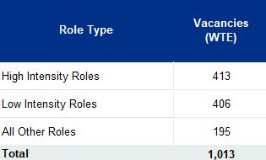

**Vacancy rate by Role Type**

7.6%

6.2%

5.5%

5.7%

High Intensity Roles

Low Intensity Roles

All Other Roles

Total Staff

## Metrics – Vacancy Rate by Service

Vacancy rates per service are reported in the chart, with one bar representing each service. Rates ranged from 0% to 26.5%. The range in 2023 was 0% to 38%.

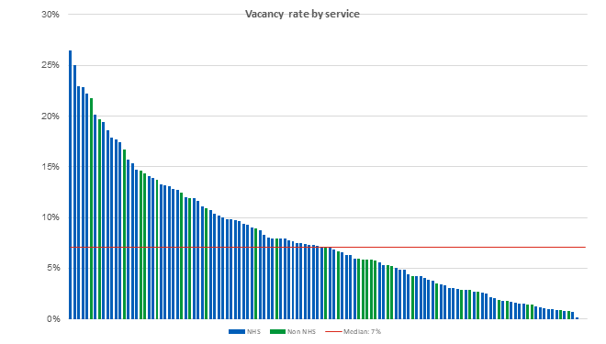

## Metrics – Sickness Absence Rate by Role Type

The sickness absence rate for the total workforce as at 31 March 2024 was 4.2%, with slight variation across role types. This compared to 4.7% for the same time point across the whole NHS workforce (March 2024)5. The sickness absence rate reported in the census in 2023 was 3.7%.

**Sickness Absense rate by Role Type**

4.6%

4.1% 4.2%

3.6%

High Intensity Roles Low Intensity Roles All Other Roles Total Staff

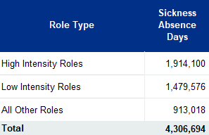

**Sickness Absence rate by Role Type**

4.6%

4.1%

4.2%

3.6%

High Intensity Roles

Low Intensity Roles

All Other Roles

Total Staff

## Metrics – Sickness Absence Rate by Service

Sickness absence rates by service for organisations that completed this information ranged from 0% to 16.4%. In 2023 the range was 0% to 27%, with the 27% being an outlier.

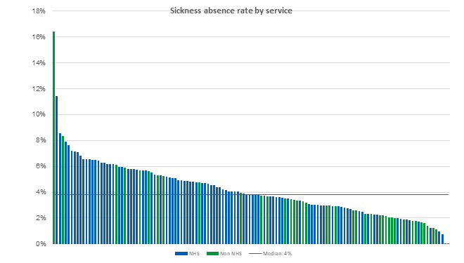

## Metrics – Joiner Rate by Role Type

Joiner rate is the proportion of joiners as a percentage of staff in post at the start of the census period (1 April 2023). Please see definitions in Appendix E.

The joiner rate for the total workforce as at 31 March 2024 was 20.5%. High intensity roles reported a joiner rate of 13.4% and the rate for low intensity roles was over double this at 29.7%. The joiner rate had decreased from 25% in the 2023 census.

Please note that joiners in the table are the total WTE reported by respondents, however if a denominator for the metric (staff in post as at 1 April 2023) was not

provided by the respondents they are not included in the joiner rate.

**Joiners rate by Role Type**

29.7%

22.7%

20.5%

13.4%

High Intensity Roles Low Intensity Roles All Other Roles Total Staff

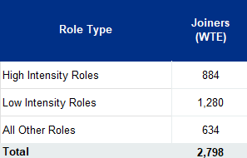

**Joiners rate by Role Type**

29.3%

22.7%

20.4%

13.4%

High Intensity Roles

Low Intensity Roles

All Other Roles

Total Staff

## Leavers by Service

Leaver rate by service for organisations that completed this information ranged from 0% to 73% with a median average of 14%.

The leaver rate was calculated as the percentage of staff in post at the start of the year who left their post during the 12-month period. This represented a methodological change. This included those leaving a post but taking up a new one in NHS talking therapies.

Leaver WTE by staff group is listed below and the breakdown of leaver rate by staff group along with the change from the 2023 is as follows:

* High intensity – 10% decreased from 12% in 2023
* Low intensity – 21% increased from 17% in 2023
* All other roles – 12% static from 2023

The turnover rate for the workforce was 14%, the same as reported in 2023.

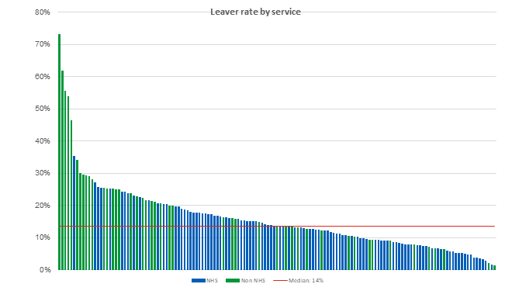

## Leavers – Destination Profile

Services were asked, where possible, to disaggregate their leavers by destination.

The overall leaver WTE had fallen from 2,341 in the 2023 census to 1,919 this year, an 18% reduction.

Of the total workforce reported, 50% of the destination of the leavers (WTE) was not known, a 5% reduction on the position in 2023. Almost a quarter (24%) of all leavers remained within NHS commissioned Talking Therapies services and 21% left NHS commissioned Talking Therapies services. The percentage of staff who retired increased to 5% in 2024 from 3% last year. In high intensity roles 9% retired, an increase from 5% in 2023, in low intensity roles 1% of leavers retired in 2024, the same as in 2023.

|  |  |  |  |  |  |
| --- | --- | --- | --- | --- | --- |
| **Role Type** | **Remained within NHS commissioned Talking Therapies services** | **Left NHS commissioned Talking Therapies services** | **Retired** | **Unknown** | **Leavers (WTE)** |
| **High Intensity Roles** | 21% | 21% | 9% | 49% | 661 |
| **Low Intensity Roles** | 31% | 19% | 1% | 49% | 912 |
| **All Other Roles** | 13% | 25% | 6% | 55% | 348 |
| **Total Staff** | **24%** | **21%** | **5%** | **50%** | **1,922** |

###### Table 16

## Bank and Agency Staffing

Bank and agency staffing can be vital for services, however reliance on this workforce can impact quality and continuity of care for service users.

Bank and agency staffing (WTE) is displayed as a proportion of total staffing (WTE) for the services who advised of spend. 158 services responded to this metric and

38% had some spend on bank and agency staffing (60 services).

The 176 WTE reported on the census date of 31 March 2024 represents a 48% decrease on the reported position in 2023.

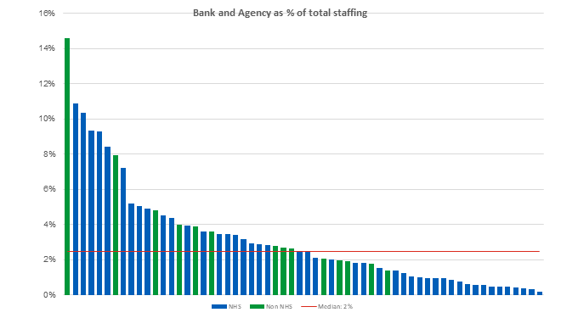

## Outsourcing

Services were asked if they had spent on outsourcing activity to external organisations e.g. Xyla Health or Dr Julian.

Outsourcing spend is displayed with one bar per service, 119 services responded to this question and of these 66 had some spend.

The range of the spend was from £4,563 to £2,220,000, with the median being £244,690, a 59% increase from an average of £153,840 in 2023.

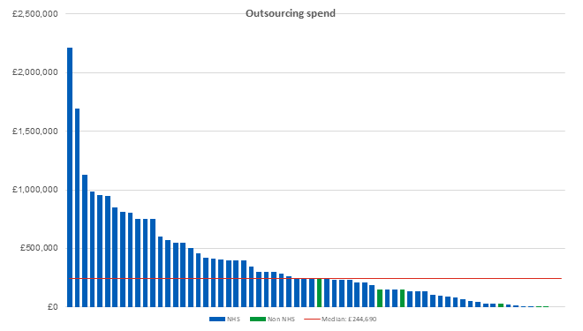

## Workforce Discrimination

# Discrimination in the Workplace

The chart shows the formal reports of discrimination within the last 12 months.

Of the 147 services who responded to this metric, 14 services comprising 10% of those who responded reported that there had been formal reports of discrimination made within the census period, an increase from 4% in 2023.

* Discrimination from colleagues was reported 22 times by a total of 13 services
* Discrimination by service users was reported 14 times by a total of 1 service.

In addition to advising of formal reports of discrimination, services also reported the grounds on which these reports were made. Of those who responded about the basis of the discrimination, 26% of these were on disability, 21% on the basis of ethnic background, 11% on gender or sexual orientation, 5% were on religion or age and 21% were listed as ‘other’.

**Formal reports of discrimination within the last 12 months**

n= 147

No, 90%

|  |  |  |  |  |  |  |  |  |
| --- | --- | --- | --- | --- | --- | --- | --- | --- |
|  | Yes, 10% |  |  |  |  |  |  |  |
|  |
|  | | | | | | | | |
|  |  |  |  |  |  |  |  |  |

## Appendix A – 2024 Workforce by WTE

## 

***Table 18***

**Table 17**

#### Appendix B – NHS Talking Therapies workforce overview 2019-2024 NHS services - breakdown by role

Table 19 shows workforce figures for those services delivered by NHS provider organisations.

|  |  |  |  |  |  |  |  |  |  |  |  |  |  |
| --- | --- | --- | --- | --- | --- | --- | --- | --- | --- | --- | --- | --- | --- |
|  | | | **2019-2020** |  | **2020-2021** |  | **2021-2022** |  | **2022-2023** |  | **2023-2024** |  | **Cumulative %** |
| **NHS Workforce Overview - Breakdown by Role (WTE)** | **2019** | **2020** | **(%** | **2021** | **(%** | **2022** | **(%** | **2023** | **(%** | **2024** | **(%** |  | **Change** |
|  |  |  | **Change)** |  | **Change)** |  | **Change)** |  | **Change)** |  | **Change)** |  | **(2019-2024)** |

**Qualified and trainee low intensity**

|  |  |  |  |  |  |  |  |  |  |  |  |  |  |
| --- | --- | --- | --- | --- | --- | --- | --- | --- | --- | --- | --- | --- | --- |
| Psychological wellbeing practitioner | 1,483 | 1,438 | -3% | 1,729 | 20% | 1,797 | 4% | 1,882 | 5% | 2,067 | 10% |  | **39%** |
| Senior psychological wellbeing practitioner | 264 | 280 | 6% | 322 | 15% | 362 | 30% | 359 | -1% | 343 | -5% | **30%** |
| Lead psychological wellbeing practitioner |  |  |  |  |  | 57 | 52 | -8% | 55 | 6% | **-** |
| **Qualified PWPs subtotal** | ***1,747*** | ***1,718*** | ***-2%*** | ***2,051*** | ***19%*** | ***2,216*** | ***8%*** | ***2,292*** | ***3%*** | ***2,465*** | ***8%*** | **41%** |
| Trainee psychological wellbeing practitioner | 660 | 1,009 | 53% | 1,290 | 28% | 1,270 | -2% | 1,262 | -1% | 1,086 | -14% | **64%** |
| **Qualified and Trainee low intensity Total** | **2,407** | **2,727** | **13%** | **3,341** | **23%** | **3,486** | **4%** | **3,555** | **2%** | **3,551** | **0%** | **48%** |
| **High intensity** | | | | | | | | | | | |  |  |
| HI CBT Therapist | 2,455 | 2,343 | 5% | 2,823 | 20% | 2,861 | 1% | 3,036 | 6% | 3,196 | 5% |  | **30%** |
| Other High Intensity Therapist e.g. without NHS Talking Therapies  recognised modality training |  | 232 | 188 | -19% | 218 | 16% | 106 | -51% | 129 | 21% | **-** |
| HI other modality Therapist / Counsellors e.g.  (CfD/IPT/DIT/CTfD/BCT/MBCT/EMDR) | 572 | 646 | 13% | 702 | 9% | 678 | -3% | 1,042 | 54% | 1,109 | 6% | **94%** |
| *Applied psychologist - Clinical* | 205 | 150 | -27% | 108 | -28% |  | | | | | | **-** |
| **Non-trainee HIT Therapists subtotal** | ***3,231*** | ***3,372*** | ***4%*** | ***3,820*** | ***13%*** | ***3,758*** | ***-2%*** | ***4,184*** | ***11%*** | ***4,433*** | ***6%*** | **37%** |
| Trainee HI CBT Therapist | 399 | 581 | 46% | 865 | 49% | 1,046 | 21% | 875 | -7% | 864 | -1% | **157%** |
| Trainee HI Other modality Therapist / Counsellor (undertaking NHS  Talking Therapies recognised modality training) | 60% |
| **High intensity Total** | **3,630** | **3,952** | **9%** | **4,686** | **19%** | **4,804** | **3%** | **5,159** | **7%** | **5,457** | **6%** | **50%** |
|  | | | | | | | | | | | |  |  |
| **Total low and high intensity staff** | **6,037** | **6,679** | **11%** | **8,027** | **20%** | **8,290** | **3%** | **8,713** | **5%** | **9,008** | **3%** |  | **49%** |

###### Table 19

Table 20 shows workforce figures for those services delivered by NHS provider organisations.

|  |  |  |  |  |  |  |  |  |  |  |  |  |  |
| --- | --- | --- | --- | --- | --- | --- | --- | --- | --- | --- | --- | --- | --- |
|  | | | **2019-2020** |  | **2020-2021** |  | **2021-2022** |  | **2022-2023** |  | **2023-2024** |  | **Cumulative %** |
| **NHS Workforce Overview - Breakdown by Role (WTE)** | **2019** | **2020** | **(%** | **2021** | **(%** | **2022** | **(%** | **2023** | **(%** | **2024** | **(%** |  | **Change** |
|  |  |  | **Change)** |  | **Change)** |  | **Change)** |  | **Change)** |  | **Change)** |  | **(2019-2024)** |

**Employment Support**

|  |  |  |  |  |  |  |  |  |  |  |  |  |  |
| --- | --- | --- | --- | --- | --- | --- | --- | --- | --- | --- | --- | --- | --- |
| Employment support advisor | 164 | 221 | 35% | 261 | 18% | 246 | -4% | 161 | -34% | 363 | 125% |  | **122%** |
| Senior employment support advisor |  |  |  |  |  | 56 | 36 | -36% | 91 | 149% | **-** |
| *Externally contracted employment advisor/coordinator* | 143 | 85 | -41% | 53 | -38% |  |  |  |  |  |  | **-** |
| **Employment Support Total** | **307** | **307** | **0%** | **314** | **2%** | **302** | **-4%** | **197** | **-35%** | **454** | **130%** | **48%** |
| **Additional roles** | | | | | | | | | | | |  |  | |
| Psychological wellbeing practitioner (not NHS Talking Therapies | 14 | | | | | | - | 19 | 32% | 31 | 64% |  | **-** |
| qualified or in NHS Talking Therapies training) |
| Assistant Psychologist | 81 | | | | | | | | | | - |  | |
| Other low intensity / assistant worker not in a PWP role e.g. | 138 | | | | | | - | 268 | 94% | 178 | -34% | **-** |
| Assistant PWP |
| *PWP workers (not NHS Talking Therapies qualified)* | 123 | 202 | 65% | 144 | -29% |  |  |  |  |  |  | **-** |
| *Other lowintensity counsellors* | 43 |  | | | | | | | | | | **-** | |
| *Other lowintensity therapists* | 70 |  | | | | | | | | | | **-** | |
| **Other low intensity staffing subtotal** | 236 | 202 | -14% | 144 | -29% | 153 | 6% | 287 | 88% | 290 | 1% | **23%** |
| *Other trainees* | 57 | 77 | 35% | 44 | -42% |  |  |  |  |  |  |  | **-** |
| Peer support worker (paid) | 34 | | | | | | - | 37 | 8% | 48 | 31% |  | **-** |
| **Additional roles Total** | **293** | **279** | **-5%** | **188** | **-33%** | **187** | **-1%** | **324** | **74%** | **338** | **4%** | **15%** |
|  | | | | | | | | | | | |  |  | |
| **Total patient-facing staff** | **6,637** | **7,265** | **9%** | **8,529** | **17%** | **8,778** | **3%** | **9,235** | **5%** | **9,800** | **6%** |  | **48%** |

###### Table 20

Table 21 shows workforce figures for those services delivered by NHS provider organisations.

**NHS Workforce Overview - Breakdown by Role (WTE)**

**2019**

**2023-2024**

**2020 2019-2020 2021 2020-2021 2022 2021-2022 2023 2022-2023 2024 (%**

**Change)**

**Cumulative % Change (2019-2024)**

**Non-patient facing roles**

*Including time spent by clinical staff providing supervision*

|  |  |  |  |  |  |  |  |  |  |  |  |
| --- | --- | --- | --- | --- | --- | --- | --- | --- | --- | --- | --- |
| Supervisors - NHS Talking Therapies supervisor trained | 429 | 609 | 42% | 719 | 18% | 732 | 2% | 708 | -3% | 520 | -27% |
| Supervisors - supervisors who have not undertaken NHS Talking  Therapies supervision module/training | 95 | 57 | -40% | 59 | 2% | 36 | -38% | 49 | 37% | 63 | 27% |
| Management / leadership roles | 341 | 394 | 15% | 612 | 55% | 631 | 3% | 531 | -16% | 709 | 34% |
| Admin and clerical staff inc. data analysts | 858 | 905 | 6% | 1,035 | 14% | 1,018 | -2% | 1,018 | 0% | 1,201 | 18% |
| Other job roles | 288 | 224 | -22% | 178 | -20% | 108 | -39% | 78 | -28% | 110 | 41% |
| **Total non-patient facing roles** | **2,012** | **2,189** | **9%** | **2,602** | **19%** | **2,525** | **-3%** | **2,385** | **-6%** | **2,603** | **9%** |

|  |
| --- |
| **21%** |
| **-34%** |
| **108%** |
| **40%** |
| **-62%** |
| **29%** |

|  |  |  |  |  |  |  |  |  |  |  |  |
| --- | --- | --- | --- | --- | --- | --- | --- | --- | --- | --- | --- |
| **Total staffing in NHS Talking Therapies services** | **8,648** | **9,454** | **9%** | **11,131** | **18%** | **11,303** | **2%** | **11,620** | **3%** | **12,403** | **7%** |

**43%**

###### Table 21

#### 

#### Appendix C – NHS Talking Therapies workforce overview 2019-2024 Non-NHS services - breakdown by role

Table 22 shows workforce figures for those services delivered by non-NHS provider organisations. These services were NHS commissioned, but provided by private or third sector providers.

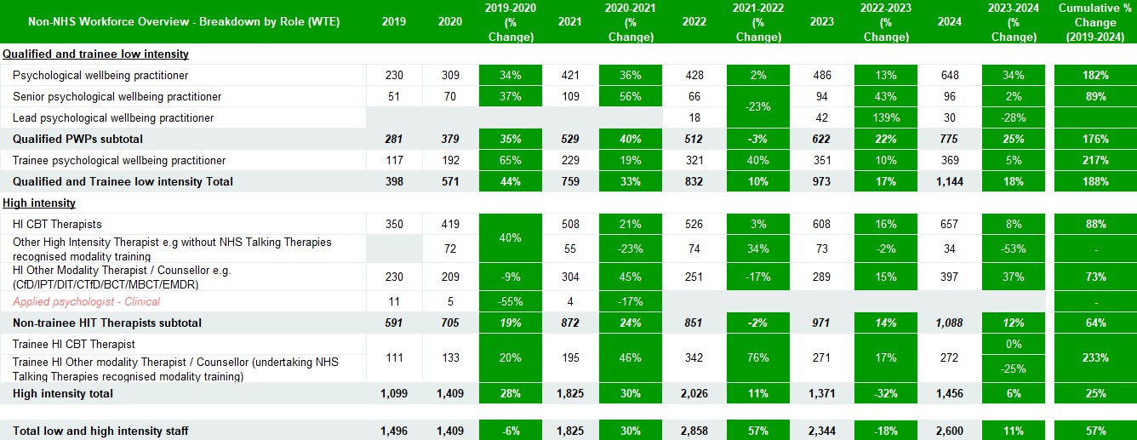

###### Table 22

Table 23 shows workforce figures for those services delivered by non-NHS provider organisations. These services were NHS commissioned, but provided by private or third sector providers.

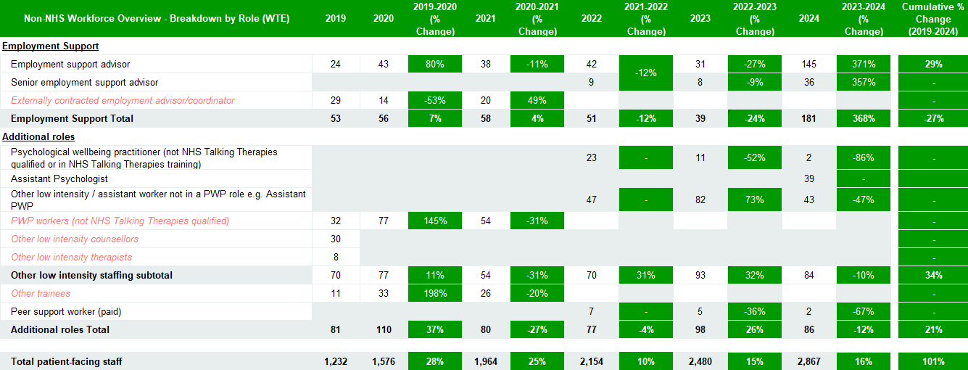

###### Table 23

Table 24 shows workforce figures for those services delivered by non-NHS provider organisations. These services were NHS commissioned, but provided by private or third sector providers.

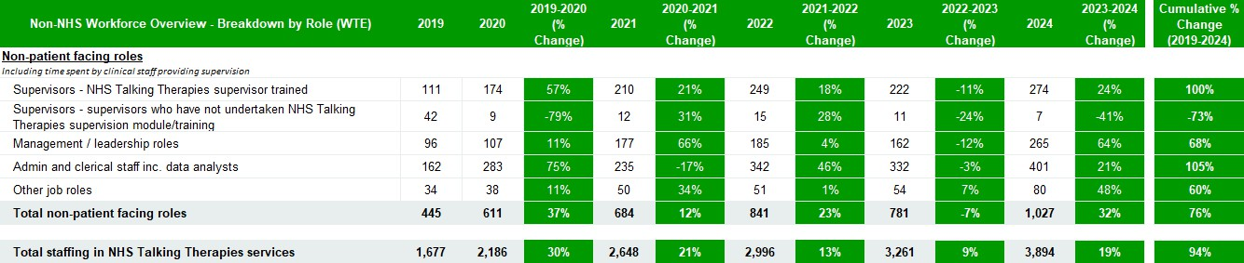

###### Table 24

## Appendix D – Key Definitions

**Whole Time Equivalent:** A measure of working time expressed as a proportion of the standard whole time working for a grade. For example, if registered nurse has a

37.5 hour week contract and they work 15 hours a week, they would be 0.4 WTE. If the standard hours for a full time Junior Doctor are 40 hours a week and an individual

Junior Doctor contracts to work 40 hours per week, then that employee's WTE is = 1.0.

**In Post:** WTE as at 31 March 2024. This includes contracted staff in post and bank and/or agency cover who were in place on this date (question will specify bank and/or agency inclusion). This should include all staff directly employed by the organisation, regardless of the location in which they work. Do not include staff employed by other organisations working within your organisation as part of a service agreement - these staff should be captured by the employing organisation.

**Bank & Agency staff (WTE):** The number of staff (WTE) who are on a bank or agency contract at 31 March 2024.

**Number of Vacancies (WTE):** The difference between the number of reported Whole Time Equivalent (WTE) permanent or fixed-term staff in post and planned workforce levels. For over establishment, this is recorded as a negative figure. All 'true' vacancies should be recorded as a positive figure. This is excluding bank and agency staff.

**Vacancy rate:** Vacancy rate is the number of vacancies divided by the funded establishment.

**Joiners (WTE):** The number of new staff that joined the service during the period from the 1 April 2023 to the 31 March 2024. This could include staff who both joined and left their role within the 12-month period. This is excluding bank and agency staff.

**Retention (WTE):** Staff in post (excluding bank and agency staff) on the 1 April 2023 who were still in post on 31 March 2024.

**Turnover rate:** The numerator is the total number of leavers, and the denominator is staff in post at the start of the year (calculated by staff in post at end of the year

excl. bank & agency, minus joiners, plus leavers).

**Sickness absence days:** Total number of WTE staff sickness days including non working days. For example, a member of staff that usually works Monday to Friday and is off sick Friday through to Monday would report four days sickness. In line with NHS Digital definition.

**Total available working days:** Total number of contracted WTE staff days available in the period. For example, a full-time member of staff would have 365 available days compared to 182.5 for a staff member working 0.5WTE. Excludes: maternity leave & unpaid leave.

#### Leaver destinations

**Remained within NHS commissioned services:** Staff who left their post between 1 April 2023 and 31 March 2024 but remained within NHS commissioned services in their next role (within the same organisation or a different organisation).

**Left NHS commissioned services:** Staff who left their post between 1 April 2023 and 31 March 2024, and did not work within NHS commissioned services in

their next role (within the same organisation or a different organisation).

**Retired:** Staff who left their post between 1 April 2023 and 31 March 2024 due to retirement

**Unknown/other:** Staff who left their post between 1 April 2023 and 31 March 2024, with an unknown destination of their next role.

## Appendix E – Staff Role Groups and changes in roles collected during the lifetime of the project

**High intensity -** HI CBT therapist / HI other modality therapist (CfD/IPT/DIT/CTfD/BCT/MBCT/EMDR) / trainee HI CBT therapist / trainee HI other modality therapist (undertaking NHS Talking Therapies recognised modality training) / other high intensity therapist e.g. without NHS Talking Therapies recognised modality training / trainee HI CBT therapist / trainee HI other modality therapist (undertaking NHS Talking Therapies recognised modality training)

**Low intensity** - lead psychological wellbeing practitioner / senior psychological wellbeing practitioner / psychological wellbeing practitioner / trainee psychological wellbeing practitioner / psychological wellbeing practitioner (not NHS Talking Therapies qualified or in NHS Talking Therapies training) / assistant psychologist / other low intensity / assistant worker not in a PWP role e.g. assistant PWP / trainee psychological wellbeing practitioner

**All other roles** - employment advisor / senior employment advisor / peer support worker (paid) / management / leadership roles / admin and clerical staff inc. data

analysts / other

Please note that organisations were requested to place supervisors in their primary role (high or low intensity). Changes in reporting of roles have occurred over the lifetime of the project.

Roles removed: applied psychologist – clinical, externally contracted employment advisor/ coordinator, PWP workers (not NHS Talking Therapies qualified), other low intensity counsellors, other low intensity therapists, other trainees.

Roles added: lead psychological wellbeing practitioner, other high intensity therapist e.g. without NHS Talking Therapies recognized modality training, senior employment support advisor, psychological wellbeing practitioner (not NHS Talking Therapies qualified or in NHS Talking Therapies training), assistant psychologist, other low intensity / assistant worker not in a PWP role e.g. assistant PWP, peer support worker (paid).

## Calculations

**Funded Establishment (WTE):** Funded Establishment is calculated by the staff in post collected in the workforce tab minus the bank & agency staff and then added to the number of vacancies.

**Vacancy rate:** Vacancy rate is the number of vacancies divided by the funded establishment.

**Joiner rate:** The numerator is the number of joiners, and the denominator is staff in post at the start of the year (calculated by staff in post at end of the year excl. bank & agency, minus joiners, plus leavers).

**Retention rate:** The numerator is the number of retained staff, and the denominator is staff in post at the start of the year (calculated by staff in post at end of the year excl. bank & agency, minus joiners, plus leavers).

**Turnover rate:** The numerator is the total number of leavers, and the denominator is staff in post at the start of the year (calculated by staff in post at end of the year

excl. bank & agency, minus joiners, plus leavers).

**Sickness absence rate:** Sickness absence rate - the number of the sickness absence days divided by the total available working days.

## References

1. Office for National Statistics (ONS) (2022) [*Cost of living and depression in adults*](https://www.ons.gov.uk/peoplepopulationandcommunity/healthandsocialcare/mentalhealth/articles/costoflivinganddepressioninadultsgreatbritain/29septemberto23october2022)*, Great Britain: 29 September to 23 October 2022.* [online]
2. NHS England (2016) [*The Five Year Forward View For Mental Health.*](https://www.england.nhs.uk/wp-content/uploads/2016/02/Mental-Health-Taskforce-FYFV-final.pdf)[online]
3. NHS England (2019) [*NHS Mental Health Implementation Plan 2019/20 – 2023/24*](https://www.longtermplan.nhs.uk/wp-content/uploads/2019/07/nhs-mental-health-implementation-plan-2019-20-2023-24.pdf)*.* [online]
4. NHS England (2018) [*NHS Talking Therapies for anxiety and depression manual*](https://www.england.nhs.uk/publication/the-improving-access-to-psychological-therapies-manual/)*.* [online]
5. NHS Digital (2024). [NHS Sickness Absence Rates](https://digital.nhs.uk/data-and-information/publications/statistical/nhs-sickness-absence-rates/march-2024#%3A~%3Atext%3DKey%20Facts%26text%3DThe%20overall%20sickness%20absence%20rate%2Csince%20March%202023%20(5.0%25).%26text%3DThe%20North%20West%20region%20reported%2Csince%20February%202024%20(6.0%25)) [online]
6. NHS England (2024) [*NHS Talking Therapies, for anxiety and depression, Annual reports, 2023-24*](https://digital.nhs.uk/data-and-information/publications/statistical/nhs-talking-therapies-for-anxiety-and-depression-annual-reports/2023-24)*.* [online]
7. NHS England (2023) [*NHS Long Term Workforce Plan*](https://www.england.nhs.uk/wp-content/uploads/2023/06/nhs-long-term-workforce-plan-v1.21.pdf)*.* [online]
8. Office for National Statistics (ONS) [*Working age population*](https://www.ethnicity-facts-figures.service.gov.uk/uk-population-by-ethnicity/demographics/working-age-population/latest/#%3A~%3Atext%3Daccording%20to%20the%202021%20Census%2C%2062.9%25%20(37.5%20million)%2Clower%20than%20the%20national%20average)(2021) *,* [online]
9. UK Parliament (2024). [*Disabled people in employment*](https://commonslibrary.parliament.uk/research-briefings/cbp-7540/#%3A~%3Atext%3DThere%20were%205.53%20million%20working%2Care%20not%20disabled%20was%2082.0%25)[online]
10. ONS Census (2021). [*Health geographies population estimates*](https://www.ons.gov.uk/peoplepopulationandcommunity/populationandmigration/populationestimates/datasets/clinicalcommissioninggroupmidyearpopulationestimates)*.* [online]

## Acknowledgements

The NHS Benchmarking Network (NHSBN) team would like to extend our thanks to all organisations for their participation in the workforce benchmarking projects.

We would also like to thank the following for their insight and support throughout the project.

* Naheem Akhtar, Strategic Lead
* Jaclyn Stoneham, Senior Programme Manager
* Adrian Whittington, National Clinical Lead for Psychological Professions
* Matthew Oates, Project Manager

**Authors:**

* Karen Rix, *Associate Director – Workforce Programme*
* Janet Heaton, *Senior Project Manager*
* Alex Parry-Jones, *Assistant Project Manager*
* Michael Court, *Assistant Project Manager*
* Luke Thomas, *Graduate Project Coordinator*

**Cite this report as:**

NHS Talking Therapies for Anxiety and Depression Workforce Census in England at 31 March 2024, NHS Benchmarking Network.