

**Children and young people’s mental health**

**National workforce census**

1 April 2023- 31 March 2024

Developed in partnership with the NHS Benchmarking Network



## Contents

Executive Summary p 3

Introduction p 6

Workforce Overview p 13

Workforce Group Profiles… p 23

HR Metrics… p 31

Staff Demographics… p 40

Local Authority Overview p 52

Voluntary Sector Overview p 55

Youth Justice Services Overview p 58

Skills and Training p 61

Service Models… p 67

Appendices… p 71

Acknowledgements… p 3

## Executive Summary

### Background and Purpose

Workforce growth and retention are cornerstones of effective health and care delivery. Ensuring a workforce of the right size, in the right place, with the right skills is essential to meeting current population needs and underpinning the ambitious transformation plans set out in key healthcare policy documents. However, the provision of high-quality health and care services is currently impacted by significant workforce challenges including staff shortages, staff retention, training and skills gaps, coupled with systemic issues related to equality of opportunity and diversity. These issues are evident throughout health and care service delivery and are a particular issue within mental health care.

There has been a sustained focus on improving the provision of mental health care for all ages. A key lever to delivering transformation objectives relates to how services are delivered, with a greater emphasis on collaborative delivery across statutory and non-statutory services, and across health and care services. While this is an opportunity to create provision and delivery of services in innovative ways to meet increasing and changing needs, it creates a challenge for understanding the wider workforce outside of NHS statutory services.

One in nine children have a diagnosable mental health problem by age 141 and by age 14 half of all mental health problems are established, rising to 75% by age

24.2 The rise in mental health disorders has impacted on demand for children and young people’s mental health services (CYPMHS), with sustained growth in referral rates over the last decade equating to a 109% increase in annual referral rates between 2013/14 and 2023/24.3 To address growing demand, the NHS Long Term Plan5 (LTP) committed to expanding mental health services for children and young people with the rate of growth in funding exceeding both overall NHS funding and total mental health spending. The growth in the CYP workforce over the last decade can be linked to the increased investment committed in both the Five Year Forward View for Mental Health (2016) and the NHS Long Term Plan (2019).

The NHS Long Term Workforce Plan6 (LTWP) renews and strengthens the commitment to grow and transform the healthcare workforce and highlights a commitment to invest £2.4 billion to fund the expansion of training places by 27% by 2028/29. By 2031 the ambition is to increase training places for clinical psychology and child and adolescent psychotherapy by 26%. As well as measuring progress to date, the CYP census provides a baseline to assess the impact of the commitments outlined in the LTWP.

To continue the progress of workforce developments and following on from the successful 2023 report, NHS England commissioned the NHS Benchmarking Network (NHSBN) to undertake a sixth annual census and analysis of the children and young people’s mental health workforce across England for 2024. Building on the success of the 2023 census it details the workforce size by role and service area, and diversity by age, gender, disability, and ethnicity. This census scope includes CYPMHS staff working in the NHS, independent, local authority, VCSE and youth justice sectors.

## Participation

In the 2024 children and young people’s mental health workforce census:

* 65 NHS trusts and 472 non-NHS organisations were contacted about the census.
* 53 NHS trusts participated in the census, with 22 submissions received from local authorities, 66 from VCSE organisations, 2 from independent providers and 70

from youth justice services.

### Workforce Summary - NHS

* **There were 15,238 whole time equivalent (WTE) staff reported as working within NHS children and young people’s mental health services.** Based on the 44 NHS trusts that consistently submitted staff in post data in 2023 and 2024 (83% of 2024 NHS participants), there was a **13% increase in W TE staff in post**. This compares to the 8% growth reported in 2023, based on the organisations that participated in both 2022 and 2023.
* Around one in two staff (47%) were reported to be working within general community teams, a marginal reduction from 2023 (53%), whilst 13% of staff were located in the inpatient setting.
* **Registered nurses made up the largest staffing group at 20% of the workforce**, with 3,043 WTE reported to be working in NHS CYPMHS services.
* A total of 554 WTE community and 55 WTE inpatient medical staff were reported as part of this census*. Across both settings, **consultant - child and adolescent**

**psychiatry represented the largest proportion of the medical workforce, at 54% in the community and 52% in inpatient services**.

* **There were a total of 1,724 WTE psychology** staff reported in the census**\*, 1,660 WTE based in the community and 64 WTE in the inpatient setting. Clinical psychologists were the largest proportion of psychology staff in both settings, constituting 57% in the community and 48% in inpatient services. Assistant psychologists also represented a notable section, 30% in community and 43% in inpatient.
* **There were a total of 1,068 WTE staff reported to be working in the psychological therapists job grouping** in the census\***, 1,048 WTE based in the community

and 20 WTE in the inpatient setting. Child and adolescent psychotherapists made up the largest proportion of roles within the psychological therapists staff grouping in both settings, constituting 44% in the community and 52% in inpatient services.

*\*Includes data from 46 full submissions only. **Please see Appendix 1 for job role mappings*

## HR metrics - NHS

* NHS providers reported around 2,000 WTE vacancies in the community setting and 300 WTE in the inpatient setting. There were 29 participating trusts that consistently submitted staff in post and vacancies data in 2023 and 2024. Based on these trusts alone, the vacancy rate reduced from 24% in 2023 to 17% in 2024.
* Nurses represented the largest number of vacancies in the community setting (468 WTE), with a vacancy rate of 22%. The second largest number of vacancies in the community setting was psychological therapists (228 WTE), with vacancy rate of 20%, closely followed by clinical psychologists (202 WTE) with a vacancy rate of 20%.
* Nurses also represented the largest number of vacancies in the inpatient setting (142 WTE) with a vacancy rate of 30%. The second largest number of vacancies was support workers (96 WTE), with a vacancy rate of 15%.
* The sickness absence rate was 4% in both the community and inpatient setting.
* Staff retention (staff in post on 1st April 2023 and still in post on 31st March 2024) averaged 75% in the community setting, and 69% in the inpatient setting.
* The distribution of staff by time in post is very similar to 2023, with the majority of staff (81%) having been in post less than five years.

### Demographics

* The ethnicity profile of the NHS children and young people’s mental health services workforce showed an under representation of Asian/Asian British staff, while

there was a higher proportion of black/black British staff working in NHS CYPMHS when compared to the England working age population

* Across all sectors the workforce was predominantly female, ranging from 86% in the NHS, to 89% in the VCSE sector.
* In the NHS 50% of staff were aged under 40, while this was 40% in the local authority sector and 45% in the VCSE sector.
* NHS providers reported the highest proportion of staff with a disability (15%), and the lowest proportion of staff whose disability status was not known (8%).

Conversely, the local authority sector had the lowest proportion of staff with a disability (6%) and the highest proportion of ‘not known’ (30%).

# Introduction

# Background and Purpose

# One in nine children have a diagnosable mental health problem by age 141 and by age 14 half of all mental health problems are established, rising to 75% by age

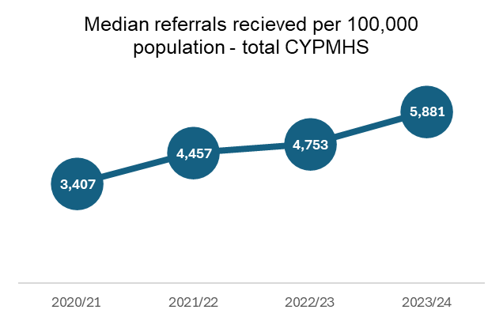24.2 Recent evidence suggests rates of probable mental health disorders have continued to rise among children and young people (CYP) in England ages seven to 19 years of age.4 The rise in mental health disorders has impacted on demand for CYP mental health services, with sustained growth in referral rates over the last decade equating to a 109% increase in annual referral rates between 2013/14 and 2023/24.3 To address growing demand, the NHS Long Term Plan5 (LTP) committed to expand mental health services for children and young people with the rate of growth in funding exceeding both overall NHS funding and total mental health spending. The growth in the CYP workforce over the last decade can be linked to the increased investment committed in both the Five Year Forward View for Mental Health (2016) and the NHS Long Term Plan (2019). The NHS Long Term Workforce Plan6 (LTWP) renews and strengthens the commitment to grow and transform the healthcare workforce, including the CYP mental health services workforce. In particular, the LTWP highlights a commitment to invest £2.4 billion to fund the expansion of training places by 27% by 2028/29. This includes a specific commitment to increase training places for mental health nursing by 38% and learning disability nursing by 46%; by 2031 the ambition is to increase training places for clinical psychology and child and adolescent psychotherapy by 26%. As well as measuring progress to date, the CYP census provides a baseline to assess the impact of the commitments outlined in the LTWP. In the parliament Committee of Public Accounts published a report in July 2023 titled ‘Progress on improving mental health services’.7 The CYPMHS workforce census provides critical evidence to address two of the six areas raised in this report: 1) workforce shortages constraining the improvement and expansion of NHS mental health services; and 2) data and information for mental health services lagging behind physical health services. The chart showing median referrals received into CYPMHS services per 100,000 population over the last four years is included here as context, showing the increasing demand on services, especially since the COVID-19 pandemic.

Source NHS Benchmarking Network

## Objectives

Provide a comprehensive census of the workforce, service model, demographics and HR metrics for children and young people’s mental health services. The objectives of the children and young people’s mental health services workforce census included:

* Provide a current overview of the national children and young people’s mental health workforce, enabling comparisons with previous annual submissions to give an accurate picture of overall workforce expansion and its alignment with the NHS Long-Term Workforce Plan.
* Provide a series of outputs to support work nationally, regionally and locally to retain, diversify and grow the workforce.

The children and young people’s mental health workforce census forms part of a larger programme of work within the [NHS Benchmarking Network](https://www.wfbenchmarking.nhs.uk/children-and-young-peoples-mental-health) which focuses on

workforce profiling and analysis.

### Scope

The project scope included children and young people’s mental health services provided by the NHS, local authority, VCSE (voluntary, community, and social enterprise) sectors and youth justice services in England.

## Data collection template

The workforce census was designed jointly by the NHS Benchmarking Network (NHSBN) and NHS England (NHSE). Data collection included:

* Details of organisation and the children and young people’s mental health services they provide.
* Workforce data by job role and salary banding.
* Workforce demographic data on gender, age, disability, and ethnic group.
* HR metric data including vacancies, sickness absence and staff retention.

For NHS providers the workforce census was included as part of the NHS Benchmarking Network’s wider CYPMHS collection in order to make the data collection

process as straightforward as possible for participants.

### Process

The 2024 children and young people’s mental health workforce census launched in April 2024 and was open for eight weeks. Extensions were agreed to maximize participation. A walkthrough event of the data collection templates took place on the date of launch to promote participation and provide guidance on how to fill out the template, the project scope, understanding the built in validation tools, and the project deadlines. Fortnightly drop-in sessions took place across the data collection period to provide further opportunity for participants to raise queries. Data was reviewed for completeness, consistency, and validity. The validation process took place across the data collection and analysis period.

### Definitions and Terminology

Details of the definitions included in the collection template are included for reference along with the details of the calculations used for the workforce metrics in Appendix 3.

### All sectors participation

Data submissions were received from 211 organisations across England. A total of 53 NHS organisations provided data, similar to in 2023 (56). Of these, 46 organisations provided data at individual staff level as requested, while a further seven provided data at an aggregated level.

Across the non-NHS sectors, a large number of organisations were contacted and invited to participate in the census, many of whom responded that they did not have services within the scope of this census and therefore they did not participate. There were also many non-NHS organisations from whom no response was received.

|  |  |  |  |  |
| --- | --- | --- | --- | --- |
| **Organisation type** | **Invited to participate** | **Participated** | **Not participated** | **Participation rate** |
| **NHS Trusts** | 65 | 53 | 12 | 82% |
| **Independent Sector** | 26 | 2 | 24 | 8% |
| **Local Authorities** | 151 | 22 | 129 | 15% |
| **Voluntary Sector** | 156 | 66 | 90 | 42% |
| **Youth Offending Teams** | 139 | 70 | 69 | 50% |
| **Total** | **537** | **213** | **324** | **40%** |

## Workforce overview: Workforce growth - NHS

For the 44 NHS organisations that consistently submitted staff in post data in both 2023 and 2024, the whole time equivalent (WTE) reported increased by 13%, rising from 11,275 to 12,778. The granular job roles used in 2023 were reclassified to align with the higher level workforce groups used in 2024 to allow for a year-on- year comparison. Please refer to appendix 1 for full details of this mapping.

Notable changes included a 68% reduction in the number of ARRS roles reported in 2024 than in 2023, and a 143% increase in the number of Senior Wellbeing Practitioners. Data collected by NHS Digital indicates the number of Consultant Child and Adolescent Psychiatrists in England has remained stable, decreasing

slightly from 639 in March 2023 to 638 in March 20241.

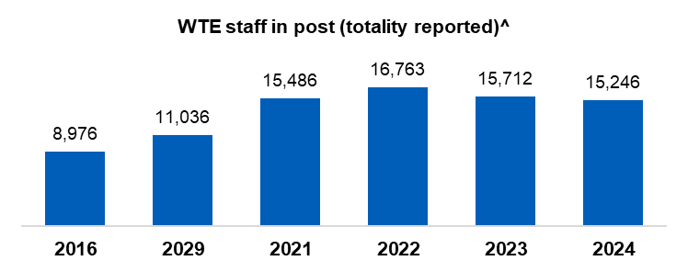

**The change in WTEs between the years 2023 and 2024 is derived from the data provided by 44 organisations that consistently participated in the census during both years.**

|  |  |  |  |  |
| --- | --- | --- | --- | --- |
| **Job role** | **2023** | **2024** | **Change** | **% change** |
| Total Nursing | 2412 | 2537 | +125 | +5% |
| Nursing Associates | 88 | 62 | -26 | -30% |
| Support Worker | 895 | 1409 | +515 | +58% |
| Consultant - Child and Adolescent Psychiatry* | - | 355 | - | - |
| Other Medical | 192 | 269 | +77 | +40% |
| Education Mental Health Practitioner | 725 | 968 | +243 | +34% |
| Children's Wellbeing Practitioner | 290 | 335 | +45 | +15% |
| Youth Worker | 43 | 19 | -24 | -57% |
| Senior Wellbeing Practitioner | 18 | 44 | +26 | +143% |
| Clinical Psychologist | 1021 | 1036 | +15 | +1% |
| Psychological Practitioners - Other** | - | 367 | - | - |
| Psychological Therapists | 958 | 1134 | +176 | +18% |
| Psychology - Other | 706 | 688 | -17 | -2% |
| Counsellor | 54 | 60 | +7 | +12% |
| AHP | 488 | 583 | +95 | +19% |
| Social Worker | 534 | 577 | +43 | +8% |
| ARRS | 135 | 43 | -92 | -68% |
| Pharmacy | 10 | 9 | -1 | -8% |
| Peer Support Worker | 23 | 31 | +9 | +40% |
| Admin/Management | 1957 | 2005 | +48 | +2% |
| Other | 726 | 247 | -480 | -66% |
| **Total** | **11275** | **12778** | **1503** | **13%** |

1Source: [NHS Workforce Statistics - September 2024](https://digital.nhs.uk/data-and-information/publications/statistical/nhs-workforce-statistics/september-2024).

*Issues identified retrospectively with data received from Trusts reporting Child and Adolescent Psychiatry hours in 2023 means that an accurate year on year comparison is not possible

** Psychological practitioners – other, was a new workforce group in 2024 and there were no roles in 2023 that accurately mapped to this.

*^Includes data from 46 organisations who made full submissions and 7 organisations who made abridged submissions*.

### Workforce by service area - NHS

As in previous years, the largest service area was general community services, with 47% of all staff reported to be working in this area. However, this represents a decrease from 53% in 2023 and 59% in 2022 and 2021. This reduction should be understood in the context of additional team types being included from 2023, allowing for more granular information to be gathered about where staff are located.

Of the inpatient settings, general admission adolescent services made up the highest proportion of the overall workforce at 8%, a marginal increase from 2023.

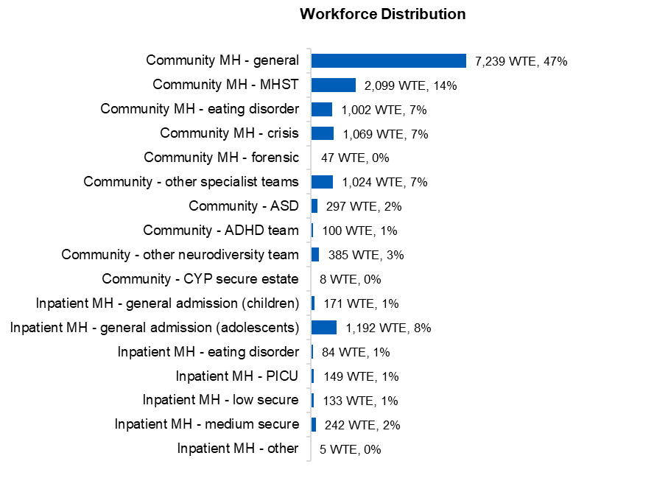

Includes data from 46 organisations who made full submissions and 7 organisations who made abridged submissions.

The ratio of whole time equivalent (WTE) to headcount in community CYPMHS services averaged 0.84, in line with the 0.83 reported in 2023. The range in community services is between 0.70 in other neurodiversity teams and 0.91 in MHSTs. In the inpatient setting, the average WTE to headcount ratio was 0.91, an increase from 0.88 in 2023. The inpatient range was from 0.89 in general admission children’s service to 1.00 in ‘other’ services. This indicates a higher proportion of staff working part time in community services than in inpatient services and has implications for the number of staff required to deliver services, especially in settings where part time working is more common. Please note, the table below does not include data from the seven abridged submission received as these only provided WTE data, not headcount.

|  |  |  |  |
| --- | --- | --- | --- |
| **Workforce distribution** | **WTE** | **Headcount** | **Ratio** |
| Community MH - general | 6,291 | 7,292 | 0.86 |
| Community MH - MHST | 1,875 | 2,060 | 0.91 |
| Community MH - eating disorder | 886 | 1,188 | 0.75 |
| Community MH - crisis | 884 | 1,101 | 0.80 |
| Community MH - forensic | 47 | 66 | 0.72 |
| Community - other specialist teams | 964 | 1,153 | 0.84 |
| Community - ASD | 287 | 367 | 0.78 |
| Community - ADHD team | 79 | 103 | 0.77 |
| Community - other neurodiversity team | 368 | 528 | 0.70 |
| **Community total** | 11,681 | 13,858 | 0.84 |
| Inpatient MH - general admission (children) | 136 | 152 | 0.89 |
| Inpatient MH - general admission (adolescents) | 993 | 1,090 | 0.91 |
| Inpatient MH - eating disorder | 85 | 95 | 0.90 |
| Inpatient MH - PICU | 149 | 158 | 0.94 |
| Inpatient MH - low secure | 22 | 23 | 0.97 |
| Inpatient MH - medium secure | 138 | 152 | 0.91 |
| Inpatient MH - other | 5 | 5 | 1.00 |
| **Inpatient total** | 1,527 | 1,675 | 0.91 |
| **Overall total** | 13,208 | 15,533 | 0.85 |

Includes data from 46 organisations who made full submissions only.

### All staff discipline mix – NHS

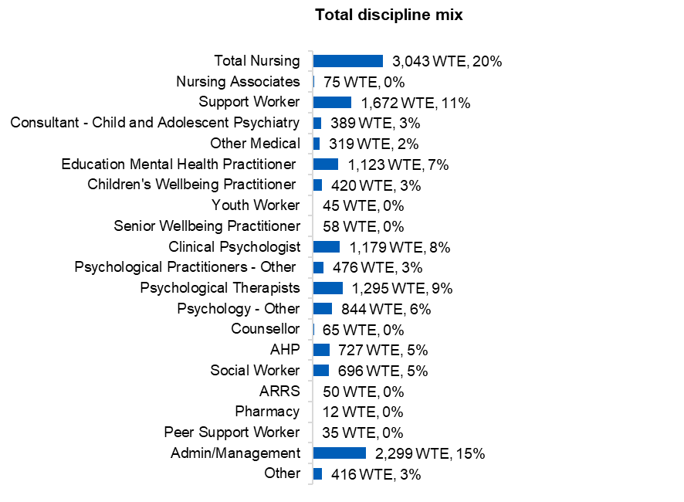Nurses made up the largest group of staff at 20%, though they have decreased as a proportion from 23% in 2023 and 26% in 2022. Admin/management are the second largest staff group, representing 15% of the workforce, again lower than the 18% reported in 2023. Support workers were the third largest workforce group, representing 11% of staff, similar to last year (10%). Please note that some of the job roles have been amended and others added since 2023, along with the mapping to these higher-level groups being reviewed. A full list of the job roles and mapping for both 2023 and 2024 can be found in appendix 1 for further information.

Includes data from 46 organisations who made full submissions and 7 organisations who made abridged submissions

### Community discipline mix – NHS

Although a smaller proportion than in previous years, nursing remained the largest workforce group in the community setting (19% in 2024, 22% in 2023, 26% in 2022). Accounting for 16% of staff, admin/management was the second largest workforce group, down from 19% in 2023. Psychological therapists, clinical psychologists and education mental health practitioners were the next three largest staff groups, at 10%, 9% and 8% respectively. This was the second year that ARRS roles were included in the collection, and though accounting for 2% of the workforce last year, in this census they represented less than 1% of staff reported in community settings.

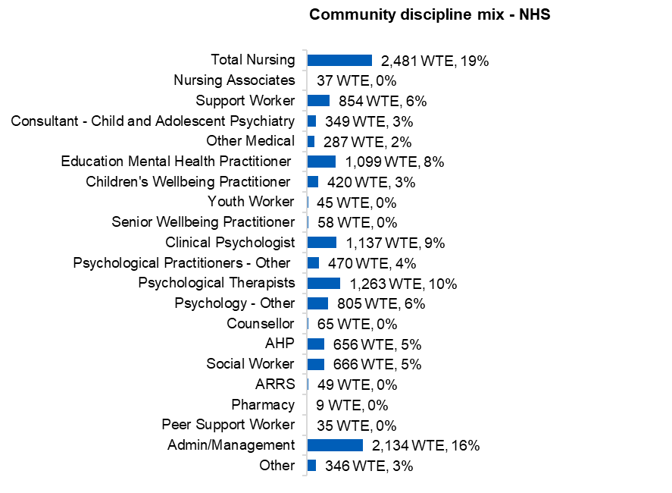

Includes data from 46 organisations who made full submissions and 7 organisations who made abridged submissions.

### Community discipline mix – NHS, LA and VCSE

When the community workforce across the NHS, local authority and VCSE sector is aggregated, admin/management was the largest workforce group accounting for 16% of WTE, closely followed by nurses at 14%. Psychology – other constituted 10% of the WTE, while psychological therapists and education mental health practitioners were the next two largest staff groups, both at 8%. Clinical psychologists constituted 7% of the total community CYPMHS workforce reported.

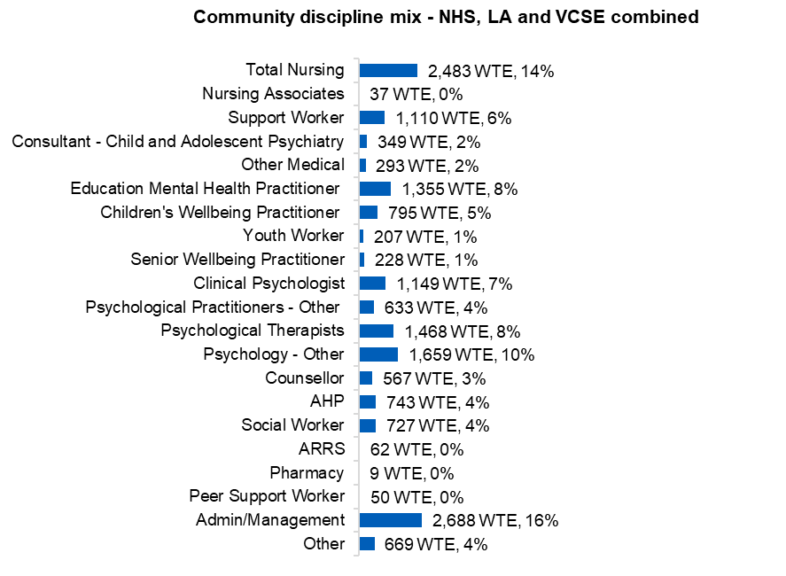

For the NHS, this includes data from 46 organisations who made full submissions and 7 organisations who made abridged submissions.

### Inpatient discipline mix – NHS

Similarly to previous years, support workers made up the largest proportion of staff in the inpatient setting (41% in 2024, 42% in 2023, 43% in 2022). Nursing was the second largest staffing group, constituting 28% of staff, a reduction from 31% in 2023. Admin/management was the third largest staffing group, though at 8% represented a much smaller proportion of staff in the inpatient setting than in community services (16%).

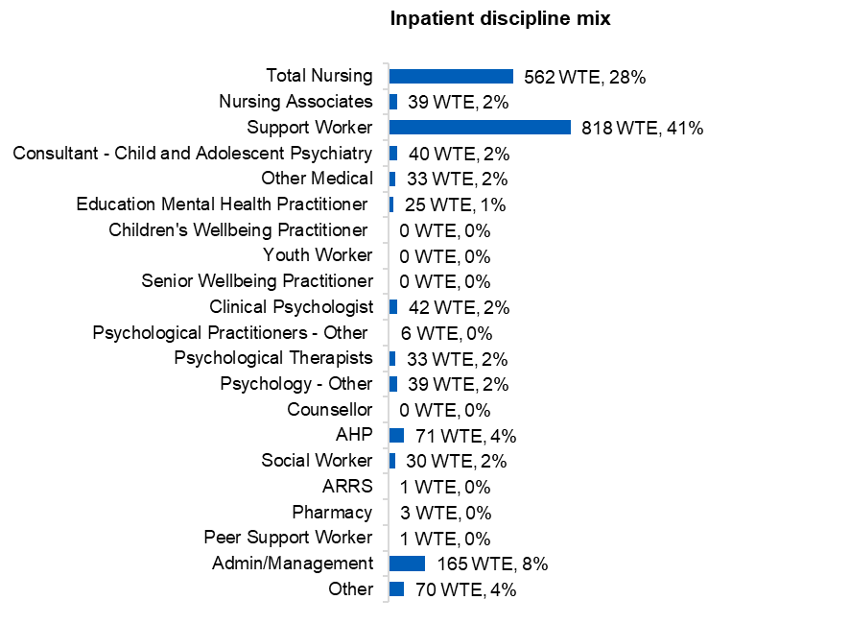

Includes data from 46 organisations who made full submissions and 7 organisations who made abridged submissions.

### Eating disorder services– NHS

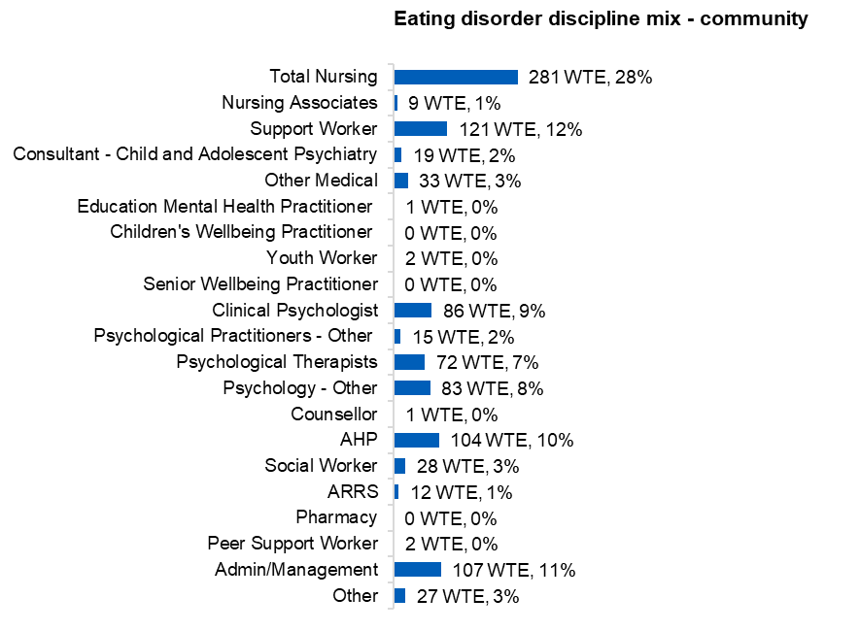Within community eating disorder services there were 1,002 WTE staff reported in the census, with the largest group being nurses, at 28%, followed by support workers at 12%. In inpatient eating disorder services there were 84 WTE staff reported, with support workers forming the largest group (29%), followed by nurses (21%). In the community setting in particular, a multidisciplinary workforce was evident, with a large range of roles delivering eating disorder services to children and young people.

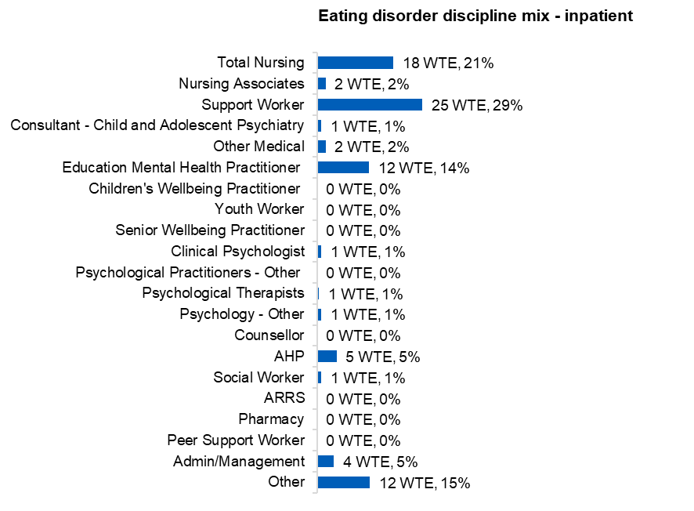

Includes data from 46 organisations who made full submissions and 7 organisations who made abridged submissions.

### Mental health support teams (MHSTs)

Mental Health Support Teams (MHSTs) provide services in school and college settings and accounted for 14% of NHS CYPMHS staff reported in this census. The largest workforce group was education mental health practitioners representing 44% of staff, a marginal decrease from 45% in 2023. In the NHS, psychological therapists made up 10% of MHST staff while admin/management accounted for a further 10%. Other roles with a notable presence in MHSTs were children’s wellbeing practitioners (7%), nurses (6%) psychological practitioners – other (6%), psychology – other (4%) and social workers (3%). The discipline mix was very similar when data from the NHS providers and local authority MHSTs was combined.

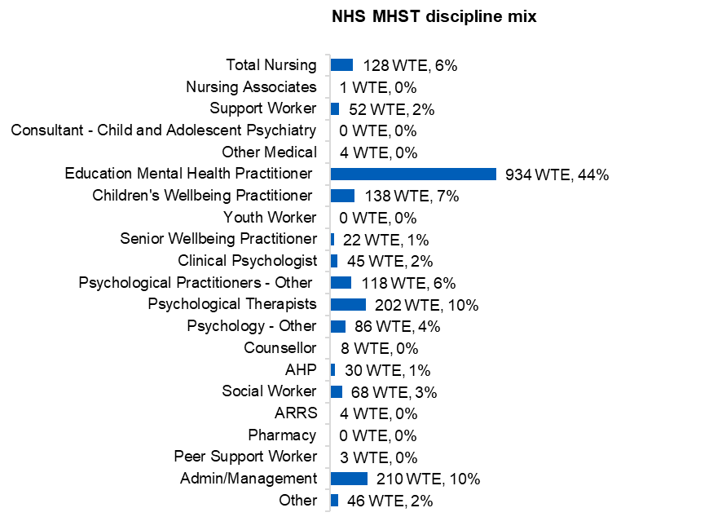

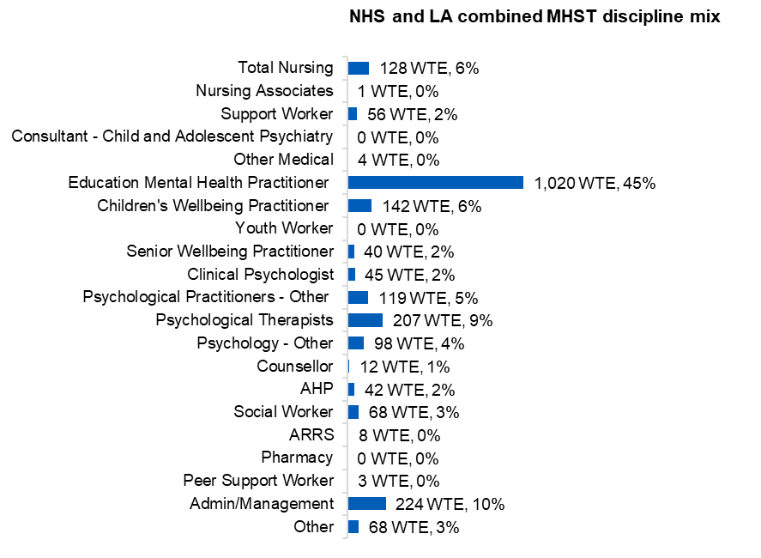

For the NHS, this includes data from 46 organisations who made full submissions and 7 organisations who made abridged submissions.

## Workforce group profiles

### Nursing salary banding - NHS

Within the community setting, the majority of nurses (79%) were band six or seven, whilst in the inpatient setting, there was a much greater presence of band five nurses, with the majority of nurses reported being band five or six (82%).

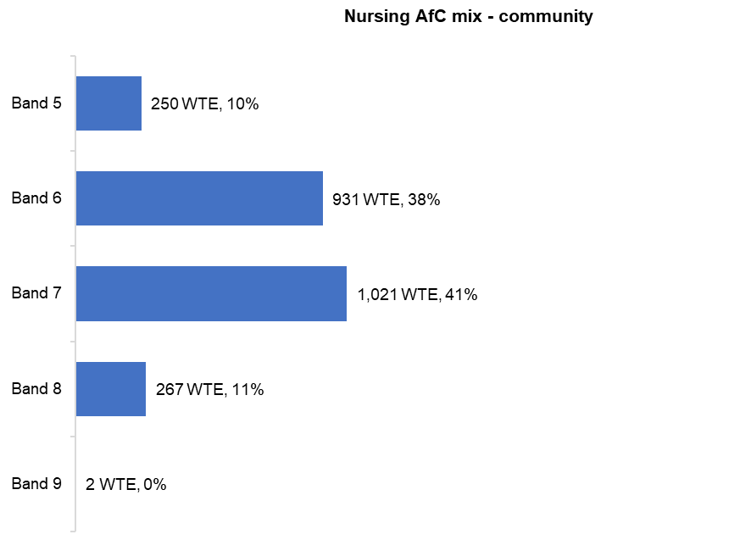

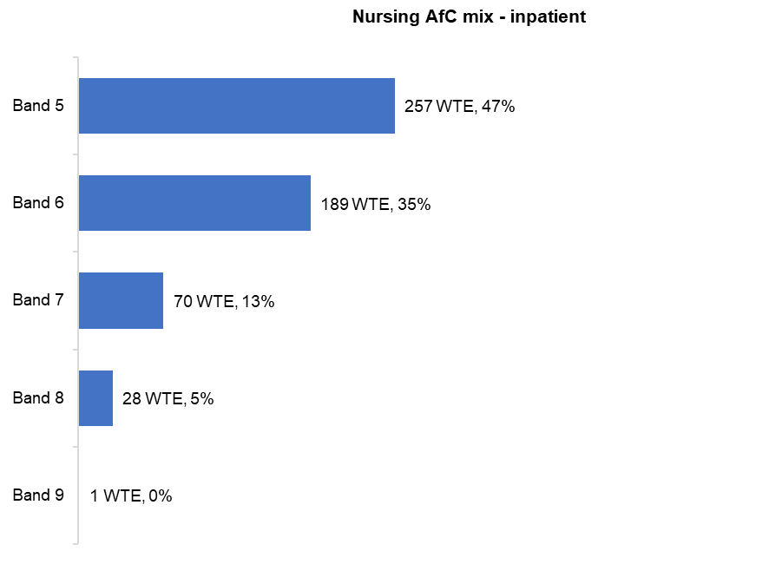

Includes data from 46 organisations who made full submissions and 7 organisations who made abridged submissions.

### Nursing salary banding timeseries - NHS

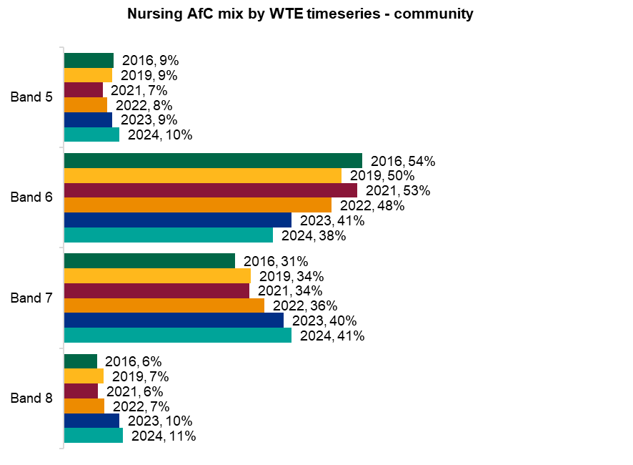Over the last four rounds of the CYPMHS workforce census there has been a sustained increase in the proportion of band five, seven and eight nurses in the community setting, and conversely a decrease in the proportion of nurses who are band six. This may indicate registered nurses within community services are upskilling, potentially taking on more advanced roles. In the inpatient setting, though band five nurses are still by far the largest group, this proportion has been decreasing over the iterations of this census.

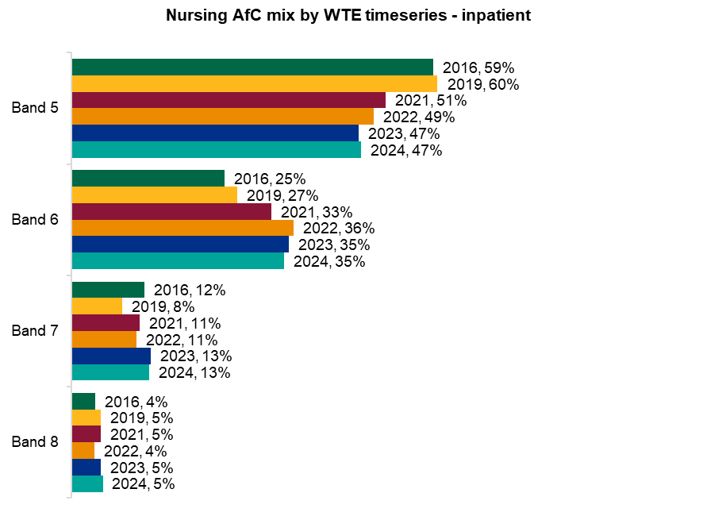

Includes data from 46 organisations who made full submissions and 7 organisations who made abridged submissions.

### Profile of medical roles – NHS

A total of 554 WTE community and 55 WTE inpatient medical staff were reported as part of this census with a more granular job role. Across both settings, consultant – child and adolescent psychiatry represented the largest proportion of the medical workforce, at 54% in the community and 52% in inpatient services. The profile of the medical workforce was largely similar across the community and inpatient settings, though there are a smaller range of medical roles represented in the inpatient setting. Trainee doctors accounted for 4% of community medical staff and 2% in the inpatient setting.

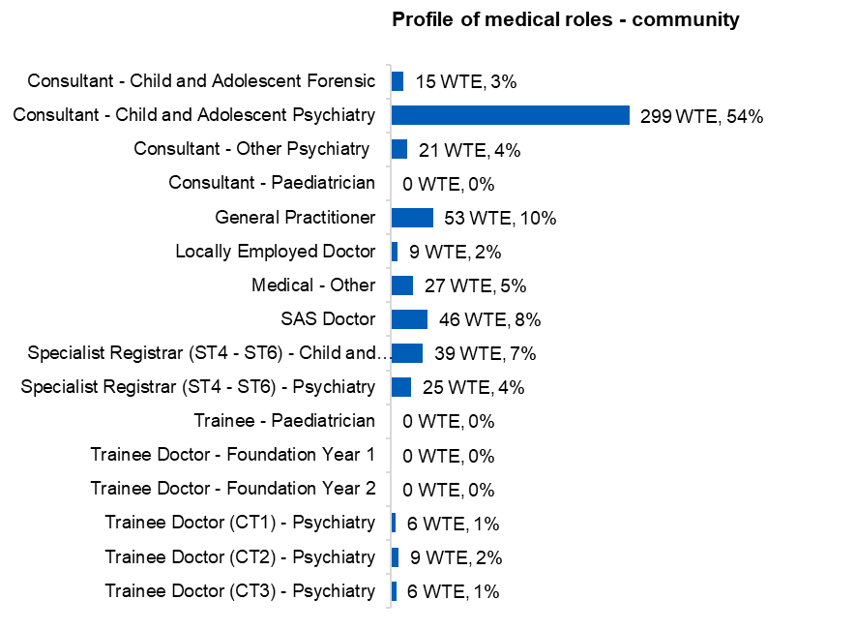

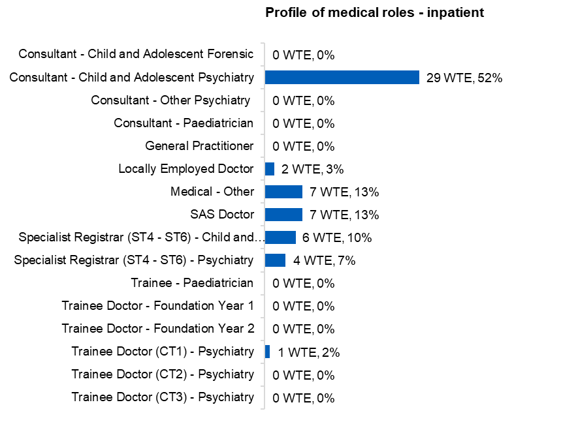

Includes data from 46 organisations who made full submissions only.

### Profile of psychology roles – NHS

There were a total of 1,724 WTE psychology staff reported in the census with a more granular job role,1,660 WTE based in the community and 64 WTE in the inpatient setting. Clinical psychologists were the largest proportion of psychology staff in both settings, constituting 57% in the community and 48% in inpatient services. Assistant psychologists also represented a notable section, 30% in community and 43% in inpatient.

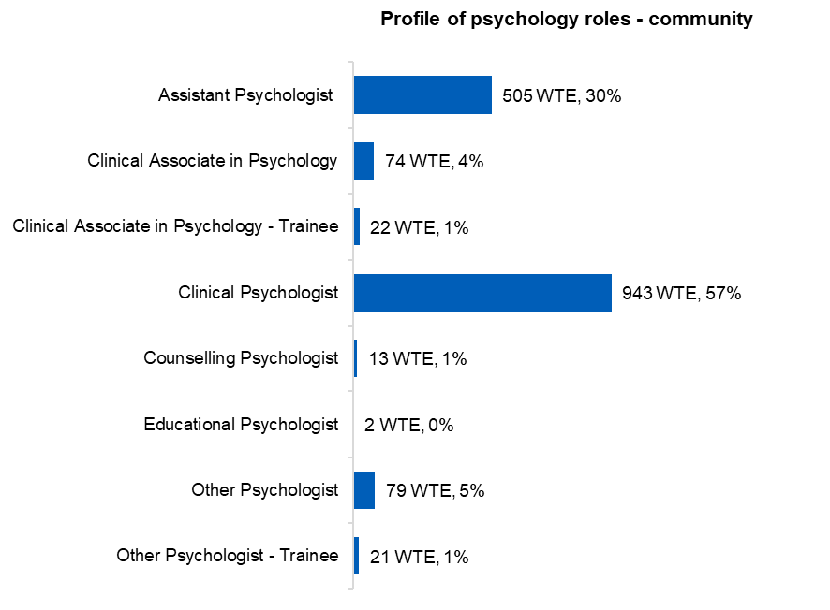

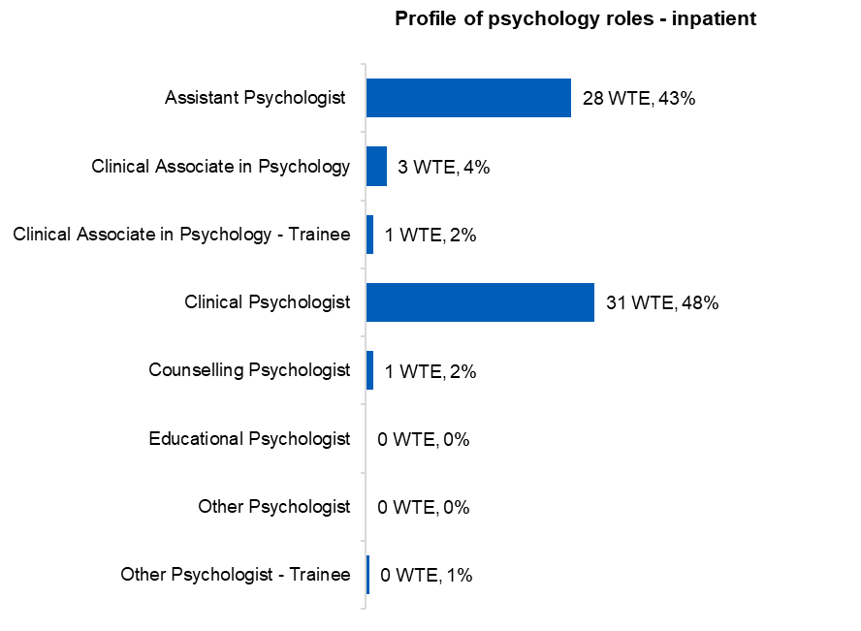

Includes data from 46 organisations who made full submissions only.

### Profile of psychological therapists roles – NHS

There were a total of 1,068 WTE staff reported within the psychological therapists staff grouping with a more granular job role, 1,048 WTE based in the community and 20 WTE in the inpatient setting. Child and adolescent psychotherapists were the largest proportion of psychological therapists staff in both settings, constituting 44% in the community and 52% in inpatient services. Other psychological therapists (31% in community), and family and systemic psychotherapists (14% in community and 35% in inpatient) also represented notable sections of the psychological therapists workforce.

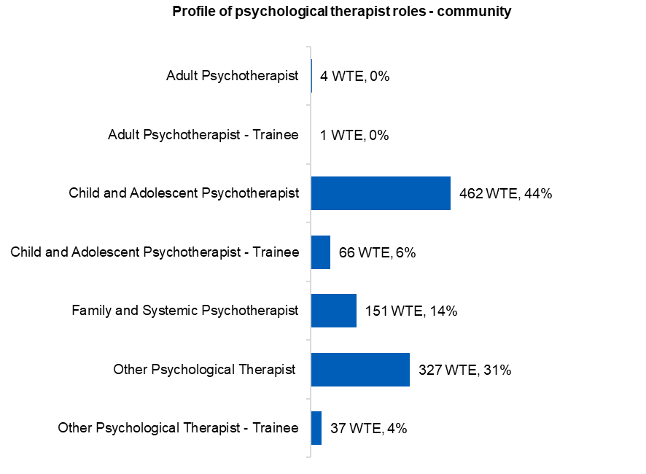

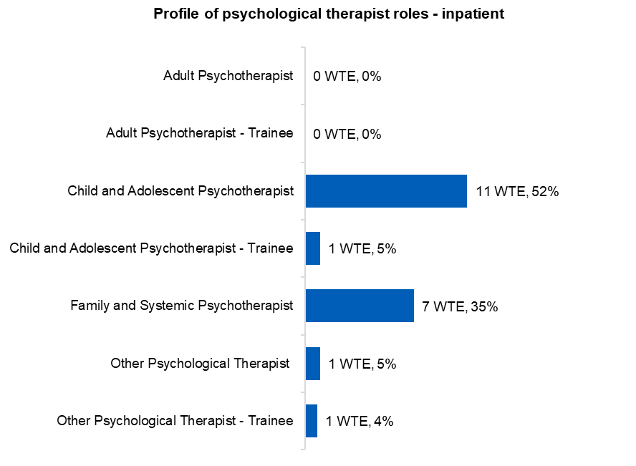

Includes data from 46 organisations who made full submissions only.

### Profile of allied health profession (AHP) roles – NHS

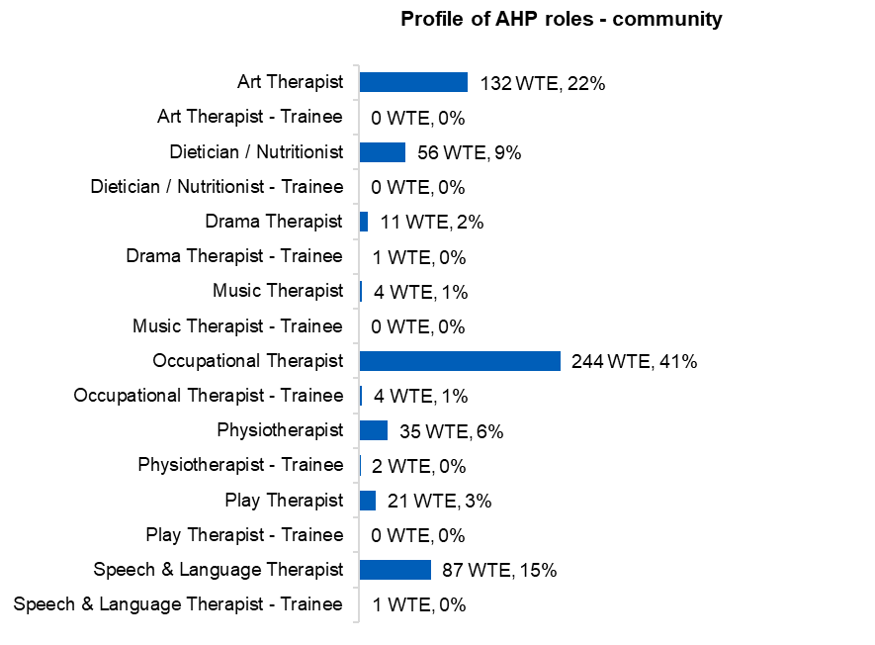In both settings, where a more granular job role was provided, occupational therapists made up the largest proportion of allied health professionals working in CYPMHS, accounting for 41% in the community and 60% in inpatient services. Art therapists were the second largest group, representing 22% of AHPs in the community and 15% of AHPs in inpatient services. Overall, there was a greater range of AHP roles present in the community setting, whereas in many of the AHP roles had no WTE reported against them in the inpatient setting.

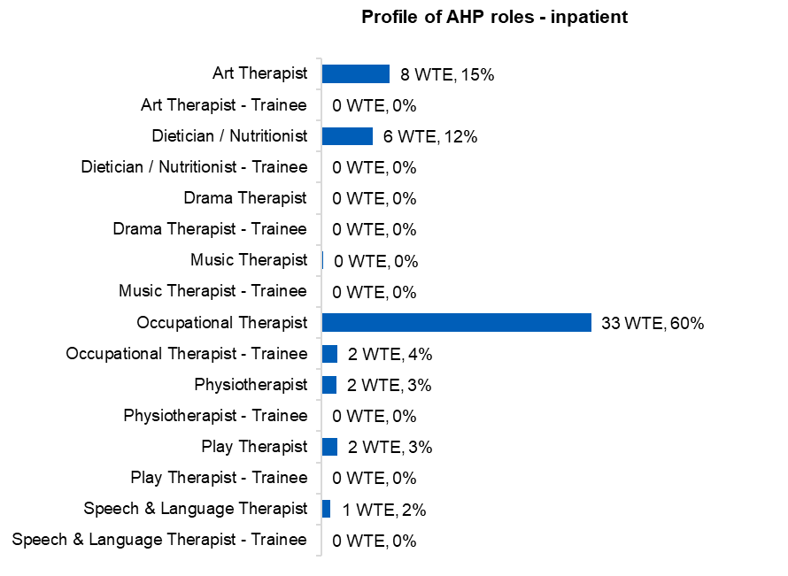

Includes data from 46 organisations who made full submissions only.

### Profile of ARRS roles – NHS

Staff reported to be working in children and young people’s mental health services as part of the additional role reimbursement scheme were predominantly mental health practitioners, with a small number of care coordinators also reported.

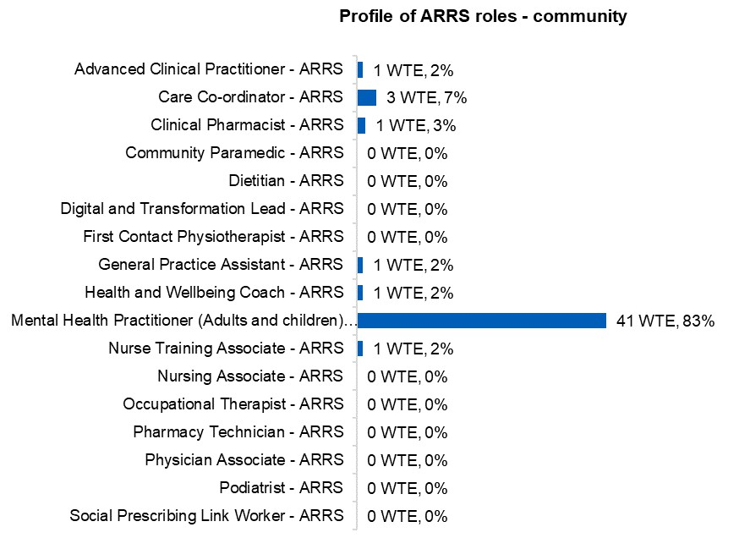

Includes data from 46 organisations who made full submissions only.

## HR metrics

### Vacancies by team type - NHS

Vacancy rates by team type were calculated using only submissions that had provided both a numerator (vacancy WTE by team type) and a denominator (funded establishment WTE by team type). Overall, the vacancy rate was 18% in the community setting, and 22% in the inpatient setting. Overall, around 2,000 WTE vacancies were reported in the community setting and 300 WTE in the inpatient setting. There were 29 participating trusts that consistently submitted staff in post and vacancies data in 2023 and 2024. Based on these trusts alone, the vacancy rate* reduced from 24% in 2023 to 17% in 2024. Notably, vacancy rates tended to be higher in the highest intensity settings working with young people with the most complex needs.

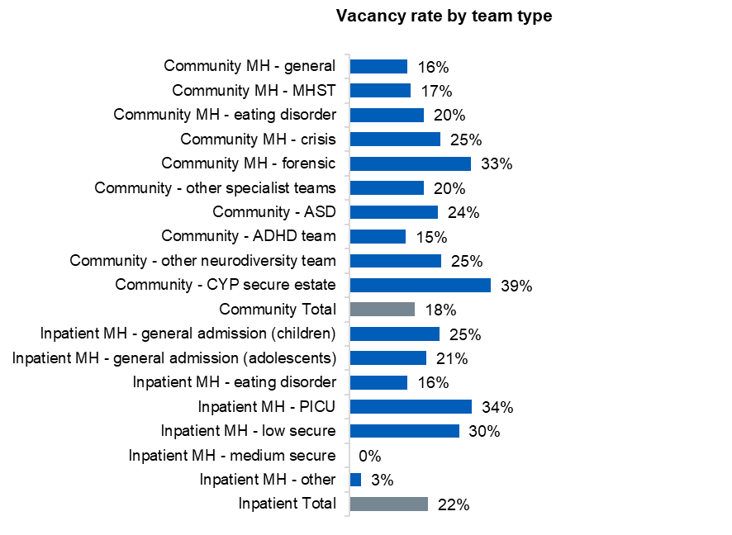

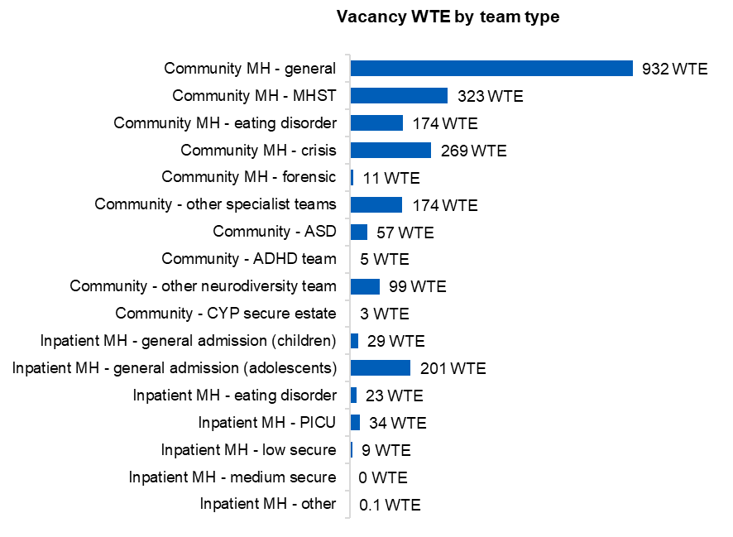

*Please note, in 2024 funded establishment was collected directly for the first time, so for the year-on-year comparison funded establishment was calculated as staff in post WTE

plus vacancy WTE in order to use a consistent methodology across the two years

### Vacancies by job role - NHS

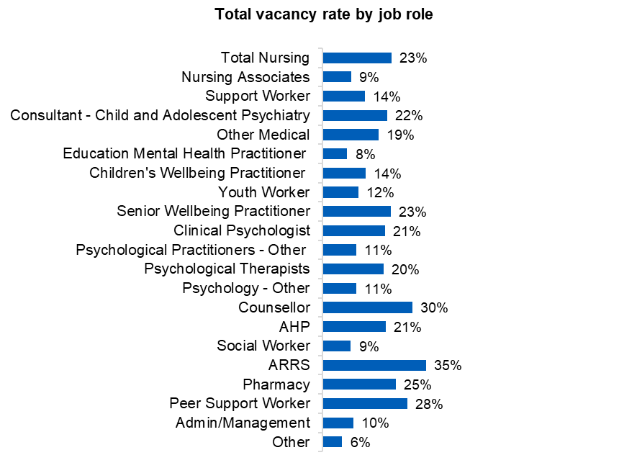Funded establishment was not collected by job role, so was instead calculated (staff in post, minus bank and agency staff, plus vacancies) to be used as the denominator to calculate the vacancy rates by job role. Rates were calculated using only submissions that had provided data for both the numerator and denominator. The nursing vacancy rate was 23% overall with a total of 610 WTE vacant posts reported. This compares to a 30% nursing vacancy rate reported by this census in 2023*. There were 234 WTE psychological therapists vacancies reported, with a 20% vacancy rate. Clinical psychiatry formed the next largest group of vacancies by WTE (217 WTE), with a 21% vacancy rate.

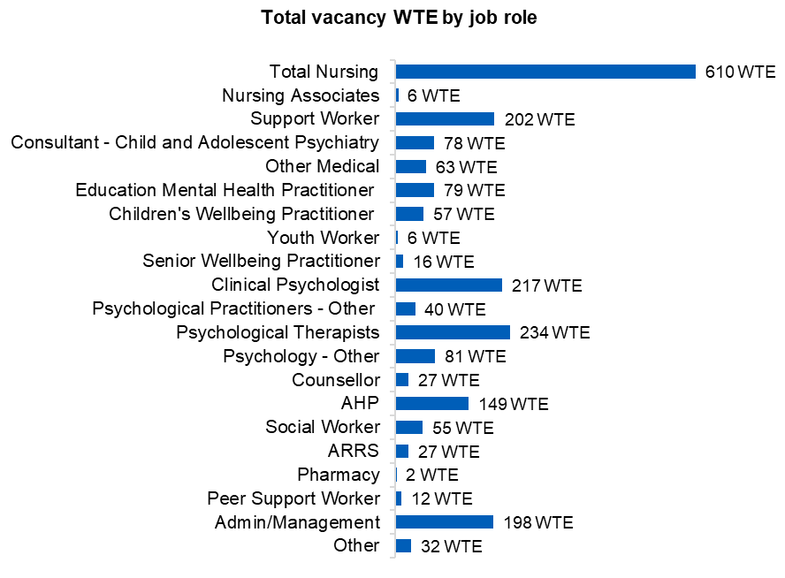

*Please note there was variation in the organisations that contributed to the census in 2023 and 2024 and therefore this is not a perfect like for like comparison

### Vacancy rates by job role - NHS

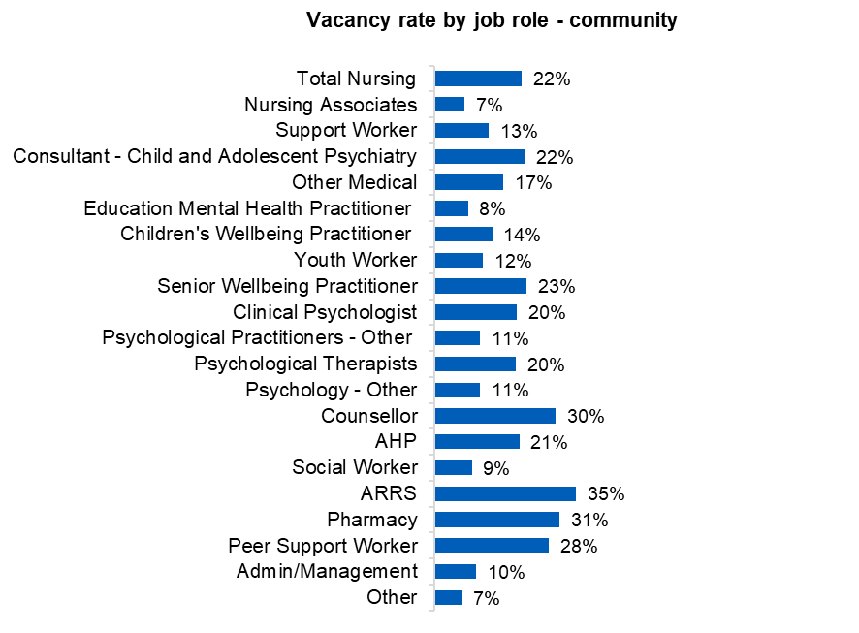Funded establishment was not collected by job role, so was instead calculated (staff in post, minus bank and agency staff, plus vacancies) to be used as the denominator to calculate the vacancy rates by job role. Rates were calculated using only submissions that had provided data for both the numerator and denominator. The nursing vacancy rate was 22% in the community setting and 30% in the inpatient setting, which compares to an overall nursing vacancy rate of 30% reported by this census in 2023*. The vacancy rate for consultant child and adolescent psychiatrists was 22% in the community setting and 14% in the inpatient setting, while for clinical psychiatrists the vacancy rate was 20% in the community and 37% in the inpatient setting.

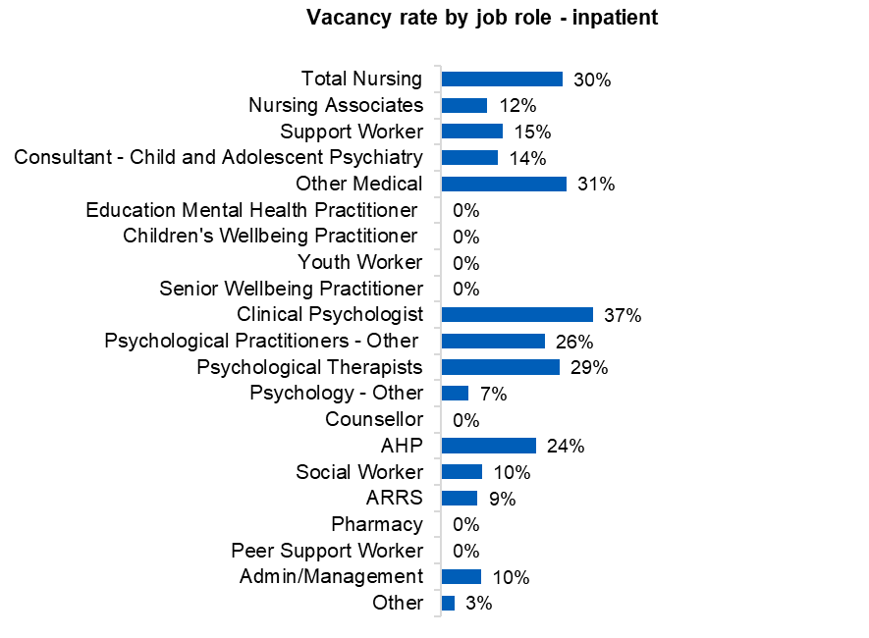

*Please note there was variation in the organisations that contributed to the census in 2023 and 2024 and therefore this is not a perfect like for like comparison

### Vacancy WTE by job role - NHS

Nurses represented the largest number of vacancies in both the community setting (468 WTE) and inpatient setting (142 WTE), as expected given they are the largest workforce group. The second largest number of vacancies in the community setting was psychological therapists (228 WTE), closely followed by clinical psychologists (202 WTE). In the inpatient setting, support workers represented the second largest number of vacancies (96 WTE).

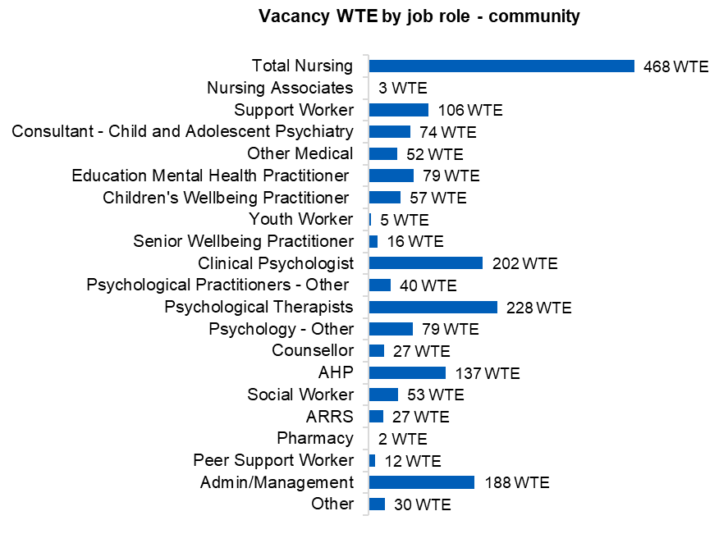

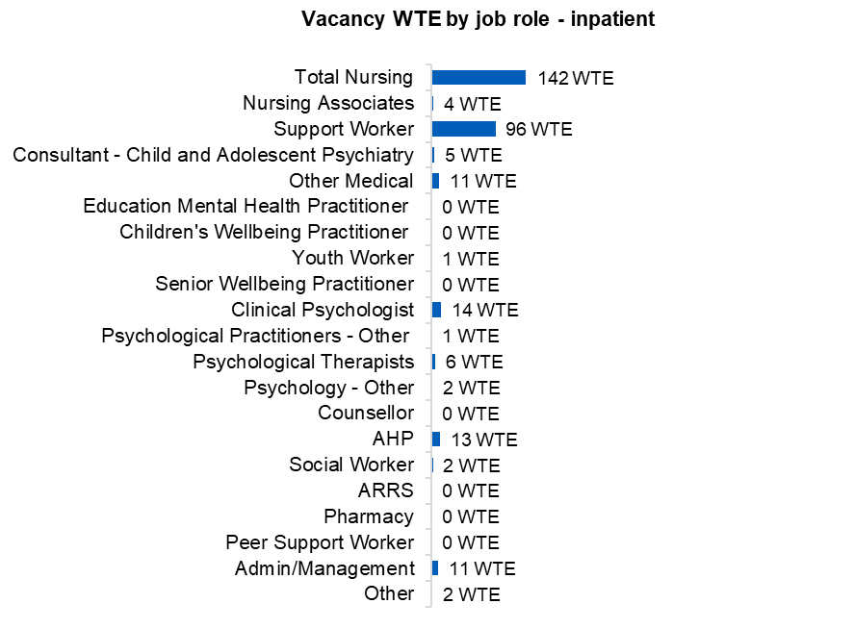

### Sickness absence rate - NHS

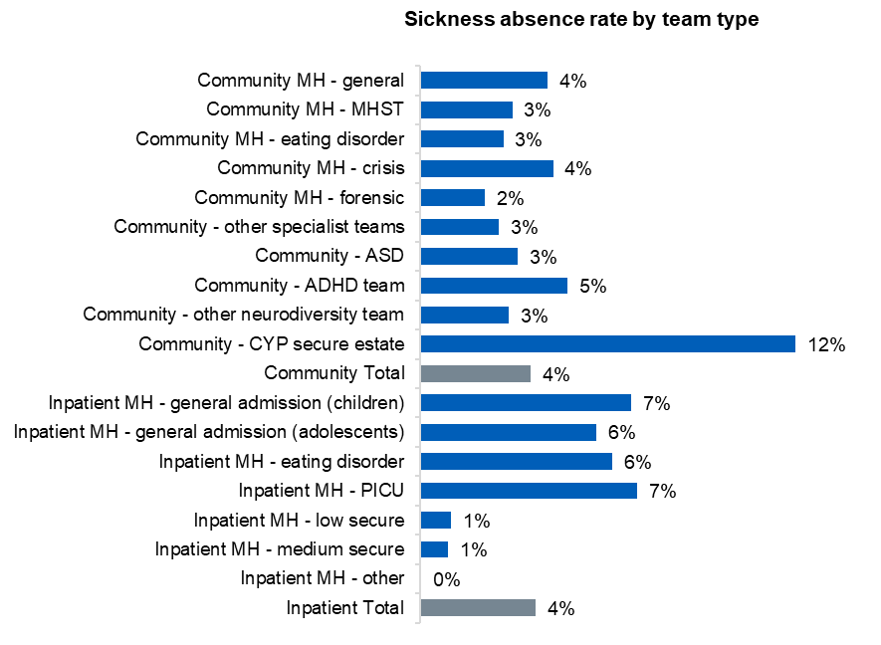Sickness absence rate was calculated using only submissions that had provided both a numerator (WTE sickness absence days by team type) and a denominator (total available WTE working days by team type). Across both the community and inpatient setting, the average sickness absence rate reported was 4%. The largest sickness absence rate reported was in the CYP secure estate, however this should be understood in the context of the relatively small number of staff working in this area.

### Staff retention rate - NHS

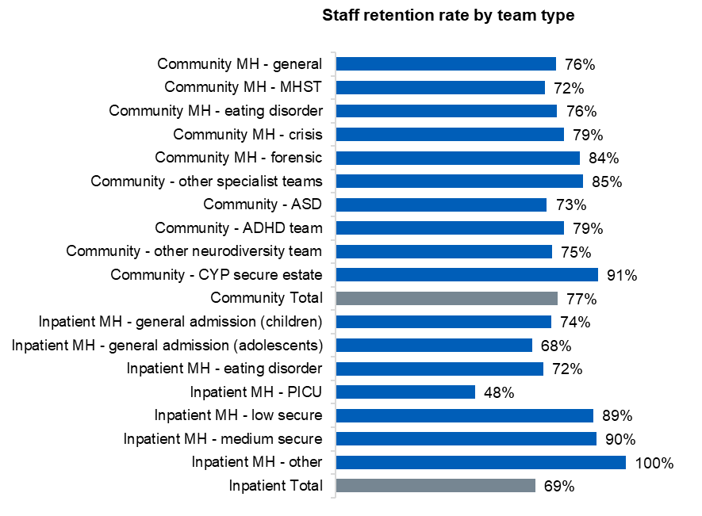Staff retention rate was calculated using only submissions that had provided both a numerator (WTE staff in post on the 1st April 2023 still in post on the 31st March 2024 by team type) and a denominator (WTE staff in post as of 1st April 2023 by team type). In the community setting, there was an average of 77% staff retention across all community team types, and a range from 42% to 99% by submission. In the inpatient setting there was an average of 69% staff retention and a range from 39% to 100% by submission.

## Community staff retention rate – by submission

**Inpatient staff retention rate – by submission**

### Time in post - NHS

Participants were asked to report the number of years staff had been in their current post. Please note, this metric only shows how staff members have been working in their current role and does not account for whether staff have been promoted or moved to a new role. The distribution of staff by time in post is very similar to 2023, with the vast majority of staff having been in post less than five years. Time in post is calculated by headcount (HC) rather than WTE.

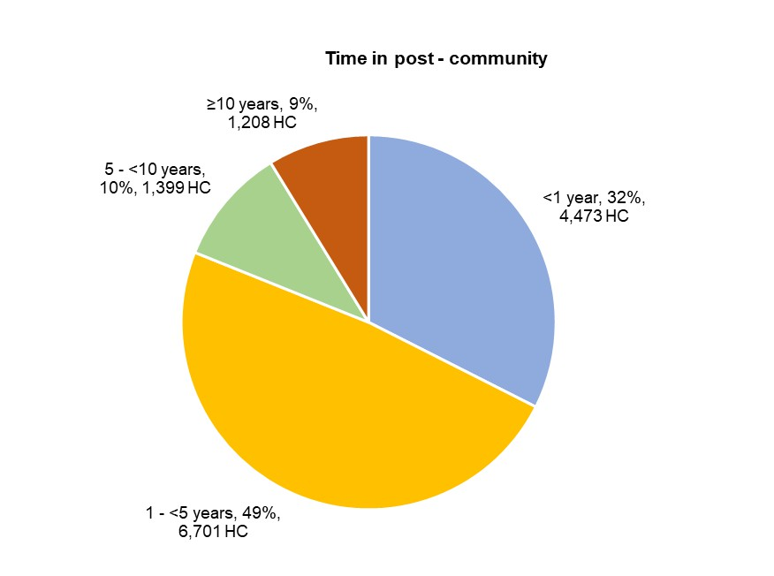

### Contract type - NHS

In both the community and inpatient setting, the majority of staff were employed on a permanent contract. However, the proportion of staff on a fixed term/temporary contract was higher in community services at 13% than in inpatient services at 5%. Bank and agency staff in post as of the census date made up a very small proportion of staff in both settings. Contract type is calculated by headcount (HC) rather than WTE.

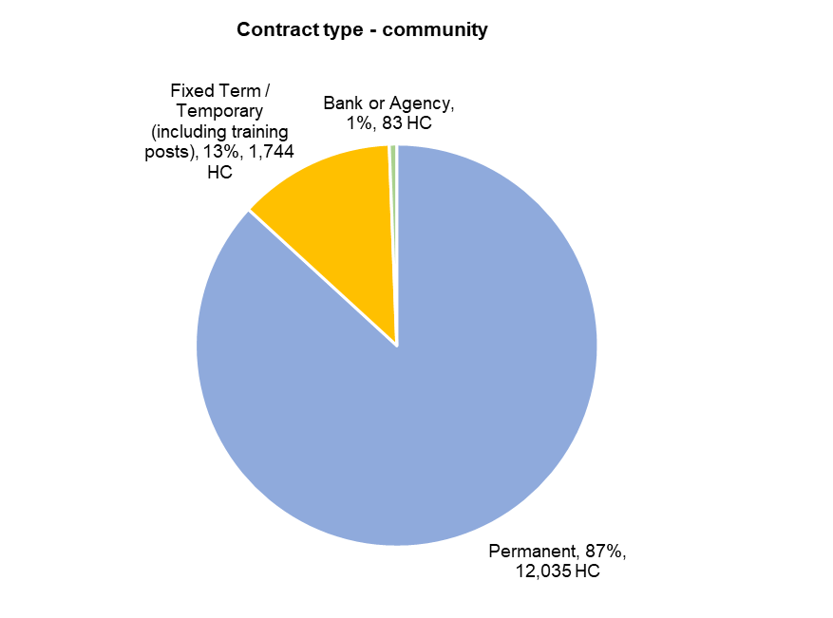

### Staff demographics: Ethnicity of staff

Asian or Asian British staff were consistently underrepresented in the CYPMHS workforce across all sectors, comparative to the proportion of the England working age and 0-17 population. Furthermore, in the NHS there was a higher proportion of black or black British staff, when compared to the general working age population. It should be noted that where there is large proportion of staff for whom ethnicity is not stated or not known, this may deflate the proportion in the identified ethnicity categories. This is particularly notable in the local authority sector where the ethnicity of 16% of staff was not recorded.

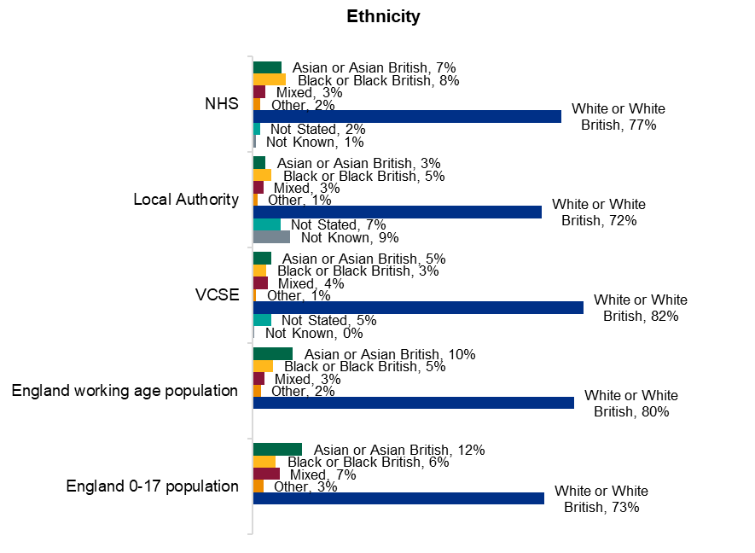

### Ethnicity of staff

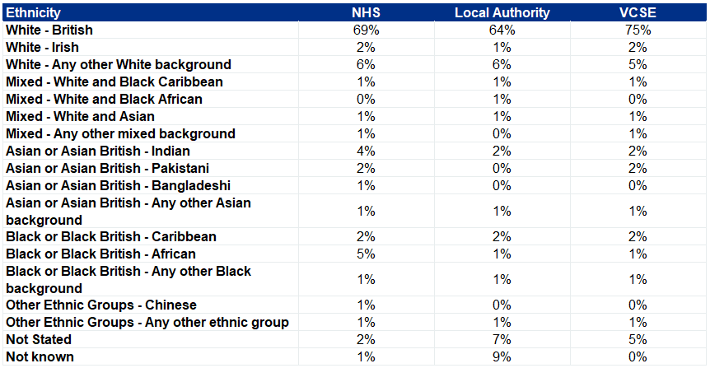Staff ethnicity was collected at a granular level, as shown in the table below. The chart on the previous slide shows the same data aggregated up to broader categories.

### Ethnicity of staff by AfC banding – NHS community

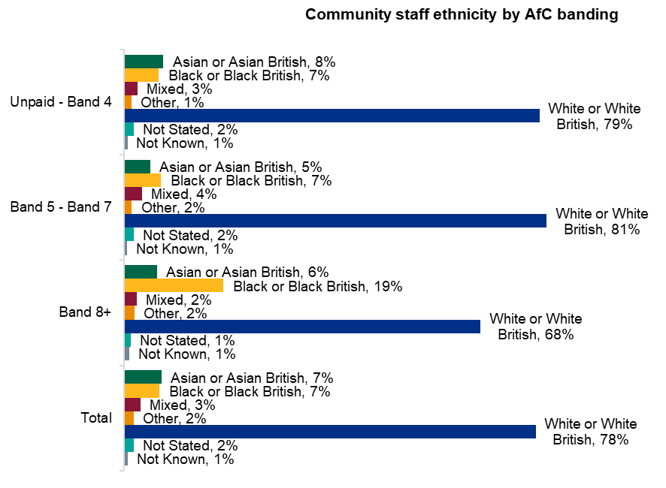For the first time, this year the CYPMHS workforce census asked participating organisations to report the ethnicity of their workforce by grouped AfC bands. The chart on the left below shows ethnic groups as a proportion of the pay band groups, while the chart on the right shows pay band groups as a proportion of the different ethnic groups.

### Ethnicity of staff by AfC banding – NHS inpatient

For the first time, this year the CYPMHS workforce census asked participating organisations to report the ethnicity of their workforce by grouped AfC bands. The chart on the left below shows ethnic groups as a proportion of the pay band groups, while the chart on the right shows pay band groups as a proportion of the different ethnic groups.

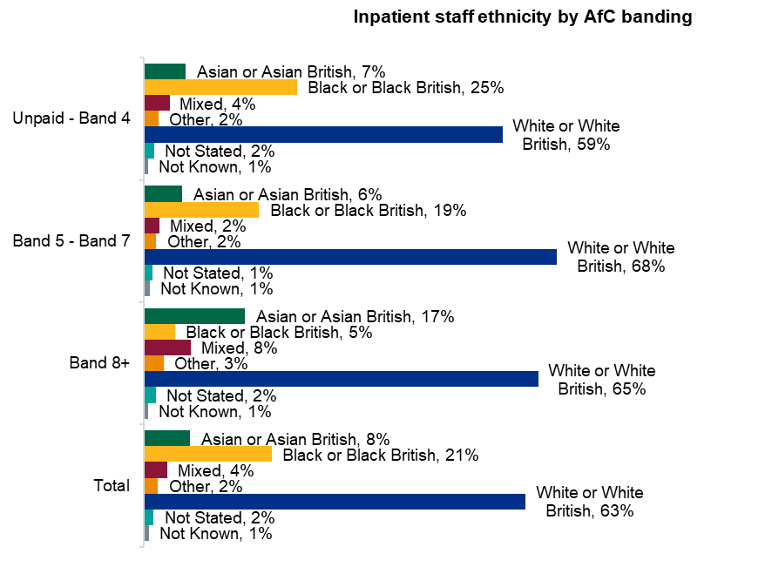

### Age of staff

NHS providers reported a slightly younger workforce, with 50% of staff aged under 40, while this was 40% in the local authority sector and 45% in the VCSE sector. Local authorities had the lowest proportion of staff aged under 30, while in the VCSE sector staff were very evenly distributed between ages 30 and 60. Across all three sectors, the distribution of staff by age band was similar to what was reported in 2023. In all sectors there were lower proportions of staff under 20 and over 60 than the overall working age population for England.

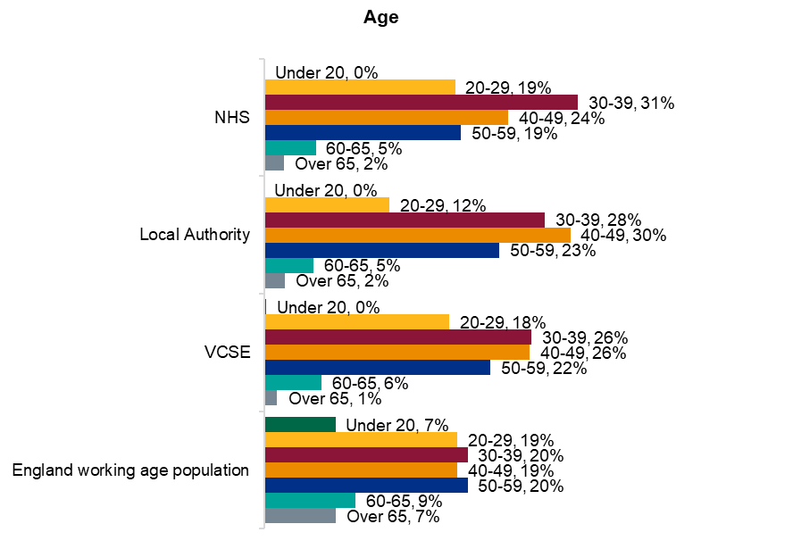

### Gender of staff

As in all previous years of the CYPMHS workforce census, the workforce was predominantly female across all sectors. The split in the NHS and VCSE sector is the same as 2023, with the proportion on males in the LA sector dropping from 15% to 12%. This compares to an overall working age adult population that is 49% male and 51% female in England (2021 census), and an overall NHS workforce that is 24% male and 76% female. In every sector non-binary people were reported to make up ≤1% of the workforce.

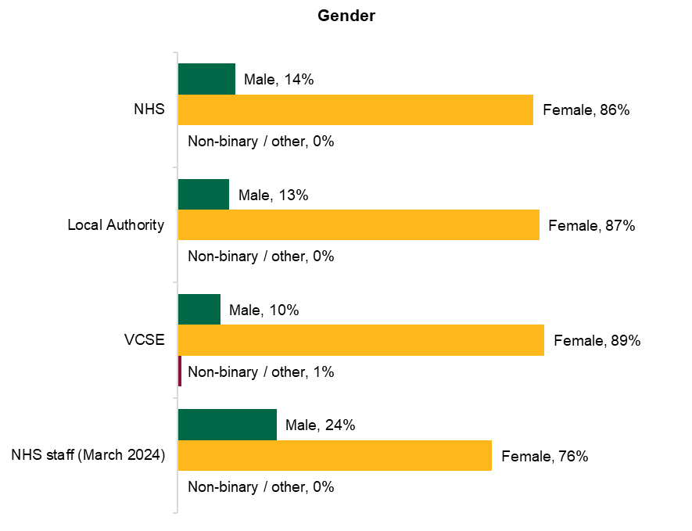

### Gender of staff by AfC banding – NHS community

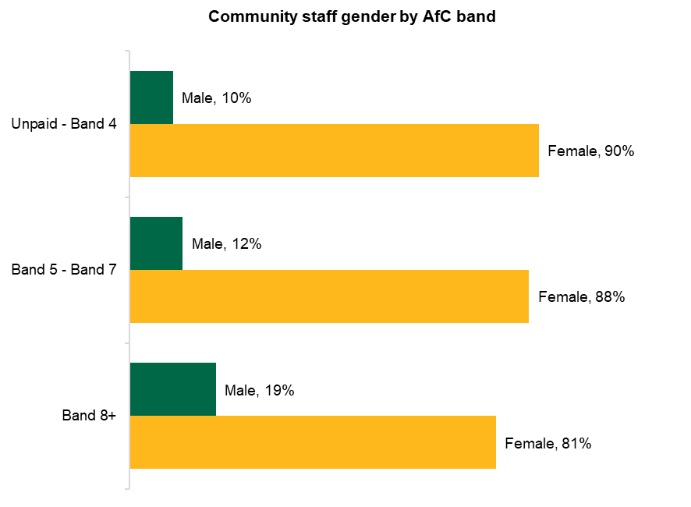The chart on the left below shows male and female staff as a proportion of the pay band groups, while the chart on the right shows pay band groups as a proportion of male and female staff. These charts show that while the workforce is predominantly female at all levels within community CYPMHS services, the gap narrows somewhat in the higher pay bands where there is a higher proportion of male staff, with 30% of male staff a band 8 or above, compared to 19% of female staff.

### Gender of staff by AfC banding – NHS inpatient

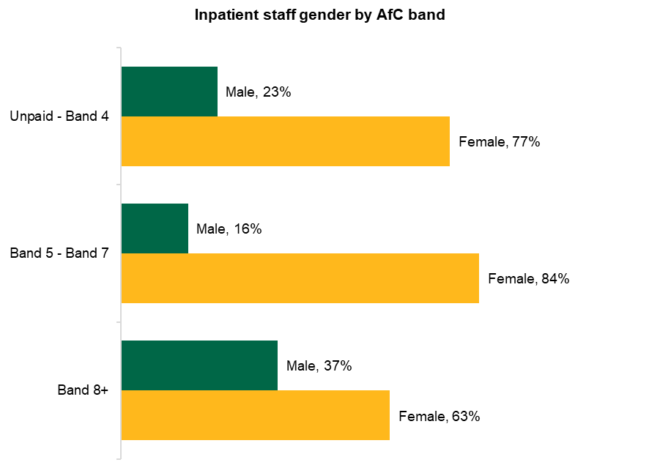The chart on the left below shows male and female staff as a proportion of the pay band groups, while the chart on the right shows pay band groups as a proportion of male and female staff. Similar to the community setting, these charts show that in inpatient services the majority of the workforce is female at all levels, but that the gap narrows somewhat in the higher pay bands where there is a higher proportion of male staff, with 12% of male staff a band 8 or above, compared to 6% of female staff.

### Staff disability status

NHS providers reported the highest proportion of staff with a disability, and the lowest proportion of staff whose disability status was not known. Conversely, the local authority sector had the lowest proportion of staff with a disability and the highest proportion of ‘not known’. This compares to the most recent ‘labour market status of disabled people’9 published by the government in August 2024 which reported that 25% of the working age population had a disability.

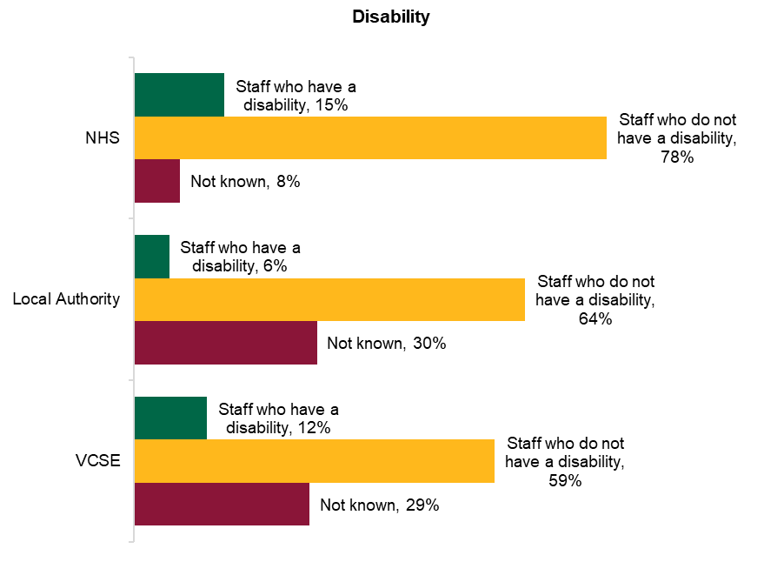

### Contracted hours

The contracted hours of staff across the three sectors varied, with a larger proportion of local authority staff working full time, and a greater proportion of part time workers in the NHS and VCSE sectors. In the NHS, the proportion of staff in each WTE band is very similar to what was reported in 2023, with only marginal change. As the NHS works to transform, grow and retain the workforce, opportunities for more flexible working may be an important consideration.

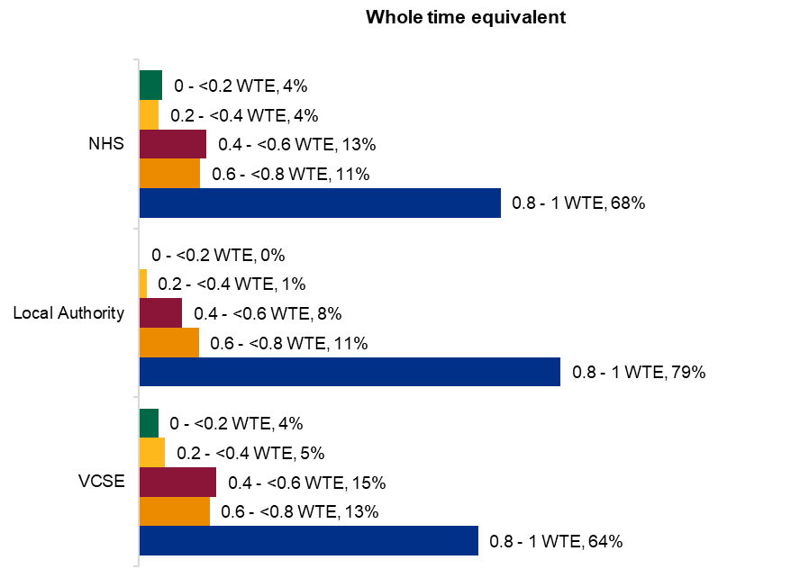

### Contracted hours by gender - NHS

The majority of CYPMHS staff in the NHS, regardless of gender worked between 0.8 and 1 WTE (76% of men and 67% of women). These proportions have increased from the last census with the gap between the proportion of men and women working full time widening to 9%, from 7% in 2023, where 72% of men worked full time and 65% of women. Similar to 2023, around 1.7 times as many women (25%) than men (15%) were reported to be working between two and four days a week (0.4 – 0.8 WTE).

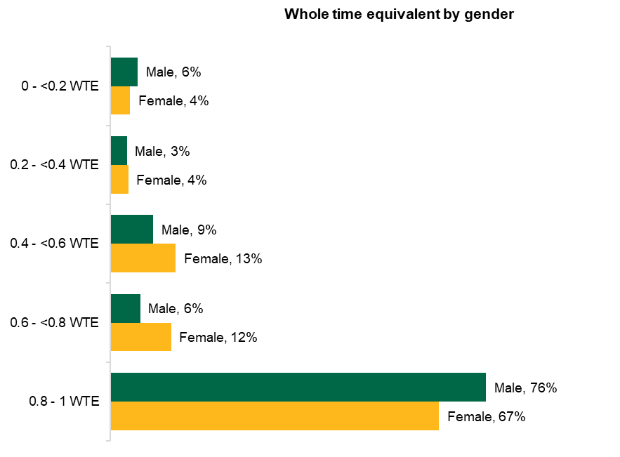

## Local authority overview

# Local authority data submissions

The local authority (LA) data collection template was distributed to all 151 local authorities in England. There were 22 LAs that confirmed that they provided CYPMH services and submitted to the census. Of the 151 local authorities that were contacted, 16% responded by confirming that they do not provide CYPMH services.

|  |  |  |  |  |  |  |
| --- | --- | --- | --- | --- | --- | --- |
| **Does the local authority provide CYPMH services?** | **2016** | **2019** | **2021** | **2022** | **2023** | **2024** |
| Yes | 37 | 57 | 46 | 53 | 34 | 22 |
| No | 23 | 68 | 45 | 40 | 42 | 24 |
| No response received | 92 | 27 | 61 | 59 | 75 | 105 |

## 

### Local authority discipline mix

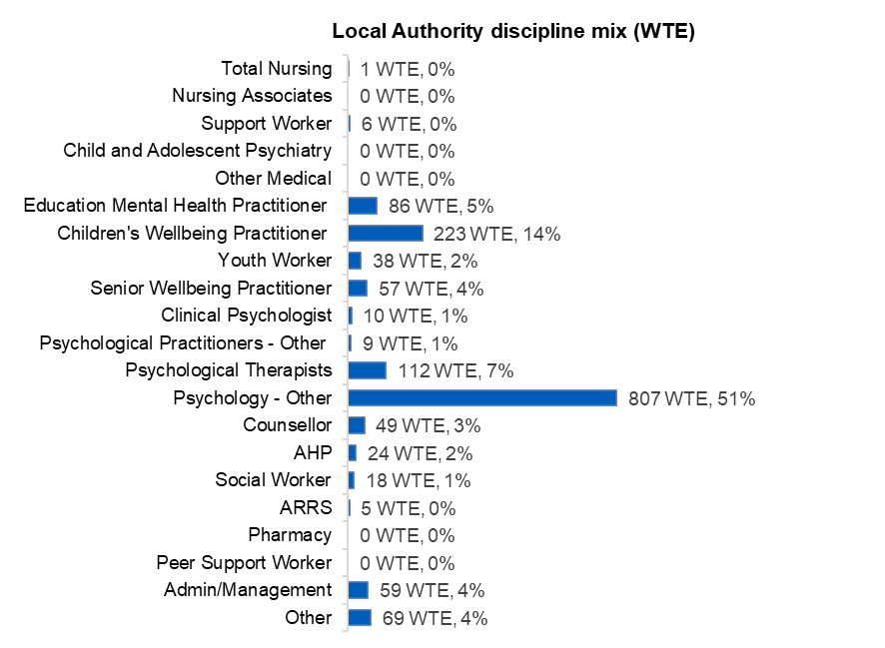Within CYPMH services delivered by local authorities, the most common job group was Psychology - Other, which represented 51% of the workforce. The second largest job group was children’s wellbeing practitioners, which accounted for 14% of the workforce. Psychological therapists (7%) and education mental health practitioners (5%) were the next largest job role groups. The highest number of WTE reported was 153 and the lowest was 0.8, with a median of 19 WTE per submission.

### Voluntary sector overview

# Voluntary sector data submissions

The voluntary sector (also known as the third sector) is one of the most diverse sectors with various commissioning arrangements across organisations including but not limited to the NHS and local authorities. The third sector has been highlighted as an important part of CYPMH service provision, providing support to children, young people, as well as parents and carers.

The voluntary sector offers a range of services which are often more diverse and tailored compared to statutory services. Many voluntary sector organisations have commissioning arrangements with local authorities and the NHS as part of their CYPMHs arrangements. Due to this there is a large variety and diversity in the services offered by the voluntary sector often targeting a specific group or need.

In 2024, 66 voluntary organisations submitted data to the project. This is an increase from the 49 organisations that took part in 2023 and the 55 organisations which took part in 2022.

This year a larger number of voluntary organisations were contacted to participate in the census – 156 compared to 147 in 2023 and 138 in 2022. These were organisations that provided services to children and young people and/or had been identified by a local authority or NHS organisation as part of their commissioned services.

### Voluntary sector discipline mix

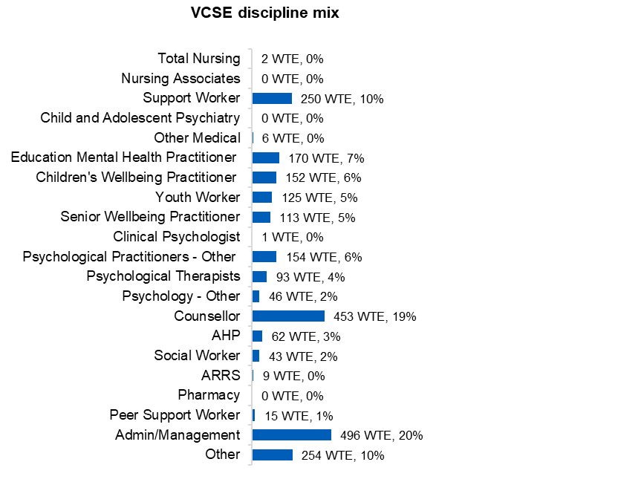The voluntary sector data collection template was distributed to 156 voluntary organisations, with 66 organisations making a submission. The organisations that submitted identified 2,444 WTE working in CYPMH services. Admin/Management formed the largest proportion of the workforce (20%), a notably higher proportion than in the other sectors in the census, increasing from 17% in 2023. The second largest workforce group was counsellors (19%) however this represents a 10 percentage point decrease from 2023 where counsellors constituted 29% of the workforce reported. The highest number of WTE reported was 576 and the lowest was 0.4, with a median of 16 WTE per submission.

## Youth justice services overview

# Youth justice services data submissions

This year 70 organisations provided data for youth justice services (YJS) (previously youth offending teams –YOTS). This was a reduction from the 89 that participated in 2023 when the CYPMHS data was collected from YJSs as part of a wider workforce collection in this sector.

When interpreting this data, it should be noted that YJSs employ a small number of CYPMH workers specifically, with the YJS workforce providing CYPMH input as part of their diverse role. The service model of YJSs tend to be organized in such a way that supporting children and young people with mental health issues is part of the holistic approach that many members of the team contribute to.

### Youth justice services workforce profile

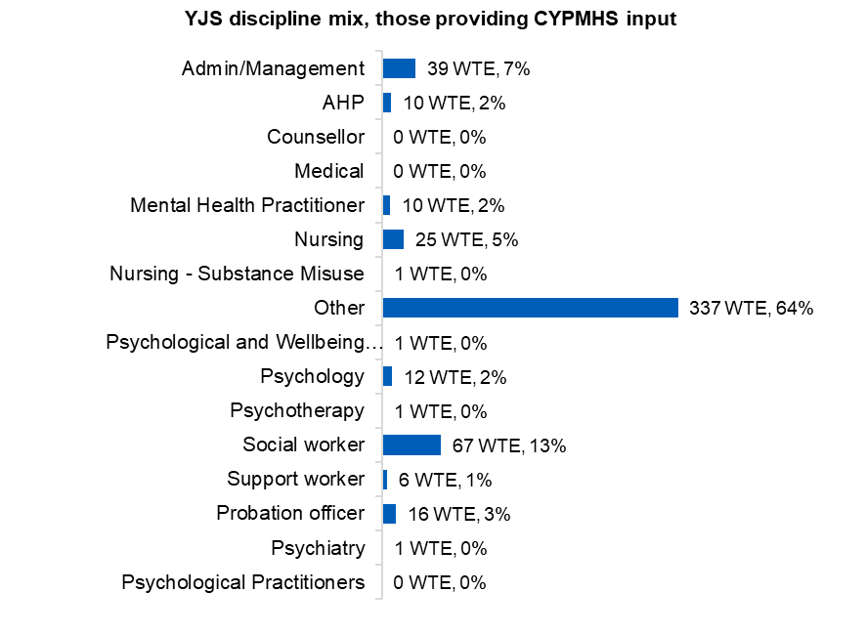This year, 70 organisations provided youth justice services (YJS) data. The services that submitted identified 525 WTE that had input into supporting children and young people in mental health services. The profile of staff providing CYPMH input in 2024 is in line with what was reported in 2023 and 2022. The largest proportion of roles is reported in ‘other roles’ (64%). Social workers and admin/management are the next largest groups, at 13% and 7% respectively. The median WTE reported to be proving input into children and young people’s mental health was 7, with a range from 47 WTE to 0.5 WTE.

## Skills and training

This year the actual numbers of submissions that reported staff trained was reported, rather than percentages. This is to increase transparency, as where trusts have not completed the skills and training section it is unclear whether this means zero staff trained, or that they just haven't got the data available. This makes defining a denominator difficult, and therefore we felt providing the actual number was more accurate.

## General community teams (NHS)

The green and orange tables on this and the following four pages show high (green) and low (orange) numbers of submissions received where the organisation reported ≥1 staff member trained in each area. As in 2023 and 2022, in general community CYPMHS teams Cognitive Behavioural Therapy (CBT) had the highest number of submissions reporting staff trained in this area. The lowest provision in 2023 was parenting for children (under 10 years) with conduct and behavioural problems), which this year rose to the 10th most reported training area.

Number of submissions received where the organisation reported ≥1 staff member trained

|  |  |
| --- | --- |
| **High provision** | |
| Cognitive Behavioural Therapy (CBT) for young people with depression and anxiety | 32 |
| Eye Movement Desensitisation Reprogramming (EMDR) | 30 |
| Formal instruction (including CYP-IAPT) in ‘developing a formulation | 29 |
| ASD assessment approaches (e.g. ADOS/ADI or DISCO) | 27 |
| CBT Informed Practice/Low Intensity | 27 |
| Dialectical Behaviour Therapy (DBT) | 27 |
| Family Therapy (FT) | 27 |
| Service Transformational Leadership | 27 |
| Trauma informed training | 27 |
| Parenting for children (under 10 years) with conduct and behavioural problems (e.g. The Incredible Years, Positive Parenting Program -Triple P, Parent-Child Interaction Therapy -PCIT, Parent Management Training - PMT, Defiant Teens) | 26 |

|  |  |
| --- | --- |
| **Low provision** | |
| Systems training for emotional predictability and problem solving  (STEPPS) | 2 |
| CBT for Avoidant Restrictive Food Intake Disorder (ARFID) | 2 |
| Dietary counselling for eating disorders | 3 |
| Focal psychodynamic therapy (FPT) | 4 |
| Adolescent-focused psychotherapy for anorexia nervosa (AFP-AN). | 5 |
| Bulimia-nervosa-focused family therapy (FT-BN) | 7 |
| Working with 0-5s training via CYP IAPT | 8 |
| Systemic Family Practice (SFP) for eating disorders | 8 |
| Social prescribing | 8 |
| Anorexia-nervosa-focused family therapy for children and young people (FT-AN) (single or multiple-family) | 9 |

### Mental health support teams (NHS)

The top four highest reported training areas in 2024 were the same as in 2023 for MHSTs. Self-harm, trauma informed training and suicide prevention were also in the top ten last year, though the order has moved slightly.

Number of submissions received where the organisation reported ≥1 staff member trained

|  |  |
| --- | --- |
| **High provision** | |
| CBT Informed Practice/Low Intensity | 27 |
| Supervision (diploma level) | 24 |
| Cognitive Behavioural Therapy (CBT) for young people with depression  and anxiety | 22 |
| Psycho-education / guided self-help | 19 |
| Self-harm | 17 |
| Trauma informed training | 17 |
| Parenting for children (under 10 years) with conduct and behavioural | 15 |
| Suicide prevention | 15 |
| Formal instruction (including CYP-IAPT) in ‘developing a formulation | 13 |
| Formal instruction in bio-psycho-social mental health assessment including | 12 |

|  |  |
| --- | --- |
| **Low provision** | |
| Family Interventions for Psychosis (FI) | 0 |
| Dietary counselling for eating disorders | 0 |
| Bulimia-nervosa-focused family therapy (FT-BN) | 0 |
| Anorexia-nervosa-focused family therapy for children and young people  (FT-AN) (single or multiple-family) | 0 |
| Adolescent-focused psychotherapy for anorexia nervosa (AFP-AN). | 0 |
| Systems training for emotional predictability and problem solving  (STEPPS) | 1 |
| Focal psychodynamic therapy (FPT) | 1 |
| Combination - prescribing and psychological therapy | 1 |
| CBT for Avoidant Restrictive Food Intake Disorder (ARFID) | 1 |
| Approved clinician (non-medical) | 1 |

### Eating disorder community teams (NHS)

The top four highest reported training areas in 2024 were the same as in 2023 for eating disorder teams. Trauma informed training, bulimia-nervosa focussed family therapy and suicide prevention were also in the top ten training areas last year, though the order has changed slightly.

#### Number of submissions received where the organisation reported ≥1 staff member trained

|  |  |
| --- | --- |
| **High provision** | |
| Anorexia-nervosa-focused family therapy for children and young people  (FT-AN) (single or multiple-family) | 18 |
| ARFID training | 17 |
| CBT for Eating Disorders | 17 |
| Family Therapy (FT) | 16 |
| Systemic Family Practice (SFP) for eating disorders | 16 |
| Bulimia-nervosa-focused family therapy (FT-BN) | 14 |
| Dialectical Behaviour Therapy (DBT) | 14 |
| Suicide prevention | 14 |
| Trauma informed training | 14 |
| Motivational Interviewing | 13 |

|  |  |
| --- | --- |
| **Low provision** | |
| Systems training for emotional predictability and problem solving  (STEPPS) | 0 |
| Social prescribing | 0 |
| Working with 0-5s training via CYP IAPT | 1 |
| SFP for over 10s with conduct problems, or depression and self-harm | 1 |
| Interpersonal Psychotherapy for adolescents (IPT-A) with moderate to  severe depression | 1 |
| Family Interventions for Psychosis (FI) | 1 |
| Enhanced Evidence Based Practitioners (EEBP) | 1 |
| Focal psychodynamic therapy (FPT) | 2 |
| Mentalisation Approaches (e.g. AMBIT) | 3 |
| CBT for Psychosis | 3 |

### Crisis community teams (NHS)

The areas that the highest number of crisis teams reported staff trained in were dialectical behaviour therapy (DBT), CYP crisis including presentations, self-harm, suicide prevention, AMBIT for crisis care risk management and trauma informed training. Conversely, no crisis teams reported staff trained in working with 0-5s training via CYP IAPT, focal psychodynamic therapy (FPT), family interventions for psychosis (FI), enhanced evidence based practitioners (EEBP) or dietary counselling for eating disorders.

Number of submissions received where the organisation reported ≥1 staff member trained

|  |  |
| --- | --- |
| **High provision** | |
| Dialectical Behaviour Therapy (DBT) | 16 |
| CYP crisis including presentations | 14 |
| Self-harm | 13 |
| Suicide prevention | 13 |
| AMBIT for crisis care and risk management | 12 |
| Trauma informed training | 12 |
| ASD assessment approaches (e.g. ADOS/ADI or DISCO) | 11 |
| Mentalisation Approaches (e.g. AMBIT) | 11 |
| Brief treatment and planning in crisis care | 10 |
| Service Transformational Leadership | 9 |

|  |  |
| --- | --- |
| **Low provision** | |
| Working with 0-5s training via CYP IAPT | 0 |
| Focal psychodynamic therapy (FPT) | 0 |
| Family Interventions for Psychosis (FI) | 0 |
| Enhanced Evidence Based Practitioners (EEBP) | 0 |
| Dietary counselling for eating disorders | 0 |
| Systems training for emotional predictability and problem solving  (STEPPS) | 1 |
| Systemic Family Practice (SFP) for eating disorders | 1 |
| Social prescribing | 1 |
| Outreach enhanced supervision (for supervisors not attending full diploma  course) | 1 |
| Interpersonal Psychotherapy for adolescents (IPT-A) with moderate to  severe depression | 1 |

### Inpatient general admission - adolescent (NHS)

The areas that the highest number of general admission adolescent services reported staff trained in were family therapy (FT), dialectical behaviour therapy (DBT), and trauma informed training. Conversely, no general admission adolescent services reported staff trained in systems training for emotional predictability and problem solving (STEPPS), focal psychodynamic therapy (FPT) or approved clinician (non-medical).

#### Number of submissions received where the organisation reported ≥1 staff member trained

|  |  |
| --- | --- |
| **High provision** | |
| Family Therapy (FT) | 9 |
| Dialectical Behaviour Therapy (DBT) | 7 |
| Trauma informed training | 7 |
| ARFID training | 6 |
| ASD assessment approaches (e.g. ADOS/ADI or DISCO) | 6 |
| Cognitive Behavioural Therapy (CBT) for young people with depression  and anxiety | 6 |
| Suicide prevention | 6 |
| Anorexia-nervosa-focused family therapy for children and young people  (FT-AN) (single or multiple-family) | 5 |
| CBT for Psychosis | 5 |
| CBT Informed Practice/Low Intensity | 5 |

# 

|  |  |
| --- | --- |
| **Low provision** | |
| Systems training for emotional predictability and problem solving  (STEPPS) | 0 |
| Focal psychodynamic therapy (FPT) | 0 |
| Approved clinician (non-medical) | 0 |
| Working with 0-5s training via CYP IAPT | 1 |
| Systemic Family Practice (SFP) for eating disorders | 1 |
| SFP for over 10s with conduct problems, or depression and self-harm | 1 |
| Mentalisation based treatment (MBT) | 1 |
| Interpersonal Psychotherapy for adolescents (IPT-A) with moderate to  severe depression | 1 |
| Formal instruction in bio-psycho-social mental health assessment including  risk assessment | 1 |
| Formal instruction (including CYP-IAPT) in ‘developing a formulation | 1 |

### Service models: Service models – general community teams (NHS)

There was substantial variation in the service offers reported, ranging from services that 94% of respondents offered, to specialised services offered by just 5% of organisations. Almost all respondents reported offering joint working, family therapy or group work as part of their CYPMH offer. Over 80% provided a specialist CYPMHS community/outpatient service, support for children and young people with ADHD, mental health promotion in the community and evidence-based parenting programmes.

Appropriate provision of services to meet population need, and to ensure equitable and timely access to appropriate services is the ambition for children and young people’s mental health services. Ensuring a workforce with the appropriate skills, training, and of the appropriate size to deliver services is the key enabler to achieving CYP service ambitions.

|  |  |  |  |  |
| --- | --- | --- | --- | --- |
| **Service model - general community teams** | **Percentage responding 'Yes'** | **Yes** | **No** | **Total responses** |
| Joint working/family therapy/group work | 94% | 64 | 4 | 68 |
| Specialist CYPMHS Community / Outpatient Service | 82% | 55 | 12 | 67 |
| Treatment and support for CYP with ADHD | 82% | 55 | 12 | 67 |
| Mental Health Promotion in the community, schools, within primary care | 82% | 54 | 12 | 66 |
| Evidence based parenting programmes | 81% | 52 | 12 | 64 |
| Outreach work | 80% | 51 | 13 | 64 |
| Training & Education to staff working in primary care/universal services (schools, GPs) | 78% | 49 | 14 | 63 |
| Adapted therapeutic approaches (e.g. CBT) for CYP with ASD accessing therapy | 77% | 48 | 14 | 62 |
| Treatment and support for CYP with a learning disability and a mental health need | 73% | 48 | 18 | 66 |
| CYPMHS workers delivering practice based care | 72% | 42 | 16 | 58 |
| Support to Youth Offending Teams | 69% | 44 | 20 | 64 |
| Do you provide specific support for the 16 - 17 age group with targeted transition services? | 68% | 45 | 21 | 66 |
| Provision of services to schools or colleges | 66% | 41 | 21 | 62 |
| Specific services for children in and leaving care and adopted children | 62% | 38 | 23 | 61 |
| Treatment and support for CYP with ASD as a primary diagnosis | 58% | 37 | 27 | 64 |

### Service models – general community teams (NHS)

|  |  |  |  |  |
| --- | --- | --- | --- | --- |
| **Service model - general community teams** | **% responding 'Yes'** | **Ys** | **No** | **Total responses** |
| Early years support for infants / toddlers | 56% | 35 | 27 | 62 |
| CYP MH Primary Care Mental Health Team (Dedicated CYP MH delivery) | 56% | 34 | 27 | 61 |
| Specific services for foster carers | 50% | 30 | 30 | 60 |
| Support to LA behaviour support & inclusion services | 50% | 31 | 31 | 62 |
| Emerging personality disorder / emotional dysregulation service | 44% | 29 | 37 | 66 |
| Post-diagnostic support for CYP with ASD | 43% | 26 | 34 | 60 |
| Paediatric Liaison Service / joint work with paediatric team (incl. in-reach for admissions) | 41% | 26 | 37 | 63 |
| Specific support to BAME groups within the community | 39% | 24 | 38 | 62 |
| Support to drug & alcohol services | 36% | 21 | 38 | 59 |
| Personality disorder services | 33% | 21 | 43 | 64 |
| Liaison and diversion for Police custody | 32% | 19 | 40 | 59 |
| Crisis response - not 24/7 | 31% | 18 | 40 | 58 |
| Ante & post-natal specific support | 28% | 17 | 44 | 61 |
| Specialist autism services | 23% | 14 | 47 | 61 |
| Assertive Outreach Teams | 22% | 13 | 47 | 60 |
| Do you offer intensive home treatment (as an alternative to inpatient care) connected to this service? | 21% | 12 | 46 | 58 |
| Eating Disorder Services | 19% | 11 | 48 | 59 |
| Do you provide services for children and young people up to the age of 25? | 16% | 10 | 53 | 63 |
| Sensory Impairment Services | 14% | 8 | 51 | 59 |
| Crisis response - 24/7 | 12% | 7 | 50 | 57 |
| Specific services for ARFID | 12% | 7 | 53 | 60 |
| Are any of your services specifically commissioned by the criminal justice system? | 11% | 7 | 54 | 61 |
| Intensive neurodisability service | 10% | 6 | 55 | 61 |
| Is your crisis service offered to patients aged 0-25? | 7% | 4 | 54 | 58 |

## Appendix 1: Job role mapping

### 2023 job role mapping

Please note, the mapping above does not relate to how roles were mapped in the 2023 CYPMHS workforce report. This shows how they were reorganised in line with the 2024 mapping in order to provide an accurate year on year comparison in this report.

|  |  |
| --- | --- |
| **Admin/Management** | **Additional Roles Reimbursement Scheme (ARRS)** |
| Administrator - Data entry | Clinical Pharmacists_ARRS |
| Administrator - General | Dietitians_ARRS |
| Project manager | Pharmacy technicians_ARRS |
| Team manager | Podiatrists_ARRS |
| Departmental Manager_ Apprentice | Nurse Training Associates_ARRS |
| Team Leader_ Apprentice | Nursing Associates_ARRS |
| Senior Leader_ Apprentice | Advanced Practitioners_ARRS |
| Chartered Manager_ Apprentice | Care co-ordinators_ARRS |
| **Allied Health Professions** | Community Paramedics_ARRS |
| Dietician / Nutritionist | General Practice Assistant_ARRS |
| Therapist - Physiotherapist | Health and well-being coaches_ARRS |
| Therapist - Speech & Language Therapist | Physician associates_ARRS |
| Therapist - Art Therapist | The Digital and Transformation Lead_ARRS |
| Therapist - Drama Therapist | The social Prescribing Link Worker_ARRS |
| Therapist - Music Therapist | First contact physiotherapists_ARRS |
| Therapist - Play Therapist |  |
| Occupational Therapist |  |

|  |  |  |  |  |  |
| --- | --- | --- | --- | --- | --- |
|  | |  |  | |  |
| **Children's Wellbeing Practitioner** | | | **Other** | | |
| Children's Wellbeing Practitioner (CWP) | | | Assistant Practitioner_ Apprentice | | |
| Children's Wellbeing Practitioner (CWP) Trainee | | | Enhanced Clinical Practitioner_ Apprentice | | |
| Children’s Psychological wellbeing practitioner | | | Other_ Apprentice | | |
|  | | | Physician associate | | |
| **Clinical Psychologist** | | | Assistant/Associate Practitioner | | |
| Psychology - Clinical Psychologist | | | Nursing - Nursery Nurse | | |
|  | | | Other | | |
| **Counsellor** | | | Student - Other | | |
|  | | | Student - Therapist | | |
| **Education Mental Health Practitioner** | | | CYP - Psychiatry - Consultant | | |
| Education Mental Health Practitioner (EMHP) | | | **Nursing Associates** | | |
| Education Mental Health Practitioner (EMHP) Trainee | | | Nursing Associate Trainees | | |
|  | | | Nursing Associates | | |

|  |  |  |
| --- | --- | --- |
| **Other Medical** | **Peer Support Worker** | **Senior Wellbeing Practitioner** |
| Other - Psychiatry - Consultant | Peer support / Expert by Experience |  |
| Paediatrician - Trainee |  | **Support Worker** |
| CYP - Psychiatry - (non-consultant) Trust/staff grade | **Pharmacy** | Healthcare support worker_ Apprentice |
| CYP - Psychiatry - Specialist Registrar (ST4 - ST6) | Pharmacist | Senior Healthcare Support Worker_ Apprentice |
| CYP - Psychiatry - Trainee Doctor |  | Social Care Support Worker |
| CYP - Psychiatry - Trainee Doctor (CT1) | **Psychological Therapists** | Support Worker / other unqualified clinical staff |
| CYP - Psychiatry - Trainee Doctor (CT2) | Psychotherapy - Adult Psychotherapist |  |
| CYP - Psychiatry - Trainee Doctor (CT3) | Psychotherapy - Psychological Therapist (other) | **Total Nursing** |
| CYP - Psychiatry - Trainee Doctor (FY1) | Psychotherapy - Child & Adolescent Psychotherapist | Student - Nurse |
| CYP - Psychiatry - Trainee Doctor (FY2) | Psychotherapy - Trainee Child & Adolescent Psychotherapist | Nursing - Advanced Practitioner |
| Medical - GP | Systemic Family Therapist | Nursing - Registered Nurse, Adult |
| Medical - Other |  | Nursing - Registered Nurse, Children's |
| Other - Psychiatry - (non-consultant) Trust/staff grade | **Psychology - Other** | Nursing - Registered Nurse, LD |
| Other - Psychiatry - Specialist Registrar (ST4 - ST6) | Psychology - Clinical Associate in Psychology | Nursing - Registered Nurse, Mental Health |
| Other - Psychiatry - Trainee Doctor | Psychology - Assistant Psychologist |  |
| Other - Psychiatry - Trainee Doctor (CT1) | Psychology - Counselling Psychologist | **Youth Worker** |
| Other - Psychiatry - Trainee Doctor (CT2) | Psychology - Educational Psychologist |  |
| Other - Psychiatry - Trainee Doctor (CT3) | Psychology - Other practitioner psychologist | Youth Worker |
| Other - Psychiatry - Trainee Doctor (FY1) | Psychology - Trainee Psychologist | Youth Intensive Psychological Practitioners (YIPP) |
| Other - Psychiatry - Trainee Doctor (FY2) |  |  |
| Paediatrician - Consultant |  |  |
| Paediatrician - Other medical grade |  |  |

|  |
| --- |
|  |

### 2024 job role mapping

|  |  |
| --- | --- |
| **Admin/Management** | **Additional Roles Reimbursement Scheme (ARRS)** |
| Administrator | Advanced Clinical Practitioner - ARRS |
| Chartered Manager - Apprentice | Care Co-ordinator - ARRS |
| Departmental Manager - Apprentice | Clinical Pharmacist - ARRS |
| Project Manager | Community Paramedic - ARRS |
| Senior Leader - Apprentice | Dietitian - ARRS |
| Senior Manager | Digital and Transformation Lead - ARRS |
| Team Leader - Apprentice | First Contact Physiotherapist - ARRS |
| Team Manager | General Practice Assistant - ARRS |
| **Allied Health Professions** | Health and Wellbeing Coach - ARRS |
| Art Therapist | Mental Health Practitioner (Adults and children) - ARRS |
| Art Therapist - Trainee | Nurse Training Associate - ARRS |
| Dietician / Nutritionist | Nursing Associate - ARRS |
| Dietician / Nutritionist - Trainee | Occupational Therapist - ARRS |
| Drama Therapist | Pharmacy Technician - ARRS |
| Drama Therapist - Trainee | Physician Associate - ARRS |
| Music Therapist | Podiatrist - ARRS |
| Music Therapist - Trainee | Social Prescribing Link Worker - ARRS |
| Occupational Therapist |  |
| Occupational Therapist - Trainee | **Children's Wellbeing Practitioner** |
| Physiotherapist | Children's Wellbeing Practitioner |
| Physiotherapist - Trainee | Children's Wellbeing Practitioner - Trainee |
| Play Therapist |  |
| Play Therapist - Trainee |  |
| Speech & Language Therapist |  |
| Speech & Language Therapist - Trainee |  |

|  |  |
| --- | --- |
| **Clinical Psychologist** | **Other Medical** |
| **Consultant - Child and Adolescent Psychiatry** | Consultant - Child and Adolescent Forensic |
|  | Consultant - Other Psychiatry |
| **Counsellor** | Consultant - Paediatrician |
| Counsellor | General Practitioner |
| Counsellor - Trainee | Locally Employed Doctor |
|  | Medical - Other |
| **Education Mental Health Practitioner** | SAS Doctor |
| Education Mental Health Practitioner | Specialist Registrar (ST4 - ST6) - Child and Adolescent Psychiatry |
| Education Mental Health Practitioner - Trainee | Specialist Registrar (ST4 - ST6) - Psychiatry |
|  | Trainee - Paediatrician |
| **Nursing Associates** | Trainee Doctor - Foundation Year 1 |
| Nursing Associate | Trainee Doctor - Foundation Year 2 |
| Nursing Associate - Trainee | Trainee Doctor (CT1) - Psychiatry |
|  | Trainee Doctor (CT2) - Psychiatry |
| **Other** | Trainee Doctor (CT3) - Psychiatry |
| Assistant Practitioner - Apprentice |  |
| Enhanced Clinical Practitioner - Apprentice | **Peer Support Worker** |
| Nursery Nurse | Peer Support Worker |
| Other | Peer Support Worker - Senior |
| Other - Apprentice | Peer Support Worker - Specialised |
| Other - Student | Peer Support Worker - Trainee |
| Physician Associate |  |
| Physician Associate - Trainee |  |

|  |  |  |
| --- | --- | --- |
| **Pharmacy** | **Psychology - Other** | **Total Nursing** |
| Pharmacist | Assistant Psychologist | Nurse - Advanced Nurse Practitioner |
| Pharmacy Technician | Clinical Associate in Psychology | Nurse - Apprentice |
| **Psychological Practitioners - Other** | Counselling Psychologist | Nurse - Registered Children |
| Mental Health and Wellbeing Practitioner | Educational Psychologist | Nurse - Registered LD / ASD |
| Psychological Wellbeing Practitioner | Other Psychologist | Nurse - Registered Mental Health |
|  | Other Psychologist - Trainee | Nurse - Student |
| **Psychological Therapists** | **Senior Wellbeing Practitioner** |  |
| Adult Psychotherapist | Senior Wellbeing Practitioner - Trainee | **Youth Worker** |
| Adult Psychotherapist - Trainee | **Social Worker** | Youth Intensive Psychological Practitioner |
| Child and Adolescent Psychotherapist |  | Youth Intensive Psychological Practitioner - Trainee |
| Child and Adolescent Psychotherapist - Trainee | **Support Worker** | Youth Worker |
| Family and Systemic Psychotherapist | Healthcare support worker - Apprentice |  |
| Other Psychological Therapist | Nursing Assistant/Associate Practitioner |  |
| Other Psychological Therapist - Trainee | Senior Healthcare Support Worker - Apprentice |  |
|  | Social Care Support Worker |  |
|  | Support Worker / Unregistered Staff - Other |  |

## Appendix 2: Skills and training

This year the actual numbers of submissions that reported staff trained was reported, rather than percentages. This is to increase transparency, as where trusts have not completed the skills and training section it is unclear whether this means zero staff trained, or that they just haven't got the data available. This makes defining a denominator difficult, and therefore we felt providing the actual number was more accurate.

## 

## General community teams

|  |  |
| --- | --- |
| **Skills & training - general community team** | **Number of submissions reporting ≥ 1 staff member trained** |
| Cognitive Behavioural Therapy (CBT) for young people with depression and anxiety | 32 |
| Eye Movement Desensitisation Reprogramming (EMDR) | 30 |
| Formal instruction (including CYP-IAPT) in ‘developing a formulation | 29 |
| ASD assessment approaches (e.g. ADOS/ADI or DISCO) | 27 |
| CBT Informed Practice/Low Intensity | 27 |
| Dialectical Behaviour Therapy (DBT) | 27 |
| Family Therapy (FT) | 27 |
| Service Transformational Leadership | 27 |
| Trauma informed training | 27 |
| Parenting for children (under 10 years) with conduct and behavioural problems (e.g. The Incredible Years, Positive Parenting Program -Triple P, Parent-Child Interaction Therapy -PCIT, Parent Management Training -PMT, Defiant Teens) | 26 |
| Psychodynamic psychotherapy | 26 |
| Supervision (diploma level) | 26 |
| Attachment informed interventions e.g. Dyadic Developmental Psychotherapy or Video Feedback to Promote Positive Parenting | 25 |
| Self-harm | 25 |
| Formal instruction in bio-psycho-social mental health assessment including risk assessment | 23 |
| Psycho-education / guided self-help | 23 |
| Counselling children and young people with mild anxiety and depression | 22 |
| Family Focused Therapy | 22 |
| Motivational Interviewing | 22 |
| Suicide prevention | 22 |
| ARFID training | 21 |
| Brief treatment and planning in crisis care | 19 |
| SFP for over 10s with conduct problems, or depression and self-harm | 19 |
| CYP crisis including presentations | 18 |

|  |  |
| --- | --- |
| **Skills & training - general community team** | **Number of submissions reporting ≥ 1 staff**  **member trained** |
| Interpersonal Psychotherapy for adolescents (IPT-A) with moderate to severe depression | 18 |
| Non-medical prescribing | 18 |
| Mentalisation based treatment (MBT) | 17 |
| Combination - prescribing and psychological therapy | 16 |
| Mentalisation Approaches (e.g. AMBIT) | 16 |
| Multi-Systemic Therapy (any modality) | 16 |
| Enhanced Evidence Based Practitioners (EEBP) | 15 |
| Children and young people with learning disabilities or autistic spectrum disorder training (via CYP IAPT) | 14 |
| Cognitive Analytic Therapy (CAT) | 14 |
| Outreach enhanced supervision (for supervisors not attending full diploma course) | 13 |
| AMBIT for crisis care and risk management | 11 |
| CBT for Eating Disorders | 11 |
| Approved clinician (non-medical) | 10 |
| CBT for Psychosis | 10 |
| Family Interventions for Psychosis (FI) | 10 |
| Anorexia-nervosa-focused family therapy for children and young people (FT-AN) (single or multiple-family) | 9 |
| Social prescribing | 8 |
| Systemic Family Practice (SFP) for eating disorders | 8 |
| Working with 0-5s training via CYP IAPT | 8 |
| Bulimia-nervosa-focused family therapy (FT-BN) | 7 |
| Adolescent-focused psychotherapy for anorexia nervosa (AFP-AN). | 5 |
| Focal psychodynamic therapy (FPT) | 4 |
| Dietary counselling for eating disorders | 3 |
| CBT for Avoidant Restrictive Food Intake Disorder (ARFID) | 2 |
| Systems training for emotional predictability and problem solving (STEPPS) | 2 |

### Skills and training – MHST

|  |  |
| --- | --- |
| **Skills & training - MHST** | **Number of submissions reporting ≥ 1 staff memberS trained** |
| CBT Informed Practice/Low Intensity | 27 |
| Supervision (diploma level) | 24 |
| Cognitive Behavioural Therapy (CBT) for young people with depression and anxiety | 22 |
| Psycho-education / guided self-help | 19 |
| Self-harm | 17 |
| Trauma informed training | 17 |
| Parenting for children (under 10 years) with conduct and behavioural problems (e.g. The | 15 |
| Suicide prevention | 15 |
| Formal instruction (including CYP-IAPT) in ‘developing a formulation | 13 |
| Formal instruction in bio-psycho-social mental health assessment including risk | 12 |
| Dialectical Behaviour Therapy (DBT) | 11 |
| Motivational Interviewing | 11 |
| Service Transformational Leadership | 10 |
| Children and young people with learning disabilities or autistic spectrum disorder training (via CYP IAPT) | 9 |
| Counselling children and young people with mild anxiety and depression | 9 |
| Attachment informed interventions e.g. Dyadic Developmental Psychotherapy or Video | 8 |
| Eye Movement Desensitisation Reprogramming (EMDR) | 8 |
| ASD assessment approaches (e.g. ADOS/ADI or DISCO) | 6 |
| Brief treatment and planning in crisis care | 6 |
| CYP crisis including presentations | 6 |
| Enhanced Evidence Based Practitioners (EEBP) | 6 |
| Family Focused Therapy | 6 |
| Psychodynamic psychotherapy | 6 |
| ARFID training | 5 |

|  |  |
| --- | --- |
| **Skills & training - MHST** | **Number of submissions reporting ≥ 1 staff**  **member trained** |
| Interpersonal Psychotherapy for adolescents (IPT-A) with moderate to severe | 5 |
| Family Therapy (FT) | 4 |
| Outreach enhanced supervision (for supervisors not attending full diploma course) | 4 |
| CBT for Eating Disorders | 3 |
| Multi-Systemic Therapy (any modality) | 3 |
| Non-medical prescribing | 3 |
| AMBIT for crisis care and risk management | 2 |
| CBT for Psychosis | 2 |
| Cognitive Analytic Therapy (CAT) | 2 |
| Mentalisation Approaches (e.g. AMBIT) | 2 |
| Mentalisation based treatment (MBT) | 2 |
| SFP for over 10s with conduct problems, or depression and self-harm | 2 |
| Social prescribing | 2 |
| Systemic Family Practice (SFP) for eating disorders | 2 |
| Working with 0-5s training via CYP IAPT | 2 |
| Approved clinician (non-medical) | 1 |
| CBT for Avoidant Restrictive Food Intake Disorder (ARFID) | 1 |
| Combination - prescribing and psychological therapy | 1 |
| Focal psychodynamic therapy (FPT) | 1 |
| Systems training for emotional predictability and problem solving (STEPPS) | 1 |
| Adolescent-focused psychotherapy for anorexia nervosa (AFP-AN). | 0 |
| Anorexia-nervosa-focused family therapy for children and young people (FT-AN) (single or multiple-family) | 0 |
| Bulimia-nervosa-focused family therapy (FT-BN) | 0 |
| Dietary counselling for eating disorders | 0 |

### Skills and training – community eating disorder

|  |  |
| --- | --- |
| **Skills & training - community eating disorder** | **Number of submissions reporting ≥ 1 staff**  **member trained** |
| Anorexia-nervosa-focused family therapy for children and young people (FT-AN) (single or multiple-family) | 18 |
| ARFID training | 17 |
| CBT for Eating Disorders | 17 |
| Family Therapy (FT) | 16 |
| Systemic Family Practice (SFP) for eating disorders | 16 |
| Bulimia-nervosa-focused family therapy (FT-BN) | 14 |
| Dialectical Behaviour Therapy (DBT) | 14 |
| Suicide prevention | 14 |
| Trauma informed training | 14 |
| Motivational Interviewing | 13 |
| Psycho-education / guided self-help | 13 |
| Eye Movement Desensitisation Reprogramming (EMDR) | 12 |
| CBT Informed Practice/Low Intensity | 11 |
| Cognitive Behavioural Therapy (CBT) for young people with depression and anxiety | 11 |
| Dietary counselling for eating disorders | 11 |
| Self-harm | 11 |
| Supervision (diploma level) | 11 |
| Formal instruction (including CYP-IAPT) in ‘developing a formulation | 9 |
| Service Transformational Leadership | 9 |
| Adolescent-focused psychotherapy for anorexia nervosa (AFP-AN). | 8 |
| ASD assessment approaches (e.g. ADOS/ADI or DISCO) | 8 |
| Family Focused Therapy | 8 |
| Multi-Systemic Therapy (any modality) | 8 |
| Non-medical prescribing | 8 |

|  |  |
| --- | --- |
| **Skills & training - community eating disorder** | **Number of submissions reporting ≥ 1 staff**  **member trained** |
| Psychodynamic psychotherapy | 8 |
| Counselling children and young people with mild anxiety and depression | 7 |
| CBT for Avoidant Restrictive Food Intake Disorder (ARFID) | 6 |
| Combination - prescribing and psychological therapy | 6 |
| CYP crisis including presentations | 6 |
| Formal instruction in bio-psycho-social mental health assessment including risk  assessment | 6 |
| Outreach enhanced supervision (for supervisors not attending full diploma course) | 6 |
| Brief treatment and planning in crisis care | 5 |
| Mentalisation based treatment (MBT) | 5 |
| Attachment informed interventions e.g. Dyadic Developmental Psychotherapy or Video  Feedback to Promote Positive Parenting | 4 |
| Children and young people with learning disabilities or autistic spectrum disorder training  (via CYP IAPT) | 4 |
| Cognitive Analytic Therapy (CAT) | 4 |
| Parenting for children (under 10 years) with conduct and behavioural problems (e.g. The Incredible Years, Positive Parenting Program -Triple P, Parent-Child Interaction  Therapy -PCIT, Parent Management Training -PMT, Defiant Teens) | 4 |
| AMBIT for crisis care and risk management | 3 |
| Approved clinician (non-medical) | 3 |
| CBT for Psychosis | 3 |
| Mentalisation Approaches (e.g. AMBIT) | 3 |
| Focal psychodynamic therapy (FPT) | 2 |
| Enhanced Evidence Based Practitioners (EEBP) | 1 |
| Family Interventions for Psychosis (FI) | 1 |

### Skills and training – crisis

|  |  |
| --- | --- |
| **Skills & training - crisis** | **Number of submissions reporting ≥ 1 staff**  **member trained** |
| Dialectical Behaviour Therapy (DBT) | 16 |
| CYP crisis including presentations | 14 |
| Self-harm | 13 |
| Suicide prevention | 13 |
| AMBIT for crisis care and risk management | 12 |
| Trauma informed training | 12 |
| ASD assessment approaches (e.g. ADOS/ADI or DISCO) | 11 |
| Mentalisation Approaches (e.g. AMBIT) | 11 |
| Brief treatment and planning in crisis care | 10 |
| Service Transformational Leadership | 9 |
| Cognitive Behavioural Therapy (CBT) for young people with depression and anxiety | 8 |
| Motivational Interviewing | 8 |
| CBT Informed Practice/Low Intensity | 7 |
| Eye Movement Desensitisation Reprogramming (EMDR) | 7 |
| Non-medical prescribing | 7 |
| Psycho-education / guided self-help | 7 |
| Family Therapy (FT) | 6 |
| Formal instruction in bio-psycho-social mental health assessment including risk assessment | 6 |
| Attachment informed interventions e.g. Dyadic Developmental Psychotherapy or Video Feedback to Promote Positive Parenting | 5 |
| ARFID training | 5 |
| Counselling children and young people with mild anxiety and depression | 5 |
| Formal instruction (including CYP-IAPT) in ‘developing a formulation | 5 |
| Bulimia-nervosa-focused family therapy (FT-BN) | 4 |
| Children and young people with learning disabilities or autistic spectrum disorder training (via CYP IAPT) | 4 |

|  |  |
| --- | --- |
| **Skills & training - crisis** | **Number of submissions reporting ≥ 1 staff**  **member trained** |
| Family Focused Therapy | 4 |
| Multi-Systemic Therapy (any modality) | 4 |
| Parenting for children (under 10 years) with conduct and behavioural problems (e.g. The Incredible Years, Positive Parenting Program -Triple P, Parent-Child Interaction  Therapy -PCIT, Parent Management Training -PMT, Defiant Teens) | 4 |
| Approved clinician (non-medical) | 3 |
| CBT for Psychosis | 3 |
| Cognitive Analytic Therapy (CAT) | 3 |
| Psychodynamic psychotherapy | 3 |
| SFP for over 10s with conduct problems, or depression and self-harm | 3 |
| Adolescent-focused psychotherapy for anorexia nervosa (AFP-AN). | 2 |
| Anorexia-nervosa-focused family therapy for children and young people (FT-AN) (single  or multiple-family) | 2 |
| CBT for Avoidant Restrictive Food Intake Disorder (ARFID) | 2 |
| CBT for Eating Disorders | 2 |
| Mentalisation based treatment (MBT) | 2 |
| Supervision (diploma level) | 2 |
| Combination - prescribing and psychological therapy | 1 |
| Interpersonal Psychotherapy for adolescents (IPT-A) with moderate to severe depression | 1 |
| Outreach enhanced supervision (for supervisors not attending full diploma course) | 1 |
| Social prescribing | 1 |
| Systemic Family Practice (SFP) for eating disorders | 1 |
| Systems training for emotional predictability and problem solving (STEPPS) | 1 |
| Dietary counselling for eating disorders | 0 |
| Enhanced Evidence Based Practitioners (EEBP) | 0 |
| Family Interventions for Psychosis (FI) | 0 |
| Focal psychodynamic therapy (FPT) | 0 |
| Working with 0-5s training via CYP IAPT | 0 |

### Skills and training – forensic

|  |  |
| --- | --- |
| **Skills & training - forensic** | **Number of submissions reporting ≥ 1 staff**  **member trained** |
| ASD assessment approaches (e.g. ADOS/ADI or DISCO) | 4 |
| Trauma informed training | 3 |
| Attachment informed interventions e.g. Dyadic Developmental Psychotherapy or Video Feedback to Promote Positive Parenting | 2 |
| Family Interventions for Psychosis (FI) | 2 |
| Non-medical prescribing | 2 |
| CBT Informed Practice/Low Intensity | 1 |
| Cognitive Analytic Therapy (CAT) | 1 |
| Cognitive Behavioural Therapy (CBT) for young people with depression and anxiety | 1 |
| Dialectical Behaviour Therapy (DBT) | 1 |
| Eye Movement Desensitisation Reprogramming (EMDR) | 1 |
| Family Focused Therapy | 1 |
| Family Therapy (FT) | 1 |
| Formal instruction (including CYP-IAPT) in ‘developing a formulation | 1 |
| Formal instruction in bio-psycho-social mental health assessment including risk assessment | 1 |
| Mentalisation based treatment (MBT) | 1 |
| Motivational Interviewing | 1 |
| Multi-Systemic Therapy (any modality) | 1 |
| Psychodynamic psychotherapy | 1 |
| Systemic Family Practice (SFP) for eating disorders | 1 |
| Adolescent-focused psychotherapy for anorexia nervosa (AFP-AN). | 0 |
| AMBIT for crisis care and risk management | 0 |
| Anorexia-nervosa-focused family therapy for children and young people (FT-AN) (single or multiple-family) | 0 |
| Approved clinician (non-medical) | 0 |
| ARFID training | 0 |

|  |  |
| --- | --- |
| **Skills & training - forensic** | **Number of submissions reporting ≥ 1 staff**  **member trained** |
| Brief treatment and planning in crisis care | 0 |
| Bulimia-nervosa-focused family therapy (FT-BN) | 0 |
| CBT for Avoidant Restrictive Food Intake Disorder (ARFID) | 0 |
| CBT for Eating Disorders | 0 |
| CBT for Psychosis | 0 |
| Children and young people with learning disabilities or autistic spectrum disorder training (via CYP IAPT) | 0 |
| Combination - prescribing and psychological therapy | 0 |
| Counselling children and young people with mild anxiety and depression | 0 |
| CYP crisis including presentations | 0 |
| Dietary counselling for eating disorders | 0 |
| Enhanced Evidence Based Practitioners (EEBP) | 0 |
| Focal psychodynamic therapy (FPT) | 0 |
| Interpersonal Psychotherapy for adolescents (IPT-A) with moderate to severe depression | 0 |
| Mentalisation Approaches (e.g. AMBIT) | 0 |
| Outreach enhanced supervision (for supervisors not attending full diploma course) | 0 |
| Parenting for children (under 10 years) with conduct and behavioural problems (e.g. The Incredible Years, Positive Parenting Program -Triple P, Parent-Child Interaction  Therapy -PCIT, Parent Management Training -PMT, Defiant Teens) | 0 |
| Psycho-education / guided self-help | 0 |
| Self-harm | 0 |
| Service Transformational Leadership | 0 |
| SFP for over 10s with conduct problems, or depression and self-harm | 0 |
| Social prescribing | 0 |
| Suicide prevention | 0 |
| Supervision (diploma level) | 0 |
| Systems training for emotional predictability and problem solving (STEPPS) | 0 |

### Skills and training – other specialist teams

|  |  |
| --- | --- |
| **Skills & training - other specialist teams** | **Number of submissions reporting ≥ 1 staff**  **member trained** |
| Self-harm | 8 |
| Trauma informed training | 8 |
| Attachment informed interventions e.g. Dyadic Developmental Psychotherapy or Video Feedback to Promote Positive Parenting | 7 |
| ASD assessment approaches (e.g. ADOS/ADI or DISCO) | 7 |
| Cognitive Behavioural Therapy (CBT) for young people with depression and anxiety | 7 |
| CYP crisis including presentations | 7 |
| Counselling children and young people with mild anxiety and depression | 6 |
| Dialectical Behaviour Therapy (DBT) | 6 |
| Eye Movement Desensitisation Reprogramming (EMDR) | 6 |
| Family Focused Therapy | 6 |
| Psychodynamic psychotherapy | 6 |
| Psycho-education / guided self-help | 6 |
| Suicide prevention | 6 |
| ARFID training | 5 |
| Brief treatment and planning in crisis care | 5 |
| CBT Informed Practice/Low Intensity | 5 |
| Parenting for children (under 10 years) with conduct and behavioural problems (e.g. The Incredible Years, Positive Parenting Program -Triple P, Parent-Child Interaction  Therapy -PCIT, Parent Management Training -PMT, Defiant Teens) | 5 |
| AMBIT for crisis care and risk management | 4 |
| Children and young people with learning disabilities or autistic spectrum disorder training (via CYP IAPT) | 4 |
| Family Therapy (FT) | 4 |
| Formal instruction (including CYP-IAPT) in ‘developing a formulation | 4 |
| Formal instruction in bio-psycho-social mental health assessment including risk assessment | 4 |
| Motivational Interviewing | 4 |
| Supervision (diploma level) | 4 |

|  |  |
| --- | --- |
| **Skills & training - other specialist teams** | **Number of submissions reporting ≥ 1 staff**  **member trained** |
| Cognitive Analytic Therapy (CAT) | 3 |
| Family Interventions for Psychosis (FI) | 3 |
| Mentalisation Approaches (e.g. AMBIT) | 3 |
| Mentalisation based treatment (MBT) | 3 |
| Multi-Systemic Therapy (any modality) | 3 |
| Service Transformational Leadership | 3 |
| Anorexia-nervosa-focused family therapy for children and young people (FT-AN) (single or multiple-family) | 2 |
| Approved clinician (non-medical) | 2 |
| CBT for Eating Disorders | 2 |
| Dietary counselling for eating disorders | 2 |
| Interpersonal Psychotherapy for adolescents (IPT-A) with moderate to severe depression | 2 |
| Non-medical prescribing | 2 |
| Social prescribing | 2 |
| Systemic Family Practice (SFP) for eating disorders | 2 |
| Systems training for emotional predictability and problem solving (STEPPS) | 2 |
| Adolescent-focused psychotherapy for anorexia nervosa (AFP-AN). | 1 |
| Bulimia-nervosa-focused family therapy (FT-BN) | 1 |
| CBT for Avoidant Restrictive Food Intake Disorder (ARFID) | 1 |
| CBT for Psychosis | 1 |
| Combination - prescribing and psychological therapy | 1 |
| SFP for over 10s with conduct problems, or depression and self-harm | 1 |
| Working with 0-5s training via CYP IAPT | 1 |
| Enhanced Evidence Based Practitioners (EEBP) | 0 |
| Focal psychodynamic therapy (FPT) | 0 |

### Skills and training – ASD team

|  |  |
| --- | --- |
| **Skills & training - ASD (autism spectrum disorder) team** | **Number of submissions reporting ≥ 1 staff**  **member trained** |
| ASD assessment approaches (e.g. ADOS/ADI or DISCO) | 6 |
| Psycho-education / guided self-help | 5 |
| Trauma informed training | 4 |
| Brief treatment and planning in crisis care | 3 |
| CBT Informed Practice/Low Intensity | 3 |
| Dialectical Behaviour Therapy (DBT) | 3 |
| Motivational Interviewing | 3 |
| Self-harm | 3 |
| Children and young people with learning disabilities or autistic spectrum disorder training (via CYP IAPT) | 2 |
| Cognitive Behavioural Therapy (CBT) for young people with depression and anxiety | 2 |
| Counselling children and young people with mild anxiety and depression | 2 |
| CYP crisis including presentations | 2 |
| Eye Movement Desensitisation Reprogramming (EMDR) | 2 |
| Formal instruction in bio-psycho-social mental health assessment including risk assessment | 2 |
| Parenting for children (under 10 years) with conduct and behavioural problems (e.g. The  Incredible Years, Positive Parenting Program -Triple P, Parent-Child Interaction Therapy -PCIT, Parent Management Training -PMT, Defiant Teens) | 2 |
| Service Transformational Leadership | 2 |
| Suicide prevention | 2 |
| Attachment informed interventions e.g. Dyadic Developmental Psychotherapy or Video Feedback to Promote Positive Parenting | 1 |
| ARFID training | 1 |
| Cognitive Analytic Therapy (CAT) | 1 |
| Dietary counselling for eating disorders | 1 |
| Family Interventions for Psychosis (FI) | 1 |
| Family Therapy (FT) | 1 |
| Formal instruction (including CYP-IAPT) in ‘developing a formulation | 1 |

|  |  |
| --- | --- |
| **Skills & training - ASD (autism spectrum disorder) team** | **Number of submissions reporting ≥ 1 staff**  **member trained** |
| Mentalisation Approaches (e.g. AMBIT) | 1 |
| Non-medical prescribing | 1 |
| Supervision (diploma level) | 1 |
| Systems training for emotional predictability and problem solving (STEPPS) | 1 |
| Adolescent-focused psychotherapy for anorexia nervosa (AFP-AN). | 0 |
| AMBIT for crisis care and risk management | 0 |
| Anorexia-nervosa-focused family therapy for children and young people (FT-AN) (single  or multiple-family) | 0 |
| Approved clinician (non-medical) | 0 |
| Bulimia-nervosa-focused family therapy (FT-BN) | 0 |
| CBT for Avoidant Restrictive Food Intake Disorder (ARFID) | 0 |
| CBT for Eating Disorders | 0 |
| CBT for Psychosis | 0 |
| Combination - prescribing and psychological therapy | 0 |
| Enhanced Evidence Based Practitioners (EEBP) | 0 |
| Family Focused Therapy | 0 |
| Focal psychodynamic therapy (FPT) | 0 |
| Interpersonal Psychotherapy for adolescents (IPT-A) with moderate to severe  depression | 0 |
| Mentalisation based treatment (MBT) | 0 |
| Multi-Systemic Therapy (any modality) | 0 |
| Outreach enhanced supervision (for supervisors not attending full diploma course) | 0 |
| Psychodynamic psychotherapy | 0 |
| SFP for over 10s with conduct problems, or depression and self-harm | 0 |
| Social prescribing | 0 |
| Systemic Family Practice (SFP) for eating disorders | 0 |

### Skills and training – ADHD team

|  |  |
| --- | --- |
| **Skills & training - ADHD team** | **Number of submissions reporting ≥ 1 staff**  **member trained** |
| Non-medical prescribing | 3 |
| Suicide prevention | 3 |
| Brief treatment and planning in crisis care | 2 |
| CBT Informed Practice/Low Intensity | 2 |
| Parenting for children (under 10 years) with conduct and behavioural problems (e.g. The Incredible Years, Positive Parenting Program -Triple P, Parent-Child Interaction  Therapy -PCIT, Parent Management Training -PMT, Defiant Teens) | 2 |
| Trauma informed training | 2 |
| Approved clinician (non-medical) | 1 |
| ASD assessment approaches (e.g. ADOS/ADI or DISCO) | 1 |
| Cognitive Behavioural Therapy (CBT) for young people with depression and anxiety | 1 |
| Counselling children and young people with mild anxiety and depression | 1 |
| CYP crisis including presentations | 1 |
| Dialectical Behaviour Therapy (DBT) | 1 |
| Formal instruction (including CYP-IAPT) in ‘developing a formulation | 1 |
| Formal instruction in bio-psycho-social mental health assessment including risk assessment | 1 |
| Motivational Interviewing | 1 |
| Psycho-education / guided self-help | 1 |
| Self-harm | 1 |
| Attachment informed interventions e.g. Dyadic Developmental Psychotherapy or Video Feedback to Promote Positive Parenting | 0 |
| Adolescent-focused psychotherapy for anorexia nervosa (AFP-AN). | 0 |
| AMBIT for crisis care and risk management | 0 |
| Anorexia-nervosa-focused family therapy for children and young people (FT-AN) (single or multiple-family) | 0 |
| ARFID training | 0 |
| Bulimia-nervosa-focused family therapy (FT-BN) | 0 |
| CBT for Avoidant Restrictive Food Intake Disorder (ARFID) | 0 |
| **Skills & training - ADHD team** | **Number of submissions reporting ≥ 1 staff**  **member trained** |
| CBT for Eating Disorders | 0 |
| CBT for Psychosis | 0 |
| Children and young people with learning disabilities or autistic spectrum disorder training (via CYP IAPT) | 0 |
| Cognitive Analytic Therapy (CAT) | 0 |
| Combination - prescribing and psychological therapy | 0 |
| Dietary counselling for eating disorders | 0 |
| Enhanced Evidence Based Practitioners (EEBP) | 0 |
| Eye Movement Desensitisation Reprogramming (EMDR) | 0 |
| Family Focused Therapy | 0 |
| Family Interventions for Psychosis (FI) | 0 |
| Family Therapy (FT) | 0 |
| Focal psychodynamic therapy (FPT) | 0 |
| Interpersonal Psychotherapy for adolescents (IPT-A) with moderate to severe depression | 0 |
| Mentalisation Approaches (e.g. AMBIT) | 0 |
| Mentalisation based treatment (MBT) | 0 |
| Multi-Systemic Therapy (any modality) | 0 |
| Outreach enhanced supervision (for supervisors not attending full diploma course) | 0 |
| Psychodynamic psychotherapy | 0 |
| Service Transformational Leadership | 0 |
| SFP for over 10s with conduct problems, or depression and self-harm | 0 |
| Social prescribing | 0 |
| Supervision (diploma level) | 0 |
| Systemic Family Practice (SFP) for eating disorders | 0 |
| Systems training for emotional predictability and problem solving (STEPPS) | 0 |

### Skills and training – other neurodiversity team

|  |  |
| --- | --- |
| **Skills & training - other neurodiversity team** | **Number of submissions reporting ≥ 1 staff**  **member trained** |
| ASD assessment approaches (e.g. ADOS/ADI or DISCO) | 4 |
| Brief treatment and planning in crisis care | 4 |
| Cognitive Behavioural Therapy (CBT) for young people with depression and anxiety | 3 |
| Eye Movement Desensitisation Reprogramming (EMDR) | 3 |
| Psycho-education / guided self-help | 3 |
| Self-harm | 3 |
| Suicide prevention | 3 |
| Trauma informed training | 3 |
| Attachment informed interventions e.g. Dyadic Developmental Psychotherapy or Video Feedback to Promote Positive Parenting | 2 |
| CBT Informed Practice/Low Intensity | 2 |
| Children and young people with learning disabilities or autistic spectrum disorder training (via CYP IAPT) | 2 |
| Counselling children and young people with mild anxiety and depression | 2 |
| Dialectical Behaviour Therapy (DBT) | 2 |
| Non-medical prescribing | 2 |
| Parenting for children (under 10 years) with conduct and behavioural problems (e.g. The  Incredible Years, Positive Parenting Program -Triple P, Parent-Child Interaction Therapy -PCIT, Parent Management Training -PMT, Defiant Teens) | 2 |
| AMBIT for crisis care and risk management | 1 |
| ARFID training | 1 |
| Combination - prescribing and psychological therapy | 1 |
| CYP crisis including presentations | 1 |
| Dietary counselling for eating disorders | 1 |
| Family Focused Therapy | 1 |
| Family Interventions for Psychosis (FI) | 1 |
| Formal instruction (including CYP-IAPT) in ‘developing a formulation | 1 |
| Formal instruction in bio-psycho-social mental health assessment including risk assessment | 1 |

|  |  |
| --- | --- |
| **Skills & training - other neurodiversity team** | **Number of submissions reporting ≥ 1 staff**  **member trained** |
| Mentalisation Approaches (e.g. AMBIT) | 1 |
| Service Transformational Leadership | 1 |
| Social prescribing | 1 |
| Supervision (diploma level) | 1 |
| Adolescent-focused psychotherapy for anorexia nervosa (AFP-AN). | 0 |
| Anorexia-nervosa-focused family therapy for children and young people (FT-AN) (single  or multiple-family) | 0 |
| Approved clinician (non-medical) | 0 |
| Bulimia-nervosa-focused family therapy (FT-BN) | 0 |
| CBT for Avoidant Restrictive Food Intake Disorder (ARFID) | 0 |
| CBT for Eating Disorders | 0 |
| CBT for Psychosis | 0 |
| Cognitive Analytic Therapy (CAT) | 0 |
| Enhanced Evidence Based Practitioners (EEBP) | 0 |
| Family Therapy (FT) | 0 |
| Focal psychodynamic therapy (FPT) | 0 |
| Interpersonal Psychotherapy for adolescents (IPT-A) with moderate to severe  depression | 0 |
| Mentalisation based treatment (MBT) | 0 |
| Motivational Interviewing | 0 |
| Multi-Systemic Therapy (any modality) | 0 |
| Outreach enhanced supervision (for supervisors not attending full diploma course) | 0 |
| Psychodynamic psychotherapy | 0 |
| SFP for over 10s with conduct problems, or depression and self-harm | 0 |
| Systemic Family Practice (SFP) for eating disorders | 0 |
| Systems training for emotional predictability and problem solving (STEPPS) | 0 |

### Skills and training – general admission adolescent

|  |  |
| --- | --- |
| **Skills & training - general admission (adolescents)** | **Number of submissions reporting ≥ 1 staff**  **member trained** |
| Family Therapy (FT) | 9 |
| Dialectical Behaviour Therapy (DBT) | 7 |
| Trauma informed training | 7 |
| ARFID training | 6 |
| ASD assessment approaches (e.g. ADOS/ADI or DISCO) | 6 |
| Cognitive Behavioural Therapy (CBT) for young people with depression and anxiety | 6 |
| Suicide prevention | 6 |
| Anorexia-nervosa-focused family therapy for children and young people (FT-AN) (single or multiple-family) | 5 |
| CBT for Psychosis | 5 |
| CBT Informed Practice/Low Intensity | 5 |
| Family Focused Therapy | 5 |
| Multi-Systemic Therapy (any modality) | 5 |
| Psychodynamic psychotherapy | 5 |
| Psycho-education / guided self-help | 5 |
| Self-harm | 5 |
| CBT for Avoidant Restrictive Food Intake Disorder (ARFID) | 4 |
| CBT for Eating Disorders | 4 |
| Children and young people with learning disabilities or autistic spectrum disorder training (via CYP IAPT) | 4 |
| Motivational Interviewing | 4 |
| Supervision (diploma level) | 4 |
| Attachment informed interventions e.g. Dyadic Developmental Psychotherapy or Video Feedback to Promote Positive Parenting | 3 |
| CYP crisis including presentations | 3 |
| Dietary counselling for eating disorders | 3 |
| Mentalisation Approaches (e.g. AMBIT) | 3 |

|  |  |
| --- | --- |
| **Skills & training - general admission (adolescents)** | **Number of submissions reporting ≥ 1 staff**  **member trained** |
| Outreach enhanced supervision (for supervisors not attending full diploma course) | 3 |
| Parenting for children (under 10 years) with conduct and behavioural problems (e.g. The  Incredible Years, Positive Parenting Program -Triple P, Parent-Child Interaction Therapy -PCIT, Parent Management Training -PMT, Defiant Teens) | 3 |
| Service Transformational Leadership | 3 |
| Adolescent-focused psychotherapy for anorexia nervosa (AFP-AN). | 2 |
| AMBIT for crisis care and risk management | 2 |
| Brief treatment and planning in crisis care | 2 |
| Bulimia-nervosa-focused family therapy (FT-BN) | 2 |
| Cognitive Analytic Therapy (CAT) | 2 |
| Counselling children and young people with mild anxiety and depression | 2 |
| Eye Movement Desensitisation Reprogramming (EMDR) | 2 |
| Family Interventions for Psychosis (FI) | 2 |
| Non-medical prescribing | 2 |
| Social prescribing | 2 |
| Combination - prescribing and psychological therapy | 1 |
| Enhanced Evidence Based Practitioners (EEBP) | 1 |
| Formal instruction (including CYP-IAPT) in ‘developing a formulation | 1 |
| Formal instruction in bio-psycho-social mental health assessment including risk assessment | 1 |
| Interpersonal Psychotherapy for adolescents (IPT-A) with moderate to severe depression | 1 |
| Mentalisation based treatment (MBT) | 1 |
| SFP for over 10s with conduct problems, or depression and self-harm | 1 |
| Systemic Family Practice (SFP) for eating disorders | 1 |
| Working with 0-5s training via CYP IAPT | 1 |
| Approved clinician (non-medical) | 0 |
| Focal psychodynamic therapy (FPT) | 0 |

## Appendix 3: Workforce definitions

|  |  |
| --- | --- |
| **Definitions** | |
| **Metric** | **Definition** |
| Whole time equivalent (WTE) | A measure of working time expressed as a proportion of the standard whole time working for a grade  EXAMPLE - The standard hours for a nurse are 37.5 and an individual Nurse contracts to work 22 hours per week, then that employee's WTE is 22 divided by 37.5 = 0.59 WTE. If the standard hours for a full time Junior Doctor are 40 hours a week and an individual Junior Doctor contracts to work 40 hours per week, then that employee's WTE is = 1.0 |
| In Post | WTE as at 31st March 2024. This includes contracted staff in post and bank and/or agency cover who were in place on this date (question will specify bank and/or agency inclusion). This should include all staff directly employed by the organisation, regardless of the location in which they work. Do not include staff employed by other organisations working within your organisation as part of a service agreement - these staff should be captured by the employing organisation. |
| Contract hours | Complete contract hours per week for staff in post as at 31st March 2024. This includes contracted staff in post and agency cover who were in place on this date, this should include all staff you directly employ regardless of the location in which they work. Please only include staff employed directly by your organisation or via an agency to fill a specific role. Do not include staff employed by other organisations working within your organisation as part of a service agreement. |
| Number of vacancies | The difference between the number of reported Whole Time Equivalent (WTE) permanent or fixed-term staff in post and planned workforce levels. Establishment - WTE permanent or fixed term staff in post. |
| Funded Establish-ment | Describes the authorised amount of time which may be contracted for a position. Each grade and the amount of WTE within each grade are added to calculate the budgeted WTE for the block. **Calculated as the staff in post minus bank & agency staff, and then added to the number of vacancies.** |
| Sickness absence days | Total number of WTE staff sickness days including non working days. For example, a member of staff that usually works Monday to Friday and is off sick Friday through to Monday would report 4 days sickness. In line with NHS Digital definition. |
| Total available days | Total number of contracted WTE staff days available in the period. For example, a full time member of staff would have 365 available days compared to 182.5 for a staff member working 0.5WTE. Excludes: Maternity Leave & Unpaid Leave. In line with NHS Digital definition. |
| Average staff in post | The In Post: Whole Time Equivalent (WTE) at the start of the census period + In Post: Whole Time Equivalent (WTE) on the last day of the census period/2 (excluding bank or agency staff) |
| Staff retention | The numerator is the number of retained staff, and the denominator is staff in post at the start of the year (calculated by staff in post at end of the year excl. bank & agency, minus joiners, plus leavers). |
| Joiners | The WTE of new staff that joined the service during the period. This could include staff who both joined and left their role within the 12 month period. |

|  |  |
| --- | --- |
| **Leavers (WTE) by reason** |  |
| Remained within CYPMH Services | Staff who left their post between 1st April 2023 and 31st March 2024, but remained within NHS commissioned CYPMH services in their next  role (within the same organisation or a different organisation). |
| Left CYPMH Services | Staff who left their post between 1st April 2023 and 31st March 2024, and did not work within NHS CYPMHS commissioned services in their  next role (within the same organisation or a different organisation). |
| Retired | Staff who left their post between 1st April 2023 and 31st March 2024 due to retirement. |
| Unknown/Other | Staff who left their post between 1st April 2023 and 31st March 2024, with an unknown destination of their next role. |

## References

1. [https://digital.nhs.uk/data-and-information/publications/statistical/mental-health-of-children-and-young-people-in-england/2017/2017](https://www.england.nhs.uk/wp-content/uploads/2016/02/Mental-Health-Taskforce-FYFV-final.pdf)
2. <https://www.england.nhs.uk/wp-content/uploads/2016/02/Mental-Health-Taskforce-FYFV-final.pdf>
3. Children and Young Peoples Mental Health Annual Benchmarking report 2023/24. NHS Benchmarking Network, 2024.
4. [Mental Health of CYP in England 2022 - wave 3 follow up to 2017 survey](https://digital.nhs.uk/data-and-information/publications/statistical/mental-health-of-children-and-young-people-in-england/2022-follow-up-to-the-2017-survey). Available at: https://digital.nhs.uk/data-and- information/publications/statistical/mental-health-of-children-and-young-people-in-england/2022-follow-up-to-the-2017-survey
5. <https://www.longtermplan.nhs.uk/wp-content/uploads/2019/08/nhs-long-term-plan-version-1.2.pdf>
6. <https://www.england.nhs.uk/wp-content/uploads/2023/06/nhs-long-term-workforce-plan-v1.2.pdf>
7. [Progress in improving NHS mental health services - Committee of Public Accounts (parliament.uk)](https://publications.parliament.uk/pa/cm5803/cmselect/cmpubacc/1000/report.html). Available at: <https://publications.parliament.uk/pa/cm5803/cmselect/cmpubacc/1000/report.html>
8. Network Contract Directed Enhanced Service: Additional Roles Reimbursement Scheme Guidance. Available at:

<https://www.england.nhs.uk/publication/network-contract-directed-enhanced-service-additional-roles-reimbursement-scheme-guidance/>

1. [A08: Labour market status of disabled people - Office for National Statistics (ons.gov.uk)](https://www.ons.gov.uk/employmentandlabourmarket/peopleinwork/employmentandemployeetypes/datasets/labourmarketstatusofdisabledpeoplea08)

## Workforce Benchmarking for Health and Care

### About the NHS Benchmarking Network

Workforce Benchmarking for Health and Care (part of the NHS Benchmarking Network) are working with NHS England to deliver a range of workforce benchmarking

projects.

Established in 1996, the NHS Benchmarking Network is a member community of health and social care providers and commissioners, and like-minded organisations. We deliver national and bespoke benchmarking projects to support planning and service improvement across the acute, community, and mental health, learning disabilities and autism sectors.

Our vision is to enable members to improve patient outcomes, raise health standards and deliver quality health and care services through data excellence, benchmarking and the sharing of innovation.

### Contact details

If you have any questions relating to this work, please contact the project team: [nhsbn.cypmhsworkforce@nhs.net](mailto:nhsbn.cypmhsworkforce@nhs.net).

### Online resources

Further project information is detailed on our designated project webpage, available [here](https://www.wfbenchmarking.nhs.uk/children-and-young-peoples-mental-health)

## Acknowledgements

The NHS Benchmarking Network (NHSBN) team extend our thanks to all organisations for their participation in the workforce benchmarking projects.

We would also like to thank the following colleagues from NHS England for their insight and support throughout the project.

* Elaine Bowden, Programme Lead
* Dominique Henson, Programme Manager
* Alex Riley, Project Manager
* Emily Voss-Bevan, Project Coordinator

**Authors:**

* Karen Rix, *Associate Director – Workforce Programme*
* Janet Heaton, *Senior Project Manager*
* Alison Worden, *Project Manager*
* Charlotte Kimpton, *Assistant Project Manager*
* Renee Thaxter, *Graduate Project Coordinator*

**Cite this report as:**

*Children and Young People’s Mental Health: Workforce Census in England at 31st March 2024, NHS Benchmarking Network.*