Booking your NHS winter vaccinations
Dear ((fullName)),
You can book free winter NHS flu and COVID-19 vaccinations because of your age. It’s best to get vaccinated as soon as you can ahead of the colder months.

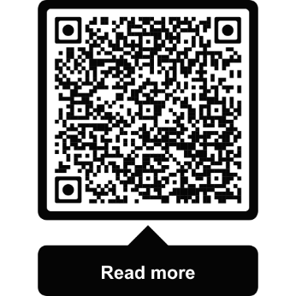
How to get your flu vaccination
- Contact your GP surgery
- Book a pharmacy appointment on the NHS App or online at www.nhs.uk/book-flu-jab
- Find a pharmacy at www.nhs.uk/flu-pharmacy

How to get your COVID-19 vaccination
- Book on the NHS App
- Book online at www.nhs.uk/get-vaccine
- Find a walk-in site at www.nhs.uk/covid-walk-in
You can arrange both of your NHS winter vaccinations for the same appointment by booking on the NHS App or online.

If you need support
If you can’t get online, phone 119. Translators are available. You can also use text phone 18001 119 or the NHS British Sign Language service at www.signvideo.co.uk/nhs119.
If you get your care at home, contact your GP surgery and ask for a home visit.
For information in easy read and other languages and formats, go to www.england.nhs.uk/seasonal-invites.

Why the NHS is offering winter vaccinations
Flu and COVID-19 spread more easily in winter and can be hard to avoid. Every year, thousands of older adults need hospital care for flu and COVID-19. It’s important you have both vaccinations every year to reduce your risk of severe symptoms. Protection fades over time and viruses change. Go to www.nhs.uk/wintervaccinations.

Other NHS vaccinations
If you haven't already, you may be able to get pneumococcal, RSV and shingles vaccinations. For full details, go to www.nhs.uk/vaccinations.
Yours sincerely,
NHS England Vaccination Team
Data protection: NHS England is responsible for processing personal data for the purpose of national vaccination programmes. You can read our privacy notice at www.england.nhs.uk/privacy-notice. To opt out: www.nhs.uk/covid-invite-preferences.

