Qabsashada ballanta qaadashada tallaalada jiilaalka ee NHS
Gacaliye ((fullName)),
Waxaad ballansan u qabsan kartaa tallaalada NHS ee bilaashka ah ee hargabka iyo COVID-19 sabab la xiriirta da'daada. Waxaa fiican in lagu tallaalo sida ugu dhakhsaha badan ee aad awoodid ka hor intaan la gaarin bilaha qabowga.

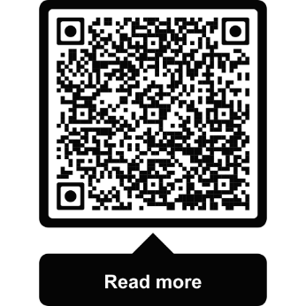
Sida loo qaato tallaalka hargabka
- La xiriir xarunta GP-gaaga.
- Ballan farmashi ka qabso ablikeeshinka NHS ama khadka www.nhs.uk/book-flu-jab
- Farmashi ka raadi www.nhs.uk/flu-pharmacy

Sida loo qaato tallaalka cudurka COVID-19
- Ballan ka qabso Ablikeeshinka NHS
- Ballan ka qabso khadka www.nhs.uk/get-vaccine
- Goobta ballan la’aan la iska tagi karo ka raadi www.nhs.uk/covid-walk-in
Waxaad qabanqaabisan kartaa tallaalada ifilada iyo COVID-19 labadaba inaad ku wada qaadato hal ballan adiga oo ballan ka qabsanaya Ablikeeshinka NHS ama khadka.

Haddii aad u baahan tahay caawimaad
Haddii aadan geli karin khadka, wac 119. Turjumaano ayaa la heli karaa. Waxaad sidoo kale isticmaali kartaa taleefanka fariimaha 18001 119 ama Adeegga Luuqadda Farakahadalka/Dhagoolayaasha ee NHS British oo laga helo www.signvideo.co.uk/nhs119 .
Haddii aad daryeelkaaga ku hesho guriga, la xiriir GP-gaaga si uu kuugu soo booqdo guriga.
Si aad u hesho macluumaad ku qoran qaab si fudud loo akhrin karo iyo qaabab kale ama ku qoran luqado kale, booqo www.england.nhs.uk/seasonal-invites.

Waa maxay sababta NHS ay u bixinayso tallaalada jiilaalka
Ifilada iyo COVID-19 waxay si fudud u faafaan xilliga jiilaalka wayna adkaan kartaa in laga fogaado. Jiilaal kasta, kumanaan carruur ah ayaa u baahda isbitaal jiifin sabab la xiriirta cudurka ifilada iyo COVID-19. Waa muhiim inaad labada tallaalba qaadato sannad kasta si aad u yarayso halista inaad la kulanto astaamo daran. Difaaca ayaa luma waqti kadib waxaana isbedela noocyada fayraska. Booqo www.nhs.uk/wintervaccinations.

Tallaallada kale ee NHS
Haddii aanad horeba u qaadan, waxa laga yaabaa inaad awoodo inaad qaadato tallaalada ‘pneumococcal’, RSV iyo cambaarta. Si aad u hesho faahfaahin buuxda, booqo www.nhs.uk/vaccinations.
Daacad kuu ah,
Kooxda Tallaallada ee NHS England
Ilaalinta Xogta: Hay'adda NHS England ayaa mas'uul ka ah ka shaqeynta xogtaada shakhsiyeed ee loogu talagalay barnaamijka qaranka ee tallaalada. Waxaad ogeysiiskeena qarsoodinimada xogta ka akhrisan kartaa www.england.nhs.uk/privacy-notice. Si aad uga baxdo: www.nhs.uk/covid-invite-preferences.

