Qabsashada ballanta qaadashada tallaalka COVID-19 ee NHS ee guga
Gacaliye ((fullName)),
Fadlan qabso ballanta qaadashada tallaalkaaga COVID-19 ee bilaashka ah ee NHS ee gu'ga. Waxaa lagugula talinayaa inaad qaadato sabab la xiriirta da'daada.

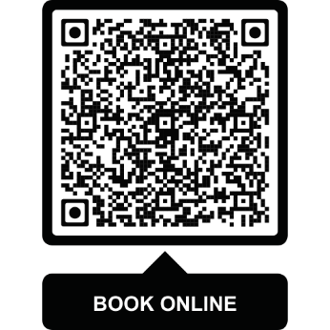
Sida loo qaato tallaalkaaga COVID-19
- Ballanta ka qabso Abka NHS, ama
- Ballanta ka qabso khadka
www.nhs.uk/get-vaccine, ama
- Goob ballan la’aan la iska tagi karo ka raadi www.nhs.uk/covid-walk-in
Taariikhda ugu dambeysa ee aad qaadan karto tallaalkaaga waa 30-ka Juun 2026.

Waa maxay sababta NHS ay kuu siinayso tallaalka COVID-19 ee gu'ga
COVID-19 si fudud ayuu u faafaa inta lagu jiro sanadka oo dhan. Waa muhiim inaad qaadato tallaaladaada markii laguu soo bandhigo fursadaas si loo yareeyo khatarta aad ugu jirto inaad qaado cudur halis ah, taasoo sii kordheysa inta aad sii gabowayso. Difaaca ayaa luma waqti kadib waxaana mar walba isbedela noocyada fayraska. Macluumaad dheeraad ah ka akhriso www.nhs.uk/covid-vaccine.

Haddii aad u baahan tahay caawimaad
Haddii aadan khad intarnet heli karin, wac 119. Turjubaano ayaa la heli karaa. Waxaad sidoo kale isticmaali kartaa taleefanka fariimaha 18001 119 ama adeegga Luqadda Dhagoolayaasha Ingiriiska (BSL) ee NHS adigoo booqanaya www.signvideo.co.uk/nhs119.
Haddii aad daryeelkaaga ku hesho guriga, la xiriir xarunta GP-gaaga si uu kuugu soo booqdo guriga.
Si aad u hesho casuumaadan oo u qoran qaab si fudud loo akhrin karo iyo qaabab kale ama ku qoran luqado kale, booqo www.england.nhs.uk/seasonal-invites.
Ma qaadatay tallaalkaaga RSV?
Dhammaan dadka da'doodu ka weyn tahay 75 sano hadda waxay u qalmaan qaadashada tallaalka RSV, si gacan looga gaysto ka hortagga fayraska ku dhaca neef-mareenka ee ‘syncytial virus’ (RSV). RSV wuxuu sababi karaa oof-wareen iyo xaalado kale oo caafimaad oo nolosha halis gelin kara. Dadka da'da ah ayaa halis weyn ugu jira.
Akhri wax badan oo ku saabsan tallaalka iyo sida loo helo adigoo booqanaya www.nhs.uk/rsv-vaccine ama ku jira NHS App-kaaga.
Daacad kuu ah,
Kooxda Tallaallada ee NHS England
Ilaalinta Xogta: Hay'adda NHS England ayaa mas'uul ka ah ka shaqeynta xogtaada shakhsiyeed ee loogu talagalay barnaamijyada tallaalka qaranka. Ogeysiiska qarsoodinimada xogta ka akhriso
www.england.nhs.uk/privacy-notice. Haddii aad wax su’aalo ah ka qabtid casuumaadan , booqo: www.england.nhs.uk/invite-enquiry. Si aad uga baxdo:
www.nhs.uk/covid-invite-preferences.

