Guidance for completing the risk assessment
The risk assessment will support pharmacy contractors to undertake the appropriate risk assessment(s) for the service(s). As part of this process pharmacy contractors should:
- Define the clinical service model(s) and identify both operational and clinical risks.
- Assign an accurate “likelihood” score and “impact” of the risk(s).
- Explain if and how the risk(s) will be mitigated and the associated subsequent action.
- Assign the person responsible for managing this risk.
- Identify an appropriate review date for the risk(s).
Some of the risks to consider may include:
- Clinical (for example, independent prescriber's scope of competency, access to medical history, access to diagnostic services, incorrect diagnosis, incorrect medication supplied, adverse effects to medication, timely access to clinical support)
- Digital (for example, digital diaries / appointment / booking systems, access to digital systems to view medical history, access to local shared care records, prescription generation, pathology systems, post event GP messaging)
- Operational (for example, suitability and availability of premises, equipment, staffing levels, business continuity plans, standard operating procedures)
- Dispensing (for example, clinically checks on prescriptions generated at the pharmacy, conflicts of interests, comments on impact on BAU dispensing)

Scoring risk
Risks should be scored between 1-5 for both likelihood and impact using the descriptions in the tables below.
Category | Likelihood Scoring
Likelihood score | 1 | 2 | 3 | 4 | 5
Descriptor | Rare | Unlikely | Possible | Likely | Very Likely
Frequency / How likely is it to happen? | This probably will never happen/recur | Do not expect it to happen/recur, but it is possible it may do so | Might happen or recur occasionally | Will probably happen/recur, but is not a persisting issue or circumstance | Very likely to happen/recur; possibly frequently

Category | Impact Scoring
Impact score | 1 | 2 | 3 | 4 | 5
Descriptor | Very low | Low | Moderate | High | Very high
Operational | Minor reduction in quality of treatment or service | Single failure to meet national standards of quality of treatment or service | Repeated failure to meet national standards of quality of treatment or service | Ongoing non-compliance with national standards of quality of treatment or service | Gross failure to meet national standards with totally unacceptable levels of quality of treatment or service
Operational | No or minimal effect for patients | Low effect for a small number of patients if unresolved | Moderate effect for multiple patients if unresolved | Significant effect for numerous patients if unresolved | Very significant effect for a large number of patients if unresolved
Reputational | Not relevant to mandate priorities | Minor impact on achieving mandate priorities | Moderate impact on achieving mandate priorities | High impact on achieving mandate priorities | Mandate priorities will not be achieved
Reputational | No adverse media coverage | Low level of adverse media coverage | Moderate amount of adverse media coverage | High level of adverse media coverage | National adverse media coverage
Reputational | No negative recognition from the public | Small amount of negative public interest | Moderate amount of negative public interest | Negative impact on public confidence | Total loss of public confidence
Financial | Negligible financial impact | Minimal financial impact | Moderate financial impact | Significant financial impact | Very significant financial impact

Each risk can be RAG rated by taking the likelihood and impact scores and using the matrix below - using the risk “RAG” rating system for scoring risks means risks can be ranked so that the most severe are addressed first. Decisions can then be made as to what actions can be taken to alleviate the risk.
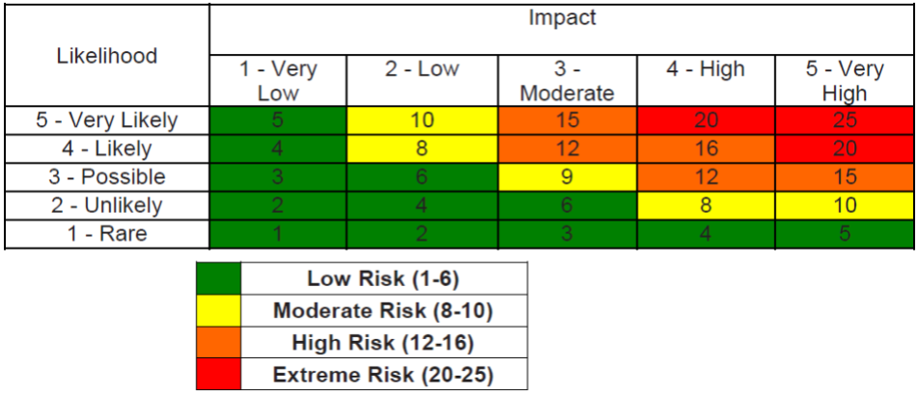

Risk assessment template

Clinical model
Location
Assessment undertaken by
Position
Signature
Date
Assessment signed off by
Position
Signature
Date
Risk assessment review date

 |  |  | Inherent risk score |  |  |  |  | Risk score on completion of actions
Risk Number | Risk description | Risk owner | Likelihood | Impact | RAG status | Action plan | Action owner | Likelihood | Impact | RAG status | Review date
1
2
3
4
5

Add more rows for additional risk as needed

