Annex H
Severance approval process – summaries

Contractual redundancies

For NHS trusts (only if over £150k or to a director)
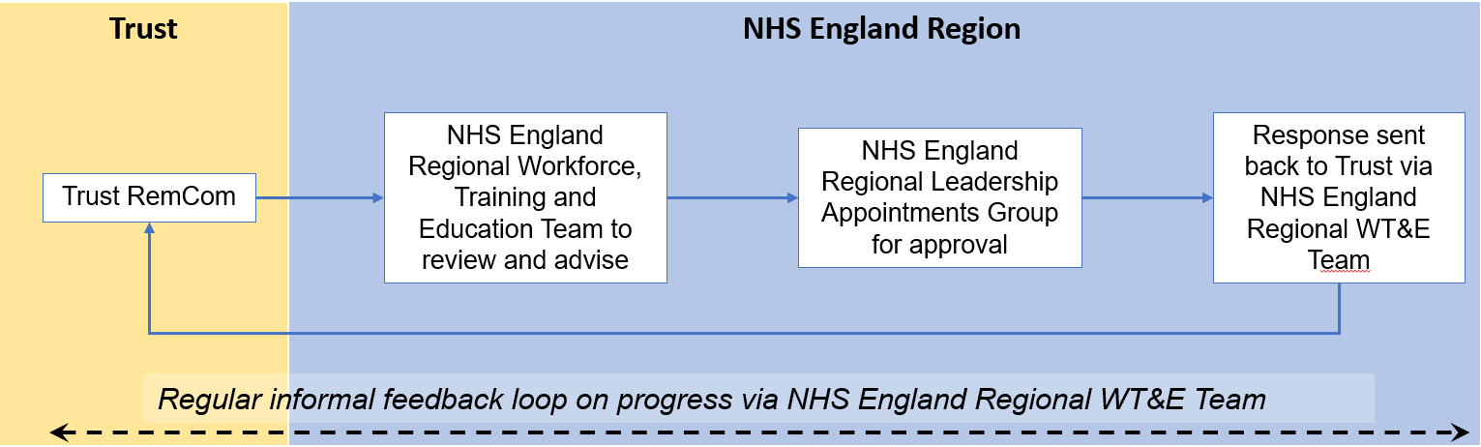
Image text:
This flowchart outlines the approval and feedback process within the NHS system, divided into two main sections:
1. Trust
- The process begins with the Trust RemCom (Remuneration Committee).
2. NHS England region
- The next step involves the NHS England Regional Workforce, Training and Education Team to review and advise
- The NHS England Regional Leadership Appointments Group then gives their approval
- A response is then sent back to the trust via the NHS England Workforce, Training and Education Team
Feedback loop
At the bottom of the chart, a dashed, double-headed arrow represents a continuous feedback loop labelled: “Regular informal feedback loop on progress via NHS England Regional Workforce, Training and Education Team.”
For NHS foundation trusts
NHS Foundation Trusts follow their own internal process for all contractual severance payments with no referral required to NHS England or HMT.

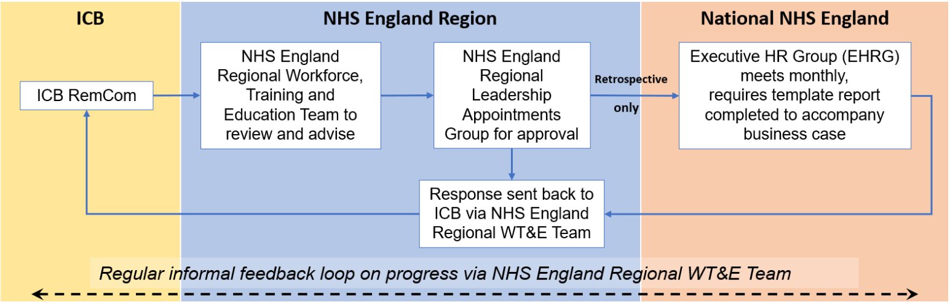
For integrated care boards

Image text:
This flowchart outlines the approval and feedback process within the NHS system, divided into three main sections:
1. Integrated care board
- The process begins with the ICB RemCom (Remuneration Committee).
2. NHS England Region
- The next step involves the NHS England Regional Workforce, Training and Education Team to review and advise
- The NHS England Regional Leadership Appointments Group then gives their approval
- A response is then sent back to the ICB via the NHS England Workforce, Training and Education Team
3. National NHS England
- If a payment is retrospective, the process continues to the Executive HR Group (EHRG), which meets monthly and requires a template report to accompany the business case
- A response is then sent back to the ICB via the NHS England Workforce, Training and Education Team
Feedback loop
At the bottom of the chart, a dashed, double-headed arrow represents a continuous feedback loop labelled: “Regular informal feedback loop on progress via NHS England Regional Workforce, Training and Education Team.”

Voluntary redundancy schemes
For NHS trusts, NHS foundation trusts and integrated care boards

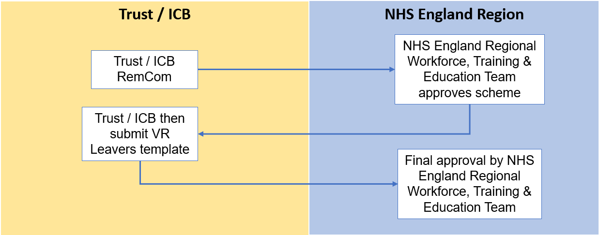

Image text:
This flowchart outlines the approval process within the NHS system, divided into two main sections:
- The process begins with the trust or ICB RemCom (Remuneration Committee)
- The NHS England Regional Workforce, Training and Education Team will approve the scheme
- The trust or ICB then submit a VR Leavers Template
- Final approval is given by the NHS England Regional Workforce, Training and Education Team

*Cases over £300k are subject to NHS England, Department of health and Social Care and HMT approval.

Special severance payments
For NHS trusts
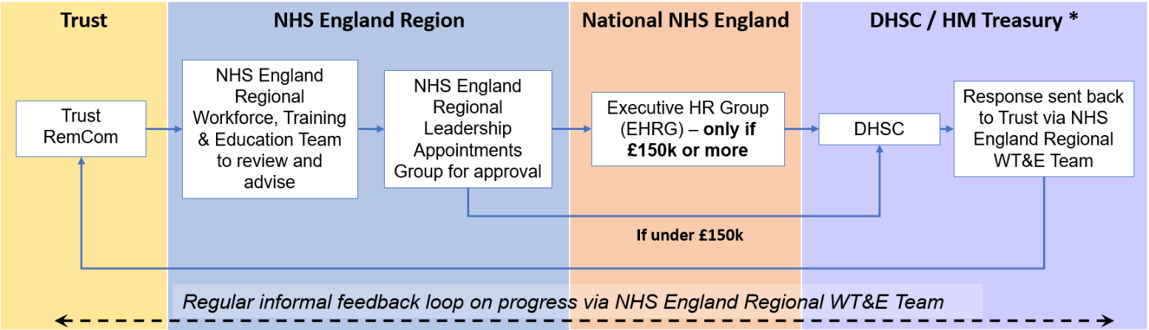
Image text:
This flowchart outlines the approval and feedback process within the NHS system, divided into four main sections:
1. Trust
- The process begins with the Trust RemCom (Remuneration Committee).
2. NHS England Region
- The next step involves the NHS England Regional Workforce, Training and Education Team to review and advise
- The NHS England Regional Leadership Appointments Group then gives their approval
- If a payment is under £150,000, the process continues to the Department of Health and Social Care (DHSC)
3. National NHS England
- If a payment is £150,000 or more, the process continues to the Executive HR Group (EHRG), which meets monthly and requires a template report to accompany the business case, before progressing to DHSC
4. DHSC / HM Treasury
- The process continues to DHSC
- A response is then sent back to the trust via the NHS England Workforce, Training and Education Team
Feedback loop
At the bottom of the chart, a dashed, double-headed arrow represents a continuous feedback loop labelled: “Regular informal feedback loop on progress via NHS England Regional Workforce, Training and Education Team.”

For NHS foundation trusts
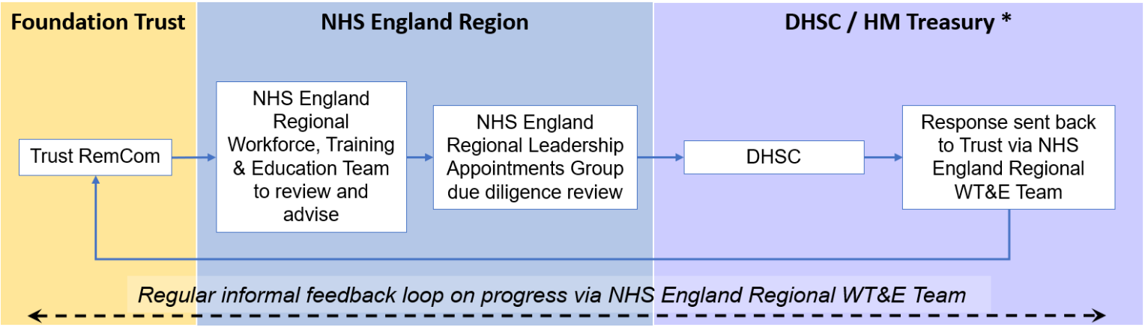
Image text:
This flowchart outlines the approval and feedback process within the NHS system, divided into three main sections:
1. Foundation Trust
- The process begins with the Foundation Trust RemCom (Remuneration Committee).
2. NHS England Region
- The next step involves the NHS England Regional Workforce, Training and Education Team to review and advise
- The NHS England Regional Leadership Appointments Group then do a due diligence review
3. DHSC / HM Treasury
- The process continues to DHSC
- A response is then sent back to the trust via the NHS England Workforce, Training and Education Team
Feedback loop
At the bottom of the chart, a dashed, double-headed arrow represents a continuous feedback loop labelled: “Regular informal feedback loop on progress via NHS England Regional Workforce, Training and Education Team.”

For integrated care boards
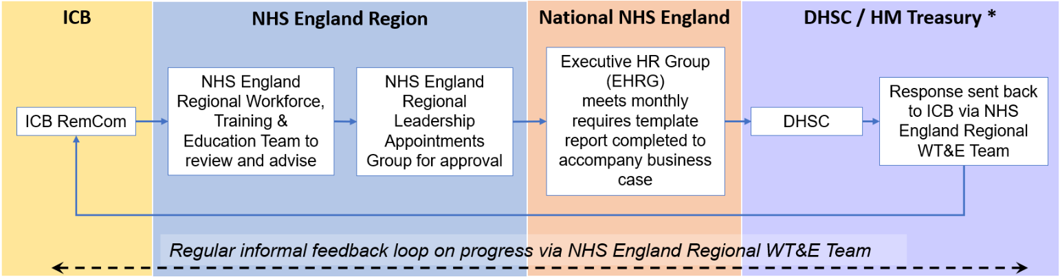
Image text:
This flowchart outlines the approval and feedback process within the NHS system, divided into four main sections:
1. Integrated care board
- The process begins with the ICB RemCom (Remuneration Committee).
2. NHS England Region
- The next step involves the NHS England Regional Workforce, Training and Education Team to review and advise
- The NHS England Regional Leadership Appointments Group then gives their approval
3. National NHS England
- The process continues to the Executive HR Group (EHRG), which meets monthly and requires a template report to accompany the business case
4. DHSC / HM Treasury
- The process continues to DHSC
- A response is then sent back to the ICB via the NHS England Workforce, Training and Education Team
Feedback loop
At the bottom of the chart, a dashed, double-headed arrow represents a continuous feedback loop labelled: “Regular informal feedback loop on progress via NHS England Regional Workforce, Training and Education Team.”
*Please see paragraph 5.4

